UNITED STATES

SECURITIES AND EXCHANGE COMMISSION

Washington, D.C. 20549

FORM 10-K

(Mark One)
- ANNUAL REPORT PURSUANT TO SECTION 13 OR 15(d) OF THE SECURITIES EXCHANGE ACT OF 1934 For the fiscal year ended December 31, 2025
OR
- TRANSITION REPORT PURSUANT TO SECTION 13 OR 15(d) OF THE SECURITIES EXCHANGE ACT OF 1934 FOR THE TRANSITION

PERIOD FROM TO

Commission File Number 001-42279

BIOAGE LABS, INC.
(Exact name of Registrant as specified in its Charter)
Delaware |  |  | 47-4721157
(State or other jurisdiction of |  |  | (I.R.S. Employer
incorporation or organization) |  |  | Identification No.)
5885 Hollis Street, Suite 370
Emeryville, CA |  |  | 94608
(Address of principal executive offices) |  |  | (Zip Code)

Registrant’s telephone number, including area code: (510) 806-1445

Securities registered pursuant to Section 12(b) of the Act:
Title of each class |  | Trading |  |  | Name of each exchange on which registered
Title of each class |  | Symbol(s) |  |  | Name of each exchange on which registered
Common Stock, par value $0.00001 per share |  | BIOA |  |  | The Nasdaq Stock Market LLC
Securities registered pursuant to Section 12(g) of the Act: None
Indicate by check mark if the Registrant is a well-known seasoned issuer, as defined in Rule 405 of the Securities Act. YES ☐ |  |  |  |  | NO ☒
Indicate by check mark if the Registrant is not required to file reports pursuant to Section 13 or 15(d) of the Act. YES ☐ NO ☒

Indicate by check mark whether the Registrant: (1) has filed all reports required to be filed by Section 13 or 15(d) of the Securities Exchange Act of 1934 during the preceding 12 months (or for such shorter period that the Registrant was required to file such reports), and (2) has been subject to such filing requirements for the past 90 days. YES ☒ NO ☐

Indicate by check mark whether the Registrant has submitted electronically every Interactive Data File required to be submitted pursuant to Rule 405 of Regulation S-T (§232.405 of this chapter) during the preceding 12 months (or for such shorter period that the Registrant was required to submit such files). YES ☒ NO ☐

Indicate by check mark whether the registrant is a large accelerated filer, an accelerated filer, a non-accelerated filer, smaller reporting company, or an emerging growth company. See the definitions of “large accelerated filer,” “accelerated filer,” “smaller reporting company,” and “emerging growth company” in Rule 12b-2 of the Exchange Act.

Large accelerated filer | ☐ | Accelerated filer | ☐
Non-accelerated filer | ☒ | Smaller reporting company | ☒
Emerging growth company | ☒

If an emerging growth company, indicate by check mark if the registrant has elected not to use the extended transition period for complying with any new or revised financial accounting standards provided pursuant to Section 13(a) of the Exchange Act. ☐

Indicate by check mark whether the registrant has filed a report on and attestation to its management’s assessment of the effectiveness of its internal control over financial reporting under Section 404(b) of the Sarbanes-Oxley Act (15 U.S.C. 7262(b)) by the registered public accounting firm that prepared or issued its audit report. ☐

If securities are registered pursuant to Section 12(b) of the Act, indicate by check mark whether the financial statements of the registrant included in the filing reflect the correction of an error to previously issued financial statements. ☐

Indicate by check mark whether any of those error corrections are restatements that required a recovery analysis of incentive-based compensation received by any of the registrant’s executive officers during the relevant recovery period pursuant to §240.10D-1(b). ☐
Indicate by check mark whether the Registrant is a shell company (as defined in Rule 12b-2 of the Exchange Act). YES ☐ NO ☒

The aggregate market value of the voting and non-voting common equity held by non-affiliates of the Registrant, based on the closing price of the shares of common stock on The Nasdaq Global Select Market on June 30, 2025, the last business day of the Registrant's most recently completed second fiscal quarter, was approximately $112.7 million.

The number of shares of Registrant’s Common Stock outstanding as of March 19, 2026 was 44,379,753.

DOCUMENTS INCORPORATED BY REFERENCE

Portions of the Registrant’s Definitive Proxy Statement (“Proxy Statement”) relating to the 2026 Annual Meeting of Stockholders will be filed with the Commission within 120 days after the end of the Registrant’s 2025 fiscal year and are incorporated by reference into Part III of this Report.

Auditor Firm ID:185 Auditor Name: KPMG LLP Auditor Location: San Francisco, California

 |  |  |  |  |  |  |  |  |  |  |  |  |  |  |  |  |  | Table of Contents
PART I |  |  |  |  |  |  |  |  |  |  |  |  |  |  |  |  |  |  |  |  |  |  |  |  |  |  | Page
Item 1. | Business |  |  |  |  |  |  |  |  |  |  |  |  |  |  |  |  |  |  |  |  |  |  |  |  |  | 1
Item 1A. | Risk Factors |  |  |  |  |  |  |  |  |  |  |  |  |  |  |  |  |  |  |  |  |  |  |  |  |  | 57
Item 1B. | Unresolved Staff Comments |  |  |  |  |  |  |  |  |  |  |  |  |  |  |  |  |  |  |  |  |  |  |  |  |  | 106
Item 1C. | Cybersecurity |  |  |  |  |  |  |  |  |  |  |  |  |  |  |  |  |  |  |  |  |  |  |  |  |  | 107
Item 2. | Properties |  |  |  |  |  |  |  |  |  |  |  |  |  |  |  |  |  |  |  |  |  |  |  |  |  | 108
Item 3. | Legal Proceedings |  |  |  |  |  |  |  |  |  |  |  |  |  |  |  |  |  |  |  |  |  |  |  |  |  | 108
Item 4. | Mine Safety Disclosures |  |  |  |  |  |  |  |  |  |  |  |  |  |  |  |  |  |  |  |  |  |  |  |  |  | 108
PART II
Item 5. | Market for Registrant’s Common Equity, Related Stockholder Matters and Issuer Purchases of Equity Securities |  |  |  |  |  |  |  |  |  |  |  |  |  |  |  |  |  |  |  |  |  |  |  |  |  | 109
Item 6. | [Reserved] |  |  |  |  |  |  |  |  |  |  |  |  |  |  |  |  |  |  |  |  |  |  |  |  |  | 109
Item 7. | Management’s Discussion and Analysis of Financial Condition and Results of Operations |  |  |  |  |  |  |  |  |  |  |  |  |  |  |  |  |  |  |  |  |  |  |  |  |  | 110
Item 7A. | Quantitative and Qualitative Disclosures About Market Risk |  |  |  |  |  |  |  |  |  |  |  |  |  |  |  |  |  |  |  |  |  |  |  |  |  | 124
Item 8. | Financial Statements and Supplementary Data |  |  |  |  |  |  |  |  |  |  |  |  |  |  |  |  |  |  |  |  |  |  |  |  |  | 124
Item 9. | Changes in and Disagreements With Accountants on Accounting and Financial Disclosure |  |  |  |  |  |  |  |  |  |  |  |  |  |  |  |  |  |  |  |  |  |  |  |  |  | 124
Item 9A. | Controls and Procedures |  |  |  |  |  |  |  |  |  |  |  |  |  |  |  |  |  |  |  |  |  |  |  |  |  | 124
Item 9B. | Other Information |  |  |  |  |  |  |  |  |  |  |  |  |  |  |  |  |  |  |  |  |  |  |  |  |  | 125
Item 9C. | Disclosure Regarding Foreign Jurisdictions that Prevent Inspections |  |  |  |  |  |  |  |  |  |  |  |  |  |  |  |  |  |  |  |  |  |  |  |  |  | 125
PART III
Item 10. | Directors, Executive Officers and Corporate Governance |  |  |  |  |  |  |  |  |  |  |  |  |  |  |  |  |  |  |  |  |  |  |  |  |  | 126
Item 11. | Executive Compensation |  |  |  |  |  |  |  |  |  |  |  |  |  |  |  |  |  |  |  |  |  |  |  |  |  | 126
Item 12. | Security Ownership of Certain Beneficial Owners and Management and Related Stockholder Matters |  |  |  |  |  |  |  |  |  |  |  |  |  |  |  |  |  |  |  |  |  |  |  |  |  | 126
Item 13. | Certain Relationships and Related Transactions, and Director Independence |  |  |  |  |  |  |  |  |  |  |  |  |  |  |  |  |  |  |  |  |  |  |  |  |  | 126
Item 14. | Principal Accounting Fees and Services |  |  |  |  |  |  |  |  |  |  |  |  |  |  |  |  |  |  |  |  |  |  |  |  |  | 126
PART IV
Item 15. | Exhibits, Financial Statement Schedules |  |  |  |  |  |  |  |  |  |  |  |  |  |  |  |  |  |  |  |  |  |  |  |  |  | 127
Item 16. | Form 10-K Summary |  |  |  |  |  |  |  |  |  |  |  |  |  |  |  |  |  |  |  |  |  |  |  |  |  | 129
 | Signatures |  |  |  |  |  |  |  |  |  |  |  |  |  |  |  |  |  |  |  |  |  |  |  |  |  | 130

SPECIAL NOTE REGARDING FORWARD-LOOKING STATEMENTS

This Annual Report on Form 10-K (this Annual Report) contains forward-looking statements. In some cases, you can identify forward-looking statements by terms such as “aim,” “may,” “will,” “should,” “expect,” “forecast,” “plan,” “anticipate,” “could,” “intend,” “target,” “project,” “contemplate,” “believe,” “estimate,” “predict,” “potential” or “continue” or the negative of these terms or other similar expressions, although not all forward-looking statements contain these words. All statements other than statements of historical fact contained in this Annual Report, including without limitation statements regarding our plans to develop and commercialize our product candidates, including BGE-102 and our APJ programs, the potential for BGE-102 as a treatment for atherosclerotic cardiovascular disease risk reduction and diabetic macular edema and the expected timeline for data readouts from our ongoing Phase 1 clinical trial, the timing and results of our ongoing or planned preclinical studies and clinical trials, risks associated with clinical trials, including our ability to adequately manage clinical activities for BGE-102 and our APJ programs, unexpected concerns that may arise from additional data or analysis obtained during clinical trials, the timing of and our ability to obtain and maintain regulatory approvals, the clinical utility of our future product candidates, our commercialization, marketing and manufacturing capabilities and strategy, our expectations about the willingness of healthcare professionals to use our product candidates, the sufficiency of our cash, cash equivalents and marketable securities, general economic conditions, the impact of industry and market conditions on our operations, including fluctuating interest rates and inflation, increased volatility in the debt and equity markets, legislative or regulatory healthcare reforms in the United States, significant political, trade or regulatory developments, including tariffs, federal government shutdowns, or shifting priorities within the U.S. Food and Drug Administration, cybersecurity incidents, and global regional conflicts, and the plans and objectives of management for future operations and capital expenditures are forward-looking statements.

The forward-looking statements in this Annual Report are only predictions and are based largely on our current expectations and projections about future events and financial trends that we believe may affect our business, financial condition and results of operations. These forward-looking statements speak only as of the date of this Annual Report and are subject to a number of known and unknown risks, uncertainties and assumptions, including those described under the sections in this Annual Report entitled “Risk Factors” and “Management’s Discussion and Analysis of Financial Condition and Results of Operations” and elsewhere in this Annual Report.

Because forward-looking statements are inherently subject to risks and uncertainties, some of which cannot be predicted or quantified and some of which are beyond our control, you should not rely on these forward-looking statements as predictions of future events. The events and circumstances reflected in our forward-looking statements may not be achieved or occur and actual results could differ materially from those projected in the forward-looking statements. Moreover, we operate in an evolving environment. New risk factors and uncertainties may emerge from time to time, and it is not possible for management to predict all risk factors and uncertainties. Except as required by applicable law, we do not plan to publicly update or revise any forward-looking statements contained herein, whether as a result of any new information, future events, changed circumstances or otherwise. We intend the forward-looking statements contained in this Annual Report to be covered by the safe harbor provisions for forward-looking statements contained in Section 27A of the Securities Act of 1933, as amended, or the Securities Act, and Section 21E of the Securities Exchange Act of 1934, as amended, or the Exchange Act.

i

PART I

Item 1. Business.

Overview

We are a clinical-stage biopharmaceutical company developing therapeutic product candidates for metabolic diseases by targeting the biology of human aging. Our technology platform and differentiated human datasets enable us to identify promising targets based on insights into molecular changes that drive aging.

In January 2025, we announced the nomination of our lead program, BGE-102, a potent, structurally novel, orally available, brain-penetrant small-molecule NLRP3 inhibitor. BGE-102 has a distinct mechanism and binding site from other NLRP3 inhibitors in development with issued patents covering both composition of matter and claims for the unique binding site.

In December 2025, we announced that BGE-102 was well-tolerated in Single Ascending Dose (SAD) and initial Multiple Ascending Dose (MAD) cohorts, with a pharmacokinetic profile supporting once-daily oral dosing, strong target engagement and high brain penetration.

We intend to advance BGE-102 in two therapeutic areas: cardiometabolic disease and ophthalmology.

Our first therapeutic area for BGE-102 is cardiometabolic disease, with a focus on atherosclerotic cardiovascular disease (ASCVD) risk reduction. Chronic systemic inflammation, as measured by high-sensitivity C-reactive protein (hsCRP), is an independent risk factor for cardiovascular events that is not adequately addressed by current lipid-lowering and antihypertensive therapies. In January 2026, we announced additional positive interim Phase 1 data, demonstrating potential for best-in-class hsCRP reduction in participants with elevated cardiovascular risk. In obese participants with elevated hsCRP, BGE-102 demonstrated an 86% median reduction in hsCRP at Day 14, with 93% of participants achieving hsCRP levels below 2 mg/L — the threshold associated with a 25% reduction in major adverse cardiovascular events. This level of hsCRP reduction is comparable to injectable anti-IL-6 monoclonal antibodies in clinical development for ASCVD, but achieved with once-daily oral dosing. We anticipate full Phase 1 SAD / MAD clinical trial results in the first half of 2026. We plan to initiate a Phase 2a proof-of-concept trial in patients with obesity and elevated hsCRP in the first half of 2026, with results anticipated by 2026 year end.

Our second therapeutic area for BGE-102 is ophthalmology. Diabetic macular edema (DME) is our first proof-of-concept indication in this area. DME affects approximately 1 million patients in the United States, and current intravitreal therapies face significant unmet need due to high injection burden and a substantial refractory population — approximately 45% of patients demonstrate refractoriness to anti-vascular endothelial growth factor (VEGF) therapy. In a preclinical model of DME, oral BGE-102 demonstrated dose-dependent preservation of retinal vascular integrity, achieving near-complete protection from vascular leakage and up to 90% preservation of microvascular integrity. We plan to initiate a Phase 1b/2a proof-of-concept trial in DME in mid-2026 with results anticipated in mid-2027. The goal is to demonstrate ocular target engagement, supporting future development across inflammation-driven retinal diseases.

Beyond NLRP3 inhibition, we are also developing novel apelin receptor APJ agonists for obesity, including programs targeting both oral and parenteral (subcutaneous) administration. In preclinical obesity models, APJ agonism has demonstrated the ability to more than double the weight loss induced by a glucagon-like peptide-1 receptor (GLP-1R) agonist while also restoring healthy body composition and improving muscle function. In June 2025, we announced an option agreement with JiKang Therapeutics for a novel APJ agonist antibody, as well as the filing of a U.S. provisional patent for novel small molecule APJ agonists. We intend to file the first Investigational New Drug applications (INDs) for an APJ program by 2026 year end.

We are also advancing earlier stage platform-derived programs in collaboration with Eli Lilly and Company (Lilly), and have an ongoing target discovery collaboration with Novartis Pharma AG (Novartis).

1

Our approach: targeting human aging biology to treat chronic metabolic diseases

The burden of many serious and chronic diseases — including cardiovascular disease and diabetes — increases with age.
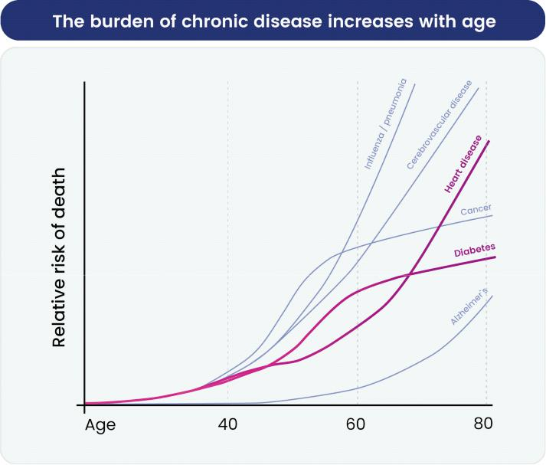

Age is a key risk factor for mortality from many chronic diseases in the United States, including cardiometabolic diseases like heart disease and diabetes.

(Source: National Center for Health Statistics).

2

However, there is substantial natural variation in the human population, resulting in a broad range of aging trajectories and outcomes, with some people experiencing much longer lifespans as well as delayed disease onset. We created our company to identify biological pathways associated with longer, healthier human lifespans and to develop pharmaceutical products that can modulate these pathways with the intent to prevent and reverse specific diseases, focusing on cardiometabolic diseases.
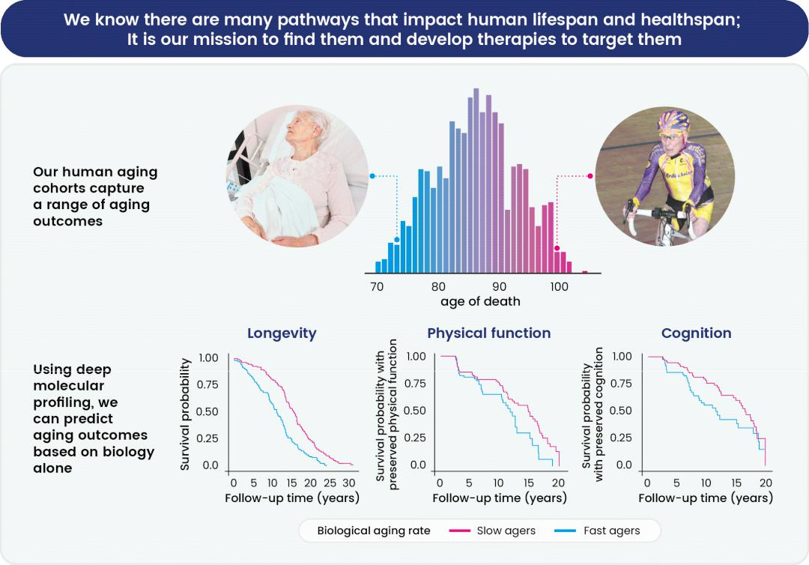

We capture a range of aging outcomes in our human aging cohorts, including functional and cognitive decline, disease incidence and mortality. In this example, deep, serial profiling of circulating proteins in these participants was used to understand the biology that drives these outcomes.

Our approach starts with human data. We examine the impact of the molecular changes that happen naturally as people age and study how these changes drive both functional decline (e.g., loss of muscle strength) and disease risk (e.g., obesity, insulin resistance, dyslipidemia, and hypertension). To develop new insights into the biological drivers of aging, we have generated proprietary longitudinal human datasets based on exclusive access to a unique resource: serial biobanked human samples coupled with health records and functional measurements collected for up to 50 years, capturing individual aging trajectories measured over several decades. We analyze these samples using state-of-the-art molecular profiling technologies,

3

measuring thousands of biologically relevant molecules, and then apply computational tools to the resulting data to extract potential drivers of a long and healthy lifespan.
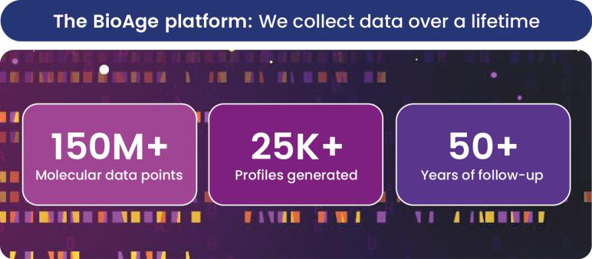

The BioAge platform encompasses over 150 million molecular data points spanning over 25 thousand individual participant profiles and over 50 years of follow-up.

We have selected chronic cardiometabolic diseases as our primary focus within age-related chronic diseases, given their high prevalence and resulting potential for impact on population health.
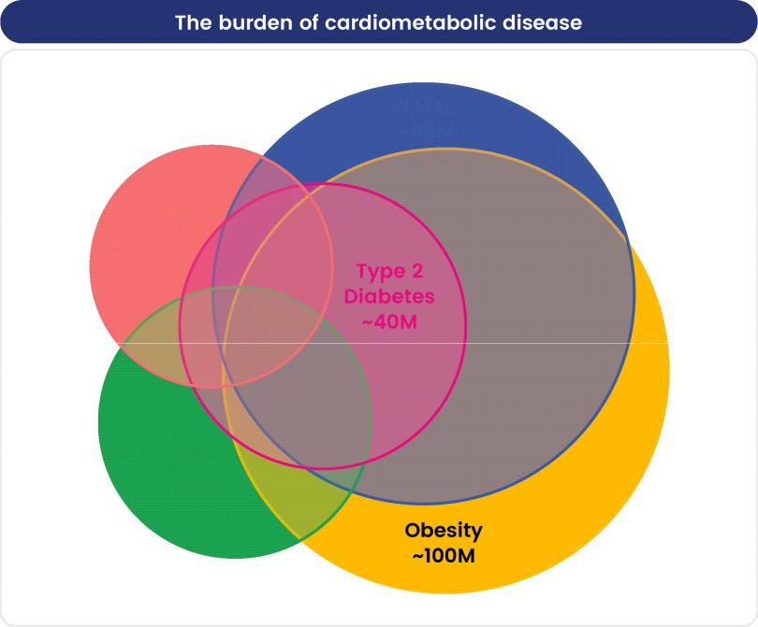

Prevalence of major cardiometabolic disease in the United States

Chronic cardiometabolic diseases also represent outsized commercial opportunities. For instance, according to third-party estimates, the global market for GLP-1R agonists, including those used to treat diabetes, is expected to grow to $150 billion by 2031.

4

Our Pipeline

We are building a pipeline of platform-derived therapeutics targeting chronic cardiometabolic disease.

Our lead program is BGE-102, a potent, structurally novel, orally available, brain-penetrant small-molecule NLRP3 inhibitor. We expect to announce full Phase 1 SAD / MAD clinical trial results in the first half of 2026. We are initially developing BGE-102 for patients with cardiovascular risk factors and DME.

- For cardiovascular risk, we intend to initiate a dose-ranging Phase 2a proof-of-concept trial in the first half of 2026 in patients with obesity and elevated hsCRP. Approximately 160 patients will be randomized BGE-102 or placebo for 12 weeks. The primary endpoint is percent change in hsCRP. Results are anticipated by 2026 year end.

- For DME, we intend to initiate a Phase 1b/2a proof-of-concept trial in mid-2026 in patients with DME. Approximately 90 patients will be randomized across groups; BGE-102 will be assessed as an adjunctive therapy to intravitreal anti-VEGF treatment and as a monotherapy. The goal of the trial is to demonstrate target engagement in the eye. Results are anticipated in mid-2027.

We are also developing novel apelin receptor APJ agonists for obesity, including programs targeting both oral and parenteral (subcutaneous) administration. We intend to file the first IND for an APJ program by 2026 year end.

We are advancing several additional platform targets, currently in molecule discovery stage in collaboration with Lilly, which we believe have the potential to transform treatment of cardiometabolic disease. We plan to expand this pipeline over time, both internally and through our target discovery collaboration with Novartis.

Our portfolio of product candidates and ongoing collaborations are summarized in the figure below:
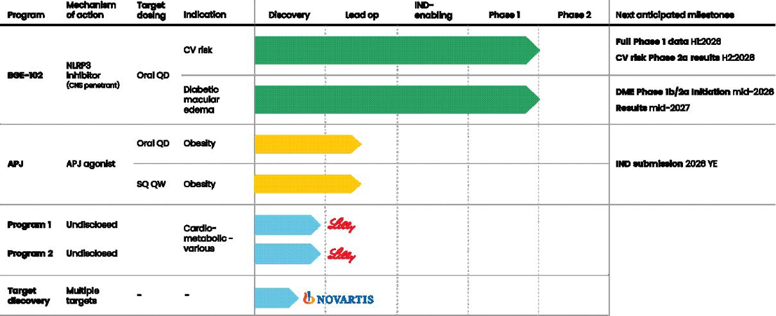

Our Team

We have assembled a leadership team of experts in aging biology and drug development. Our senior team consists of the following members:

- Kristen Fortney, Ph.D., our Chief Executive Officer and co-founder. Dr. Fortney has extensive experience in aging biology, genetics and bioinformatics and systems biology from her work at Stanford and the University of Toronto.

- Eric Morgen, M.D., our Chief Operating Officer and co-founder. Dr. Morgen was previously on the faculty at the University of Toronto, where his research focused on biomarker discovery and characterization in high-dimensional datasets from human cohorts.

5

- Dov Goldstein, M.D., our Chief Financial Officer. Dr. Goldstein previously served as Chief Financial Officer at Vicuron Pharmaceuticals Inc. and Loxo Oncology Inc., as well as a Managing Partner at Aisling Capital. He was most recently the Chief Financial Officer and Chief Business Officer of Indapta Therapeutics, Inc.

- Paul Rubin, M.D., our Chief Medical Officer. Dr. Rubin has over 35 years of experience in the biotechnology industry and has led 12 compounds to U.S. approval, with five led from discovery through approval, including Lunesta® and Xopenex®. He most recently served as Executive Vice President Research and Development at miRagen Therapeutics, Inc. and was previously Chief Medical Officer at XOMA Corporation and Executive Vice President Research and Development at Sepracor.

- Ann Neale, our Chief Development Officer. Ms. Neale has over 30 years of experience in the biotechnology industry. She was most recently Senior Vice President of Development Operations at Principia BioPharma Inc. (acquired by Sanofi S.A.), where she led operations and resourcing strategy for multiple global early- and late-phase clinical programs.

- Peng Leong, Ph.D., our Chief Business Officer. Dr. Leong has extensive experience in the biotech industry, previously serving in healthcare investment banking at Piper Jaffray and as Head of General Medicine Business Development at Merck KgaA and Chief Business Officer at Kazia Therapeutics Limited.

- BJ Sullivan, Ph.D., our Chief Strategy Officer. Dr. Sullivan was previously in L.E.K. Consulting’s life sciences practice, where he advised biopharma companies on growth strategy and M&A.

- George Hartman, Ph.D., our Senior Vice President, Chemistry. Dr. Hartman is a co-founder of Novira Therapeutics, Inc. and previously served as executive director of medicinal chemistry at Merck & Co., Inc. where he and his group identified and brought 12 drug candidates into Phase 2 or Phase 3 clinical trials.

Our Strategy

Our goal is to develop a focused portfolio of therapies for cardiometabolic disease by targeting the biology of human aging. Below is a summary of key product candidate and platform differentiation.
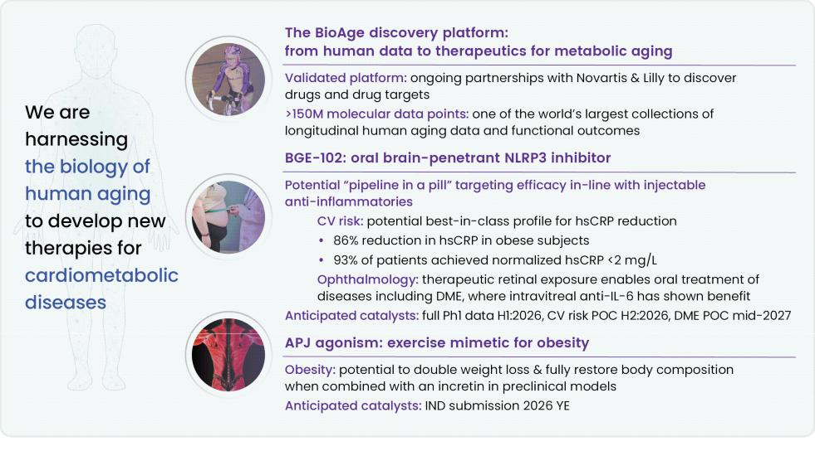

Our strategy is to:

- Apply novel insights into aging biology to build a pipeline of therapeutics to transform the treatment of chronic cardiometabolic diseases. Our platform provides unique insights into human aging biology spanning over 50 years. These insights enabled the identification of NLRP3 and apelin as targets. We also have several discovery-stage programs targeting this novel biology, which we will continue to advance through our ongoing collaborations with Lilly and Novartis. We plan to grow this pipeline over time, both internally and potentially through additional partnerships with pharmaceutical companies that have complementary datasets and capabilities.

6

- Efficiently advance our lead program, BGE-102, a potent, structurally novel, orally available, brain-penetrant small-molecule NLRP3 inhibitor in cardiometabolic disease and ophthalmology. BGE-102 has demonstrated potential best-in-class potency and efficacy in reducing hsCRP and other inflammatory markers in our Phase 1 trial. We plan to initiate a cardiovascular risk Phase 2a proof-of-concept trial in patients with obesity and elevated hsCRP in the first half of 2026 and expect to report results by 2026 year end. We are also pursuing diabetic macular edema as a second initial indication, with a Phase 1b/2a proof-of-concept trial planned to begin in mid-2026, with results anticipated in mid-2027.

- Advance both oral and parenteral apelin receptor APJ agonists as a novel exercise mimetic approach for the treatment of obesity. We believe that APJ agonism has the potential to transform the treatment of obesity by increasing weight loss quantity and quality, including improved body composition and tolerability.

- Selectively partner our product candidates to maximize patient impact and shareholder value. According to third-party estimates, the global market opportunity for cardiometabolic diseases is very large, with GLP-1Rs and incretins for obesity alone expected to grow to $150 billion by 2031. Given the resulting activity and investment of pharmaceutical companies in the therapeutic area, we may selectively partner our product candidates to accelerate the path to market in multiple large indications and maximize shareholder value.

BGE-102: a Potential Best-in-Class NLRP3 Inhibitor

NLRP3 and inflammation — a predictor of decreased longevity

NLRP3 is a component of a multi-protein complex referred to as the inflammasome, part of the innate immune system. Activation of the NLRP3 inflammasome leads to the secretion of inflammatory cytokines interleukin 1 beta (IL-1ß) and interleukin 18 (IL-18). However, NLRP3 can become hyperactivated in certain disease states, resulting in sustained cytokine release and chronic sterile inflammation.
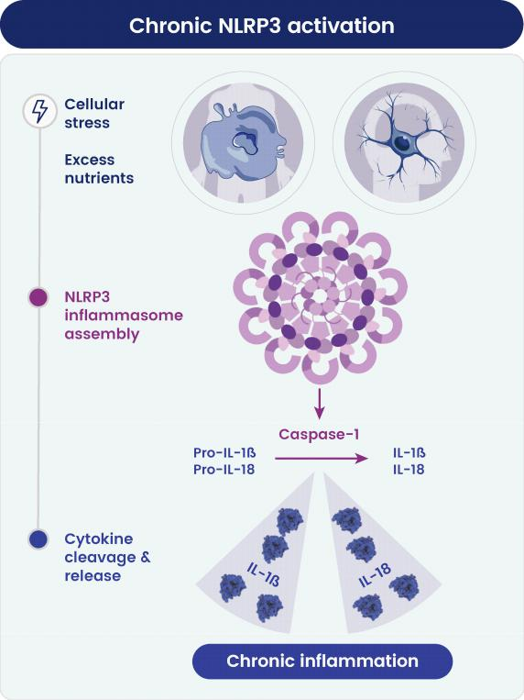

NLRP3 dysregulation: in certain disease states, intrinsic stimuli like cellular stress and excess nutrients can result in NLRP3 hyperactivation, resulting in sustained cytokine cleavage and a chronic inflammatory state.

7

We found that increased transcription of genes for NLRP3, IL-1ß, and IL-18 in our human aging cohorts was associated with significantly increased all-cause mortality risk. These findings align with human genetic evidence from Mendelian randomization studies, which demonstrate that a one standard deviation increase in NLRP3 expression is associated with up to a 70% increase in heart failure risk. Additionally, gain-of-function mutations in NLRP3 have been associated with reduced lean mass, impaired body composition, and accelerated atherosclerosis.

Consistent with our findings that NLRP3 can have detrimental effects on human longevity, previous studies have shown that genetic deletion of NLRP3 significantly extended mouse lifespan and also improved healthspan as measured by parameters such as muscle strength including muscle size and wire hang latency to fall, and cognitive function such as preserved contextual memory.
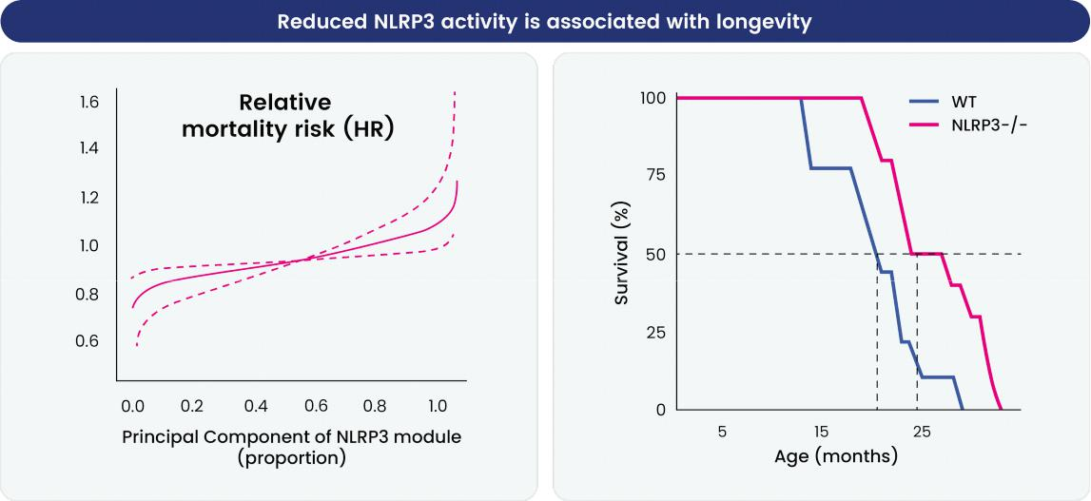

Levels of NLRP3-associated proteins (principal component) are inversely related to mortality risk in our human aging cohorts (left). Consistently, in a third-party preclinical study, knockout of the NLRP3 gene in mice significantly extends lifespan (n = 10 mice per group) (right). (Source: Marín-Aguilar et al. 2020).

8

BGE-102, our lead program
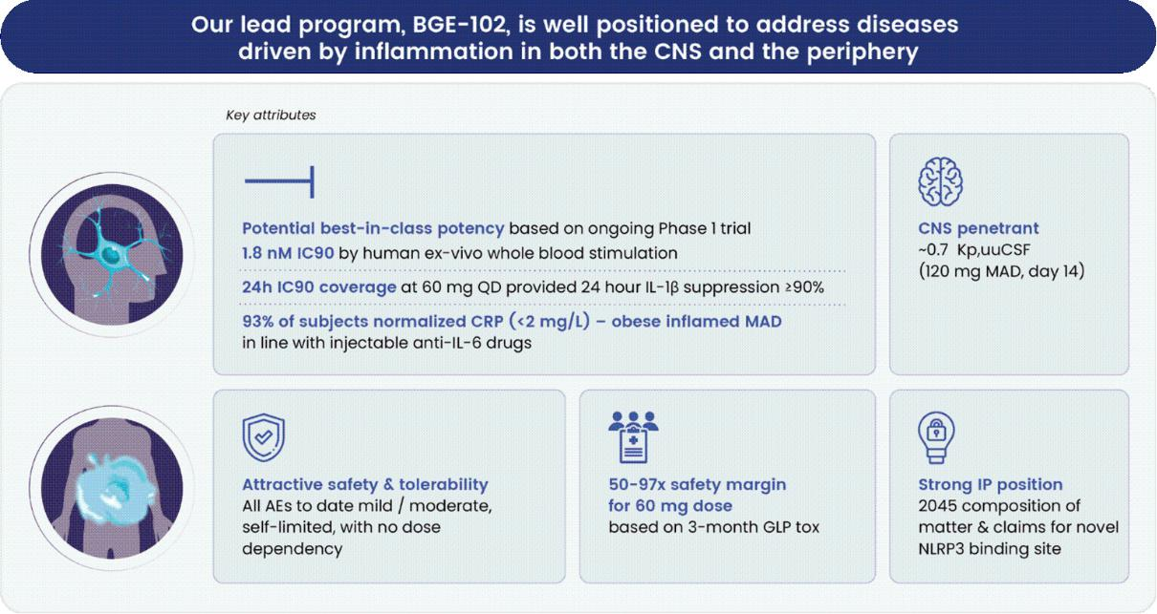

BGE-102 is a potent, orally available, structurally novel, brain-penetrant small-molecule NLRP3 inhibitor discovered through screening of a HitGen DNA-encoded chemical library and optimized through structure-activity relationship studies. Through a collaboration with Dr. Matthias Geyer at the University of Bonn, we identified a binding site on NLRP3 that is distinct from previously described inhibitors, including the reference compound MCC950, as confirmed by cryo-electron microscopy. Unlike MCC950 and related inhibitors, which have been reported to inhibit NLRP3 ATPase activity, BGE-102 has not demonstrated ATPase inhibition in our in vitro assays, suggesting a fundamentally distinct mechanism that may offer advantages in specificity or side effect profile.
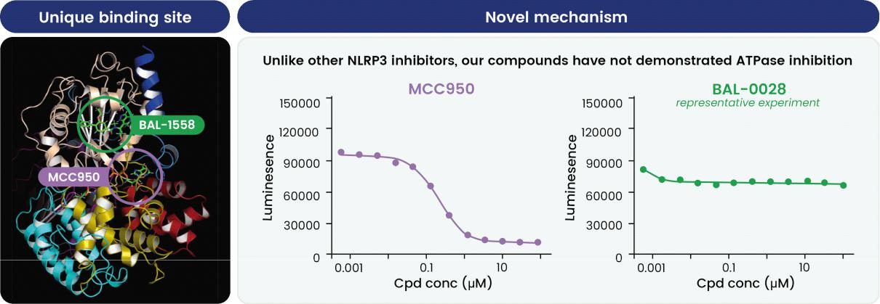

BGE-102 has been shown to exhibit robust potency and favorable pharmacokinetic properties. In human ex vivo whole blood stimulation assays, BGE-102 achieves an IC90 (the concentration at which 90% target engagement is achieved) of 1.8 nanomolar for IL-1β. At 60 mg once daily, mean trough plasma concentrations provide approximately 24-hour IC90 coverage and ≥90% suppression of IL-1β. The compound penetrates the central nervous system, with a mean brain-to-plasma concentration ratio (Kp,uuCSF) of approximately 0.7 measured after 14 days of 120 mg once-daily dosing, exceeding the estimated IC90 for IL-1β suppression in the central nervous system. The safety margin at the 60 mg dose, based on exposures at Day 14 in the healthy volunteer MAD cohort, ranges from 42-fold to 90-fold relative to the no-observed-adverse-effect level (NOAEL) in 3-month GLP toxicology studies.

9

Our intellectual property portfolio includes composition of matter claims and claims covering the novel NLRP3 binding site, with patent protection extending through 2045 prior to patent term restoration.

Phase 1 clinical trial results

Trial design

We are conducting a Phase 1 clinical trial designed to evaluate the safety, tolerability, pharmacokinetics, and pharmacodynamics of BGE-102 in both healthy volunteers and individuals with obesity. The entire study has been conducted in a clinical trial unit. The trial consisted of SAD cohorts, MAD cohorts in healthy volunteers, and ongoing MAD cohorts in obese participants with elevated baseline hsCRP.
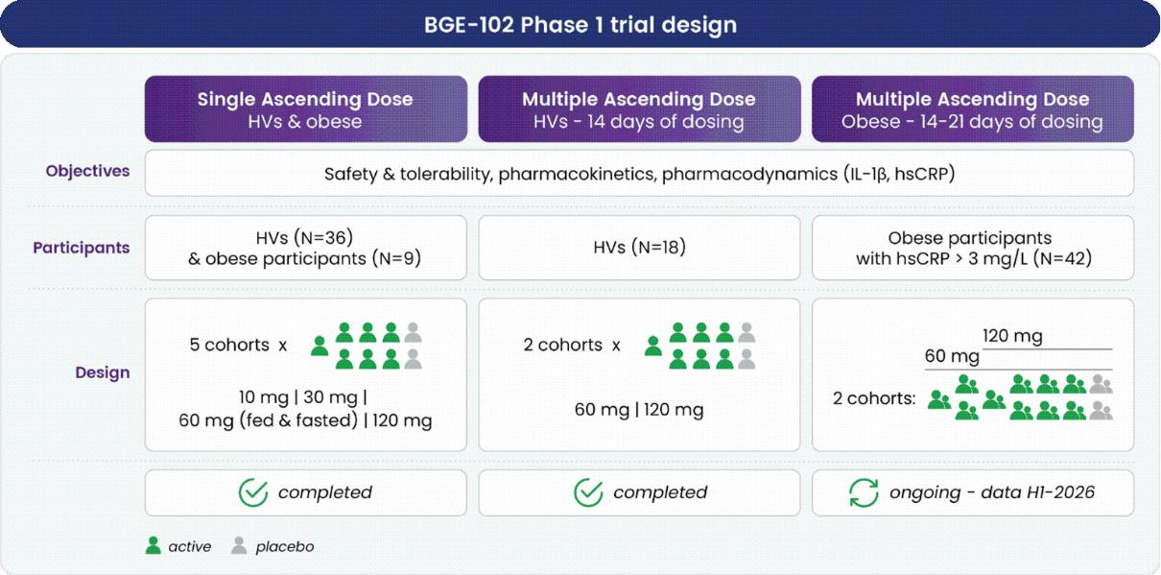

BGE-102 has met key objectives to date. We anticipate completion of all Phase 1 cohorts and a full data readout in the first half of 2026.
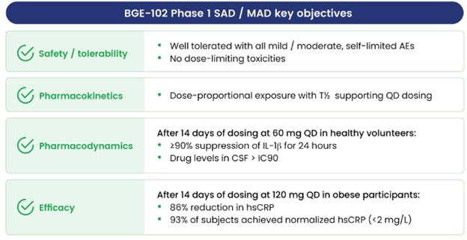

10

Safety profile and tolerability

In our Phase 1 trials, BGE-102 has been well tolerated across all completed cohorts. All adverse events observed to date have been mild to moderate in severity, self-limited in nature, and without apparent dose-dependency. We have observed no dose-limiting toxicities in any cohort.

Pharmacokinetics

Single dose pharmacokinetic studies demonstrated dose-proportional exposure across the 10 mg to 120 mg dose range, indicating linear pharmacokinetics within the studied dose range.
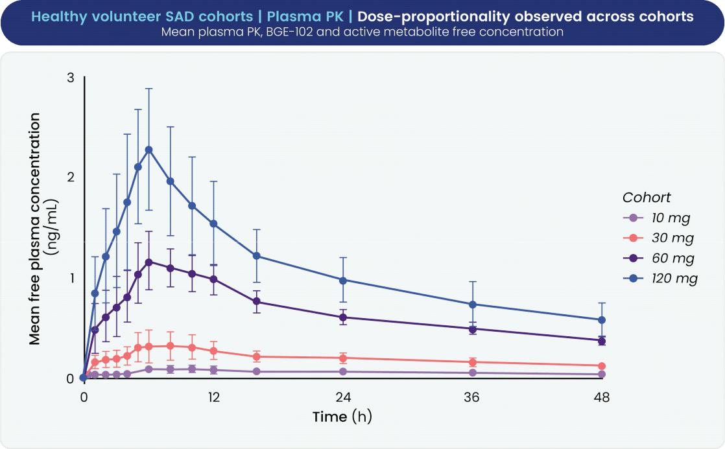

11

Upon multiple daily dosing, BGE-102 exhibits accumulation with once-daily dosing. Trough plasma concentrations reached approximate steady state by Day 14 of dosing, where mean trough concentrations at both the 60 mg and 120 mg once-daily doses exceeded the human IL-1β IC90.
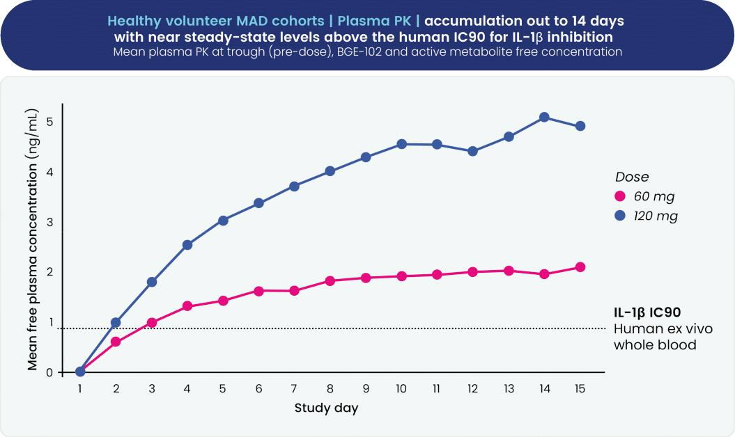

CNS Exposure

A key differentiator of BGE-102 is its demonstrated ability to cross the blood-brain barrier and achieve therapeutically meaningful concentrations in cerebrospinal fluid (CSF). On Day 14 of MAD dosing at 60 mg once daily, mean CSF concentrations of BGE-102 approximated the human IL-1β IC90. At the 120 mg dose, mean CSF concentrations exceeded the IC90.
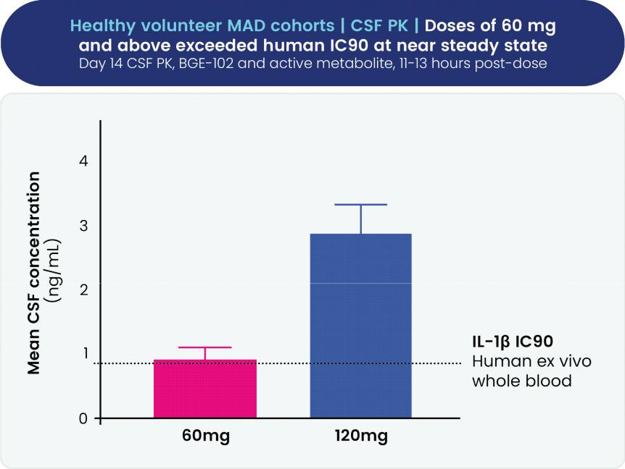

12

This CNS exposure differentiates BGE-102 from peripherally selective NLRP3 inhibitors and potentially enables BGE-102 to address neuroinflammatory indications.

Target engagement: IL-1β suppression

Ex vivo whole blood stimulation assays confirmed robust and sustained target engagement across all dosing cohorts. In the 60 mg MAD cohort, BGE-102 achieved 90% suppression of IL-1β at trough concentrations on Day 14. In the 120 mg MAD cohort in healthy volunteers, IL-1β suppression reached 98% at trough on Day 14.
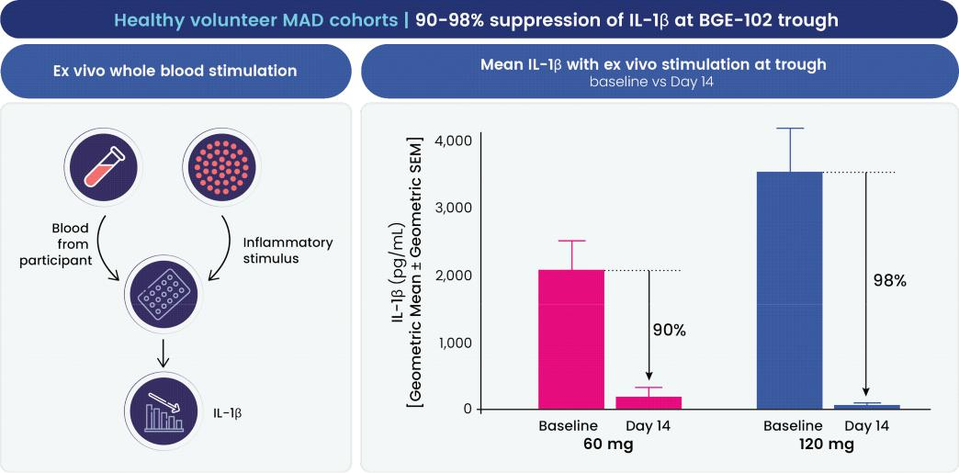

Time-course pharmacodynamic data from the 120 mg cohort demonstrate that near-maximal IL-1β suppression was achieved by Day 7 and maintained throughout the entire 24-hour dosing interval, confirming sustained target engagement with once-daily dosing.
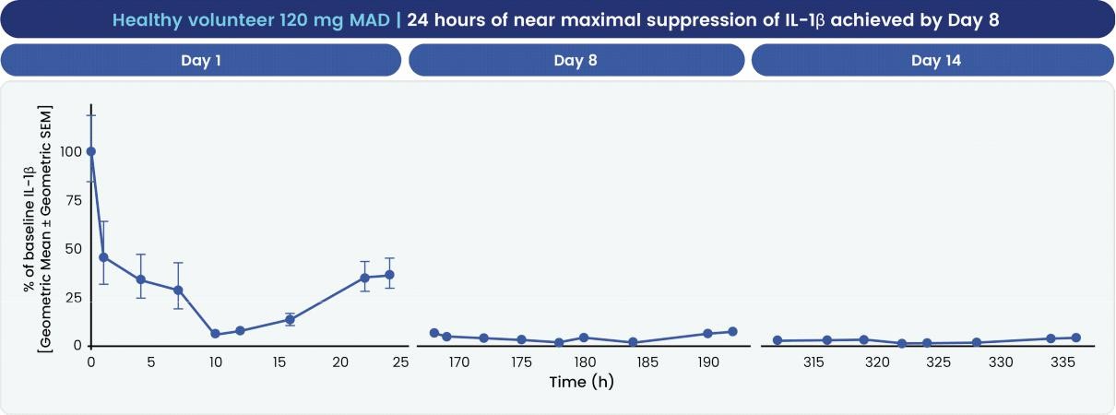

13

Inflammatory biomarkers in obese subjects with elevated baseline hsCRP

In addition to healthy volunteers, we are conducting two additional MAD cohorts in obese patients with elevated baseline hsCRP. In these cohorts, we are evaluating circulating biomarkers of systemic inflammation. Results from the first cohort, 120 mg once daily, are reported here.
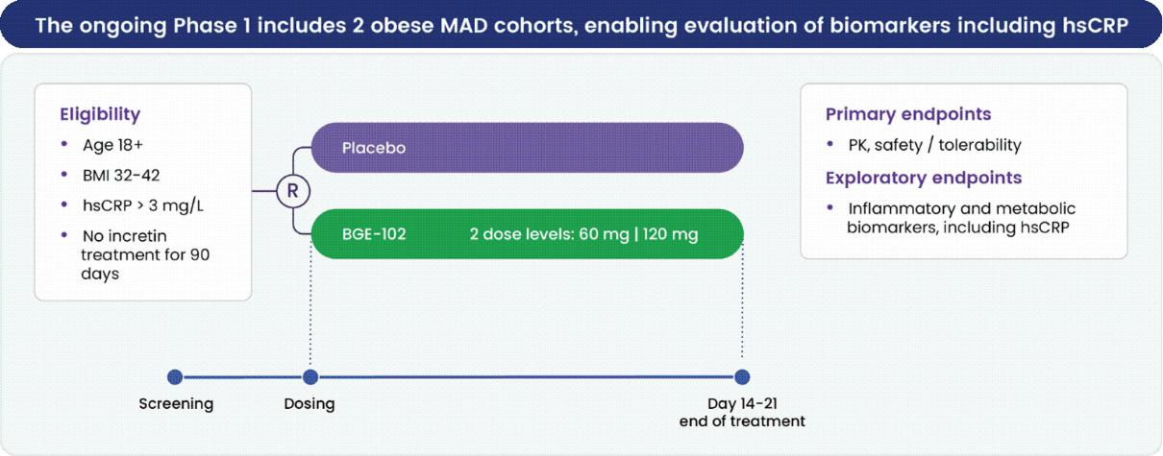

In the obese subjects, IL-1β suppression measured 93% at trough on Day 14, confirming that robust target engagement is also observed in subjects with elevated baseline hsCRP.
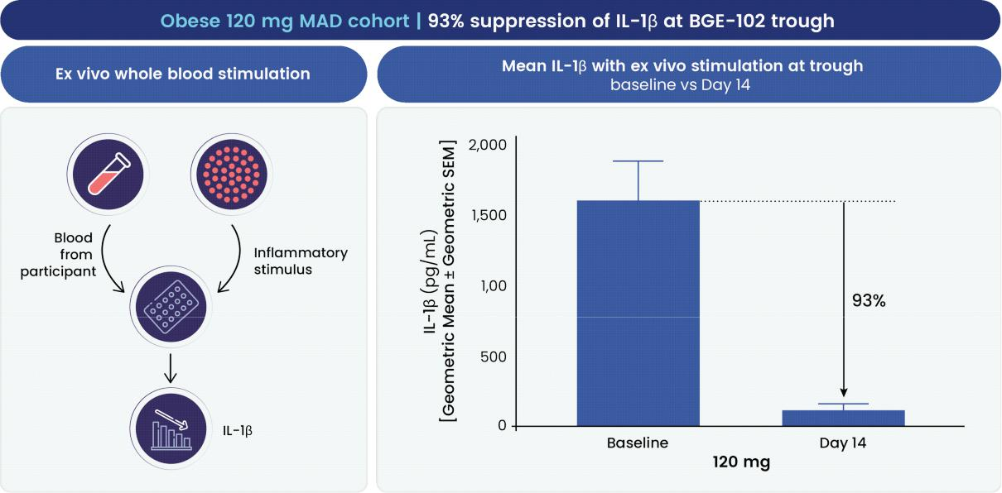

14

In obese subjects, BGE-102 achieved a median reduction in hsCRP of 86% by Day 14. The effect was evident earlier, with a median 83% reduction already observed on Day 7, suggesting rapid anti-inflammatory activity.
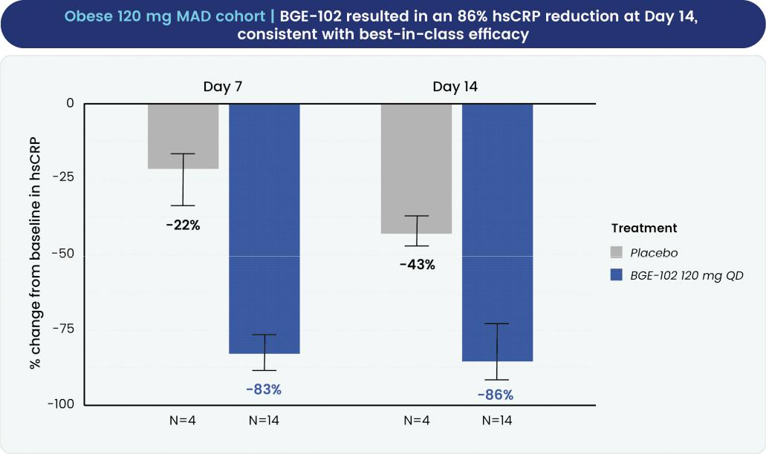

Note: median values, error bars show IQR (Q1-Q3); median baseline hsCRP 4.85 mg/L for active treatment and 4.25 mg/L for placebo.

By Day 14, 93% of subjects receiving BGE-102 (13 of 14 subjects) achieved hsCRP levels below 2 mg/L. This threshold is clinically significant: in the landmark CANTOS trial (Canakinumab Anti-inflammatory Thrombosis Outcomes Study), participants who achieved on-treatment hsCRP below 2 mg/L experienced a 25% reduction in major adverse cardiovascular events (MACE; hazard ratio 0.75, p<0.0001), while those who failed to achieve this threshold showed no significant benefit from anti-inflammatory therapy, establishing hsCRP normalization as a meaningful marker of therapeutic response. Furthermore, 71% of participants achieved hsCRP levels at or below 1 mg/L, a level associated with the lowest tertile of inflammatory risk in population studies.
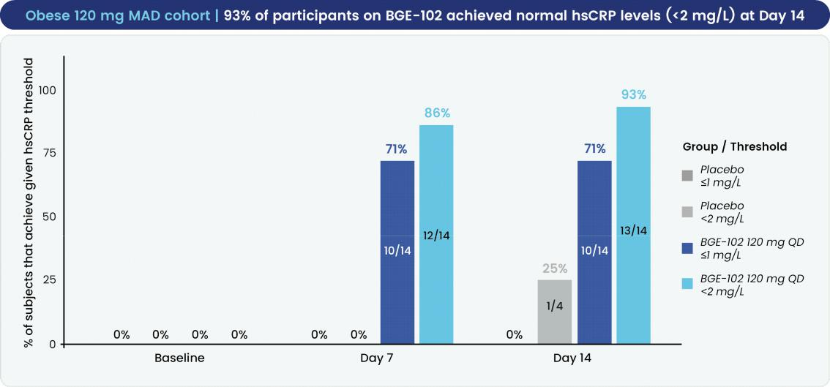

Note: median baseline hsCRP 4.85 mg/L for active treatment and 4.25 mg/L for placebo.

15

IL-6, a cytokine downstream of IL-1β signaling and a driver of hsCRP production, was also substantially reduced. At Day 7, BGE-102-treated subjects exhibited a median reduction in plasma IL-6 of 69%, compared to a 5% reduction in placebo recipients. By Day 14, the median IL-6 reduction in BGE-102 recipients was 58%, whereas placebo participants showed a 13% increase in IL-6 levels.
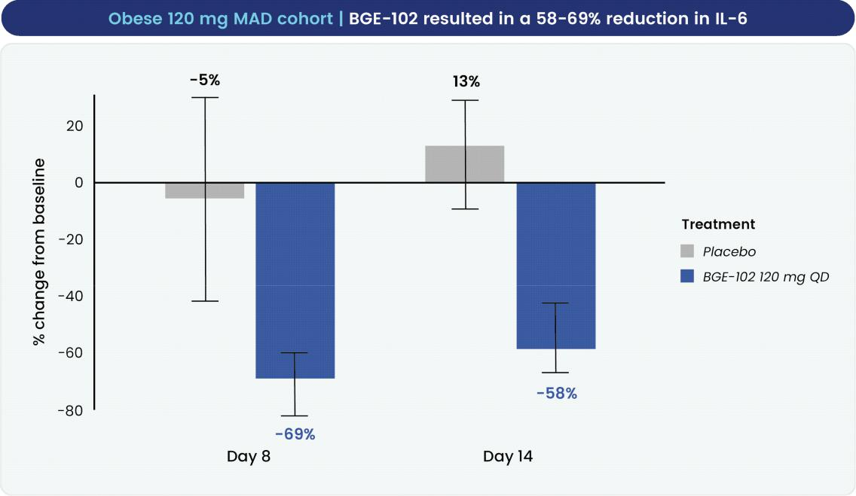

Note: measurements performed using the Alamar NULISA platform given higher sensitivity below 2.5 pg/mL; in the median values, error bars show IQR (Q1-Q3); median baseline IL-6 2.3 pg/mL for active treatment and 1.3 pg/mL for placebo.

Fibrinogen, another circulating biomarker of systemic inflammation and an independent risk factor for thrombotic events, was reduced by a median of 30% at Day 14 in BGE-102 recipients, compared to a 1% increase in placebo recipients.
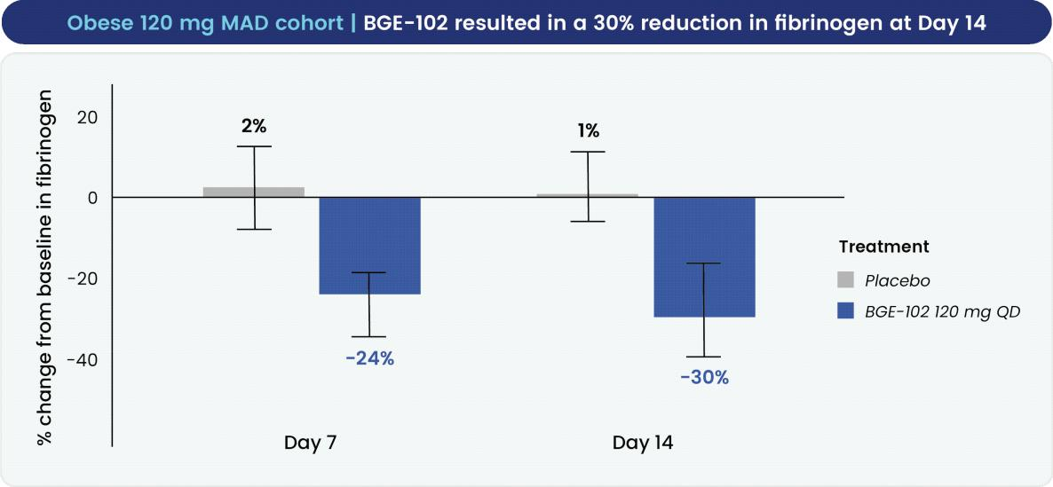

Note: median values, error bars show IQR (Q1-Q3); median baseline fibrinogen 331 mg/dL for active treatment and 290 mg/dL for placebo.

16

In two participants with elevated baseline CSF IL-6 (>7 pg/mL), BGE-102 reduced CSF IL-6 levels by 84% at Day 14, with a corresponding 62% reduction in plasma IL-6. This finding demonstrates functional pharmacodynamic activity within the central nervous system and suggests that BGE-102 may have utility in neuroinflammatory conditions where NLRP3 activation contributes to pathology.
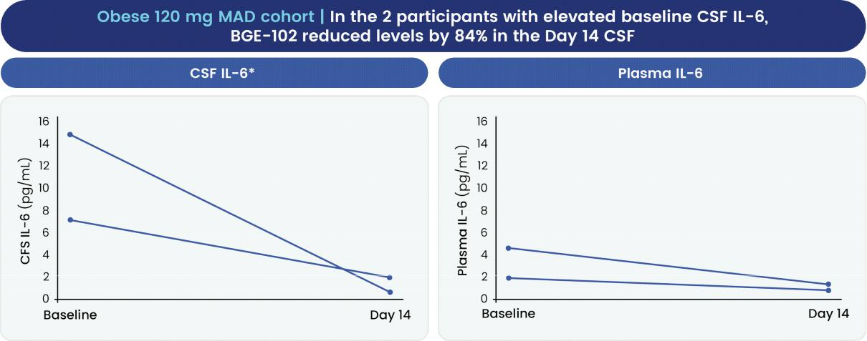

Note: *IL-6 levels >7 pg/mL in the CSF are considered elevated; corresponding decrease in the plasma was 62%; measurements performed using the Alamar NULISA platform.

Anticipated development milestones

We anticipate completion of the Phase 1 trial with a full data readout in the first half of 2026.

We subsequently intend to advance BGE-102 for both cardiometabolic disease and ophthalmology. In the first half of 2026, we plan to initiate a Phase 2a cardiovascular risk proof-of-concept trial in patients with obesity and elevated hsCRP, with results expected by 2026 year end. In mid-2026, we plan to initiate a Phase 1b/2a proof-of-concept trial in patients with DME, with results anticipated in mid-2027.

Atherosclerotic cardiovascular disease opportunity

Burden of cardiovascular disease and unmet need

Cardiovascular disease remains the leading cause of death globally, responsible for approximately 20 million deaths annually. Within the spectrum of cardiovascular disease, ASCVD represents a major and growing burden. ASCVD is characterized by the progressive accumulation of cholesterol-laden plaques within arterial walls. These atherosclerotic plaques are inherently unstable and may rupture, triggering thrombotic events that manifest clinically as myocardial infarction, ischemic stroke, or sudden cardiac death.

Current therapeutic management of ASCVD focuses primarily on lipid modification through statins, PCSK9 inhibitors, and related agents; blood pressure management through antihypertensive agents; and antiplatelet therapy with aspirin and P2Y12 inhibitors. These therapies have substantially reduced cardiovascular morbidity and mortality over the past several decades. However, despite the widespread use and optimization of these evidence-based therapies, substantial residual cardiovascular risk persists in treated populations.

This residual risk — affecting patients even after optimization of lipid and blood pressure targets — is increasingly attributed to chronic systemic inflammation, a pathway that current cardiovascular therapeutics do not adequately address. The resulting patient population with residual inflammatory risk is large and clinically important, currently lacking specific anti-inflammatory therapeutics in routine cardiovascular practice.

17

Inflammation and high-sensitivity C-reactive protein as independent cardiovascular risk factors

A growing body of evidence supports inflammation as an independent driver of ASCVD. hsCRP, a circulating biomarker of systemic inflammation, has emerged as a robust predictor of cardiovascular risk that is independent of traditional lipid-based risk factors.

The Women's Health Study, a prospective cohort study of approximately 28,000 women followed for 30 years and published in the New England Journal of Medicine, provides compelling evidence for the independent predictive value of hsCRP. In this study, women in the highest quintile of baseline hsCRP had a 67% increased risk of major adverse cardiovascular events (MACE) — comprising myocardial infarction, ischemic stroke, and cardiovascular death — compared to women in the lowest quintile (hazard ratio 1.67). Notably, this risk gradient exceeded the risk gradient observed for low-density lipoprotein (LDL) cholesterol (hazard ratio 1.37) and lipoprotein(a) (hazard ratio 1.32), establishing hsCRP as a powerful cardiovascular risk predictor that may exceed traditional lipid-based risk factors.
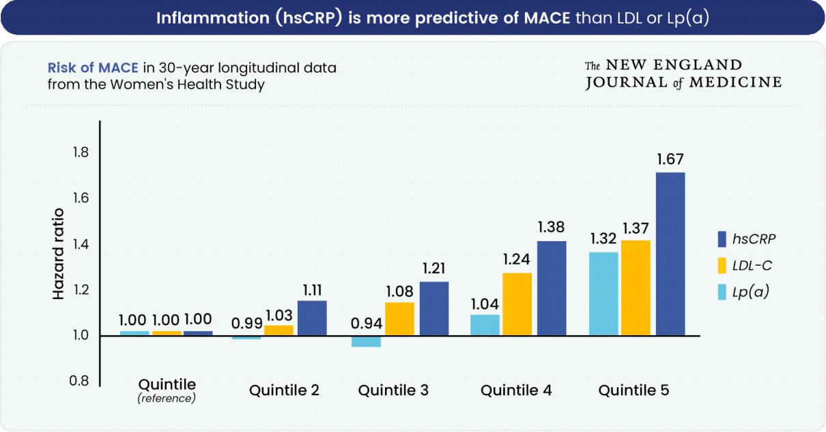

Adapted from Ridker et al. 2024. Results for Fine-Gray model, adjusted for age and covariables.

Clinical validation that targeting inflammation can reduce cardiovascular events was provided by the CANTOS trial , a large, prospective, randomized controlled trial of canakinumab, a monoclonal antibody targeting IL-1β, a cytokine directly downstream of NLRP3, in patients with prior myocardial infarction and elevated hsCRP. In CANTOS, participants who achieved on-treatment hsCRP levels below 2 mg/L experienced a 25% reduction in major adverse cardiovascular events (hazard ratio 0.75, p<0.0001) compared to those who did not achieve hsCRP normalization. Importantly, participants who failed to

18

normalize hsCRP to below 2 mg/L showed no significant benefit from the active treatment, establishing hsCRP normalization as a meaningful therapeutic goal for reducing cardiovascular risk.
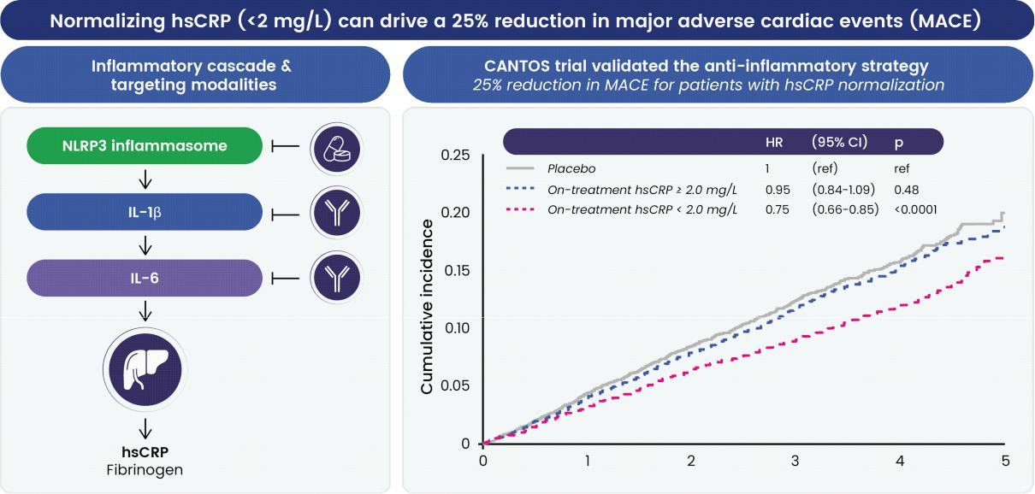

The magnitude of residual inflammatory risk is substantial. At any given LDL cholesterol level, patients with elevated hsCRP have increased cardiovascular risk. This observation underscores that inflammation contributes to cardiovascular risk independently of dyslipidemia and, moreover, additively increases risk when elevated LDL cholesterol and elevated hsCRP coexist.
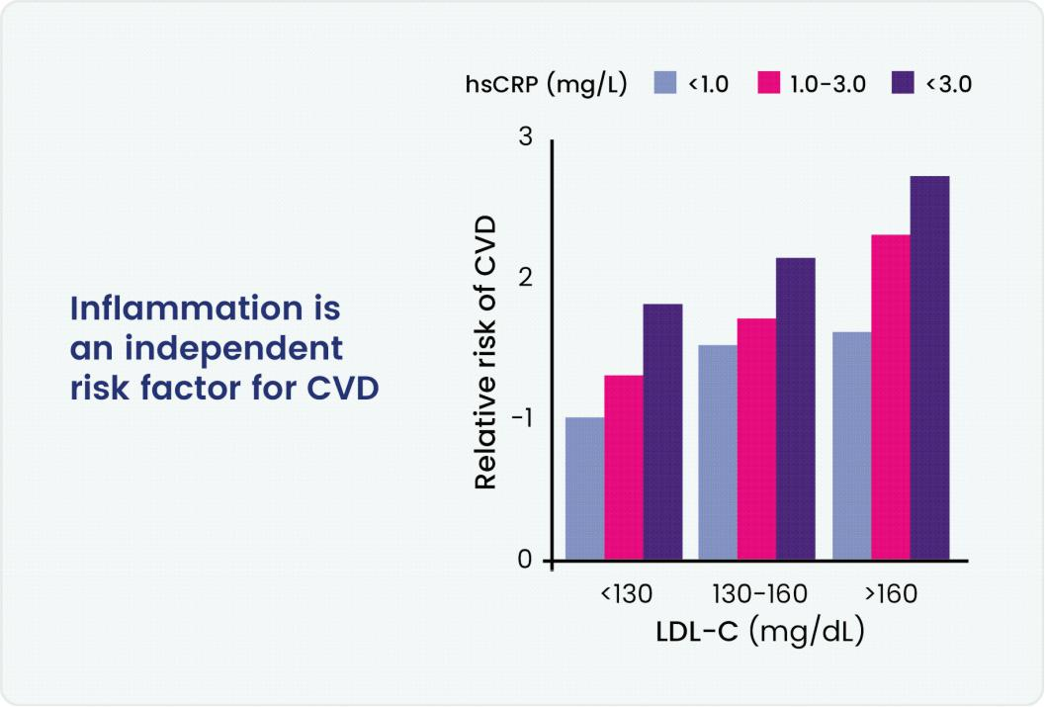

NLRP3 inhibition as a cardiovascular target: mechanistic advantages over downstream cytokine inhibition.

19

The NLRP3 inflammasome occupies a unique position within the inflammatory cascade relevant to cardiovascular disease, serving as a nodal point upstream of multiple inflammatory mediators implicated in atherosclerotic disease progression. Upon activation, NLRP3 triggers the secretion of IL-1β, which in turn drives the production of IL-6, which subsequently stimulates the hepatic production of hsCRP and fibrinogen. NLRP3 inhibition therefore targets the inflammatory cascade upstream of both IL-1β and IL-6, with the potential to suppress multiple downstream inflammatory pathways more comprehensively than selective targeting of any single cytokine.

Beyond its effects on IL-1β and the IL-6/hsCRP axis, NLRP3 inhibition offers potential mechanistic advantages that may prove clinically relevant. First, NLRP3 activation also drives the production of IL-18, an inflammatory cytokine that has emerged as an independent predictor of cardiovascular risk and that is not addressed by current anti-IL-6 or anti-IL-1β therapeutic approaches. In the CANTOS trial, patients in the highest tertile of baseline IL-18 had approximately 45% higher risk of cardiovascular death compared to patients in the lowest tertile (hazard ratio 1.44, P < 0.0001; Ridker et al., European Heart Journal 2020), establishing IL-18 as an independent contributor to cardiovascular mortality. A therapy that suppresses both IL-18 and the IL-6/hsCRP axis through NLRP3 inhibition may therefore provide more comprehensive anti-inflammatory benefit than selective IL-6 or IL-1β blockade.

Second, NLRP3 inflammasome activation can trigger pyroptosis, a form of inflammatory cell death that releases intracellular contents and may contribute to atherosclerotic plaque destabilization. NLRP3 inhibitors can prevent pyroptosis, whereas anti-IL-6 and anti-IL-1β monoclonal antibodies do not address this mechanism. Pyroptosis inhibition may therefore represent an additional mechanism through which NLRP3 inhibition reduces cardiovascular risk.
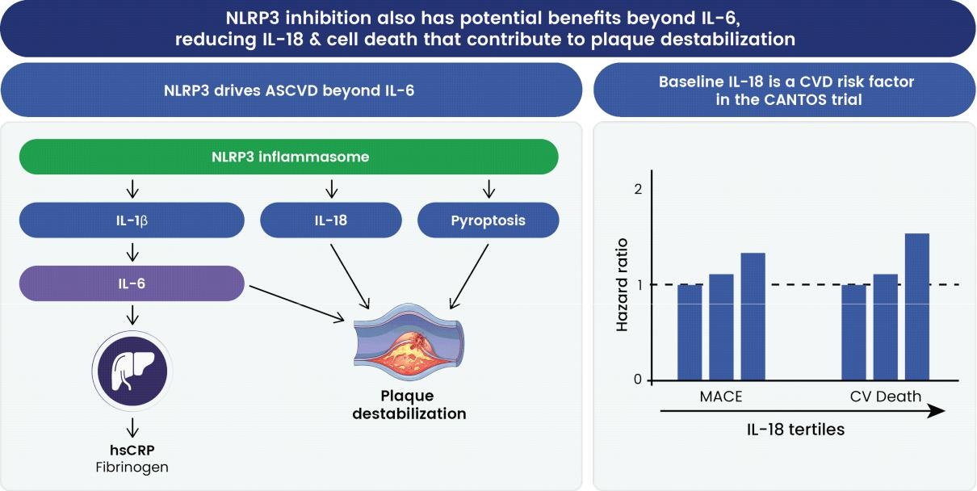

20

BGE-102's 86% median hsCRP reduction (obese participants with elevated baseline hsCRP, Day 14 of 120 mg QD dosing) is comparable to biologic approaches targeting the IL-1β and IL-6 pathways, and this effect was achieved with once-daily oral dosing rather than injectable administration.
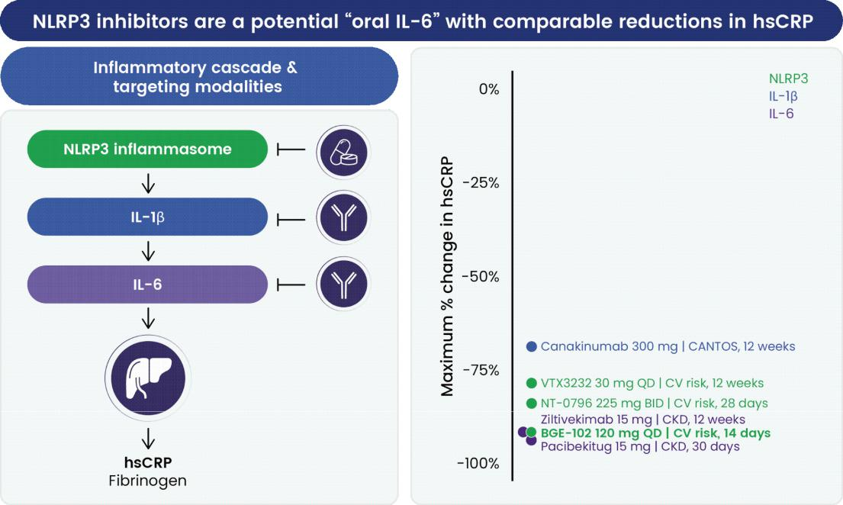

The cardiovascular market opportunity

Cardiovascular risk reduction represents a substantial and growing therapeutic market. Approximately 25 million adults in the United States have a diagnosis of ASCVD, of whom approximately 60% — representing roughly 15 million individuals — have elevated hsCRP and may be candidates for anti-inflammatory therapy. The global market for lipid-lowering therapies is expected to reach approximately $50 billion by 2035, and an oral anti-inflammatory agent that reduces cardiovascular risk through a complementary mechanism could meaningfully expand the overall cardiovascular therapeutics market.
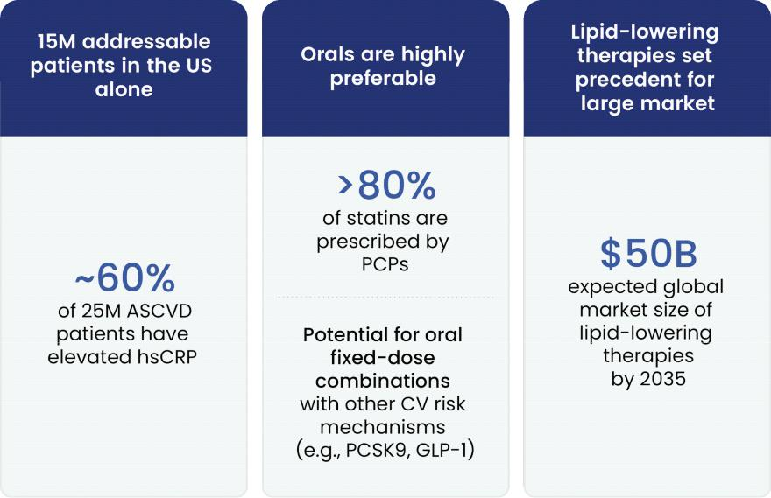

21

The distinction between an oral small-molecule inhibitor and injectable biologic therapies may represent a substantial practical and commercial advantage. All anti-IL-6 inhibitors in cardiovascular development are injectable monoclonal antibodies, administered subcutaneously on a monthly or quarterly basis. In contrast, BGE-102 is an oral, once-daily small molecule. The vast majority of patients treated for cardiovascular risk receive their care in settings where oral medications are the standard modality. An oral once-daily anti-inflammatory agent may therefore enable broader adoption and prescribing across both cardiology and primary care. Additionally, an oral formulation creates potential for fixed-dose combination products with statins, PCSK9 inhibitors, and GLP-1 receptor agonists — combinations that may improve patient convenience and treatment adherence, which are critical considerations in chronic cardiovascular disease management.

Phase 2a proof-of-concept trial in cardiovascular risk

We plan to initiate a dose-ranging Phase 2a cardiovascular risk proof-of-concept trial of BGE-102 in patients with obesity and elevated hsCRP in the first half of 2026. This trial is designed to confirm and extend the hsCRP and inflammatory biomarker effects observed in our Phase 1 obese cohorts and to further characterize the safety and tolerability of BGE-102 over an extended treatment period.
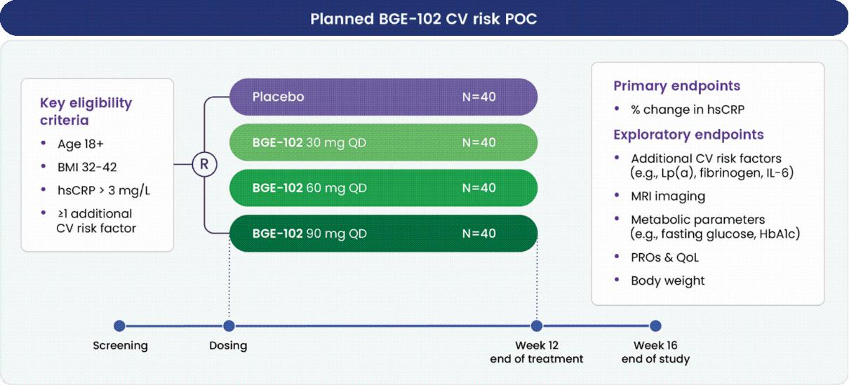

The Phase 2a trial will be a double-blind, randomized, placebo-controlled study enrolling approximately 160 patients with a 12-week treatment period. The primary endpoint is percent change in hsCRP from baseline to Week 12. Results are anticipated by 2026 year end.

22

Ophthalmology — Diabetic Macular Edema and Geographic Atrophy

Our second target therapeutic area for BGE-102 is ophthalmology. NLRP3 inflammasome activation sits at the center of multiple retinal diseases, including DME and geographic atrophy (GA), which are prevalent conditions with substantial unmet needs.
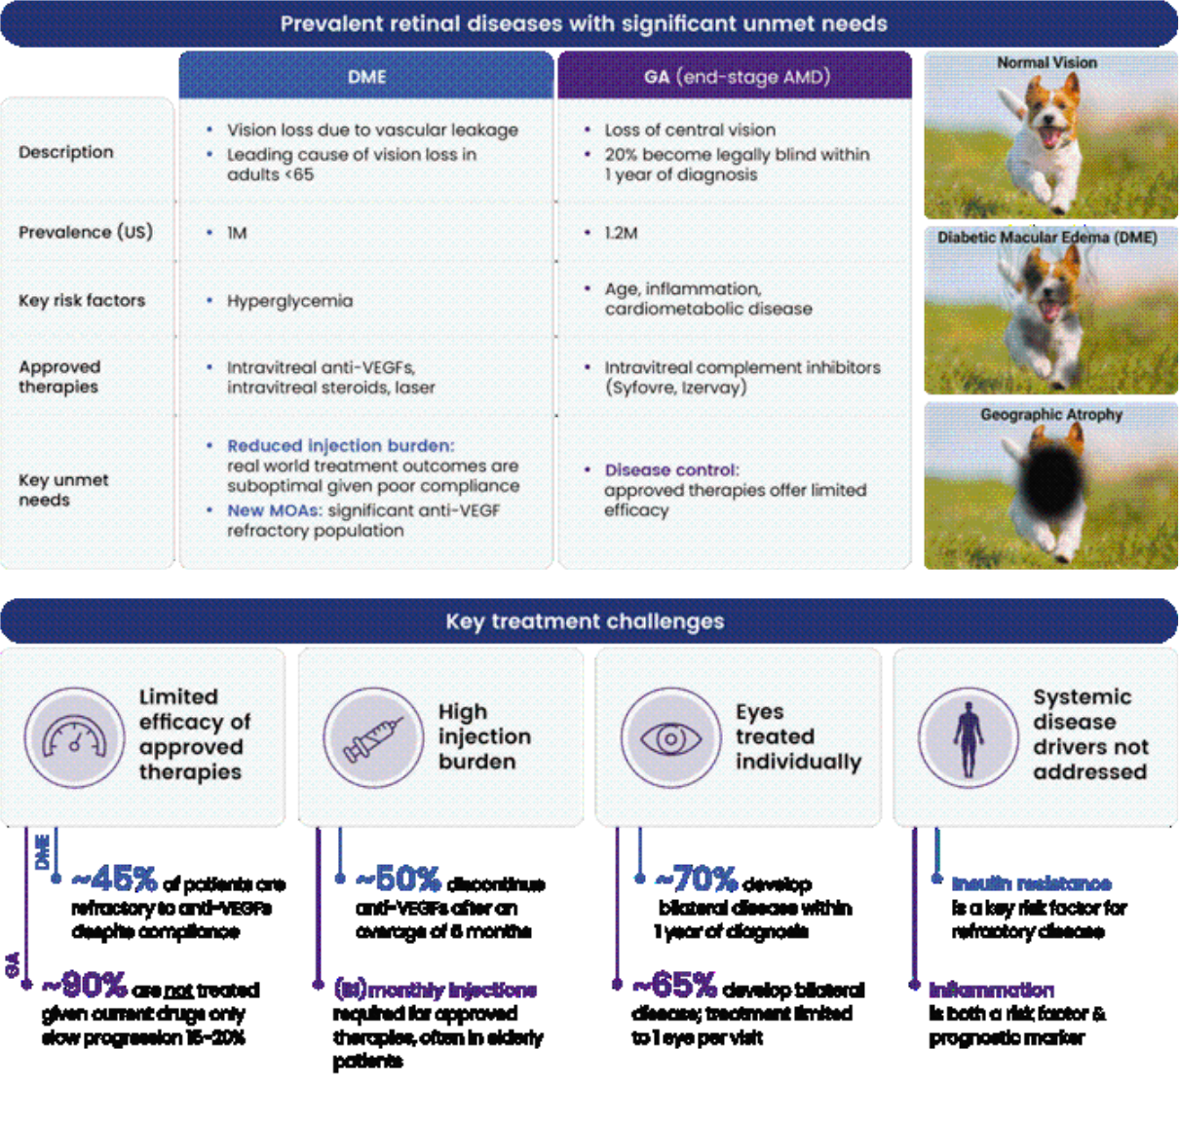

23

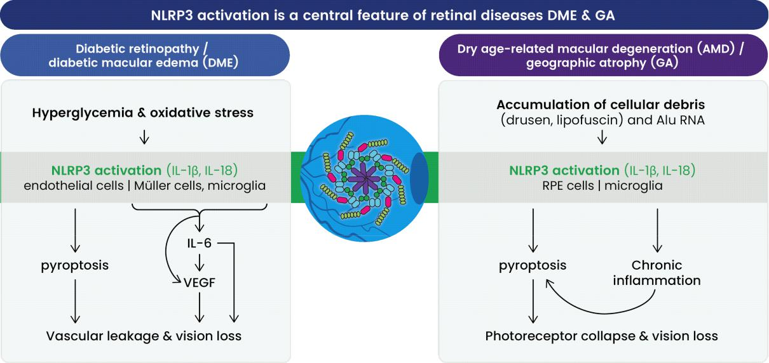

BGE-102 possesses several characteristics that may differentiate it for retinal diseases: it is administered orally as a once-daily medication, eliminating the injection burden that limits long-term adherence with current intravitreal therapies and allowing simultaneous treatment of both eyes. We have demonstrated in preclinical studies across multiple species, including non-human primates, that BGE-102 achieves therapeutic concentrations in retinal tissue following oral administration. NLRP3 inhibition addresses both systemic and local drivers of retinal disease, and oral NLRP3 inhibition has the potential to have a broader effect than intravitreal anti-IL-6 approaches by sitting upstream in the inflammatory cascade while simultaneously addressing systemic disease drivers that local intravitreal therapies do not.
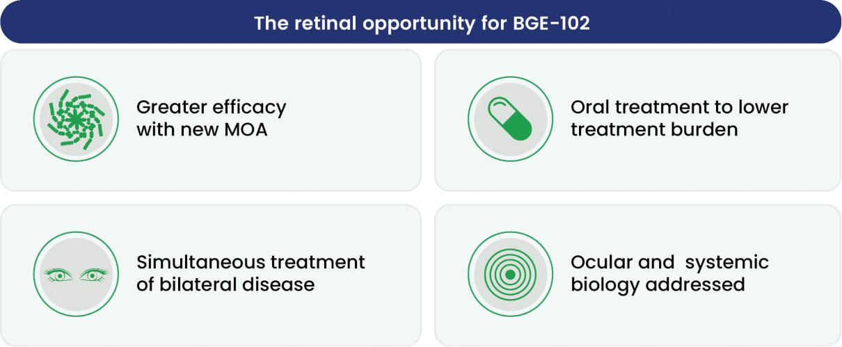

DME is our first proof-of-concept indication in ophthalmology.

Diabetic macular edema

Disease burden and unmet medical need. DME represents one of the leading causes of vision loss in the working-age population, affecting approximately 1 million patients in the United States. DME develops as hyperglycemia and associated systemic inflammation drive vascular leakage within the retina, impairing central vision and reducing quality of life. Approximately 70% of DME patients develop vision-threatening edema in both eyes within one year of diagnosis.

24

Current standard-of-care therapies for DME rely predominantly on intravitreal anti-VEGF injections and intravitreal corticosteroid implants. These approaches face substantial clinical and practical limitations. Approximately 45% of DME patients demonstrate refractoriness to anti-VEGF therapy despite sustained treatment, suggesting that targeting a single effector molecule does not address the full pathophysiology of the disease. Adherence to the demanding injection regimen is challenging: approximately 50% of patients discontinue anti-VEGF injections after an average of six months, resulting in suboptimal real-world outcomes. Additionally, current ocular therapies do not address insulin resistance, a systemic metabolic factor that our analysis indicates is a key driver of DME.

NLRP3 inflammasome in DME. In DME, hyperglycemia and oxidative stress activate NLRP3. Release of IL-1β and IL-18 stimulates IL-6 production in retinal tissue, which in turn promotes VEGF expression and vascular leakage; this process is exacerbated by pyroptosis in endothelial cells, compromising microvascular integrity. NLRP3 thus represents a mechanistic bridge between systemic metabolic dysregulation in diabetes and local pathological vascular permeability in the retina.

Growing clinical evidence supports the anti-inflammatory strategy in retinal disease. Several programs have explored intravitreal anti-IL-6 therapies in DME; studies by Roche, Kodiak, and EyePoint have demonstrated that reducing IL-6 in the eye can produce rapid improvements in best-corrected visual acuity and central subfield thickness within four to eight weeks of treatment. We believe that oral NLRP3 inhibition has the potential to have a broader effect by sitting upstream in the inflammatory cascade, while simultaneously addressing systemic metabolic drivers.

Preclinical evidence for BGE-102 in DME. In a streptozotocin-induced diabetic mouse model, oral BGE-102 demonstrated dose-dependent preservation of retinal vascular permeability. Additionally, BGE-102 preserved blood-retina barrier tight junction proteins, including claudin-5.
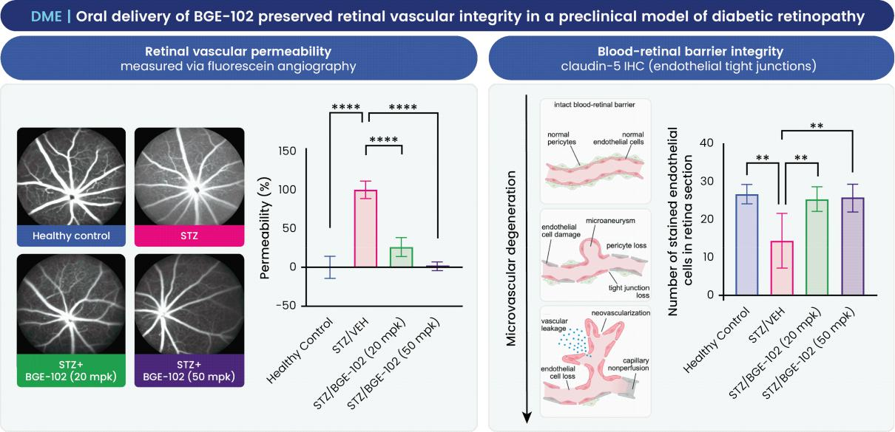

In diet-induced obese mice, BGE-102 improved insulin sensitivity as measured by HOMA-IR (Homeostatic Model Assessment for Insulin Resistance) to a degree comparable to semaglutide, a GLP-1 receptor agonist with well-established metabolic benefits. This improvement phenocopies the metabolic phenotype of Nlrp3-knockout mice (Vandanmagsar et al.

25

2011) and provides evidence that BGE-102 has the potential to address the key driver of DME that current intravitreal therapies do not.
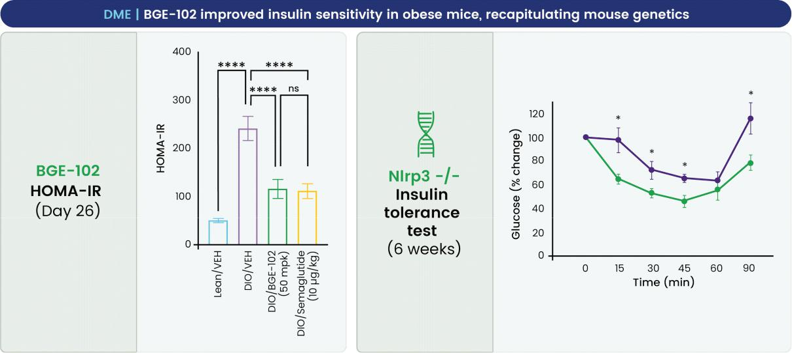

Phase 1b/2a proof-of-concept trial in DME

We plan to initiate a Phase 1b/2a proof-of-concept trial of BGE-102 in patients with DME in mid-2026. The trial is designed to demonstrate pharmacodynamic activity of BGE-102 in the eye following oral administration and to evaluate its potential as an adjunctive therapy to anti-VEGF treatment and as a monotherapy.
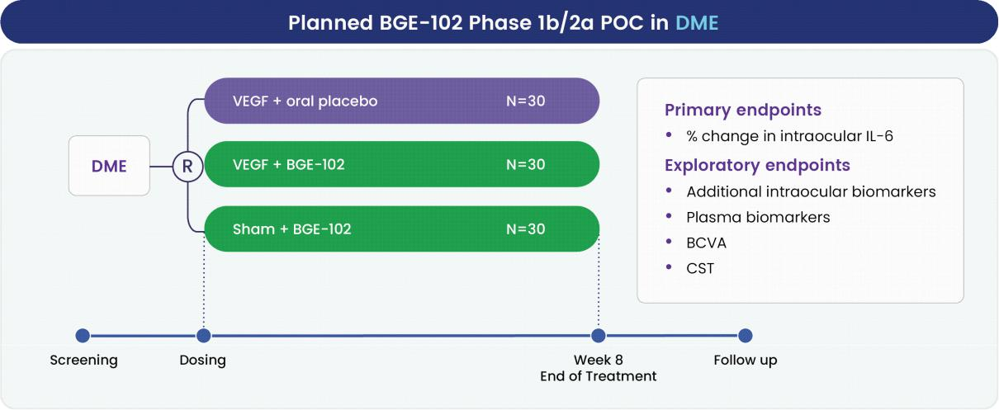

The trial will be a randomized study with an 8-week treatment period. The primary endpoint is percent change in intraocular IL-6. We anticipate preliminary results in mid-2027.

26

Geographic atrophy

Disease burden and unmet medical need. Geographic atrophy (GA), the advanced dry form of age-related macular degeneration (AMD), affects approximately 1.2 million patients in the United States. GA is characterized by progressive degeneration of the retinal pigment epithelium (RPE) and photoreceptors, resulting in irreversible loss of central vision. The disease progression is severe: approximately 20% of patients become legally blind within one year of diagnosis, significantly limiting independence and quality of life in an aging population.

Recent approvals of intravitreal complement inhibitors, including pegcetacoplan (Syfovre) and avacincaptad pegol (Izervay), have provided the first disease-modifying treatments for GA. However, their clinical efficacy is modest, slowing lesion growth by approximately 15% to 20% in treated eyes. Given this limited benefit relative to the burden of frequent intravitreal injections, approximately 90% of GA patients remain untreated. We believe there is substantial unmet need for oral therapies offering improved efficacy, simpler administration, and broader mechanistic activity.

NLRP3 inflammasome in GA. In GA, progressive accumulation of cellular debris (e.g. drusen, lipofuscin), along with Alu RNA, activates NLRP3 in RPE cells and resident microglia. Chronic inflammasome activation and resulting pyroptosis contribute to progressive RPE degeneration and secondary photoreceptor loss.

Systemic inflammation is increasingly recognized as a risk factor for GA progression: elevated circulating inflammatory markers, including hsCRP and IL-6, have been associated with increased risk of AMD progression in epidemiological studies. As a result, systemic NLRP3 inhibition may offer advantages over regional intravitreal approaches.

Emerging clinical and preclinical evidence. Published preclinical studies support the relevance of NLRP3 to GA. In third-party studies, Nlrp3-knockout mice were completely protected against RPE degeneration induced by both drusen-associated pathogenic stimuli (amyloid-β oligomers) and endosomal damage caused by Alu RNA.
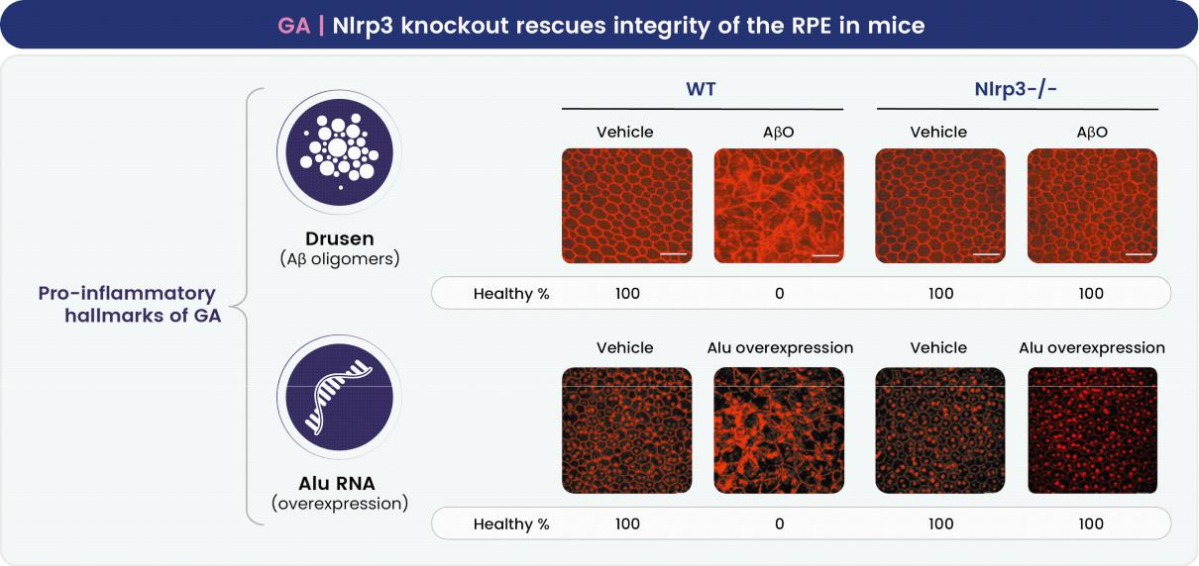

27

Adapted from Narendran et al. 2021 and Tarallo et al. 2012

In a natural aging model of AMD, oral administration of a BGE-102 analog almost completely prevented age-related lipofuscin accumulation, a cardinal feature of GA progression. These findings support the therapeutic hypothesis that NLRP3 inhibition may slow or arrest GA progression.
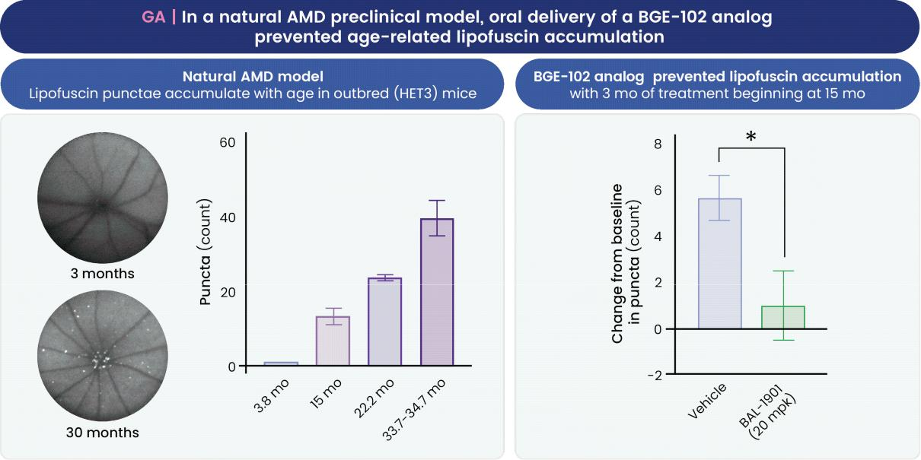

Clinical evidence further supports inflammasome inhibition in GA. A third-party clinical study of an inflammasome inhibitor (K8, an intravitreal implant, N=10) demonstrated a 53% reduction in GA lesion growth at three months (p=0.03 compared to fellow eye), substantially exceeding the approximately 15% reduction observed with approved complement inhibitors at 12 months. In a supporting epidemiological analysis, chronic exposure to fluoxetine, a compound with weak NLRP3 inhibitory activity at micromolar concentrations, was associated with a 22% reduction in incident AMD (hazard ratio 0.778, p<0.001). While these epidemiological data are exploratory, this observation is consistent with the hypothesis that NLRP3 inhibition may slow progression of AMD/GA.
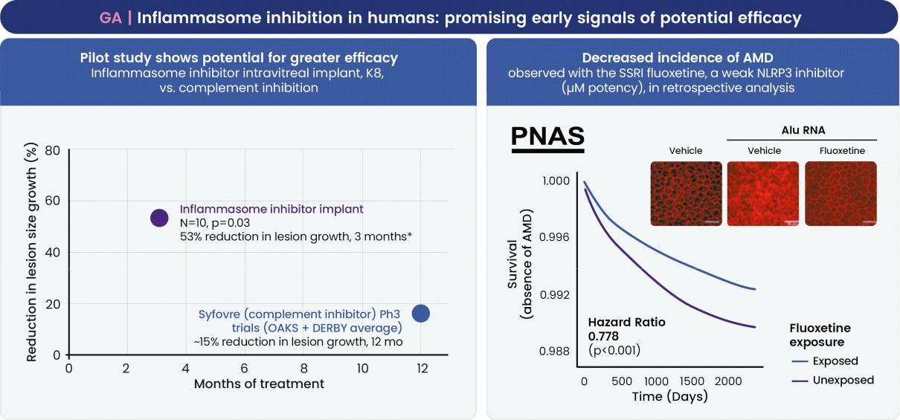

28

Right panel adapted from Ambati et al. 2021

Apelin Receptor APJ Agonists: An Exercise Mimetic Approach for the Treatment of Obesity and Metabolic Disease

We are developing novel, potent agonists of the apelin receptor APJ, including both oral small-molecule and parenteral programs. Apelin is a molecule that is secreted in response to exercise, and activation of the apelin pathway has been shown to recapitulate many of the benefits of exercise. We have previously shown that the agonism of the apelin receptor APJ has the potential to double weight loss and fully restore body composition on a GLP-1R agonist background in preclinical models of obesity. We believe the combination of an APJ agonist and an incretin is a pharmacological parallel to diet and exercise: one mechanism relies largely on reducing energy intake, the other on increasing energy expenditure.
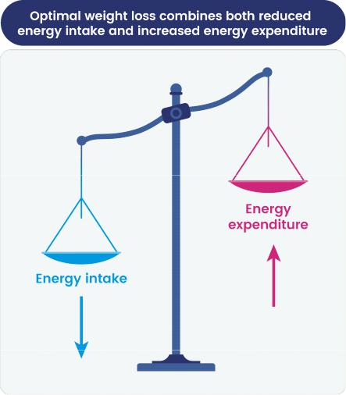

Levels of the exercise-secreted protein apelin predicted both function and metabolic health in our longitudinal human aging cohorts.

The aging process is characterized by profound dysregulation in many biological systems. Examining protein changes over decades in our longitudinal human aging cohorts, we observed that higher levels of circulating apelin were associated with both increased longevity and preservation of physical function (i.e., subjects with higher apelin levels lived longer, with improved health). We also observed that apelin levels are significantly associated with a range of metabolic traits in our human aging cohorts. These results led us to the therapeutic hypothesis that augmenting apelin signaling could provide therapeutic benefits in age-related disease.
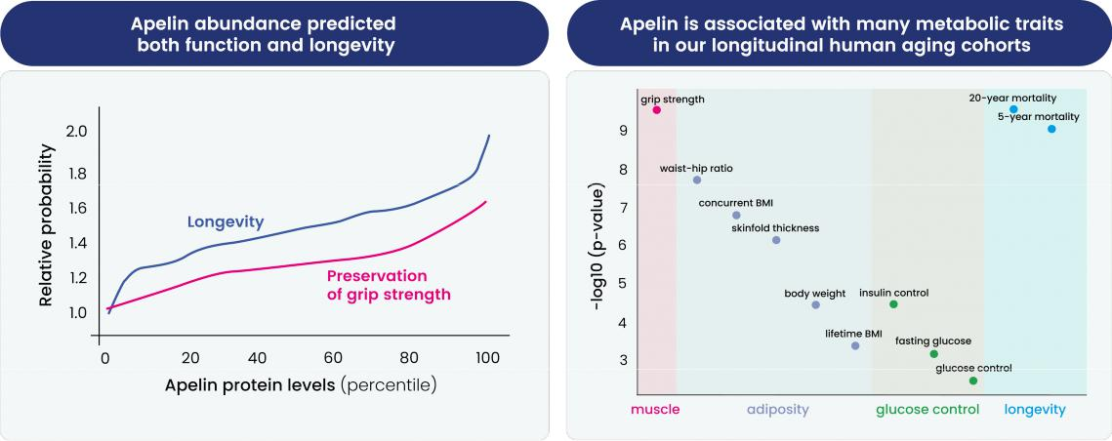

29

Higher apelin protein levels predicted improved longevity and grip strength in our human aging cohorts (left). Levels were also associated with traits related to muscle function, adiposity, glucose control, and longevity (right). Glucose and insulin control measure the ability to regulate blood glucose increases via insulin secretion after a glucose challenge.

Enhancing apelin signaling can recapitulate many of the benefits of exercise

Apelin is a peptide hormone referred to as an exerkine, a signaling molecule released by skeletal muscle in response to exercise that mediates beneficial metabolic and functional adaptations to physical activity.

Comparing the physiological effects of enhanced apelin signaling to those of exercise reveals multiple areas of overlap:

- Both apelin and exercise have a beneficial effect on body composition, improving the ratio of lean to fat mass. The proportion of lean mass is a very strong predictor of functional capacity, metabolic health, and cardiovascular outcomes (and more predictive than absolute lean mass or absolute fat mass).

- In skeletal muscle, both apelin signaling and exercise boost protein synthesis, mitochondrial biogenesis and basal metabolic rate, thereby increasing resting energy expenditure.

- In both muscle and adipose tissue, apelin and exercise increase insulin sensitivity, resulting in upregulation of glucose uptake and metabolism.

This striking congruence between the actions of apelin and exercise suggests that this peptide acts as a key molecular transducer of the systemic exercise response, and that targeting the apelin/APJ axis may be able to mimic many of the benefits of physical activity sometimes referred to as “exercise in a pill.”
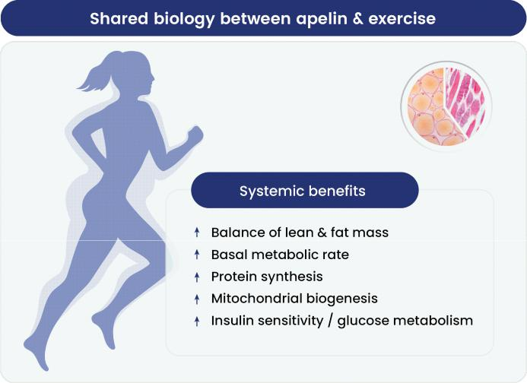

30

Exercise ameliorates many of the negative health outcomes associated with aging. Circulating apelin levels increase acutely after exercise, with the magnitude of this response strongly predicting physical performance in older adults.
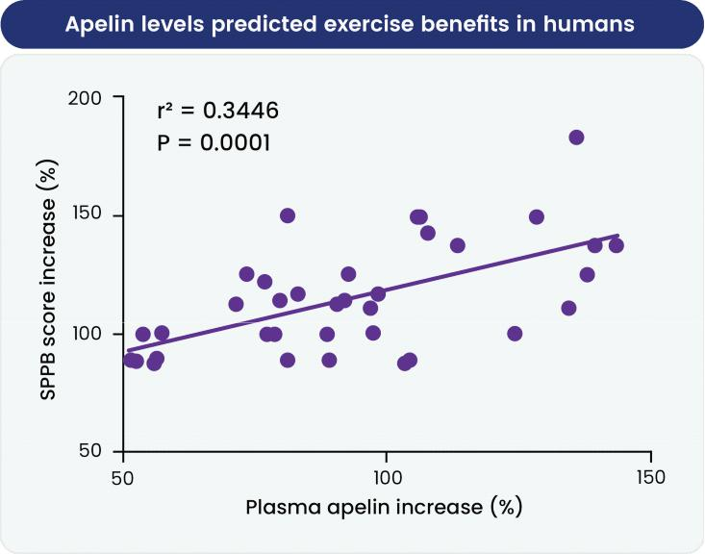

In a third-party preclinical study, apelin levels were significantly correlated with the benefits of exercise over 6 months. Older people (> 70y) with the greatest increase in plasma apelin levels after 6 months of an exercise program had the highest improvement in Short Physical Performance Battery (SPPB) test score. Apelin measurements were taken from 34 individuals. r² represents the correlation coefficient, a statistical measure of the strength of a linear relationship between two variables. A correlation coefficient of -1 describes a perfect negative, or inverse, correlation. A coefficient of 1 shows a perfect positive correlation, or a direct relationship. A correlation coefficient of 0 means there is no linear relationship. The p-value is used to determine the probability as to whether the difference between two data sets is due to chance. The smaller the p-value, the more likely the differences are not due to chance alone. In general, if the p-value is less than or equal to 0.05, the outcome is considered statistically significant. (Source: Vinel et al. 2018).

31

However, both basal levels of apelin and the degree of exercise-induced elevation of the peptide decline with age, coinciding with deterioration of fitness and muscle function.
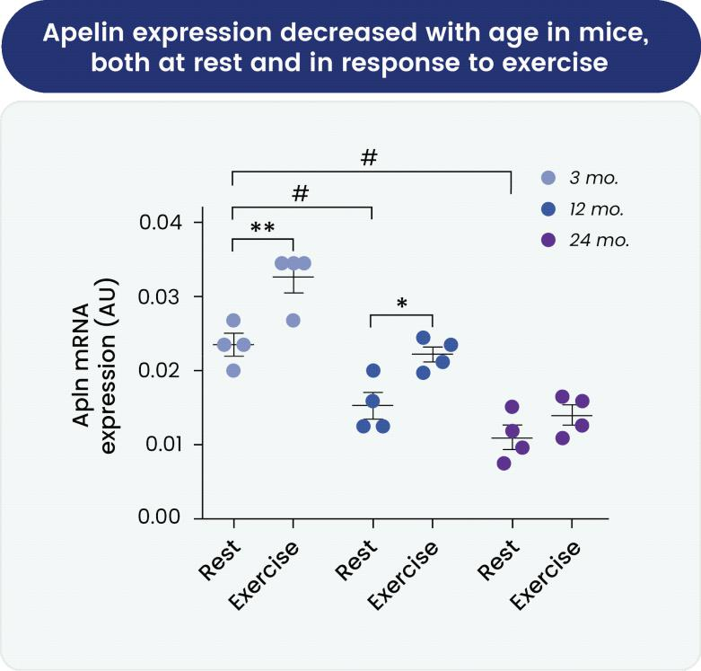

In a third-party preclinical study, apelin expression in mice significantly decreased with age (n= 6 mice per group). There was also a lower magnitude increase in apelin expression in response to exercise with age, with no significant increase observed in the 24 month group. In mice, 12 months represents middle age and 24 months old age. #p< 0.05; *p< 0.05; ** p< 0.01. (Source: Vinel et al. 2018).

The relationship between apelin, exercise and function over the lifespan, taken together with the correlation between apelin levels and muscle-related health parameters observed in our longitudinal cohorts, suggest that apelin may help mediate the beneficial anti-aging effects of exercise.

32

Apelin activates key metabolic regulators AMPK, PI3K, and ERK

The molecular mechanisms of apelin pathway signaling are well characterized. As depicted in the figure below, the physiological effects of apelin in target cells are mediated by the apelin receptor (APJ/APLNR), a G protein-coupled receptor that activates multiple intracellular signaling pathways including AMP-activated protein kinase (AMPK) and PI3K. In parallel, via recruitment of ß-arrestin upon apelin binding, APJ activates extracellular signal regulated kinase (ERK). These pathways are involved in metabolic processes consistent with apelin’s role as an exerkine, including glucose uptake, mitochondrial biogenesis, and fatty acid oxidation.
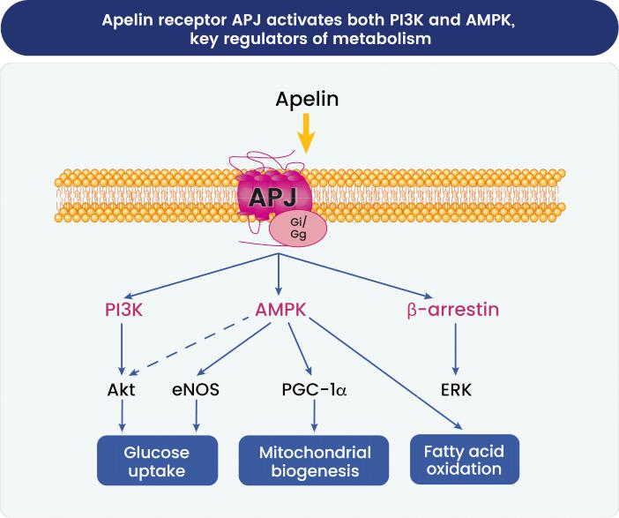

APJ is a G protein-coupled receptor that signals through AMPK and PI3K. AMPK and PI3K activate downstream effectors Akt and endothelial nitric oxide synthase (eNOS), which increase cellular glucose uptake. AMPK activates transcriptional coactivator PGC-1a, which increases mitochondrial biogenesis. AMPK directly increases fatty acid oxidation. APJ also activates ERK signaling through ß-arrestin. (Source: Bertrand et al. 2015).

33

Genetic evidence supports the potential of APJ agonists to improve metabolism

Genetic studies of apelin in mice published by other groups provide support for the potential role of APJ agonists in the treatment of obesity. Inactivation of the gene for apelin was shown to result in mice with a statistically significant increase in fat content compared to similarly treated wild-type mice. Apelin knockout mice fed a high fat diet for three weeks also had significantly decreased insulin sensitivity compared to similarly treated wild-type mice.
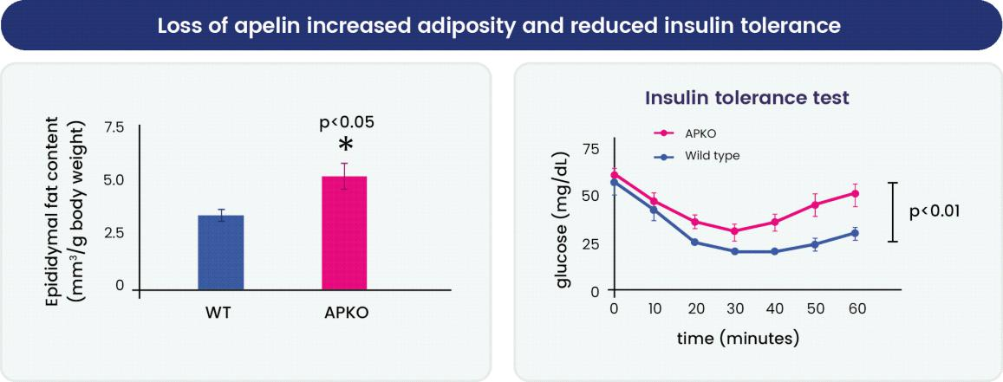

In a third-party preclinical study, inactivation of the gene for apelin (APKO) in mice led to a significant increase in fat content compared to wild-type counterparts (p<0.05) (n =10–15 mice per group). In a separate third-party preclinical study, APKO mice had significantly worse performance on an insulin tolerance test (p<0.01) (n= 6 –7 mice per group). (Source: Yue et al. 2010, Yue et al. 2011).

In contrast, transgenic mice with overexpressed apelin showed several metabolic benefits. Animals were significantly protected from weight gain when placed on a high fat diet. This was not due to a decrease in food intake, but instead to an increased metabolic rate. Consistent with apelin’s role as an exerkine, transgenic apelin mice also had increased skeletal muscle mitochondrial biogenesis and increased oxygen intake compared to wild-type counterparts.
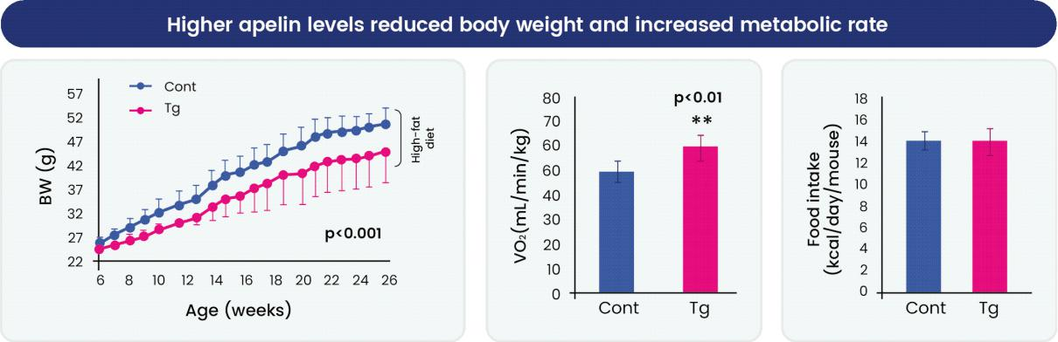

In a third-party preclinical study, overexpression of apelin in a transgenic mouse (Tg) resulted in significantly reduced weight when fed a high fat diet compared to wild-type control mice (Cont) (p<0.001) (n= 19–24 mice per group). Tg mice had a significantly higher basal metabolic rate than their wild-type counterparts on a high fat diet (p<0.01) (n= 7-9 mice per group) with no significant difference in food intake (n= 19–24 mice per group). (Source: Yamamoto et al. 2011).

34

Human genetics are consistent with findings in interventional genetic studies in mice. Significant genome-wide associations have been reported at the apelin receptor, APJ, and body mass index, lean body mass and serum lipid levels across diverse populations.
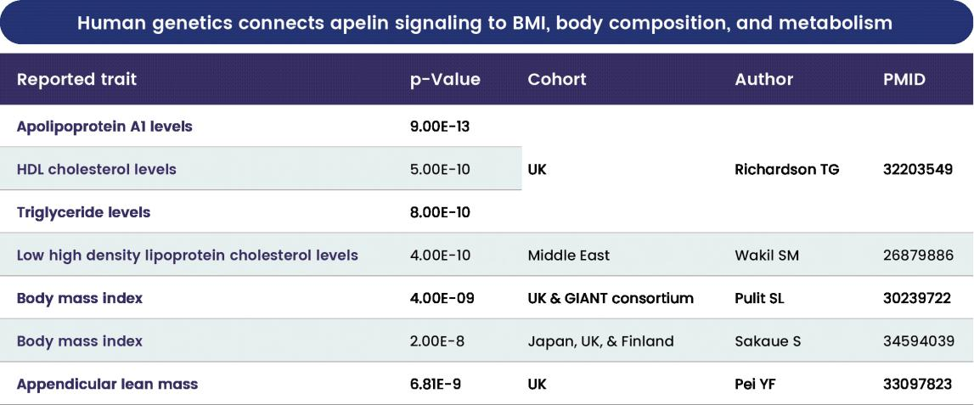

Preclinical results in a diet-induced obesity mouse model demonstrate the potential of apelin receptor APJ agonists to increase weight loss quantity and quality

We evaluated the effects of an investigational oral small molecule APJ agonist, azelaprag, on weight loss and other outcomes in a diet-induced obesity mouse model.

Azelaprag, in combination with tirzepatide, restored body weight and body composition of obese mice to lean control levels. Tirzepatide monotherapy led to a reduction in body weight of approximately 15% at the dose tested. The addition of azelaprag to tirzepatide treatment led to further significant, dose-dependent decreases in body weight, with 40% weight reduction by three weeks in the highest dose group.

In addition to correcting total weight back to lean control levels, the addition of azelaprag in combination with tirzepatide also restored the body composition of obese mice to that of lean controls in a significant, dose-dependent fashion. The proportion of lean body mass increased while that of fat decreased over the three-week dosing period.

35

In the context of clinical care, body composition — and specifically the proportion of lean mass — is highly predictive of multiple health outcomes including physical function, metabolic health and cardiovascular outcomes (and more predictive than absolute levels of lean or fat mass).
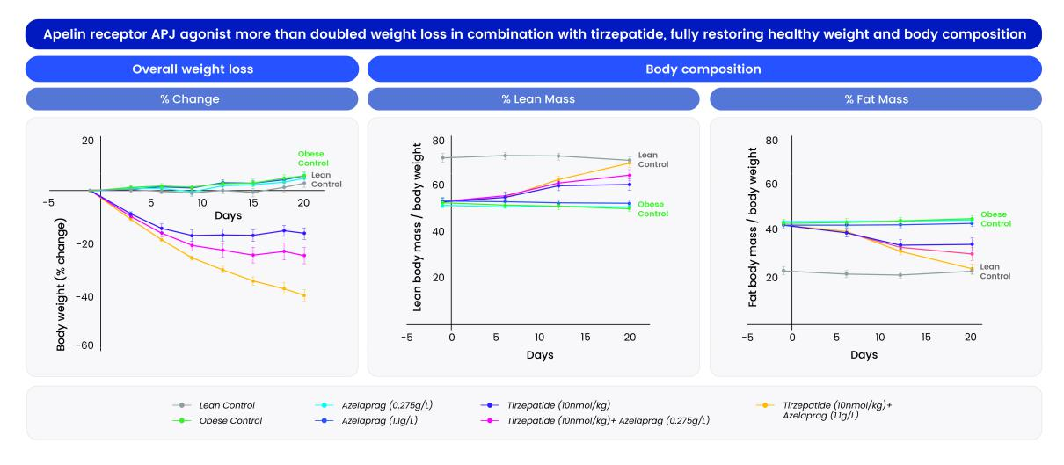

The combination of azelaprag and tirzepatide resulted in significant, dose-dependent increases in overall weight loss compared to tirzepatide monotherapy in diet-induced obesity mouse model (left), as well as full restoration of body composition (% lean, % fat, lean / fat ratio) of obese mice to that of lean controls (middle, right). Lean and fat mass were measured by EchoMRI. Group size: n=6-14 per group. Tirzepatide (10nmol/kg) vs. tirzepatide (10nmol/kg) + azelaprag (1.1g/l) on day 20: p<0.0001 for all measurements.

Clinical Case Study: azelaprag results demonstrate the potential of apelin receptor APJ agonists to function as an exerkine mimetic to improve body composition and metabolism

We completed a double-blind, non-randomized Phase 1b bed rest atrophy trial of apelin receptor APJ agonist, azelaprag, in 21 healthy individuals 65 years of age or older. Bed rest studies are a well-established method to model muscle and functional aging on a compressed timeline. In the trial, subjects on bed rest for 10 days received daily doses of 240 mg azelaprag or placebo delivered by intravenous infusion.

We observed that treatment with azelaprag significantly decreased (p<0.05) bed-rest-induced muscle atrophy across multiple endpoints as shown in the figure below.
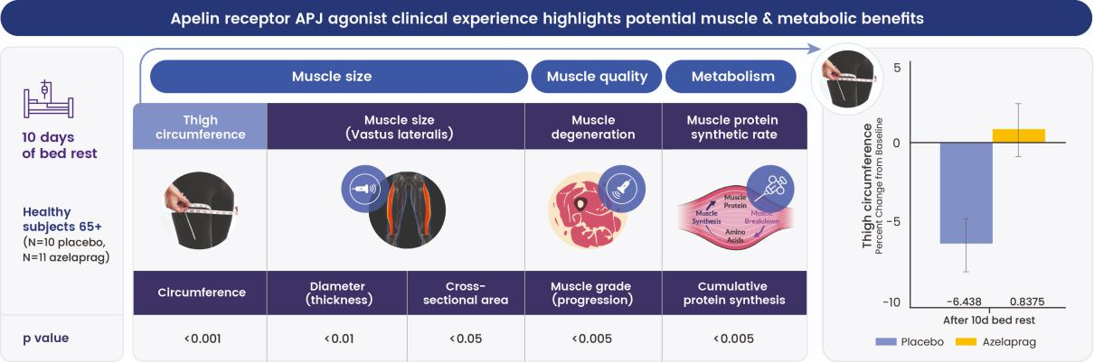

Overview endpoints and significance of results from the azelaprag bed rest atrophy Phase 1b trial. Thigh circumference results are shown as an example at right: 10 days of bed rest led to a mean decrease of 6.4% in thigh circumference in subjects that received placebo. By contrast, we observed no significant decrease in thigh circumference in subjects dosed with azelaprag.

36

In January 2025, we terminated development of azelaprag, an orally available small molecule agonist of APJ, for obesity and other chronic diseases. The decision followed observations of liver transaminitis without clinically significant symptoms, and without clear dose dependence, in some patients in the azelaprag arms of the STRIDES Phase 2 clinical trial for obesity.

However, we believe the results of the azelaprag Phase 1 trials demonstrate the potential of apelin receptor APJ agonists; therefore, we are advancing distinct, orally available apelin receptor APJ agonists as a novel exercise mimetic approach for the treatment of obesity.

Development strategy and timelines

We are advancing APJ agonists through both oral and parenteral development pathways to maximize the potential of this therapeutic approach across different clinical contexts and patient populations.
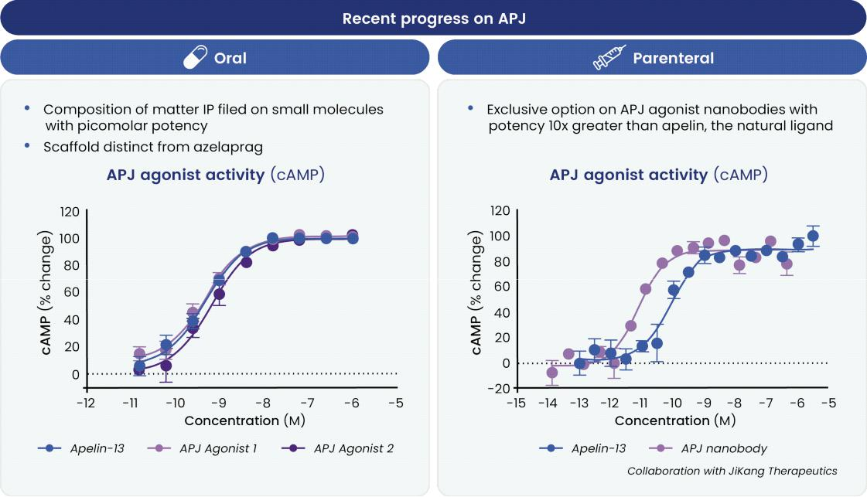

Oral APJ agonist program. We have filed composition of matter intellectual property protecting novel small molecule APJ agonists with picomolar potency. These compounds are based on an innovative chemical scaffold and achieve agonist potency comparable to native apelin-13, the endogenous ligand. We intend to characterize these compounds further and advance the most promising candidate toward IND-enabling studies.

Parenteral APJ agonist program. In June 2025, we announced an option agreement with JiKang Therapeutics for a novel APJ agonist nanobody — a single-domain antibody derived from camelid immunoglobulin. The nanobody demonstrates approximately 10-fold greater agonist potency than native apelin and is optimized for subcutaneous administration, providing a longer-acting modality suitable for chronic obesity treatment. We are conducting preclinical characterization and advancing this program toward IND-enabling studies.

We intend to file the first IND for an APJ program by the end of 2026.

The evolving obesity treatment landscape

Obesity disease overview: a growing driver of both morbidity and healthcare spending

Obesity is a complex medical disorder that has been described as an accelerated aging condition, as it increases the risk of both morbidity and mortality from age-related chronic disease. It involves both appetite dysregulation and altered lipid and energy metabolism, which in turn result in excessive accumulation of fat tissue. Globally, over 875 million adults age 20+ are living with obesity, defined as a body mass index (BMI) of 30 or greater. Furthermore, the worldwide prevalence of obesity in

37

adults 20+ more than doubled from under 7% in 1990 to over 16% in 2022. The global estimated cost of overweight and obesity is in the trillions of dollars, representing more than 2% of the global gross domestic product.

Obesity is associated with over 200 health comorbidities and complications, including many cardiometabolic disorders. Among obese patients, the prevalence of these conditions is high: 19-23% have type 2 diabetes, dyslipidemia (66-70%), hypertension (51-61%), metabolic dysfunction-associated steatohepatitis (30-36%), and heart disease (3-5% congestive heart failure, 8% ischemic heart disease, 21% myocardial infarction). Obesity is also associated with an increased risk of developing infertility and certain cancers. Weight loss leads to improvements across many comorbidities associated with obesity.
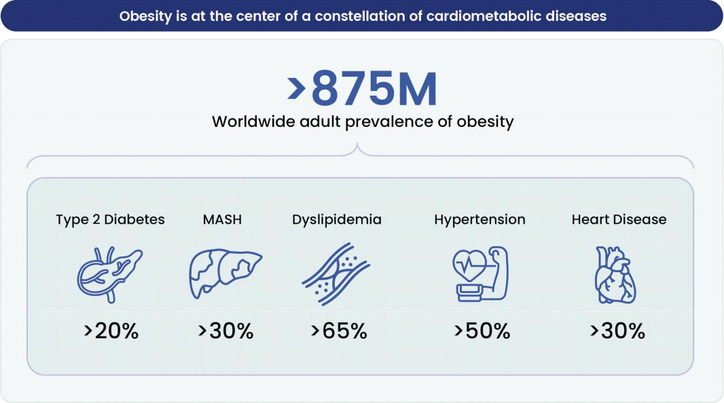

Obesity treatment landscape: incretin drugs are transforming care, creating an important clinical and commercial opportunity

The treatment landscape for obesity has undergone a fundamental transformation with the emergence of GLP-1R agonists. Injectable GLP-1R agonists, including semaglutide (Wegovy) and tirzepatide (Zepbound), have demonstrated unprecedented efficacy in achieving sustained weight loss and improving cardiometabolic risk factors. In pivotal clinical trials, injectable semaglutide produced approximately 15% weight loss; tirzepatide, a dual GLP-1R/GIP receptor agonist, produced approximately 21% weight loss.

The commercial success of injectable GLP-1R agonists has been significant. The global market for GLP-1R agonists is projected to exceed $150 billion by 2031, driven by expanding indications beyond obesity and diabetes, new oral and combination formulations, and increasing treatment penetration across broader patient populations. The scale of this market reflects both the severity of the underlying unmet need and the magnitude of the commercial opportunity for therapies that can

38

address the limitations of current incretin-based approaches — limitations that we believe APJ agonism is well positioned to complement.
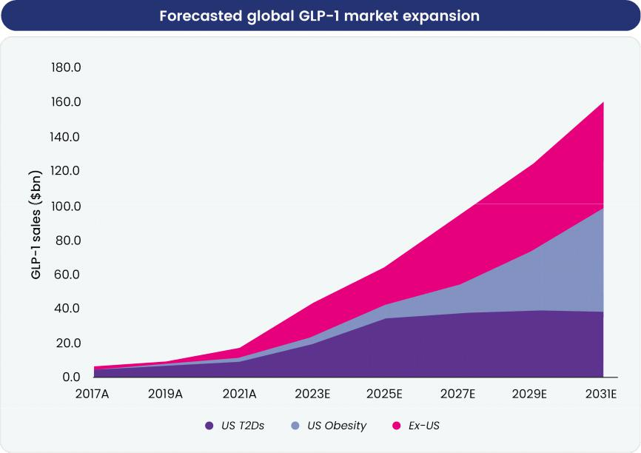

Key unmet needs

Despite the advances represented by GLP-1R agonist therapy, substantial unmet medical needs persist in obesity treatment. These unmet needs span three critical dimensions: oral efficacy parity with injectables, gastrointestinal tolerability, and preservation of body composition during weight loss. Current therapeutic approaches address only a subset of these needs, leaving significant therapeutic gaps.
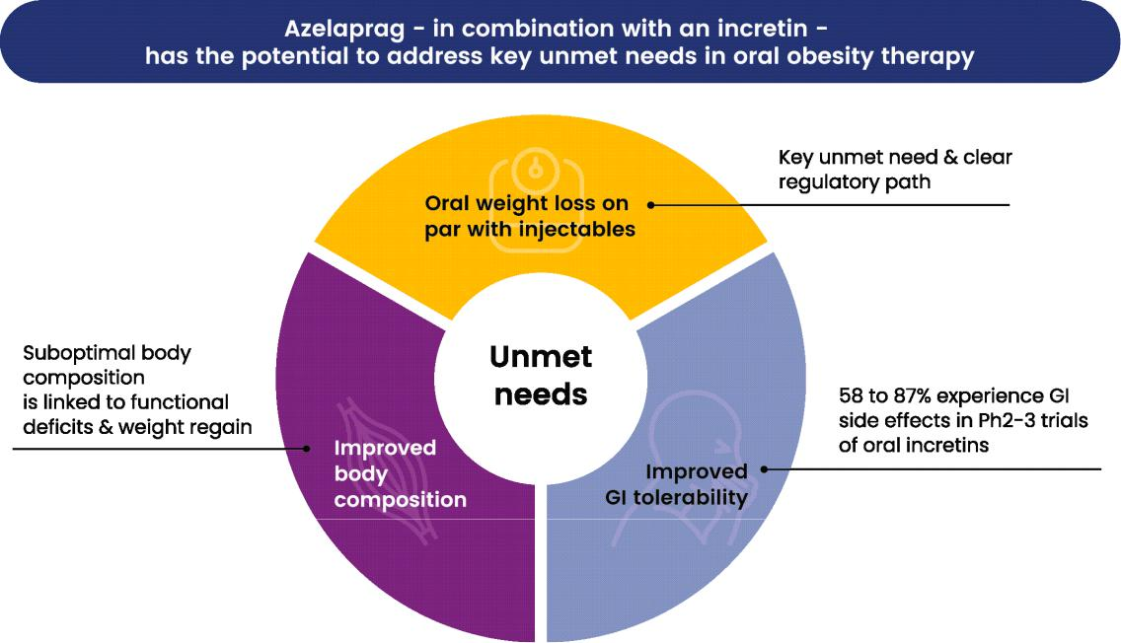

39

Oral weight loss. Oral GLP-1R agonist programs have generally underperformed relative to injectable formulations. Oral approaches employing permeation enhancers and structural modifications have achieved weight loss in the range of 7% to 12%, substantially lower than the 15% to 24% weight loss achieved by injectable GLP-1R agonists and triple agonists. This efficacy gap — representing approximately a 50% reduction in weight loss from injectable to oral formulation — limits the clinical utility of oral approaches as monotherapy and reflects fundamental challenges in achieving adequate intestinal permeability and systemic bioavailability of peptide-based GLP-1R agonists via the oral route.

Tolerability. Gastrointestinal side effects represent a substantial barrier to tolerability and adherence with incretin-based obesity therapeutics. In Phase 2 and Phase 3 clinical trials, gastrointestinal adverse events — including nausea, vomiting, constipation, and diarrhea — occur in 31% to 44% of patients treated with injectable incretin agonists and in 58% to 87% of patients treated with oral incretin programs. These side effects are dose-dependent and frequently motivate dose reductions or treatment discontinuation. In controlled clinical trials, discontinuation due to adverse events reaches approximately 17%, and real-world discontinuation rates are substantially higher, with some analyses indicating discontinuation in up to 68% of patients. The tolerability barrier thus represents a major impediment to treatment initiation, dose escalation, and treatment persistence in a substantial proportion of patients with obesity.

Body composition. A fundamental limitation of current obesity therapeutics, including GLP-1R agonists, is that weight loss achieved through appetite suppression is not accompanied by preferential loss of adipose tissue. Rather, a substantial proportion of weight loss represents loss of lean muscle mass. Clinical data indicate that up to 50% of weight lost during GLP-1R agonist treatment may comprise lean body mass rather than adipose tissue.

The loss of lean mass during weight loss carries profound physiological consequences. Lean mass, primarily skeletal muscle, is the principal contributor to basal metabolic rate — the energy expenditure required at rest to maintain basic cellular and organ function. When lean mass is lost disproportionately during weight loss, basal metabolic rate decreases, reducing daily energy expenditure. This metabolic adaptation creates a disadvantage: the patient, now at a lower body weight, has a substantially reduced caloric requirement and is thus more susceptible to weight regain even when consuming the same number of calories that previously maintained the lower weight. Furthermore, loss of lean mass increases frailty risk, impairs physical function, and may accelerate age-related physical decline, particularly in older adults with obesity.

A particularly concerning manifestation of lean mass loss during weight loss therapy is increased bone fragility and fracture risk. In the SELECT trial (Semaglutide Effects on Cardiovascular Outcomes in People with Overweight or Obesity), a large randomized controlled trial of semaglutide in patients with obesity and established cardiovascular disease, an approximately 5-fold increase in hip and pelvis fractures was observed in female participants treated with semaglutide compared to placebo, a finding that has prompted re-evaluation of the benefit-risk profile in populations at elevated baseline fracture risk.

APJ agonism in obesity

The combination of APJ agonism with GLP-1R/GIP agonists represents a therapeutically rational approach based on complementary mechanisms of action — appetite suppression plus energy expenditure enhancement — and supported by preclinical evidence of additive effects on body weight and composition. We believe this combination approach may address multiple unmet needs simultaneously: the dual oral and parenteral portfolio provides formulation flexibility, the complementary mechanism may reduce reliance on maximal doses of appetite-suppressing agents with associated GI side effects, and the energy expenditure and lean mass preservation properties may improve body composition outcomes.

Our Platform for Discovery of Novel Targets that Drive Human Metabolic Aging

We have built a target discovery capability specifically designed to identify and validate drug targets that drive metabolic aging and age-related diseases in humans. Our approach combines:

- Long-term longitudinal cohorts of naturally aging individuals. We have generated proprietary datasets based on serial biological samples from cohort studies that satisfy a set of unusual and valuable requirements for the study of aging biology: (1) being composed of healthy aging adults originally recruited decades in the past, (2) having followed subject outcomes and collected deep healthspan data continuously to the present day, and (3) having collected longitudinal biosamples that have also been maintained to the present day.

- Serial multi-omic molecular profiling. Through partnerships with companies using state-of-the-art molecular profiling techniques, we quantified thousands of components from these samples, such as proteins and metabolites, with high sensitivity.

40

- Data science analysis. We have developed a suite of analytic approaches allowing us to integrate longitudinal molecular profiles with clinical and health outcome data to directly decode the biology that drives disparate aging trajectories and metabolic aging and related health outcomes and identify novel drug targets for treating metabolic disease.

- Expertise in aging biology. We apply our knowledge of the aging process, including our own large colony of naturally aged rodents, to validate potential drug targets in relevant in vitro and in vivo models of age-related metabolic disorders.

- Technology-forward approach to clinical trials. We aim to maximize the value of our clinical trials by leveraging advanced analytic approaches to quantify participants’ biology and health, derive mechanistic insights, and link trial observations back to long-term healthspan outcomes from our natural aging cohorts. Examples from prior and ongoing trials include plasma proteomic profiling, wearable devices, protein synthetic rate analysis, and single-nucleus RNA sequencing of biopsy samples.
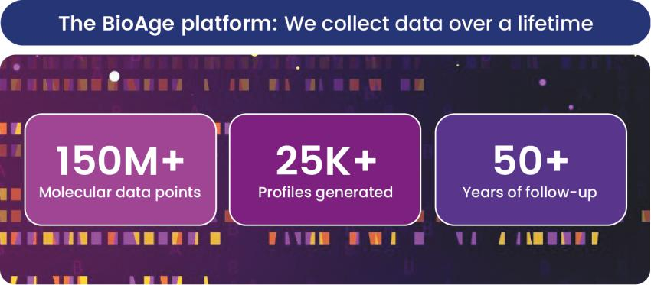

The BioAge platform encompasses over 150 million molecular data points spanning over 25 thousand individual participant profiles and over 50 years of follow-up.

Approach for identifying novel targets based on unique insights into human aging biology

We have negotiated favorable agreements with biobanks to access long-term longitudinal cohorts of individuals with serially biobanked samples who were enrolled as healthy adults and followed for up to 50 years.

In these cohorts, we have detailed medical outcomes and physiological measurements systematically collected over the course of these studies, including lifespan outcomes, such as all-cause and disease-specific mortality; functional healthspan outcomes such as grip strength and walking speed; and disease outcomes such as cognitive scores and dementia diagnoses, cardiovascular disease progression, BMI and skinfold thickness.

41

The biobanks to which we have secured access are from distinct geographical regions and include samples from individuals whose demographics are representative of those regions, enabling us to identify aging processes that are conserved across populations and environmental backgrounds.
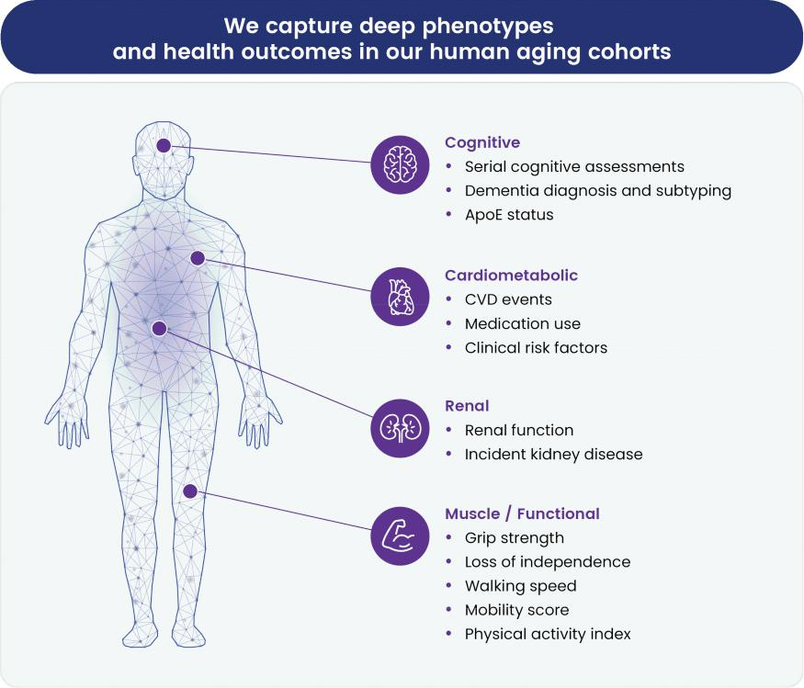

Example of longitudinal lifespan and health outcomes captured in human aging cohorts. CVD: Cardiovascular. ApoE: Apolipoprotein E.

We partner with organizations and companies leading the development of highly sensitive multi-omic molecular profiling technologies, including SomaLogic and Metabolon, to identify and quantify components of longitudinally biobanked serum and plasma specimens from our aging cohorts. The capabilities that these organizations and companies bring allow us to generate molecular profiles with more detail than had previously been possible.

We combine proteomics and metabolomics with orthogonal data such as clinical outcomes and healthspan phenotypes to obtain insights into the underlying pathways and potential targets that predispose individuals to age more quickly or be more resistant to developing multi-morbidity. Our goal as a company is to use these insights to develop pharmaceuticals that can treat a range of metabolic diseases driven by aging.

42

We have previously shared the identification of apelin and NLRP3 from our platform. Beyond these targets, there are many promising targets emerging from our data sets. The figure below highlights the many proteins that have significant signals for both longevity as well as multiple health outcomes in our cohort data.
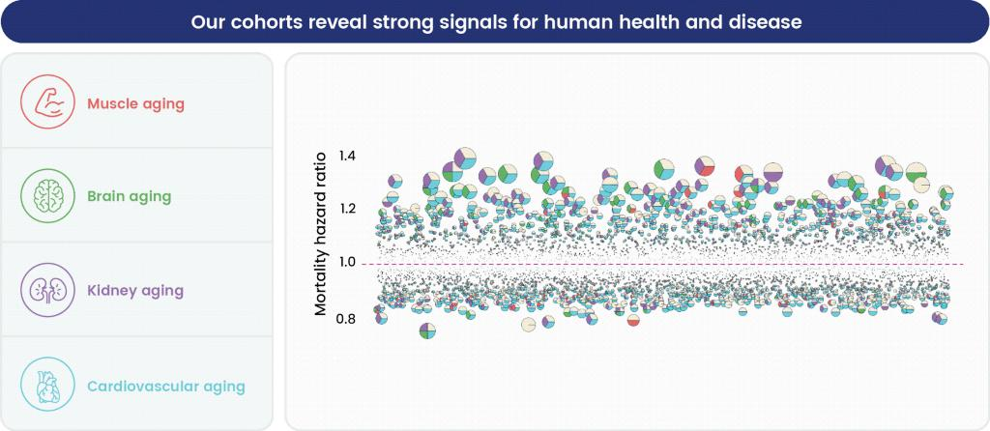

Circulating proteins are shown based on their magnitude of association with mortality (hazard ratio) in the BioAge human aging cohorts. Proteins are color coded based on significant associations (p<0.05) with future healthspan outcomes representing different organ systems, including grip strength (muscle aging), cognitive scores (brain aging), renal function quantified with cystatin C (kidney aging), and cardiovascular aging. A protein was considered significant for cardiovascular aging if significantly associated with ≥2+ of the following risk factors: total cholesterol, HDL, LDL, systolic or diastolic BP, fasting glucose, CRP, MCP-1 and ICAM-1.

Our Longevity Map (as defined below) is the result of applying an aging-biology-focused analytic approach that integrates proprietary data originating from our human aging cohorts with public data on aging and target biology to generate powerful insights into human aging mechanisms and targets. Our core analytical pipeline leverages (among other approaches):

- longitudinal multi-omic and clinical data,

- relationships across multiple datasets and data modalities,

- network based propagation of biological signals, and

43

- causal evidence from genetic signals via a bespoke mendelian randomization analysis.
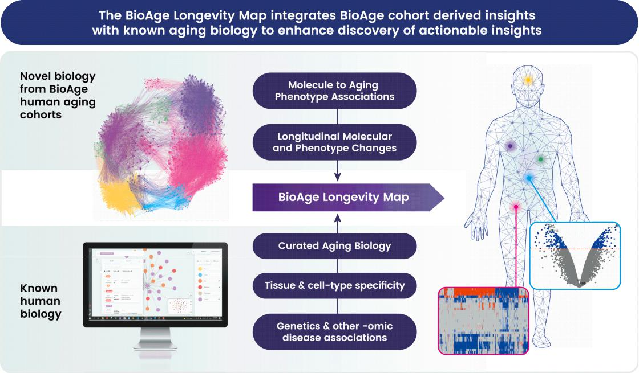

The BioAge Longevity Map integrates novel aging biology and public data to derive insights into aging biology and resulting therapeutic targets.

We are advancing several additional platform targets, currently in molecule discovery stage in collaboration with Lilly, which we believe have the potential to transform treatment of metabolic disease. We plan to expand this pipeline over time, both internally and through the target discovery collaboration with Novartis, and potentially through additional partnerships with pharmaceutical companies.

Manufacturing

We oversee and manage contract development and manufacturing organizations (CDMOs) to support development and manufacture of product candidates for our clinical trials. We expect our strategy to use CDMOs will enable us to maintain a more efficient infrastructure, avoiding the necessity to acquire our own manufacturing facility and equipment, while simultaneously enabling us to focus our expertise on the clinical development and the potential future commercialization of our products. Currently, we rely on and have agreements with multiple third-party CDMOs to manufacture and supply active pharmaceutical ingredients (APIs) and drug products (DPs) for our clinical trials. To prepare for advancement of our drug candidates to Phase 3 clinical trials, we anticipate the need to enter into a manufacture and supply agreement with, and transfer API and DP manufacture to, one or more additional third-party CDMOs with whom we would also likely enter into commercial supply agreements prior to any potential regulatory approval if any of our drug candidates are commercialized. The DP for our drug candidates is manufactured via conventional pharmaceutical processing procedures, employing commonly used and commercially available excipients and packaging materials. The procedure and equipment employed for manufacture and analysis are consistent with standard organic synthesis or pharmaceutical production, and are transferable to a range of manufacturing facilities, if needed.

Competition

The biotechnology and pharmaceutical industries are characterized by rapid evolution of technologies, fierce competition and strong defense of intellectual property. While we believe that our platform, knowledge, experience and scientific resources provide us with competitive advantages, we face competition from major pharmaceutical and biotechnology companies, academic institutions, governmental agencies and public and private research institutions, among others.

44

If any of our product candidates are approved for the indications for which we expect to conduct clinical trials, they will compete with existing therapies and currently marketed drugs, as well as any drug products currently or in the future in development that are ultimately approved, that are potential treatments for metabolic diseases, such as obesity. It is also possible that we will face competition from other pharmaceutical approaches as well as other types of therapies. The key competitive factors affecting the success of all our programs, if approved, are likely to be their efficacy, safety, convenience, price, level of generic competition, and availability of reimbursement.

Many of our current or potential competitors, either alone or with their collaboration partners, have significantly greater financial resources and expertise in research and development, manufacturing, preclinical testing, conducting clinical trials, obtaining regulatory approvals and marketing approved products than we do. These competitors also compete with us in recruiting and retaining qualified scientific and management personnel and establishing clinical trial sites and patient registration for clinical trials, as well as in acquiring technologies complementary to, or necessary for, our programs. Mergers and acquisitions in the biopharmaceutical industries may result in even more resources being concentrated among a smaller number of our competitors. Smaller or early-stage companies may also prove to be significant competitors, particularly through collaborative arrangements with large and established companies. With respect to BGE-102, direct competition is currently limited as there are no approved NLRP3 inhibitors or other inflammasome-targeted therapeutics. However, we are aware of NLRP3 inhibitor pipeline programs including those from Ventyx Biosciences (pending acquisition by Eli Lilly), NodThera, Roche, Merck, Novo Nordisk, AstraZeneca, Neumora, Ventus, Tenvie, Insilico, Brenig, and Zydus. Our competitors for the apelin receptor APJ agonist program include Structure Therapeutics, Bristol Myers Squibb, APIE Therapeutics and Sanofi, S.A. who have or had small molecule APJ agonists in preclinical or clinical development.

We anticipate that we will continue to face increasing competition as new therapies and combinations thereof, and related data emerge. Competitors, independently or through collaboration, are developing products that potentially directly compete with our current or future product candidates and which may (i) be a longer lasting or a more efficacious treatment, or better tolerated or (ii) receive FDA or other applicable regulatory approval more rapidly than our current or future product candidates. Our commercial opportunity could be reduced or eliminated if our competitors develop and commercialize products that are safer, more effective, have fewer or less severe side effects, are more convenient or are less expensive than any products that we may develop. Our competitors also may obtain FDA or other applicable regulatory approval for their products more rapidly than we may obtain approval for ours, which could result in our competitors establishing a strong market position before we are able to enter the market.

Intellectual Property

Intellectual property is of vital importance in our field and in biotechnology generally. We seek to protect and enhance proprietary technology, inventions, and improvements that are commercially important to the development of our business by seeking, maintaining and defending patent rights, whether developed internally or licensed from third parties. We will also seek to rely on regulatory protection afforded through inclusion in expedited development and review, data exclusivity, market exclusivity and patent term extensions where available.

We have sought patent protection in the United States and internationally related to our novel drugs, including compositions of matter directed both specifically and generically to our leads and backup compounds and corresponding methods of use directed to various clinical indications of the same, and other inventions and improvements that are central to our research and development efforts. In addition, we intend to seek additional patent protection which may enhance commercial success to the extent warranted by future developments.

As of February 20, 2026, our intellectual property portfolio contained owned and in-licensed cases and contains several issued U.S. and foreign national patents, and multiple pending U.S., Patent Cooperation Treaty (PCT) and foreign national applications. These patent families are expected to expire between 2032 and 2046, excluding patent term adjustments, extensions or terminal disclaimers, and assuming payment of all appropriate maintenance fees.

APJ Agonist Program

As of February 20, 2026, we owned one patent family relating to novel apelin receptor APJ agonists and related methods. This patent family includes three U.S. provisional applications having filing dates of May 27, 2025; September 17, 2025; and January 7, 2026. Any patents that may issue and claim priority to the pending applications are expected to expire in 2046, without taking into account any patent term adjustments, extensions or terminal disclaimers, and assuming payment of all appropriate maintenance fees.

45

As of February 20, 2026, we had optioned to license one patent family from JiKang Therapeutics relating to a novel APJ agonist antibody. This patent family includes one PCT non-provisional application, and any patents that may issue and claim priority to the pending application are expected to expire in 2046, without taking into account any patent term adjustments, extensions or terminal disclaimers, and assuming payment of all appropriate maintenance fees.

As of February 20, 2026, we had in-licensed one patent family from INSERM relating to use of the class of apelin receptor agonists for treating sarcopenia. This patent family includes one U.S. Patent, and foreign national patents in Japan and Europe (with validation in 5 European states), which patents are expected to expire in 2032, without taking into account any patent term adjustments, or extensions, and assuming payment of all appropriate maintenance fees.

As of February 20, 2026, we owned six patent families relating to methods of using APJ agonists, including therapeutic uses for frailty, muscle atrophy, or obesity. These patent families include six pending U.S. and PCT non-provisional applications, and 34 pending foreign national applications, including applications in Australia, Brazil, Canada, China, Europe, Israel, Japan, Korea, Mexico, New Zealand, Singapore and Taiwan. Any patents that may issue from our pending patent applications or claim priority to pending provisional applications are expected to expire between 2042 and 2045, without taking into account any patent term adjustments, extensions or terminal disclaimers, and assuming payment of all appropriate maintenance fees.

NLRP3 Inhibitor Program

As of February 20, 2026, we owned eleven patent families relating to novel NLRP3 (nucleotide binding oligomerization domain-like receptor family pyrin domain-containing 3) inhibitors and related methods. One of these patent families is co-owned with HitGen, Inc. The eleven patent families include eight issued U.S. patents (one co-owned with HitGen that is under our exclusive control, and seven solely-owned by BioAge), five pending U.S. provisional applications, nine pending U.S. and PCT non-provisional applications, and 40 pending foreign national applications, including applications in Argentina, Australia, Canada, China, Europe, Eurasia, Japan, Korea and Taiwan. Patent term is based on the effective filing date of each family. Of the eight issued patents, five will expire on March 23, 2042, two will expire on January 27, 2043, and one will expire on March 25, 2045, without taking into account any patent term adjustments, extensions or terminal disclaimers, and assuming payment of all appropriate maintenance fees. Future patents that result from pending applications in these families are projected to expire on one of March 23, 2042; January 27, 2043; September 19, 2043; September 11, 2044; October 4, 2044; or March 25, 2045, without taking into account any patent term adjustments, extensions, or terminal disclaimers, and assuming payment of all appropriate maintenance fees.

Platform Technology and Discovery Program

As of February 20, 2026, we owned 3 patent families relating to platform technology for identifying pathways for healthy aging and druggable targets, and 1 patent family relating to a class of therapeutic fusion proteins that bind endogenous RAGE ligands. These patent families include 4 issued U. S. patents, one issued Japanese patent, 3 pending U.S. applications, and 3 pending foreign national applications, including applications in Canada, and Europe. U.S. Patent No. 11,881,311 expires September 23, 2041, inclusive of patent term adjustment, and without taking into account any potential future extension. U.S. Patent No. 11,445,981 expires August 11, 2039, inclusive of patent term adjustment, and without taking into account any potential future extension. U.S. Patent No. 10,913,784 expires September 13, 2039, without taking into account any potential future extension. U.S. Patent No. 11,535,661, expires September 13, 2039, inclusive of a terminal disclaimer, and without taking into account any potential future extension. Japanese Patent No. 7,307,178 expires in September 2039, without taking into account any potential future extension. The 3 pending U.S. applications are expected to expire respectively in February 2038, July 2038, and October 2038, without taking into account any potential patent term adjustment, terminal disclaimer, or future extension. The 3 pending foreign national applications are expected to expire in October 2038 or September 2039, without taking into account any potential future supplementary protection certificate or extension.

We expect to file additional patent applications in support of current and future clinical candidates as well as new platform and core technologies.

Our commercial success will depend in part on obtaining and maintaining patent protection on our current and future product candidates and their related methods of use, as well as successfully defending any such patents against third-party challenges and operating without infringing on the proprietary rights of others. Our ability to stop third parties from making, using, selling, offering to sell or importing our product candidates will depend, in part, on the extent to which we have rights under valid and enforceable patents that cover these activities. We cannot be sure that patents will be granted with respect to any of our pending patent applications or with respect to any patent applications filed by us in the future, nor can we be sure

46

that any patents that may be granted to us in the future will be commercially useful in protecting our product candidates, discovery programs and processes. For this and more comprehensive risks related to intellectual property, see “Risk Factors—Risks Related to Intellectual Property.”

The terms of individual patents depend upon the legal term of the patents in the countries in which they are obtained. In most countries in which we file, including the United States, the patent term is 20 years from the earliest date of filing a non-provisional patent application. In the United States, a patent’s term may be lengthened by patent term adjustment, which compensates a patentee for administrative delays by the U.S. Patent and Trademark Office (USPTO) in examining and granting a patent, or may be shortened if a patent is terminally disclaimed over an earlier filed patent. In the United States, the term of a patent that covers a drug approved by the FDA may also be eligible for extension, which permits patent term restoration as compensation for the patent term lost during the FDA regulatory review process. The Hatch-Waxman Act permits a patent term extension of up to five years beyond the expiration of the patent. The length of the patent term extension is related to the length of time the subject drug candidate is under regulatory review. Patent term extension cannot extend the remaining term of a patent beyond a total of 14 years from the date of product approval, only one patent applicable to an approved drug may be extended and only those claims covering the approved drug, a method for using it, or a method for manufacturing it may be extended. Similar provisions to extend the term of a patent that covers an approved drug are available in Europe and other foreign jurisdictions. In the future, if and when our products receive FDA approval, we expect to apply for patent term extensions on patents covering those products. We plan to seek patent term extensions to any issued patents we may obtain in any jurisdiction where such patent term extensions are available, however there is no guarantee that the applicable authorities, including the FDA in the United States, will agree with our assessment that such extensions should be granted, and if granted, the length of such extensions. For more information regarding the risks related to intellectual property, see “Risk Factors —Risks Related to Intellectual Property.”

In most instances, we have submitted and expect to submit patent applications directly to the USPTO as provisional patent applications. Corresponding non-provisional patent applications must be filed not later than 12 months after the provisional application filing date. While we intend to timely file non-provisional patent applications relating to our provisional patent applications, we cannot predict whether any such patent applications will result in the issuance of patents that provide us with any competitive advantage.

We file U.S. non-provisional applications, PCT applications and non-PCT foreign national applications that claim the benefit of the priority date of earlier filed provisional applications, when applicable. The PCT system allows a single application to be filed within 12 months of the original priority date of the patent application, and to designate all of the PCT member states in which national patent applications can later be pursued based on the international patent application filed under the PCT. The PCT searching authority performs a patentability search and issues a non-binding patentability opinion which can be used to evaluate the chances of success for the national applications in foreign countries prior to having to incur the filing fees. Although a PCT application does not issue as a patent, it allows the applicant to seek protection in any of the member states through national-phase applications. Before the end of the period of approximately two and a half years from the first priority date of the patent application, separate patent applications can be pursued in any of the PCT member states either by direct national filing or, in some cases, by filing through a regional patent organization, such as the European Patent Office. The PCT system delays expenses, allows a limited evaluation of the chances of success for national/regional patent applications, and enables substantial savings where applications are abandoned within the first two and a half years of filing.

For all patent applications, we determine claiming strategy on a case-by-case basis. Advice of counsel and our business model and needs are always considered. We seek to file patents containing claims for protection of all useful applications of our proprietary technologies and any products, as well as all new applications and/or uses we discover for existing technologies and products, assuming these are strategically valuable. We continuously reassess the number and type of patent applications, as well as the pending and issued patent claims to pursue maximum coverage and value for our processes, and compositions, given existing patent office rules and regulations. Further, claims may be modified during patent prosecution to meet our intellectual property and business needs.

47

We recognize that the ability to obtain patent protection and the degree of such protection depends on a number of factors, including the extent of the prior art, the novelty and non-obviousness of the invention, and the ability to satisfy the enablement requirement of the patent laws. In addition, the coverage claimed in a patent application can be significantly reduced before the patent is issued, and its scope can be reinterpreted or further altered even after patent issuance. Consequently, we may not obtain or maintain adequate patent protection for any of our future product candidates or for our technology platform. We cannot predict whether the patent applications we are currently pursuing will issue as patents in any particular jurisdiction or whether the claims of any issued patents will provide sufficient proprietary protection from competitors. Any patents that we hold may be challenged, circumvented or invalidated by third parties.

In addition to patent protection, we also rely on trademark registration, trade secrets, know how, other proprietary information and continuing technological innovation to develop and maintain our competitive position. We seek to protect and maintain the confidentiality of proprietary information to protect aspects of our business that are not amenable to, or that we do not consider appropriate for, patent protection. Although we take steps to protect our proprietary information and trade secrets, including through contractual means with our employees and consultants, third parties may independently develop substantially equivalent proprietary information and techniques or otherwise gain access to our trade secrets or disclose our technology. Thus, we may not be able to meaningfully protect our trade secrets. It is our policy to require our employees, consultants, outside scientific collaborators, sponsored researchers and other advisors to execute confidentiality agreements upon the commencement of employment or consulting relationships with us. These agreements provide that all confidential information concerning our business or financial affairs developed or made known to the individual during the course of the individual’s relationship with us is to be kept confidential and not disclosed to third parties except in specific circumstances. Our agreements with employees also provide that all inventions conceived by the employee in the course of employment with us or from the employee’s use of our confidential information are our exclusive property. However, such confidentiality agreements and invention assignment agreements can be breached and we may not have adequate remedies for any such breach. In addition, our trade secrets may otherwise become known or be independently discovered by competitors. To the extent that our consultants, contractors or collaborators use intellectual property owned by others in their work for us, disputes may arise as to the rights in related or resulting trade secrets, know-how and inventions. For more information regarding the risks related to our intellectual property, see “Risk Factors—Risks Related to Intellectual Property.”

The patent positions of biotechnology companies like ours are generally uncertain and involve complex legal, scientific and factual questions. Our commercial success will also depend in part on not infringing upon the proprietary rights of third parties. Third-party patents could require us to alter our development or commercial strategies, or our products or processes, obtain licenses or cease certain activities. Our breach of any license agreements or our failure to obtain a license to proprietary rights required to develop or commercialize our future products may have a material adverse impact on us. If third parties prepare and file patent applications in the United States that also claim technology to which we have rights, we may have to participate in interference or derivation proceedings in the USPTO to determine priority, or rights in, an invention. For more information, see “Risk Factors—Risks Related to Intellectual Property.”

When available to expand market exclusivity, our strategy is to obtain or license additional intellectual property related to current or contemplated development platforms, core elements of technology and/or clinical candidates.

Government Regulation

Pharmaceutical products are subject to extensive regulation by government authorities in the United States, at the federal, state and local level, and in other countries and jurisdictions. The processes for obtaining regulatory approvals in the United States and in foreign countries and jurisdictions, along with subsequent compliance with applicable statutes and regulations and other regulatory authorities, require the expenditure of substantial time and financial resources.

FDA Review and Approval Process

In the United States, pharmaceutical products are subject to extensive regulation by the FDA. The Federal Food, Drug, and Cosmetic Act (the FD&C Act) and other federal and state statutes and regulations govern, among other things, the research, development, testing, manufacture, quality control, storage, recordkeeping, approval, labeling, promotion and marketing, distribution, post-approval monitoring and reporting, sampling and import and export of pharmaceutical products. Failure to comply with applicable U.S. requirements may subject a company to a variety of administrative or judicial sanctions, such as a clinical hold, FDA refusal to approve pending new drug applications (NDAs), warning or untitled letters, product recalls, product seizures, total or partial suspension of production or distribution, injunctions, fines, civil penalties and criminal prosecution.

48

Pharmaceutical product development for a new product or certain changes to an approved product in the U.S. typically involves preclinical laboratory and animal tests, the submission to the FDA of an investigational new drug application (IND), which must become effective before clinical testing may commence, and adequate and well-controlled clinical trials to establish the safety and effectiveness of the drug for each indication for which FDA approval is sought. Satisfaction of FDA pre-market approval requirements typically takes many years and the actual time required may vary substantially based upon the type, complexity and novelty of the product or disease.

Preclinical tests include laboratory evaluation of product chemistry, formulation and toxicity, as well as animal studies to assess the characteristics and potential safety and efficacy of the product, as well as in some cases to establish a rationale for therapeutic use. The conduct of the preclinical tests must comply with federal regulations and requirements, including good laboratory practices for safety/toxicology studies. The results of preclinical testing are submitted to the FDA as part of an IND along with other information, including information about product chemistry, manufacturing and controls, and a proposed clinical trial protocol. Long-term preclinical tests, such as animal tests of reproductive toxicity and carcinogenicity, may continue after the IND is submitted. An IND automatically becomes effective and the proposed clinical trial may commence 30 days after receipt of the IND by the FDA, unless before that time the FDA raises concerns or questions related to one or more proposed clinical trials and places the trial on clinical hold. In such a case, the IND sponsor must resolve the issues to the FDA’s satisfaction before the clinical trial can begin. As a result, submission of an IND may not result in the FDA allowing clinical trials to commence.

Clinical trials involve the administration of the investigational new drug to healthy volunteers or patients under the supervision of a qualified investigator. Clinical trials must be conducted: (i) in compliance with federal regulations; (ii) in compliance with good clinical practices (GCP), an international standard meant to protect the rights and health of participants and to define the roles of clinical trial sponsors, administrators and monitors; as well as (iii) under protocols detailing the objectives of the trial, the parameters to be used in monitoring safety and the effectiveness criteria to be evaluated. Each protocol involving testing on U.S. patients and subsequent protocol amendments must be submitted to the FDA as part of the IND. While the IND is active, progress reports summarizing the results, if known, of the clinical trials and preclinical studies performed since the last progress report, among other information, must be submitted at least annually to the FDA, and written IND safety reports must be submitted to the FDA and investigators in certain circumstances.

The FDA may order the temporary, or permanent, discontinuation of a clinical trial at any time, or impose other sanctions, if it believes that the clinical trial either is not being conducted in accordance with FDA requirements or presents an unacceptable risk to the clinical trial participants. The study protocol and informed consent information for participants in clinical trials must also be submitted to an institutional review board (IRB) or ethics committee at each clinical site for approval before each trial begins. An IRB monitors clinical trials through to completion and may also require the clinical trial at the site to be halted, either temporarily or permanently, for failure to comply with the IRB’s requirements, or may impose other conditions.

Clinical trials to support NDAs for marketing approval are typically conducted in three sequential phases, but the phases may overlap. In Phase 1, the initial introduction of the drug into healthy human subjects or patients, the drug is tested to assess metabolism, pharmacokinetics, pharmacological actions, side effects associated with increasing doses, and, if possible, early evidence of effectiveness. Phase 2 usually involves trials in a limited patient population to determine the effectiveness of the drug for a particular indication, dosage tolerance and optimum dosage, and to identify common adverse effects and safety risks. If a drug demonstrates evidence of effectiveness and an acceptable safety profile in Phase 2 evaluations, Phase 3 trials are undertaken to obtain the additional information about clinical efficacy and safety in a larger number of patients, typically at geographically dispersed clinical trial sites, to permit the FDA to evaluate the overall benefit-risk relationship of the drug and to provide adequate information for the labeling of the drug. In many cases, particularly for prevalent diseases, the FDA requires two adequate and well-controlled Phase 3 clinical trials to demonstrate the efficacy of the drug. A single adequate and well-controlled Phase 3 trial in conjunction with confirmatory evidence may be sufficient in many other instances, particularly for rare disease therapies. A single adequate and well-controlled trial may also be sufficient, though it is less common, when the trial is a large multicenter trial demonstrating internal consistency and a statistically very persuasive finding of a clinically meaningful effect on mortality, irreversible morbidity or prevention of a disease with a potentially serious outcome and confirmation of the result in a second trial would be practically or ethically impossible.

The manufacturer of an investigational new drug in a Phase 2 or 3 clinical trial for a serious or life-threatening disease is required to make available, such as by posting on its website, its policy on evaluating and responding to requests for expanded access.

49

After completion of the required clinical testing, an NDA is prepared and submitted to the FDA. FDA approval of the NDA is required before marketing and distribution of the product may begin in the U.S. The NDA must include the results of all preclinical, clinical and other testing and a compilation of data relating to the product’s pharmacology, chemistry, manufacture and controls, as well as any proposed labeling. The cost of preparing and submitting an NDA is substantial and includes an application user fee (unless a waiver applies) as well as an annual program fee, and the fees are typically increased annually.

The FDA has 60 days from its receipt of an NDA to conduct a preliminary review and determine whether the application will be filed based on the agency’s threshold determination that it is sufficiently complete to permit substantive review. If the FDA determines the application is incomplete because it does not on its face contain required information, the FDA may refuse to file the application and request additional information rather than file the NDA. In this event, the NDA must be resubmitted with the additional information. The resubmitted application is subject to preliminary review before the FDA files it. Once the submission is filed, the FDA begins an in-depth review. The FDA has agreed to certain performance goals in the review of NDAs to encourage timeliness. Applications for new molecular entity (NME) standard review drug products are reviewed within twelve months of the date of submission of the NDA to the FDA; applications for priority review NMEs are reviewed within eight months of the date of submission of the NDA to the FDA. Priority review can be applied to drugs that the FDA determines offer major advances in treatment or provide a treatment where no adequate therapy exists. The review process for both standard and priority review may be extended by the FDA for three additional months to consider certain late-submitted information, or information intended to clarify information already provided in the submission.

The FDA may also refer applications for novel drug products, or drug products that present difficult questions of safety or efficacy, to an outside advisory committee—typically a panel that includes clinicians and other experts—for review, evaluation and a recommendation as to whether the application should be approved. The FDA is not bound by the recommendation of an advisory committee, but it generally follows such recommendations.

Before approving an NDA, the FDA will typically inspect one or more clinical sites to assure compliance with GCP. Additionally, the FDA will inspect the facility or the facilities at which the drug is manufactured. The FDA will not approve the product unless compliance with current good manufacturing practices (cGMPs) is satisfactory and the NDA contains data that provide substantial evidence that the drug is safe and effective in the indication studied.

After the FDA evaluates the NDA and completes any clinical and manufacturing facility inspections, it issues either an approval letter or a complete response letter (CRL). A CRL generally outlines the deficiencies the FDA identified during its review of the submission and may require substantial additional testing, or information, in order for the FDA to reconsider the application for approval. If, or when, those deficiencies have been addressed to the FDA’s satisfaction in a resubmission of the NDA, the FDA will issue an approval letter. The FDA has committed to reviewing such resubmissions in two or six months depending on the type of information included. Even if such data and information are submitted, the FDA may decide that the NDA does not satisfy the criteria for approval.

An approval letter authorizes commercial marketing and distribution of the drug with specific prescribing information for specific indications. As a condition of NDA approval, the FDA may require a risk evaluation and mitigation strategy (REMS) to help ensure that the benefits of the drug outweigh the potential risks. REMS can include medication guides, communication plans for healthcare professionals, and elements to assure safe use (ETASU). ETASU can include, but are not limited to, special training or certification for prescribing or dispensing, dispensing only under certain circumstances, special monitoring and the use of patient registries. The requirement for a REMS can materially affect the potential market and profitability of the drug. Moreover, product approval may require substantial post-approval testing and surveillance to monitor the drug’s safety or efficacy and may limit further marketing of the product based on the results of this post-approval testing or surveillance.

Once granted, product approvals may be withdrawn if compliance with regulatory standards is not maintained or problems are identified following initial marketing. Changes to some of the conditions established in an approved application, including changes in indications, labeling, or manufacturing processes or facilities, require submission and FDA approval of a new NDA or NDA supplement before the change can be implemented. An NDA supplement for a new indication typically requires clinical data similar to that in the original application, and the FDA uses the same procedures and actions in reviewing NDA supplements as it does in reviewing NDAs.

50

Disclosure of Clinical Trial Information

Sponsors of clinical trials of FDA regulated products, including drugs, are required to register and disclose certain clinical trial information on ClinicalTrials.gov. Information related to the product, patient population, phase of investigation, study sites and investigators, and other aspects of the clinical trial is then made public as part of the registration. Sponsors are also obligated to disclose the results of their clinical trials after completion. Disclosure of the results of these trials can be delayed in certain circumstances for up to two years after the date of completion of the trial. Competitors may use this publicly available information to gain knowledge regarding the progress of development programs.

Pediatric Information

Under the Pediatric Research Equity Act (PREA), NDAs or supplements to NDAs must contain data to assess the safety and effectiveness of the drug for the claimed indications in all relevant pediatric subpopulations and to support dosing and administration for each pediatric subpopulation for which the drug is safe and effective. The FD&C Act requires that a sponsor who is planning to submit a marketing application for a product that includes a new active ingredient, new indication, new dosage form, new dosing regimen or new route of administration submit an initial Pediatric Study Plan (PSP), within 60 days of an end-of-Phase 2 meeting or as may be agreed between the sponsor and FDA. The FDA and the sponsor must reach agreement on the PSP. The FDA may grant full or partial waivers, or deferrals, for submission of data.

The Best Pharmaceuticals for Children Act (BPCA) provides NDA holders a six-month extension of any exclusivity—patent or nonpatent—for a drug if certain conditions are met. Conditions for exclusivity include the FDA’s determination that information relating to the use of a new drug in the pediatric population may produce health benefits in that population, the FDA making a written request for pediatric studies, and the applicant agreeing to perform, and reporting on, the requested studies within the statutory timeframe. Applications under the BPCA are treated as priority applications, with all of the benefits that designation confers.

Post-Approval Requirements

Once an NDA is approved, a product will be subject to certain post-approval requirements. For instance, the FDA closely regulates the post-approval marketing and promotion of drugs, including standards and regulations for direct-to-consumer advertising, off-label promotion, industry-sponsored scientific and educational activities and promotional activities involving the internet. Drugs may be marketed only for the approved indications and in accordance with the provisions of the approved labeling. The FDA and other agencies actively enforce the laws and regulations prohibiting the promotion of off-label uses, and a company that is found to have improperly promoted off-label uses may be subject to significant liability, including investigation by federal and state authorities.

Adverse event reporting and submission of periodic reports are required following FDA approval of an NDA. The FDA also may require post-marketing testing, sometimes referred to as Phase 4 testing, REMS, and surveillance to monitor the effects of an approved product, or the FDA may place conditions on an approval that could restrict the distribution or use of the product. In addition, quality control, drug manufacture, packaging and labeling procedures must continue to conform to cGMPs after approval. Drug manufacturers and certain of their subcontractors are required to register their establishments with the FDA and certain state agencies. Registration with the FDA subjects entities to periodic unannounced inspections by the FDA, during which the Agency inspects manufacturing facilities to assess compliance with cGMPs. Accordingly, manufacturers must continue to expend time, money and effort in the areas of production and quality-control to maintain compliance with cGMPs. FDA may withdraw product approvals or request product recalls if a company fails to comply with regulatory standards, if it encounters problems following initial marketing, or if previously unrecognized problems are subsequently discovered.

The Hatch-Waxman Amendments

Orange Book Listing

Under the Drug Price Competition and Patent Term Restoration Act of 1984, commonly referred to as the Hatch Waxman Amendments, NDA applicants are required to list with the FDA each patent whose claims cover the applicant’s product or approved method of using the product. Upon approval of a drug, each of the patents listed in the application for the drug is then published in the FDA’s Approved Drug Products with Therapeutic Equivalence Evaluations, commonly known as the Orange Book. Drugs listed in the Orange Book can, in turn, be cited by potential generic competitors in support of approval of an abbreviated new drug application (ANDA). An ANDA provides for marketing of a drug product that has the same active

51

ingredients in the same strengths and dosage form as the listed drug and has been shown through bioequivalence testing to be therapeutically equivalent to the listed drug. Other than the requirement for bioequivalence testing, ANDA applicants are not required to conduct, or submit results of, preclinical or clinical tests to prove the safety or effectiveness of their drug product. Drugs approved in this way are commonly referred to as “generic equivalents” to the listed drug and can often be substituted by pharmacists under prescriptions written for the original listed drug.

The ANDA applicant is required to certify to the FDA concerning any patents listed for the approved product in the FDA’s Orange Book. Specifically, the applicant must certify that (i) the required patent information has not been filed; (ii) the listed patent has expired; (iii) the listed patent has not expired but will expire on a particular date and approval is sought after patent expiration; or (iv) the listed patent is invalid or will not be infringed by the new product. The ANDA applicant may also elect to submit a Section VIII statement certifying that its proposed ANDA label does not contain (or carve out) any language regarding the patented method-of-use rather than certify to a listed method-of-use patent. If the applicant does not challenge the listed patents, the ANDA application will not be approved until all the listed patents claiming the referenced product have expired.

A certification that the new product will not infringe the already approved product’s listed patents, or that such patents are invalid, is called a Paragraph IV certification. If the ANDA applicant has provided a Paragraph IV certification to the FDA, the applicant must also send notice of the Paragraph IV certification to the NDA and patent holders once the ANDA has been accepted for filing by the FDA. The NDA and patent holders may then initiate a patent infringement lawsuit in response to the notice of the Paragraph IV certification. The filing of a patent infringement lawsuit within 45 days of the receipt of a Paragraph IV certification automatically prevents the FDA from approving the ANDA until the earlier of 30 months, expiration of the patent, settlement of the lawsuit, or a decision in the infringement case that is favorable to the ANDA applicant.

Exclusivity

Market exclusivity provisions under the FD&C Act also can delay the submission or the approval of certain applications. An ANDA application will not be approved until any applicable non-patent exclusivity listed in the Orange Book for the referenced product has expired. Upon NDA approval of a new chemical entity (NCE), which is a drug that contains no active moiety that has been approved by the FDA in any other NDA, that drug receives five years of marketing exclusivity during which the FDA cannot receive any ANDA seeking approval of a generic version of that drug. An ANDA may be submitted one year before NCE exclusivity expires if a Paragraph IV certification is filed. If there is no listed patent in the Orange Book, there may not be a Paragraph IV certification, and, thus, no ANDA may be filed before the expiration of the exclusivity period. Certain changes to a drug, such as the approval of a new indication, new strength, or new condition of use, can be the subject of a three-year period of exclusivity from the date of approval if the application contains reports of new clinical investigations (other than bioavailability studies) conducted or sponsored by the sponsor that were essential to the approval of the application. The FDA cannot approve an ANDA for a generic drug that includes the change during the exclusivity period. In some instances, an ANDA applicant may receive approval prior to expiration of certain non-patent exclusivity if the applicant seeks, and FDA permits, the omission of such exclusivity-protected information from the ANDA prescribing information.

Patent Term Restoration

After NDA approval, the owner of a relevant drug patent may apply for up to a five-year patent extension. Only one patent may be extended for each regulatory review period, which is composed of two parts: a testing phase and an approval phase. The allowable patent term extension is generally calculated as half of the drug’s testing phase (the time between IND application and NDA submission) and all of the review phase (the time between NDA submission and approval) up to a maximum of five years. If the extended patent was issued during the development or review period, the calculation begins from the date of patent issuance. The review period can be shortened if the FDA determines that the applicant did not pursue approval with due diligence. The total patent term after the extension may not exceed 14 years.

For patents that might expire during the application phase, the patent owner may request an interim patent extension. An interim patent extension increases the patent term by one year and may be renewed up to four times. For each interim patent extension granted, the post-approval patent extension is reduced by one year. The director of the United States Patent and Trademark Office must determine that approval of the drug covered by the patent for which a patent extension is being sought is likely. Interim patent extensions are not available for a drug for which an NDA has not been submitted.

52

Coverage and Reimbursement

Sales of a product in the U.S. will depend, in part, on the extent to which such products will be covered by third-party payors, such as government healthcare programs, commercial insurance and managed healthcare organizations. These third-party payors are increasingly limiting coverage and/or reducing reimbursements for medical products and services. The process for determining whether a payor will provide coverage for a drug product may be separate from the process for setting the reimbursement rate that the payor will pay for the drug. Third-party payors may limit coverage to specific drug products on an approved list, or formulary, which might not include all of FDA-approved drugs for a particular indication. Further, one payor’s determination to provide coverage for a drug product does not ensure that other payors will also provide coverage for the drug product. Coverage policies and third-party payor reimbursement rates may change at any time and can differ significantly from payor to payor.

In addition, the U.S. government, state legislatures and foreign governments have continued implementing cost-containment programs, including price controls, restrictions on reimbursement and requirements for substitution of generic products. Third-party payors are increasingly challenging the prices charged for medical products and services, examining the medical necessity, and reviewing the cost effectiveness of pharmaceutical or biological products, medical devices, and medical services, in addition to questioning safety and efficacy. Adoption of price controls and cost-containment measures, and adoption of more restrictive policies in jurisdictions with existing controls and measures, could further limit sales of any product that receives approval. Decreases in third-party payor reimbursement or a decision by a third-party payor to not cover a product could reduce physician usage and patient demand for the product.

Other Healthcare Laws

In addition to FDA restrictions on marketing of pharmaceutical products, several other types of state and federal laws have been applied to restrict certain general business and marketing practices in the pharmaceutical industry in recent years. These laws include anti-kickback statutes, false claims statutes, price transparency and reporting, privacy and cybersecurity laws, and other healthcare laws and regulations.

The federal Anti-Kickback Statute prohibits, among other things, knowingly and willfully offering, paying, soliciting or receiving remuneration to induce, or in return for, purchasing, leasing, ordering or arranging for the purchase, lease or order of any healthcare item or service reimbursable under Medicare, Medicaid, or other federally financed healthcare programs. The Patient Protection and Affordable Care Act as amended by the Health Care and Education Reconciliation Act (collectively, the ACA) amended the intent element of the federal statute so that a person or entity no longer needs to have actual knowledge of the statute or specific intent to violate it in order to commit a violation. This statute has been interpreted to apply to arrangements between pharmaceutical manufacturers on the one hand and prescribers, purchasers and formulary managers, among others, on the other. Violations of the federal Anti-Kickback Statute are punishable by imprisonment, criminal fines, civil monetary penalties, and exclusion from participation in federal healthcare programs. Although there are a number of statutory exceptions and regulatory safe harbors protecting certain common activities from prosecution or other regulatory sanctions, the exceptions and safe harbors are drawn narrowly, and practices that involve remuneration intended to induce prescribing, purchases or recommendations may be subject to scrutiny if they do not qualify for an exception or safe harbor. Additionally, a violation of the federal Anti-Kickback Statute can serve as a basis for liability under the federal civil False Claims Act.

Federal civil and criminal false claims laws, including the federal civil False Claims Act, prohibit any person or entity from knowingly presenting, or causing to be presented, a false claim for payment to the federal government, or knowingly making, or causing to be made, a false statement to have a false claim paid. This includes claims made to programs where the federal government reimburses, such as Medicare and Medicaid, as well as programs where the federal government is a direct purchaser, such as when it purchases off the Federal Supply Schedule. Pharmaceutical and other healthcare companies have been prosecuted under these laws for allegedly inflating drug prices they report to pricing services, which in turn were used by the government to set Medicare and Medicaid reimbursement rates, and for allegedly providing free product to customers with the expectation that the customers would bill federal programs for the product. In addition, certain marketing practices, including off-label promotion, may also violate false claims laws. Additionally, the ACA amended the federal Anti-Kickback Statute such that a violation of that statute can serve as a basis for liability under the federal civil False Claims Act. Most states also have statutes or regulations similar to the federal Anti-Kickback Statute and civil False Claims Act, which apply to items and services reimbursed under Medicaid and other state programs, or, in several states, apply regardless of the payor.

53

Other federal statutes pertaining to healthcare fraud and abuse include the civil monetary penalties statute, which prohibits, among other things, the offer or payment of remuneration to a Medicaid or Medicare beneficiary that the offeror or payor knows or should know is likely to influence the beneficiary to order a receive a reimbursable item or service from a particular supplier, and the additional federal criminal statutes created by the Health Insurance Portability and Accountability Act of 1996 (HIPAA), which prohibits, among other things, knowingly and willfully executing or attempting to execute a scheme to defraud any healthcare benefit program or obtain by means of false or fraudulent pretenses, representations or promises any money or property owned by or under the control of any healthcare benefit program in connection with the delivery of or payment for healthcare benefits, items or services.

In addition, HIPAA, as amended by the Health Information Technology for Economic and Clinical Health Act of 2009 (HITECH), and their respective implementing regulations, impose obligations on certain healthcare providers, health plans, and healthcare clearinghouses, known as covered entities, as well as their business associates and subcontractors that perform certain services involving the storage, use or disclosure of individually identifiable health information, including mandatory contractual terms, with respect to safeguarding the privacy, security, and transmission of individually identifiable health information, and require notification to affected individuals and regulatory authorities of certain breaches of security of individually identifiable health information. HITECH increased the civil and criminal penalties that may be imposed against covered entities, business associates and possibly other persons, and gave state attorneys general new authority to file civil actions for damages or injunctions in federal courts to enforce the federal HIPAA laws and seek attorney’s fees and costs associated with pursuing federal civil actions. In addition, many state laws govern the privacy and security of health information in certain circumstances, many of which differ from each other in significant ways and may not have the same effect, and often are not pre-empted by HIPAA. Each of these laws may increase the complexity, variation in requirements, restrictions and potential legal risks, and could require increased compliance costs and changes in business practices and policies. For example, the California Consumer Privacy Act of 2018 (CCPA), imposes obligations on businesses to which it applies, including, but not limited to, providing specific disclosures in privacy notices and affording California residents certain rights related to their personal data, although it exempts some data processed in the context of clinical trials. In addition, the California Privacy Rights Act of 2020 (CPRA), which went into effect on January 1, 2023, imposes additional obligations on companies covered by the legislation and significantly modifies the CCPA, including by expanding consumers’ rights with respect to certain sensitive personal information. The CPRA also creates a new state agency that is vested with authority to implement and enforce the CCPA and CPRA. Other states have also enacted, proposed, or are considering proposing, data privacy laws, which could further complicate compliance efforts, increase our potential liability and adversely affect our business.

Further, pursuant to the federal Physician Payments Sunshine Act, enacted as part of the ACA, the Centers for Medicare & Medicaid Services (CMS), has issued a final rule that requires manufacturers of approved prescription drugs that are reimbursable under Medicare, Medicaid, or the Children’s Health Insurance Program, with certain exceptions, to collect and report information on certain payments or transfers of value to physicians (defined to include doctors, dentists, optometrists, podiatrists and chiropractors), certain non-physician practitioners (such as physician assistants and nurse practitioners) and teaching hospitals, as well as investment interests held by physicians and their immediate family members. The reports must be submitted on an annual basis. The reported data is made available in searchable form on a public website on an annual basis. Failure to submit required information may result in civil monetary penalties.

In addition, several states now require prescription drug companies to report certain expenses relating to the marketing and promotion of drug products and to report gifts and payments to individual healthcare practitioners in these states. Other states prohibit various marketing-related activities, such as the provision of certain kinds of gifts or meals. Several states, including California, Connecticut, Nevada, and Massachusetts, require pharmaceutical companies to implement compliance programs and/or marketing codes. Still other states require the posting of information relating to clinical studies and their outcomes. A growing number of states require the reporting of certain drug pricing information, including information pertaining to and justifying price increases and the prices of newly launched drugs, or prohibit prescription drug price gouging. In addition, certain states require pharmaceutical companies to implement compliance programs and/or marketing codes. Certain states and local jurisdictions also require the registration of pharmaceutical sales and medical representatives. Compliance with these laws is difficult and time consuming, and companies that do not comply with these state laws face civil penalties.

54

Efforts to ensure that business arrangements with third parties comply with applicable healthcare laws and regulations involve substantial costs. If a drug company’s operations are found to be in violation of any such requirements, it may be subject to significant penalties, including civil, criminal and administrative penalties, damages, fines, disgorgement, imprisonment, the curtailment or restructuring of its operations, loss of eligibility to obtain approvals from the FDA, exclusion from participation in government contracting, healthcare reimbursement or other federal or state government healthcare programs, including Medicare and Medicaid, integrity oversight and reporting obligations, imprisonment, and reputational harm. Any action for an alleged or suspected violation can cause a drug company to incur significant legal expenses and divert management’s attention from the operation of the business, even if such action is successfully defended.

U.S. Healthcare Reform

In the United States there have been, and continue to be, proposals by the federal government, state governments, regulators and third-party payors to control or manage the increased costs of health care and, more generally, to reform the U.S. healthcare system. The pharmaceutical industry has been a particular focus of these efforts and has been significantly affected by major legislative initiatives. For example, in March 2010, the ACA was enacted, which was intended to broaden access to health insurance, reduce or constrain the growth of healthcare spending, enhance remedies against fraud and abuse, add new transparency requirements for the healthcare and health insurance industries, impose new taxes and fees on the health industry and impose additional health policy reforms.

Several healthcare reform proposals culminated in the enactment of the Inflation Reduction Act (IRA) in August 2022, which, among other things, allows HHS to directly negotiate the selling price of a statutorily specified number of drugs and biologics each year that CMS reimburses under Medicare Part B and Part D. The negotiated price may not exceed a statutory ceiling price. Only high-expenditure single-source drugs that have been approved for at least 7 years (11 years for single-source biologics) are eligible to be selected by CMS for negotiation, with the negotiated price taking effect two years after the selection year. For 2026, the first year in which negotiated prices become effective, CMS selected 10 high-cost Medicare Part D products in 2023, negotiations began in 2024, and the negotiated maximum fair price for each product has been announced. In addition, CMS has selected and announced the negotiated maximum fair price for 15 additional Medicare Part D drugs, which will become effective in 2027. For 2028, CMS has selected an additional 15 drugs, comprised of drugs covered under Medicare Part D and, for the first time, drugs payable under Medicare Part B. For 2029 and subsequent years, 20 Part B or Part D drugs will be selected. The IRA also imposes rebates on Medicare Part B and Part D drugs whose prices have increased at a rate greater than the rate of inflation and in November 2024, CMS finalized regulations for these inflation rebates. In addition, the law eliminated the “donut hole” under Medicare Part D beginning in 2025 by significantly lowering the beneficiary maximum out-of-pocket cost through a newly established manufacturer discount program, which requires manufacturers, in order for their drugs to be covered by Medicare Part D, to provide statutorily defined discounts on their brand (approved NDA or BLA) drugs dispensed to Part D enrollees. The IRA permits the Secretary of HHS to implement many of these provisions through guidance, as opposed to regulation, for the initial years. Manufacturers that fail to comply with the IRA may be subject to various penalties, including civil monetary penalties. These provisions began taking effect progressively starting in 2023 and may be subject to legal challenges. For example, the provisions related to the negotiation of selling prices of high-expenditure single-source drugs and biologics have been challenged in multiple lawsuits brought by pharmaceutical manufacturers. The outcome of these lawsuits is uncertain. Thus, while it is unclear how the IRA will be implemented, it will likely have a significant impact on the pharmaceutical industry and the pricing of prescription drug products.

Employees and Human Capital Resources

As of December 31, 2025, we had 62 employees, 60 of whom were full-time and 44 of whom were engaged in research and development activities. Approximately 44% of our employees hold Ph.D. or M.D. degrees. Women comprise approximately 50% of our employees, and individuals from underrepresented ethnic groups comprise approximately 31%. Women comprise approximately 39% of our senior leadership team and 25% of our board of directors. None of our employees are represented by a labor union or covered under a collective bargaining agreement. We consider our relationship with our employees to be good.

55

Our human capital resources objectives include, as applicable, identifying, recruiting, retaining, incentivizing and integrating our existing and new employees, advisors and consultants. It is important that we not only attract and retain the best and brightest diverse talent, but also ensure they remain engaged and can thrive in an environment that is committed to helping them grow, succeed and contribute directly to achieving our purpose. The principal purposes of our equity and cash incentive plans are to attract, retain and reward personnel through the granting of stock-based and cash-based compensation awards, in order to increase the success of our Company by motivating such individuals to perform to the best of their abilities and achieve our objectives.

Facilities

Our headquarters are located in Emeryville, California where we lease and occupy 10,479 square feet of office and laboratory space.

We believe that our existing facilities and new facilities under construction are sufficient to meet our near-term needs.

Additional Information

We were incorporated under the laws of the State of Delaware in April 2015 under the name BioAge Labs, Inc. Our principal executive office is located at 5885 Hollis Street Suite 370 Emeryville California, 94608, and our telephone number is (510) 806-1445. Our website address is www.bioagelabs.com. The information contained on, or that can be accessed through, our website is not part of, and is not incorporated by reference into, this Annual Report.

We file annual, quarterly and current reports, proxy statements and other documents with the Securities and Exchange Commission, or SEC, under the Securities Exchange Act of 1934, as amended, or Exchange Act. The SEC maintains an Internet website that contains reports, proxy and information statements, and other information regarding issuers, including us, that file electronically with the SEC. The public can obtain any documents that we file with the SEC at www.sec.gov. Copies of each of our filings with the SEC can also be viewed and downloaded free of charge at our website, https://ir.bioagelabs.com, after the reports and amendments are electronically filed with or furnished to the SEC.

56

Item 1A. Risk Factors.

Investing in our common stock involves a high degree of risk. Before making your decision to invest in shares of our common stock, you should carefully consider the risks described below, together with the other information contained in this Annual Report, including in the section titled “Management’s Discussion and Analysis of Financial Condition and Results of Operations” and in our consolidated financial statements and the related notes included elsewhere in this Annual Report. The risks and uncertainties described below are not the only ones we face. Additional risks and uncertainties that we are unaware of or that we deem immaterial may also become important factors that adversely affect our business. We cannot assure you that any of the events discussed below will not occur. These events could have a material and adverse impact on our business, financial condition, results of operations and prospects. If that were to happen, the trading price of our common stock could decline, and you could lose all or part of your investment. These disclosures reflect the Company’s beliefs and opinions as to factors that could materially and adversely affect the Company and its securities in the future. References to past events are provided by way of example only and are not intended to be a complete listing of such events or a representation as to whether or not such factors or similar events have occurred in the past or their likelihood of occurring in the future.

Risk Factors Summary

Our business is subject to a number of risks and uncertainties, including, among others, the following:

- We are a clinical-stage biopharmaceutical company with a limited operating history, have not completed any clinical trials beyond Phase 1b and have no products approved for commercial sale, which may make it difficult for investors to evaluate our business, likelihood of success and viability.

- We have incurred significant operating losses since our inception and expect to incur significant losses for the foreseeable future. We are not currently profitable, and may never achieve or sustain profitability. If we are unable to achieve or sustain profitability, the market value of our common stock will likely decline.

- We will require substantial additional capital to finance our operations and achieve our goals. If we are unable to raise capital when needed or on terms acceptable to us, we may be forced to delay, reduce or eliminate our research or development programs, any future commercialization efforts or other operations.

- If we are unable to advance the development of, receive regulatory approval for and ultimately successfully commercialize BGE-102 or any future product candidates we may develop, or experience significant delays in doing so, our business will be materially harmed.

- Drug development is a lengthy and expensive process, the outcome of clinical testing is inherently uncertain, and results of earlier studies and trials may not be predictive of future trial results. We may incur additional costs or experience additional delays in completing, or ultimately be unable to complete, the development and commercialization of BGE-102, our APJ programs or any future product candidates for many reasons, including a failure to replicate positive results from earlier preclinical studies or clinical trials in future preclinical studies or clinical trials.

- We may develop future product candidates in combination with other therapies, which would expose us to additional risks.

- We expect to expand our development, clinical and regulatory capabilities and operations as we grow, and as a result, we may encounter difficulties in managing our growth, which could disrupt our operations.

- Our quarterly and annual operating results may fluctuate significantly or may fall below the expectations of investors or securities analysts, each of which may cause our stock price to fluctuate or decline.

- Negative results or publicity for one drug for atherosclerotic cardiovascular disease (ASCVD) risk reduction, diabetic macular edema (DME), or obesity could have a substantial impact on all drugs and product candidates for ASCVD risk reduction, DME, or obesity, including any potential product candidates we may have in the future.

- We are subject to securities litigation, which is expensive and could divert management attention.

- We previously identified material weaknesses in our internal control over financial reporting. Although we have remediated these material weaknesses, we may identify additional material weaknesses or other deficiencies in the future or otherwise fail to maintain an effective system of internal controls, which could result in material misstatements of our financial statements or cause us to fail to meet our reporting obligations.

57

- We rely, and intend to continue to rely, on third parties to conduct clinical trials and perform some of our research and preclinical studies. If these third parties do not satisfactorily carry out their contractual duties, fail to comply with applicable regulatory requirements or do not meet expected deadlines, our development programs may be delayed or subject to increased costs or we may be unable to obtain regulatory approval, each of which may have an adverse effect on our business, financial condition, results of operations and prospects.

- The manufacture of pharmaceutical products, including BGE-102 our APJ programs or any future product candidates, is complex. Our third-party manufacturers may encounter difficulties in production, which could delay or entirely halt their ability in the future to supply our product candidates for clinical trials or, if approved, for commercial sale.

Risks Related to Our Financial Position, Limited Operating History and Need for Additional Capital

We are a clinical-stage biopharmaceutical company with a limited operating history, have not completed any clinical trials beyond Phase 1b and have no products approved for commercial sale, which may make it difficult for investors to evaluate our business, likelihood of success and viability.

We are a clinical-stage biopharmaceutical company with a limited operating history on which to base your investment decision. Drug development is a highly speculative undertaking and involves a substantial degree of risk. It entails substantial upfront capital expenditures and significant risk that any product candidate will fail to demonstrate adequate efficacy or an acceptable safety profile, gain regulatory approval or become commercially viable. We commenced operations in 2015, have no products approved for commercial sale and have never generated any revenue. To date, we have devoted substantially all of our resources to identifying, acquiring and developing our product candidates and licensed technologies, building our pipeline, performing research, conducting preclinical studies and early-stage clinical trials, organizing and staffing our company, business planning, establishing and maintaining our intellectual property portfolio, establishing arrangements with third parties for the manufacture of our product candidates, raising capital and providing general and administrative support for these operations.

To date, we have funded our operations with proceeds from sales of our redeemable convertible preferred stock, convertible notes, proceeds from the sale of our common stock, and stock option exercises. We have not yet demonstrated an ability to successfully complete any clinical trials beyond Phase 1b for our former lead product, azelaprag. Additionally, we have not yet demonstrated an ability to obtain regulatory approvals, manufacture a commercial-scale product or arrange for a third party to do so on our behalf, or conduct sales and marketing activities necessary for successful product commercialization. As a result, it may be more difficult for you to accurately predict our likelihood of success and viability than it could be if we had a longer operating history.

In addition, we may encounter unforeseen expenses, difficulties, complications, delays and other known and unknown factors and risks frequently experienced by biopharmaceutical companies. We also may need to transition from a company with a research and development focus to a company capable of supporting commercial activities. We have not yet demonstrated an ability to successfully overcome such risks and difficulties, or to make such a transition. If we do not adequately address these risks and difficulties or successfully make such a transition, our business will suffer.

We have incurred significant operating losses since our inception and expect to incur significant losses for the foreseeable future. We are not currently profitable, and may never achieve or sustain profitability. If we are unable to achieve or sustain profitability, the market value of our common stock will likely decline.

We have incurred significant operating losses since our inception and expect to incur significant losses for the foreseeable future. We do not have any products approved for sale and have not generated any product revenue since our inception. If our future product candidates are not successfully developed, approved and commercialized, we may never generate significant revenue, if we generate any revenue at all. Our net losses were $80.6 million and $71.1 million for the years ended December 31, 2025 and 2024, respectively. As of December 31, 2025, we had an accumulated deficit of $333.4 million. Substantially all of our losses have resulted from expenses incurred in connection with the development of, and in-licensing of intellectual property related to, our former product candidate azelaprag, the research and development of our NLRP3 programs, our longitudinal human aging platform, and from general and administrative costs associated with our operations. BGE-102 and any future product candidates will require substantial additional development time and resources before we would be able to apply for or receive regulatory approvals and begin generating revenue from product sales. We expect to continue to incur losses for the foreseeable future, and we anticipate these losses will increase substantially in connection with our planned and ongoing clinical trials for BGE-102, an NLRP3 inhibitor for patients with elevated cardiovascular risk or diabetic macular edema, our planned development of APJ agonists, and as we continue our development of, seek regulatory approval for and potentially commercialize BGE-102 or any future product candidates we may develop.

58

In addition, in May 2022, we entered into a loan and security agreement (the Loan Agreement) with SVB Innovative Credit Growth Fund IX, LP and Innovative Credit Growth Fund VIII-A, LP (collectively, the Lenders) pursuant to which we were able to borrow up to an aggregate of $25.0 million across two potential tranches until December 31, 2023 (the Term Loan). The Term Loan is secured by a lien covering substantially all of our assets, but not including our intellectual property or non-assignable licenses. In connection with the Term Loan, the Lenders were concurrently issued warrants to purchase 24,968 shares of our common stock at an exercise price of $10.26 per share, with a term of 10 years. The Loan Agreement required us to pay monthly interest payments until November 1, 2023, after which we commenced monthly principal payments. As of December 31, 2025, we had $2.0 million outstanding principal under the Term Loan. The Term Loan matures by April 1, 2026. For additional information about the Loan Agreement, see Note 5 to our consolidated financial statements included elsewhere in this Annual Report.

To become and remain profitable, we must succeed in developing, obtaining regulatory approvals for, and eventually commercializing products that generate significant revenue. This will require us to be successful in a range of challenging activities, including identifying, discovering, developing, in-licensing or acquiring any future product candidates, completing clinical trials of our product candidates, obtaining regulatory approval for BGE-102 and any future product candidates, and manufacturing, marketing, and selling any products for which we may obtain regulatory approval. We are only in the preliminary stages of these activities. We may never succeed in these activities and, even if we do, may never generate revenue that is significant enough to achieve profitability. Because of the numerous risks and uncertainties associated with biopharmaceutical product development, we are unable to accurately predict the timing or amount of increased expenses or when, or if, we will be able to achieve profitability. Even if we do achieve profitability, we may not be able to sustain or increase profitability on a quarterly or annual basis. Our failure to become and remain profitable may have an adverse effect on the value of our company and could impair our ability to raise capital, expand our business, maintain our research and development efforts, diversify our product candidates, achieve our strategic objectives or even continue our operations. A decline in the value of our company could also cause you to lose all or part of your investment.

We will require substantial additional capital to finance our operations and achieve our goals. If we are unable to raise capital when needed or on terms acceptable to us, we may be forced to delay, reduce or eliminate our research or development programs, any future commercialization efforts or other operations.

Developing pharmaceutical products, including conducting preclinical studies and clinical trials, is a very time-consuming, expensive and uncertain process that takes years to complete. Our operations have consumed substantial amounts of cash since inception, and we expect our expenses to increase substantially in connection with our ongoing activities, particularly as we advance our lead product candidate, BGE-102, through clinical development and any future product candidates through preclinical and clinical development. We expect increased expenses as we continue our research and development, initiate clinical trials, seek to expand our product pipeline and clinical applications, seek regulatory approval for our current and future product candidates and invest in our organization. In addition, if we obtain regulatory approval for any of our product candidates, we expect to incur significant commercialization expenses related to product manufacturing, marketing, sales and distribution. Because the outcome of any preclinical study or clinical trial is highly uncertain, we cannot reasonably estimate the actual amount of capital necessary to successfully complete the development and commercialization of our product candidates.

We had $285.1 million in cash, cash equivalents and marketable securities as of December 31, 2025, of which $4.0 million were long-term marketable securities. Based on our current operating plan, we estimate that our existing cash, cash equivalents and marketable securities as of the filing date of this Annual Report will be sufficient to fund our operations and capital expenses through 2029. Changes beyond our control may occur that would cause us to use our available capital before that time, including changes in and progress of our drug development activities and changes in regulation. Our future capital requirements will be dependent on many factors, including:

- the progress, timing and results of clinical trials for our lead product candidate, BGE-102, or any future product candidates;

- the extent to which we develop, in-license or acquire any future product candidates or technologies;

- the number of future product candidates and additional indications for our current product candidates we may pursue, and the preclinical studies and clinical trials necessary to develop them;

- the costs, timing and outcome of seeking regulatory approvals of our current or future product candidates;

- the scope and costs of making arrangements with third-party manufacturers, or establishing manufacturing capabilities, for both clinical and commercial supplies of our current or future product candidates;

59

- the costs involved in growing our organization to the size needed to allow for the research, development and potential commercialization of our current or future product candidates;

- the costs associated with commercializing any approved product candidates, including establishing sales, marketing, market access and distribution capabilities;

- to the extent we pursue strategic collaborations, including collaborations to commercialize BGE-102 or any future product candidates, our ability to establish and maintain collaborations on favorable terms, if at all, as well as the timing and amount of any milestone or royalty payments we are required to make or are eligible to receive under such collaborations or our current licenses;

- the costs associated with completing any post-marketing studies or trials required by the U.S. Food and Drug Administration (FDA) or other regulatory authorities;

- the revenue, if any, received from commercial sales of BGE-102 or any future product candidates, if any are approved;

- the costs of preparing, filing and prosecuting patent applications, maintaining and enforcing our intellectual property rights and defending intellectual property-related claims that we may become subject to, including any litigation costs and the outcome of such litigation; and

- the costs associated with potential product liability claims, including the costs associated with obtaining insurance against such claims and with defending against such claims.

We will require additional capital to complete our planned preclinical development programs and advance any product candidates into clinical trials in order to seek regulatory approval, and we anticipate needing to raise additional capital to complete the development of, and eventually commercialize, any of our product candidates, if approved. For example, we are party to the Sales Agreement with Leerink relating to the sale and issuance, from time to time, of shares of our common stock in at-the-market equity offerings with an aggregate offering price up to $75.0 million. Adequate additional financing may not be available to us on favorable terms, or at all. Our ability to raise additional funds will be dependent on financial, economic and market conditions, geopolitical issues and other factors, over which we may have limited or no control. In addition, we may seek additional capital due to favorable market conditions or strategic considerations even if we believe we have sufficient funds for our current or future operating plans. If adequate funds are not available on commercially acceptable terms when needed, we may be forced to delay, reduce or terminate the development or commercialization, if approved, of all or part of our research programs or future product candidates or we may be unable to take advantage of future business opportunities. Furthermore, any additional capital-raising efforts may divert our management from their day-to-day activities, which may adversely affect our ability to develop and commercialize our current and any future product candidates, if approved. Changing circumstances, some of which may be beyond our control, could cause us to consume capital significantly faster than we currently anticipate, and we may need to seek additional funds sooner than planned.

We will be required to obtain further funding through public or private equity financings, debt financings, collaborative agreements, licensing arrangements or other sources of financing, which may dilute our stockholders or restrict our operating activities. We do not have any committed external source of funds. To the extent that we raise additional capital through the sale of equity or convertible debt securities, each investor’s ownership interests will be diluted, and the terms may include liquidation or other preferences that adversely affect each investor’s rights as a stockholder. Debt financing or preferred equity financing, if available, may involve agreements that include covenants limiting or restricting our ability to take specific actions, such as incurring additional debt, making capital expenditures or declaring dividends. Such restrictions could adversely impact our ability to conduct our operations and execute our business plan. If we raise additional funds through upfront payments or milestone payments pursuant to strategic collaborations with third parties, we may have to relinquish valuable rights to our product candidates or grant licenses on terms that are not favorable to us.

Our failure to raise capital as and when needed or on acceptable terms could significantly harm our business, financial condition, results of operations and prospects and cause the price of our common stock to decline, and we may have to delay, reduce the scope of, suspend or eliminate one or more of our research or drug development programs, preclinical studies, future clinical trials or future commercialization efforts.

60

Risk Related to Research, Discovery, Development, Regulatory Approval and Commercialization of our

Product Candidates

We are substantially dependent on our ability to identify and develop future product candidates. If we are unable to advance the development of, receive regulatory approval for and ultimately successfully commercialize BGE-102 or any future product candidates we may develop, or experience significant delays in doing so, our business will be materially harmed.

Our future success is highly dependent on our ability to identify and develop, obtain regulatory approval for, and then successfully commercialize our lead product candidate, BGE-102, and any future product candidates, which may never occur. We are early in our development efforts with respect to BGE-102, which is a brain-penetrant structurally novel small molecule inhibitor of NLRP3 that has a novel binding site. We are also developing APJ agonists, which are in earlier stages of development. We currently have no products that are approved for sale in any jurisdiction. There can be no assurance that BGE-102 or any future product candidates we develop will achieve success in their respective clinical trials or obtain regulatory approval. We may also become dependent on product candidates that we may develop or acquire in the future. Given our early stage of development, it may be several years, if at all, before we have demonstrated the safety and efficacy of a product candidate sufficient to warrant approval for commercialization.

Our ability to generate product revenue, which we do not expect will occur for many years, if ever, will be heavily dependent on the successful development and eventual commercialization of BGE-102, our APJ programs and any future product candidates. The success of BGE-102 and any future product candidates will be dependent on several factors, including the following:

- successful and timely completion of preclinical studies and clinical trials demonstrating attractive, competitive target product profiles for our product candidates;

- clearance of INDs by the FDA or other similar clinical trial applications from other regulatory authorities for our future clinical trials for our pipeline product candidates;

- timely and successful enrollment of patients in, and completion of, clinical trials with favorable results;

- demonstration of safety, efficacy and acceptable risk-benefit profiles of our product candidates to the satisfaction of the FDA and other comparable foreign regulatory agencies;

- receipt of regulatory approvals from applicable regulatory authorities, if granted, including the completion of any required post-marketing studies or trials and available funding to perform any post-marketing commitments;

- raising additional funds necessary to complete clinical development of and commercialize our current or any future product candidates;

- obtaining, protecting and enforcing our patent, trade secret and other intellectual property and regulatory exclusivity for our current and future product candidates;

- making arrangements with third-party manufacturers, or establishing manufacturing capabilities, for both clinical and commercial supplies of our current or future product candidates and ensuring a resilient, effective supply chain that produces supply that outpaces demand;

- developing and implementing marketing and reimbursement strategies, as well as adequate demand forecasts for supply and sales planning;

- establishing sales, marketing and distribution capabilities and launching commercial sales of our products, if and when approved, whether alone or in collaboration with others in a market where promotional sales approaches are rapidly moving to digital platforms;

- demonstration of product characteristics attractive to physicians, patients, advocates, payors and caregivers;

- acceptance of our products, if and when approved, by patients, the medical community and third-party payors underpinned by adequate health economic data and a meaningful value proposition;

- effectively competing with other therapies, including those that have not yet entered the market;

61

- obtaining and maintaining third-party payor coverage and adequate reimbursement in both public and private payor spaces, given the significant number of obese patients in the United States who may benefit from our product candidates;

- obtaining appropriate support from patient advocacy organizations;

- addressing any delays in our clinical trials resulting from any major natural disasters, health pandemics or significant political events; and

- maintaining a continued acceptable safety profile of the products following approval.

Many of these factors are beyond our control, and it is possible that none of our product candidates will ever obtain regulatory approval even if we expend substantial time and resources seeking such approval. If we do not achieve one or more of these factors in a timely manner or at all, we could experience significant delays or an inability to successfully commercialize our product candidates, which would materially harm our business. For example, our business could be harmed if clinical trial results for future product candidates show unexpected adverse events or a lack of efficacy in the indications we intend to treat or do not meet the clinical endpoints, or if we experience other regulatory or developmental issues. For instance, in December 2024, we announced the discontinuation of our Phase 2 clinical trial of our former lead product candidate azelaprag following observation of liver transaminitis without clinically significant symptoms in some subjects receiving azelaprag.

Due to our limited resources and access to capital, we must, and have in the past decided to, prioritize development of certain potential product candidates over other potential product candidates. These decisions may prove to have been wrong and may adversely affect our ability to develop our own programs or our attractiveness as a commercial partner, and may ultimately have an impact on our commercial success.

Because we have limited resources and access to capital to fund our operations, we must decide which product candidates to pursue and the amount of resources to allocate to each. Our decisions concerning the allocation of research, collaboration, management and financial resources toward particular product candidates or therapeutic areas may not lead to the development of viable commercial products and may divert resources away from better opportunities. Similarly, any decisions to delay, terminate or collaborate with third parties in respect of certain product development programs may also prove not to be optimal and could cause us to miss valuable opportunities. If we make incorrect determinations regarding the market potential of any future product candidates or misread trends in the biopharmaceutical industry, our business, financial condition and results of operations would be materially adversely affected.

Drug development is a lengthy and expensive process, the outcome of clinical testing is inherently uncertain, and results of earlier studies and trials may not be predictive of future trial results. We may incur additional costs or experience additional delays in completing, or ultimately be unable to complete, the development and commercialization of BGE-102, our APJ programs or any future product candidates for many reasons, including a failure to replicate positive results from earlier preclinical studies or clinical trials in future preclinical studies or clinical trials.

On August 15, 2025, we announced that the first patient was dosed in our Phase 1 SAD / MAD clinical trial for BGE-102. It is impossible to predict when or if BGE-102 or any future product candidates will prove effective and safe in humans or will receive regulatory approval. To obtain the requisite regulatory approvals to commercialize any product candidate, we must demonstrate through extensive preclinical studies and lengthy, complex and expensive clinical trials that our product candidates are safe and effective in humans. Clinical testing can take many years to complete, and its outcome is inherently uncertain. Failure can occur at any time during the clinical trial process. The results of preclinical studies and early clinical trials of BGE-102 or any future product candidates, or a competitor’s product candidate in the same class, may not be predictive of the results of later-stage clinical trials. For example, despite encouraging results from our Phase 1b bed rest atrophy clinical trial and the lack of any negative safety signals in other Phase 1 clinical trials of azelaprag, in January 2025, we announced the discontinuation of the azelaprag program following observation of liver transaminitis without clinically significant symptoms in some subjects receiving azelaprag in our Phase 2 clinical trial. Interim, topline or preliminary results of a clinical trial are not necessarily indicative of final results. We may be unable to establish benefit on clinical endpoints that applicable regulatory authorities would consider clinically meaningful, and a clinical trial can fail at any stage of testing. Differences in trial design between early-stage clinical trials and later-stage clinical trials make it difficult to extrapolate the results of earlier clinical trials to later clinical trials. Moreover, clinical data are often susceptible to varying interpretations and analyses, and many companies that have believed their product candidates performed satisfactorily in clinical trials have nonetheless failed to obtain regulatory approval of their products. A number of companies in the biopharmaceutical industry have suffered significant setbacks in advanced clinical trials due to lack of efficacy or to unfavorable safety profiles, notwithstanding promising results in earlier trials. There is typically a high rate of failure of product candidates proceeding through clinical trials, particularly in the earlier

62

stages of development. Most product candidates that commence clinical trials are never approved as products, and there can be no assurance that any of our future clinical trials will ultimately be successful or support clinical development of any future product candidates.

We may experience delays in initiating or completing clinical trials of our future product candidates. We also may experience unforeseen events during, or as a result of, any future clinical trials that we conduct that could delay or prevent our ability to receive regulatory approval or commercialize BGE-102 or any future product candidates, including:

- regulators, institutional review boards (IRBs) or ethics committees may not authorize us or our investigators to commence a clinical trial or conduct a clinical trial at a prospective trial site, or may halt or suspend an ongoing clinical trial;

- we may experience delays in reaching or fail to reach agreement on acceptable terms with prospective trial sites and prospective contract research organizations (CROs) the terms of which can be subject to extensive negotiation and may vary significantly among different CROs and trial sites;

- clinical trial sites deviating from the trial protocol or dropping out of a trial;

- clinical trials of any product candidates may fail to show safety or efficacy, produce negative or inconclusive results and we may decide, or regulators may require us, to conduct additional preclinical studies or clinical trials or we may decide to abandon product development programs;

- failure of our current or future product candidates in clinical trials to demonstrate important functional or patient-reported outcomes;

- the number of subjects required for clinical trials of any product candidates may be larger than we anticipate, enrollment in these clinical trials may be slower than we anticipate or subjects may drop out of these clinical trials or fail to return for post-treatment follow-up at a higher rate than we anticipate;

- our third-party contractors may fail to comply with regulatory requirements or meet their contractual obligations to us in a timely manner, or at all, or may deviate from the clinical trial protocol or drop out of the trial, which may require that we add new clinical trial sites or investigators;

- we may elect, or regulators, IRBs, or ethics committees may require, that we or our investigators, suspend or terminate clinical research or trials for various reasons, including noncompliance with regulatory requirements or a finding that the participants in our trials are being exposed to unacceptable health risks;

- the cost of clinical trials of BGE-102 or any future product candidates may be greater than we anticipate, and we may not have sufficient funds to complete such trials;

- the quality of BGE-102 or any future product candidates or other materials necessary to conduct clinical trials of BGE-102 or any future product candidates may be inadequate to initiate or complete a given clinical trial;

- our inability to manufacture sufficient quantities of BGE-102 or any future product candidates for use in clinical trials;

- our inability to meet drug specifications suitable for use in clinical trials and commercial applications;

- reports from clinical testing of other therapies may raise safety or efficacy concerns about BGE-102 or any future product candidates;

- the receipt of feedback from regulatory authorities that requires us to modify the design of our clinical trials;

- our failure to establish an appropriate safety profile for a product candidate based on clinical or preclinical data for such product candidate as well as data emerging from other molecules in the same class as BGE-102 or any future product candidates; and

- the FDA or other regulatory authorities may require us to submit additional data such as long-term toxicology studies or impose other requirements before permitting us to initiate a clinical trial.

We could also encounter additional delays if a future clinical trial is suspended or terminated by us, the IRBs of the institutions in which such trials are being conducted, or the FDA or other regulatory authorities, or if a clinical trial is recommended for suspension or termination by the Data Safety Monitoring Board for such trial. A suspension or termination may be imposed due to a number of factors, including failure to conduct the clinical trial in accordance with regulatory requirements, including the FDA’s Good Clinical Practice (GCP) regulations, or our clinical protocols, inspection of the clinical

63

trial operations or trial site by the FDA or other regulatory authorities resulting in the imposition of a clinical hold, unforeseen safety issues or adverse side effects, failure to demonstrate a benefit from using a product or treatment, failure to establish or achieve clinically meaningful trial endpoints, changes in governmental regulations or administrative actions or lack of adequate funding to continue the clinical trial. Clinical studies may also be delayed or terminated as a result of ambiguous or negative interim results. Many of the factors that cause, or lead to, a delay in the commencement or completion of clinical trials may also ultimately lead to the denial of regulatory approval of BGE-102 or any future product candidates. Further, the FDA or other regulatory authorities may disagree with our clinical trial design and our interpretation of data from clinical trials, or may change the requirements for approval even after they have reviewed and commented on the design for our clinical trials.

We cannot predict with any certainty the schedule for commencement and completion of future clinical trials. Further, conducting clinical trials in foreign countries, as we have done and may do in the future for our product candidates, presents additional risks that may delay completion of our clinical trials. These risks include the failure of enrolled patients in foreign countries to adhere to clinical protocol as a result of differences in healthcare services or cultural customs, managing additional administrative burdens associated with foreign regulatory schemes, as well as political and economic risks relevant to such foreign countries.

If we are required to conduct additional clinical trials or other testing of our current or future product candidates beyond those that we currently contemplate, if we are unable to successfully complete clinical trials of our current or future product candidates or other testing in a timely manner, if the results of these trials or tests are not positive or are only modestly positive or if there are safety concerns, we may incur unplanned costs, be delayed in seeking and obtaining regulatory approval, if we receive such approval at all, receive more limited or restrictive regulatory approval, be subject to additional post-marketing testing requirements or have the drug removed from the market after obtaining regulatory approval.

Additionally, if the results of our clinical trials are inconclusive or if there are safety concerns or serious adverse events associated with our product candidates, we may:

- be delayed in obtaining regulatory approval, if at all;

- obtain approval for indications or patient populations that are not as broad as intended or desired or may have restricted duration expectations or guidance;

- obtain approval with labeling that includes significant use or distribution restrictions or safety warnings;

- be subject to additional post-marketing testing requirements;

- be required to perform additional clinical trials to support approval or be subject to additional post- marketing testing requirements;

- have regulatory authorities withdraw, or suspend, their approval of the drug or impose restrictions on its distribution in the form of a Risk Evaluation and Mitigation Strategy (REMS);

- be subject to the addition of labeling statements, such as warnings or contraindications;

- be sued; or

- experience damage to our reputation.

Our drug development costs will also increase if we experience delays in testing or obtaining regulatory approvals. Also, delays in obtaining regulatory approval may increase commercialization costs if the competitive environment becomes more intense prior to market entry. We do not know whether any of our preclinical studies or clinical trials will begin as planned, need to be restructured or be completed on schedule, if at all.

Moreover, principal investigators for our clinical trials may serve as scientific advisors or consultants to us from time to time and receive compensation in connection with such services. Under certain circumstances, we may be required to report some of these relationships to the FDA or other regulatory authorities. The FDA or other regulatory authorities may conclude that a financial relationship between us and a principal investigator has created a conflict of interest or otherwise affected interpretation of the study. The FDA or comparable foreign regulatory authority may therefore question the integrity of the data generated at the applicable clinical trial site and the utility of the clinical trial itself may be jeopardized. This could result in a delay in approval, or rejection, of our marketing applications by the FDA or other regulatory authority, as the case may be, and may ultimately lead to the denial of regulatory approval of one or more of our product candidates.

In addition, many of the factors that cause, or lead to, termination or suspension of, or a delay in the commencement or completion of, clinical trials may also ultimately lead to the denial of regulatory approval of a product candidate. We may make formulation or manufacturing changes to our product candidates, in which case we may need to conduct additional preclinical

64

studies to bridge our modified product candidates to earlier versions. If we experience delays in the commencement or completion of our clinical trials, or if we terminate a clinical trial prior to completion, the commercial prospects of any future product candidates could be negatively impacted, and our ability to generate revenues from our current or future product candidates may be delayed or eliminated entirely.

We may develop future product candidates in combination with other therapies, which would expose us to additional risks.

We may develop other product candidates for use in combination with other therapies in the future. The development of product candidates for use in combination with another product may present challenges that are not faced for single agent product candidates. For example, any future clinical trial for our product candidates in combination with other therapies that is designed to evaluate efficacy could show that our product candidate does not sufficiently contribute to the observed effects of individuals who participate in these trials. Even if any future product candidates were to receive regulatory approval or be commercialized for use in combination with other existing therapies, we would continue to be subject to the risks that the FDA or other comparable foreign regulatory authorities could revoke approval of the therapy used in combination with any of our product candidates, or safety, efficacy, manufacturing or supply issues could arise with these existing therapies. In addition, it is possible that existing therapies with which any future product candidates are approved for use could themselves fall out of favor or be relegated to later lines of treatment. This could result in the FDA or similar foreign regulatory authorities requiring us to conduct additional clinical trials, the need to identify other combination therapies for our product candidates or our own products being removed from the market or being less successful commercially.

If the FDA or other comparable foreign regulatory authorities do not approve or withdraw their approval of these other therapies, or if safety, efficacy, commercial adoption, manufacturing or supply issues arise with the therapies we choose to evaluate in combination with any future product candidates, we may be unable to obtain approval of or successfully market any one or all of the future product candidates we may develop. Additionally, if the third-party providers of therapies or therapies in development used in combination with any future product candidates are unable to produce sufficient quantities for clinical trials or for commercialization of any future product candidates, or if the cost of combination therapies are prohibitive, our development and commercialization efforts would be impaired, which would have an adverse effect on our business, financial condition, results of operations and prospects.

Preliminary, topline or interim data from our clinical trials that we announce or publish from time to time may change as more patient data become available and/or are subject to audit and verification procedures that could result in material changes in the final data.

From time to time, we may publicly disclose preliminary, topline or interim data from our clinical trials, such as preliminary, topline or interim data analysis from our ongoing and planned clinical trials of BGE-102. For example, we announced interim data from our Phase 1 SAD / MAD study of BGE-102 in December 2025 and January 2026. These data and related findings and conclusions may only reflect certain endpoints rather than all endpoints and are subject to change. We also make assumptions, estimations, calculations and conclusions as part of our analyses of data, and we may not have received or had the opportunity to fully and carefully evaluate all data. As a result, the preliminary or topline results that we report may differ from future results of the same studies, or different conclusions or considerations may qualify such results, once additional data have been received and fully evaluated.

Preliminary or topline data also remain subject to review and verification procedures that may result in the final data being materially different from the preliminary or topline data we previously published. As a result, preliminary and topline data should be viewed with caution until the final data are available. In addition, we may report preliminary data or interim analyses of the clinical trials we may conduct and complete, which are subject to the risk that one or more of the clinical outcomes may materially change as patient enrollment continues and more patient data become available. Adverse changes between preliminary or interim data and final data could significantly harm our business and prospects. Further, additional disclosure of preliminary or interim data by us including, for example, preliminary or interim data that becomes available to us from our ongoing and planned clinical trials of BGE-102 or other future product candidates or by our competitors in the future could result in volatility in the price of our common stock.

Further, the information we choose to publicly disclose regarding a particular study or clinical trial is typically selected from a more extensive amount of available information. You or others may not agree with what we determine is the material or otherwise appropriate information to include in our disclosure, and any information we determine not to disclose may ultimately be deemed significant with respect to future decisions, conclusions, views, activities or otherwise regarding a particular product, product candidate or our business. If the preliminary, topline or interim data that we report differ from later, final or actual results, or if others, including regulatory authorities, disagree with the conclusions reached, our ability to obtain

65

approval for, and commercialize, our product candidates may be harmed, which could harm our business, financial condition, results of operations and prospects.

We may not be successful in applying our longitudinal human aging platform to identify additional targets with therapeutic and commercial potential or in the discovery and development of commercially viable product candidates for us or our collaborators.

We use our longitudinal human aging platform to identify and prioritize potential drug targets, to assess the likelihood that we can develop a product candidate that interacts with the target to elicit the desired therapeutic effect, and to transition these insights efficiently into well supported therapeutic candidates. While we believe our platform will increase the likelihood of producing additional product candidates that provide meaningful clinical benefit, past success in identifying potential product candidates does not assure future success for our internal drug discovery programs. Our longitudinal human aging platform is novel, and we may not succeed in applying our platform to identify additional drug targets or transition these targets into promising future product candidates. We similarly cannot provide any assurance that, even if we do successfully identify additional targets, we will be able to successfully develop future product candidates and advance any such future product candidates into and through clinical development. Therefore, we are unable to predict the time and cost associated with the identification and development of any future product candidate or whether the application of our platform will result in the identification, development and ultimately regulatory approval of any future product candidates.

Efforts through our platform to identify, discover, acquire or in-license, and ultimately develop, product candidates require substantial technical, financial and human resources, whether or not any such future product candidates are ultimately identified. Our efforts may initially show promise in identifying potential product candidates, yet fail to yield product candidates for clinical development or regulatory approval for many reasons, including the following:

- the methodology used may not be successful in identifying any future potential product candidates;

- competitors may develop alternatives that render any product candidates we develop obsolete;

- any product candidates we develop may nevertheless be covered by third parties’ patents or other exclusive rights;

- a product candidate may be shown, in subsequent preclinical or clinical investigations, to have harmful side effects or characteristics that indicate it is unlikely to be effective, or otherwise would not meet applicable regulatory criteria;

- a product candidate may not be capable of being produced in commercial quantities at an acceptable cost, or at all; and

- a product candidate may not be accepted as safe and effective by physicians, patients, the medical community or third-party payors.

Our future growth may be dependent, in part, on our ability to operate in foreign markets, where we would be subject to additional regulatory burdens and other risks and uncertainties.

Our future growth may be dependent, in part, on our ability to develop and commercialize BGE-102, if approved, and any future product candidates in foreign markets for which we may rely on collaboration with third parties. We are not permitted to market or promote BGE-102 or any future product candidates before we receive regulatory approval from the applicable regulatory authority in that foreign market and may never receive such regulatory approval for BGE-102 or any future product candidates. To obtain separate regulatory approval in many other countries, we must comply with numerous and varying regulatory requirements of such countries regarding safety and efficacy and governing, among other things, clinical trials and commercial sales, pricing and distribution of BGE-102 or any future product candidates, and we cannot predict success in these jurisdictions. If we fail to comply with the regulatory requirements in international markets and receive applicable regulatory approvals, our target market will be reduced and our ability to realize the full market potential of BGE-102 or any future product candidates will be harmed, and our business will be adversely affected. We may not obtain foreign regulatory approvals on a timely basis, if at all. Our failure to obtain approval of BGE-102 or any future product candidates by regulatory authorities in another country may significantly diminish the commercial prospects of that product candidate and our business, financial condition, results of operations and prospects could be materially and adversely affected. Moreover, even if we obtain approval of BGE-102 or any future product candidates and ultimately commercialize BGE-102 or any future product candidates in foreign markets, we would be subject to the risks and uncertainties, including the burden of complying with complex and

66

changing foreign regulatory, tax, accounting and legal requirements and reduced protection of intellectual property rights in some foreign countries.

We may experience difficulty enrolling or keeping patients in our clinical trials, which could delay or prevent us from proceeding with, or otherwise adversely affect, clinical trials of our product candidates.

Our clinical trials will compete with other clinical trials for product candidates that are in the same therapeutic areas as our product candidates, and this competition could reduce the number and types of patients available to us, because some patients who might have opted to enroll in our trials may instead opt to enroll in a trial being conducted by one of our competitors. Since the number of qualified clinical investigators is limited, it is possible that we will be required to conduct some of our clinical trials at the same clinical trial sites that some of our competitors use, which could negatively impact the number of patients who are available for our clinical trials in such clinical trial site.

Delays related to patient enrollment and difficulties related to patient retention may result in increased costs or may affect the timing or outcome of our future clinical trials, which could prevent completion of these trials and adversely affect our ability to advance the development of our product candidates. Further, if patients drop out of our clinical trials, miss scheduled doses or follow-up visits, or otherwise fail to follow clinical trial protocols, the integrity of data from our clinical trials may be compromised or not accepted by the FDA or other regulatory authorities, which would represent a significant setback for the applicable program.

Our current or future product candidates may not achieve adequate market acceptance among physicians, patients or their families, healthcare payors and others in the medical community necessary for commercial success.

Even if our current or future product candidates receive regulatory approval, they may not gain adequate market acceptance among physicians, patients or their families, third-party payors and others in the medical community. The degree of market acceptance of any of our approved product candidates will be dependent on a number of factors, including:

- the efficacy, durability and safety profile as demonstrated in clinical trials compared to alternative treatments;

- the timing of market introduction of the product candidate, as well as competitive products;

- the clinical indications for which a product candidate is approved;

- restrictions on the use of product candidates in the labeling approved by regulatory authorities, such as boxed warnings or contraindications in labeling, or a REMS, if any, which may not be required of alternative treatments and competitor products;

- the potential and perceived advantages of our current or future product candidates over alternative treatments;

- the cost of treatment in relation to alternative treatments and the cost/benefit ratios of each;

- the availability of coverage and adequate reimbursement by third-party payors, including government authorities, given the significant number of obese patients in the United States, and timing of relevant formulary decision-making resulting in this coverage and reimbursement;

- the availability of an approved product for use as a combination therapy;

- relative convenience and ease of administration in relation to competition;

- the willingness of the target patient population to try new therapies and of physicians to prescribe these therapies;

- the effectiveness of sales, marketing efforts and market access;

- publicity relating to our product candidates or those of our competitors; and

- the approval of new therapies for the same indications.

If any of our current or future product candidates are approved but do not achieve an adequate level of acceptance by physicians, hospitals, healthcare payors and patients, we may not generate or derive sufficient revenue from that product candidate and our financial results would be negatively impacted.

67

We have never commercialized a product candidate as a company before and currently lack the comprehensive, fully staffed expertise, personnel and resources to successfully commercialize any products on our own or together with suitable collaborators. If, in the future, we are unable to establish sales and marketing capabilities or enter into agreements with third parties to sell and market any product we may develop, we may not be successful in commercializing those products if they are approved.

We do not have a sales or marketing infrastructure and have no experience in the sales, marketing or distribution of any current or future product candidates. To achieve commercial success for any approved product, we must either develop a sales and marketing organization or outsource these functions to third parties. In the future and if any of our product candidates are approved, we may choose to build a focused sales, marketing and commercial support infrastructure to sell, or participate in sales activities with collaborators for some of our current or future product candidates.

There are risks involved with both establishing our own commercial capabilities and entering into arrangements with third parties to perform these services. For example, factors that may inhibit our efforts to commercialize any approved product candidates include:

- the inability to recruit and retain adequate numbers of effective sales, marketing, coverage or reimbursement, customer service, medical affairs and other support personnel;

- the inability of sales personnel to obtain access to or persuade adequate numbers of decision makers to utilize any future approved product candidates;

- the inability of reimbursement professionals to negotiate arrangements for formulary access, reimbursement and other acceptance by payors;

- the inability to price any of our current or future product candidates at a sufficient price point to ensure an adequate and attractive level of profitability;

- restricted or closed distribution channels that make it difficult to distribute our current or future product candidates to segments of the patient population;

- the lack of complementary product candidates to be offered by sales personnel, which may put us at a competitive disadvantage relative to companies with more extensive product candidate lines; and

- unforeseen costs and expenses associated with creating an independent commercialization organization.

If the commercial launch of a product candidate, if approved, for which we recruit a sales force and establish marketing and other commercialization capabilities is delayed or does not occur for any reason, we would have prematurely or unnecessarily incurred these commercialization expenses. This may be costly, and our investment would be lost if we cannot retain or reposition our commercialization personnel.

If we enter into arrangements with third parties to perform sales, marketing, commercial support and distribution services, our sales revenue or the profitability of sales revenue may be lower than if we were to do so ourselves. In addition, we may not be successful in entering into arrangements with third parties to commercialize our product candidates or may be unable to do so on terms that are favorable to us. We may have little control over such third parties, and any of them may fail to devote the necessary resources and attention to sell and market our product candidates effectively. If we do not establish commercialization capabilities successfully, either on our own or in collaboration with third parties, we will not be successful in commercializing our product candidates, if approved.

Risks Related to Our Business and Operations

Our future performance is dependent on our ability to retain key employees and to attract, retain and motivate qualified personnel and manage our human capital.

Our ability to compete in the highly competitive biotechnology and biopharmaceutical industries is largely dependent on our ability to attract, motivate and retain highly qualified managerial, clinical, scientific and medical personnel. We are highly dependent on the scientific and management expertise of Dr. Fortney, our Chief Executive Officer, the other members of our management team and other key employees and advisors. We currently do not maintain “key person” life insurance on these individuals or any of our employees. This lack of insurance means that we may not have adequate compensation for the loss of the services of any such individuals. The loss of one or more members of our management team or other key employees or advisors could delay our research and development programs and have a material and adverse effect on our business, financial

68

condition, results of operations and prospects. We are dependent on the continued service of our technical personnel, because of the highly technical nature of drug development and the specific knowledge related to BGE-102 or any future product candidates and technologies, and the specialized nature of the regulatory approval process. Because our management team and key employees are not obligated to provide us with continued service, they could terminate their employment with us at any time without penalty.

In addition, job candidates and existing employees often consider the value of the stock awards they receive in connection with their employment. If the perceived benefits of our stock awards decline, either because we are a public company or for other reasons, it may harm our ability to recruit and retain highly skilled employees. Our employees may be more likely to leave us if the shares they own have significantly appreciated in value relative to the original purchase prices of the shares, or if the exercise prices of the options that they hold are significantly below the market price of our common stock.

We are currently a remote-based company, with a majority of our employees working remotely, and we primarily conduct our in-person operations at our research facility in Emeryville, California. This region is headquarters to many other biopharmaceutical companies and academic and research institutions. Competition for skilled personnel in our market, and nationally, is intense and may limit our ability to hire and retain highly qualified personnel on acceptable terms or at all. We also face competition for personnel from other companies, universities, public and private research institutions, government entities and other organizations. Our industry has experienced a high rate of turnover of management personnel in recent years. Our future performance will be dependent in large part on our continued ability to attract and retain highly qualified scientific, technical and management personnel, as well as personnel with expertise in clinical testing, manufacturing, governmental regulation and commercialization. If we are unable to continue to attract and retain high-quality personnel, the rate and success at which we can discover and develop product candidates will be limited, which could have a material and adverse effect on our business, financial condition, results of operations and prospects.

Our quarterly and annual operating results may fluctuate significantly or may fall below the expectations of investors or securities analysts, each of which may cause our stock price to fluctuate or decline.

We expect our operating results to be subject to quarterly fluctuations. Our net loss and other operating results will be affected by numerous factors, including:

- variations in the level of expense related to the ongoing development of BGE-102 or any future development programs;

- results of preclinical studies and clinical trials, or the addition or termination of future clinical trials or funding support by us, or existing or future collaborators or licensing partners;

- our ability to enroll patients in clinical trials and the timing of enrollment;

- the need to conduct unanticipated clinical trials or trials that are larger or more complex than anticipated;

- our execution of any additional collaboration, licensing or similar arrangements, and the timing of payments we may make or receive under existing or future arrangements or the termination or modification of any such existing or future arrangements;

- any intellectual property infringement lawsuit or opposition, interference or cancellation proceeding in which we may become involved;

- additions and departures of key personnel;

- strategic decisions by us or our competitors, such as acquisitions, divestitures, spin-offs, joint ventures, strategic investments or changes in business strategy;

- regulatory developments affecting BGE-102 or any future product candidates or those of our competitors;

- potential unforeseen business disruptions that increase our costs or expenses; effects of global macroeconomic events, such as inflation, tariffs, geopolitical conflicts, such as the armed conflict between the U.S. military and Iran and related disruption in the region, pandemics, natural disasters and supply chain issues, on our business and operations; and

- changes in general market and economic conditions.

69

If our quarterly or annual operating results fall below the expectations of investors or securities analysts, the price of our common stock could decline substantially. Furthermore, any quarterly or annual fluctuations in our operating results may, in turn, cause the price of our common stock to fluctuate substantially. We believe that quarterly or annual comparisons of our financial results are not necessarily meaningful and should not be relied on as an indication of our future performance.

We expect to expand our development, clinical and regulatory capabilities and operations as we grow, and as a result, we may encounter difficulties in managing our growth, which could disrupt our operations.

We expect to increase the number of our employees and the scope of our operations, particularly in the areas of clinical development, clinical operations, manufacturing, regulatory affairs, finance, accounting, business operations, communications and other corporate development functions, and, if BGE-102 or any future product candidates receive regulatory approval, sales, marketing and distribution capabilities. If we acquire additional product candidates or enter into future collaborations, we may have to further expand our employee base beyond our current projections, which may include further preclinical research and development or regulatory operations. To manage our anticipated future growth, we must continue to implement and improve our managerial, operational and financial systems, expand our facilities and continue to recruit and train additional qualified personnel. Due to our limited financial resources and the limited experience of our management team in managing a company with such anticipated growth and with developing sales, marketing and distribution infrastructure, we may not be able to effectively manage the expansion of our operations or recruit and train additional qualified personnel. The expansion of our operations may lead to significant costs and may divert our management and business development resources.

If we are not able to effectively manage growth and expand our operations, we may not be able to successfully implement the tasks necessary to further develop and commercialize, if approved, BGE-102 or any future product candidates and, accordingly, we may not achieve our research, development and commercialization goals.

We face substantial competition, which may result in others discovering, developing or commercializing products before or more successfully than we do, if at all.

The development and commercialization of new drug products is highly competitive, and specifically the development and commercialization of therapeutics for cardiometabolic diseases, ophthalmology, and obesity is particularly competitive. Our current and any future product candidates, if approved, will face significant competition, including from well-established, currently marketed therapies or recommended standards of care, and our failure to demonstrate a meaningful improvement to the existing standards of care may prevent us from achieving significant market penetration. Many of our competitors have significantly greater resources and experience than we do, and we may not be able to successfully compete. We face substantial competition from multiple sources, including large and specialty biopharmaceutical and biotechnology companies, academic research institutions and governmental agencies and public and private research institutions.

Any future product candidates, if approved, would face competition from other approved treatments, some of which have already achieved commercial success. To compete successfully, we will need to differentiate any of our future therapies, if approved, from currently marketed drugs as well as those that may be approved in the future, meaning that we will have to demonstrate that the relative cost, method of administration, safety, tolerability or efficacy of our future therapies provides a better alternative or complement to existing and new therapies. Our commercial opportunity and likelihood of success will be reduced or eliminated if our future therapies are not ultimately demonstrated to be safer, more effective, more conveniently administered, or less expensive than the current standards of care. Furthermore, even if future therapies are able to achieve these attributes, acceptance of such therapies may be inhibited by the reluctance of physicians to switch from existing therapies, or if physicians choose to reserve our future therapies for use in limited circumstances.

Many of our competitors have significantly greater financial, technical, manufacturing, marketing, sales and supply resources or experience than we have. If we obtain regulatory approval for any product candidate, we will face competition based on many different factors, including the safety and effectiveness of any future product candidates, the ease with which any future product candidates can be administered and the extent to which participants accept relatively new routes of administration, the timing and scope of regulatory approvals for these product candidates, the availability and cost of manufacturing, marketing and sales capabilities, price, reimbursement coverage and patent position. Competing products could present superior treatment alternatives, including by being more effective, safer, less expensive or marketed and sold more effectively than any products we may develop. Competitive products may make any products we develop obsolete or noncompetitive before we recover the expense of developing and commercializing any future product candidates. Such competitors could also recruit our employees, which could negatively impact our level of expertise and our ability to execute our business plan. Mergers and acquisitions in the biopharmaceutical and biotechnology industries may result in even more resources being concentrated among a smaller number of our competitors. Early-stage companies may also prove to be

70

significant competitors, particularly through collaborative arrangements with large and established companies. These third parties compete with us in recruiting and retaining qualified management and other personnel and establishing clinical trial sites and participants registration for clinical trials, as well as in acquiring technologies complementary to, or necessary for, our programs.

The estimates of market opportunity and forecasts of market growth included in this Annual Report may prove to be smaller than we believe, and even if the markets in which we compete achieve the forecasted growth, our business may not grow at similar rates, or at all.

We intend to initially focus our product candidate development on treatments for ASCVD risk reduction, DME, and obesity. Our projections of addressable patient populations within any particular disease state that may benefit from treatment with our product candidates are based on our estimates. Market opportunity estimates and growth forecasts included in this Annual Report are subject to significant uncertainty and are based on assumptions and estimates. These estimates, which have been derived from a variety of sources, including scientific literature, surveys of clinics, patient foundations and market research, may prove to be incorrect. Further, new studies may change the estimated incidence or prevalence of these diseases. Similarly, the percent of the population with cardiovascular risk factors, DME, and obesity could be lower than we anticipate. In both instances, the pool of potential patients that our current or any future product candidates could address could be substantially smaller than we anticipate. Additionally, the potentially addressable patient population for any future product candidates may not ultimately be amenable to treatment with any future product candidates. Our market opportunity may also be limited by future competitor treatments that enter the market. If any of our estimates prove to be inaccurate, the market opportunity for any future product candidates that we or our strategic partners develop could be significantly diminished and have an adverse material impact on our business.

Negative results or publicity for one drug for ASCVD risk reduction, DME, or obesity could have a substantial impact on all drugs and product candidates for ASCVD risk reduction, DME, or obesity, including any potential product candidates we may have in the future.

Our business can be affected by adverse publicity or negative public perception about us, our competitors, our future product candidates or products, if approved, or our industry or competitors generally. Adverse publicity may include publicity about ASCVD risk reduction, DME, or obesity or GLP-1R agonists generally, the efficacy, safety and quality of our future product candidates, as well as of the broader category of obesity products, including any products that our future product candidates are intended to be used in combination with, and regulatory investigations, regardless of whether these investigations involve us or the business practices or products of our competitors or our customers. Any adverse publicity or negative public perception could have a material adverse effect on our business, financial condition and results of operations. Further, any adverse effects in our future clinical trials, even if not ultimately attributable to our future product candidates, and the resulting publicity could result in withdrawal of clinical trial participants, and a decrease in demand for any such future product candidates. Our business, financial condition and results of operations could be adversely affected if any of our future product candidates or products, if approved, or any similar products distributed by other companies are alleged to be or are proved to be harmful to consumers or to have unanticipated and unwanted health consequences.

Our business entails a significant risk of product liability, and our ability to obtain sufficient insurance coverage could have a material and adverse effect on our business, financial condition, results of operations and prospects. If product liability lawsuits are brought against us, we may incur substantial liabilities and may be required to limit, delay or cease commercialization of our products.

When we conduct clinical trials of our current and any future product candidates, we may be exposed to significant product liability risks inherent in the development, testing, manufacturing and marketing of therapeutic treatments. Product liability claims could delay or prevent completion of our development programs. If we succeed in marketing products, if approved, such claims could result in an FDA investigation of the safety and effectiveness of our products, our manufacturing processes and facilities or our marketing programs and potentially a recall of our products or more serious enforcement action, limitations on the approved indications for which they may be used or suspension or withdrawal of approvals. If we cannot successfully defend ourselves against product liability claims, we may incur substantial liabilities or be required to limit, delay or cease the commercialization of our products. Regardless of the merits or eventual outcome, liability claims may also result in decreased demand for our products, termination of clinical trial sites or entire trial programs, withdrawal of clinical trial participants, injury to our reputation and significant negative media attention, significant costs to defend the related litigation, a diversion of management’s time and our resources from our business operations, substantial monetary awards to trial participants or patients, loss of revenue, the inability to commercialize any products that we may develop and a decline in our stock price.

71

We currently maintain approximately $18.0 million in general liability insurance and product liability insurance in the aggregate. We may, however, need to obtain higher levels of insurance coverage for later stages of clinical development or marketing any of our product candidates. Any insurance we have or may obtain may not provide sufficient coverage against potential liabilities. Furthermore, clinical trial and product liability insurance is becoming increasingly expensive. As a result, we may be unable to obtain sufficient insurance at a reasonable cost to protect us against losses caused by product liability claims that could have a material and adverse effect on our business, financial condition, results of operations and prospects. Our inability to obtain and retain sufficient product liability insurance at an acceptable cost to protect against potential product liability claims could prevent or inhibit the commercialization of our product candidates. Although we will maintain such insurance, any claim that may be brought against us could result in a court judgment or settlement in an amount that is not covered, in whole or in part, by our insurance or that is in excess of the limits of our insurance coverage. Our insurance policies will also have various exclusions, and we may be subject to a product liability claim for which we have no coverage. We may have to pay any amounts awarded by a court or negotiated in a settlement that exceed our coverage limitations or that are not covered by our insurance, and we may not have, or be able to obtain, sufficient capital to pay such amounts.

Our employees, independent contractors, consultants and vendors may engage in misconduct or other improper activities, including noncompliance with regulatory standards and requirements and insider trading, and we may be subject to claims that our employees, consultants or independent contractors have wrongfully used or disclosed confidential information of third parties.

We are exposed to the risk of employee fraud or other illegal activity by our employees, independent contractors, consultants and vendors. Misconduct by these parties could include intentional, reckless and/or negligent conduct that fails to comply with FDA regulations, provide true, complete and accurate information to the FDA or other regulatory authorities, comply with manufacturing standards we may establish, comply with healthcare fraud and abuse laws and regulations, report financial information or data accurately or disclose unauthorized activities to us. If we obtain FDA approval of any of our current or future product candidates and begin commercializing those products in the United States, our potential exposure under these laws will increase significantly, and our costs associated with compliance with these laws will likely increase. In particular, sales, marketing and business arrangements in the healthcare industry are subject to extensive laws and regulations intended to prevent fraud, kickbacks, self-dealing and other abusive practices. These laws and regulations may restrict or prohibit a wide range of pricing, discounting, marketing and promotion, sales commission, customer incentive programs and other business arrangements. Employee misconduct could also involve the improper use of information obtained in the course of clinical trials, which could result in regulatory sanctions and serious harm to our reputation. Additionally, we are subject to the risk that a person could allege such fraud or other misconduct, even if none occurred. It is not always possible to identify and deter employee misconduct, and the precautions we take to detect and prevent this activity may not be effective in controlling unknown or unmanaged risks or losses or in protecting us from governmental investigations or other actions or lawsuits stemming from a failure to comply with such laws or regulations. If any such actions are instituted against us, and we are not successful in defending ourselves or asserting our rights, those actions could have a material and adverse effect on our business, financial condition, results of operations and prospects, including the imposition of significant civil, criminal and administrative penalties, damages, fines, disgorgement, imprisonment, the curtailment or restructuring of our operations, loss of eligibility to obtain approvals from the FDA or other regulatory authorities exclusion from participation in government contracting, healthcare reimbursement or other government programs, including Medicare and Medicaid, integrity oversight and reporting obligations, or reputational harm.

We have received confidential and proprietary information from third parties. In addition, we employ individuals who were previously employed at other biotechnology or pharmaceutical companies. Although we try to ensure that individuals working for or collaborating with us do not use the proprietary information or know-how of others in their work for us, we may be subject to claims that we or our employees, consultants or independent contractors have inadvertently or otherwise used or disclosed confidential information proprietary to these third parties or our employees’ former employers, or that we caused an employee to breach the terms of his or her non-competition or non-solicitation agreement. We may be subject to claims that patents and applications we have filed to protect inventions of our employees, consultants, advisors or other third parties, even those related to one or more of our product candidates, are rightfully owned by their former or concurrent employer. Litigation may be necessary to defend against these claims. Even if we are successful in defending against these claims, litigation could result in substantial cost and be a distraction to our management and employees. If our defenses to these claims fail, in addition to requiring us to pay monetary damages, a court could prohibit us from using technologies or features that are essential to our product candidates, if such technologies or features are found to incorporate or be derived from the trade secrets or other proprietary information of the former employers. Moreover, any such litigation or the threat thereof may adversely affect our reputation, our ability to form strategic alliances or sublicense our rights to collaborators, engage with scientific advisors or hire employees or consultants, each of which would have an adverse effect on our business, results of operations and financial condition. Even if we are successful in defending against such claims, litigation could result in substantial costs and be a distraction to management.

72

We may engage in strategic transactions that could increase our capital requirements, dilute our stockholders, cause us to incur debt or assume contingent liabilities, subject us to other risks, adversely affect our liquidity, increase our expenses and present significant distractions to our management.

From time to time, we may consider strategic transactions, such as acquisitions of companies, asset purchases and out-licensing or in-licensing of intellectual property, products or technologies. Additional potential transactions that we may consider include a variety of business arrangements, including spin-offs, strategic partnerships, joint ventures, restructurings, divestitures, business combinations and investments. We may not be able to find suitable partners or acquisition candidates, and we may not be able to complete such transactions on favorable terms, if at all. Any future transactions could increase our near and long-term expenditures, result in potentially dilutive issuances of our equity securities, including our common stock, or the incurrence of debt, contingent liabilities, amortization expenses or acquired in-process research and development expenses, any of which could affect our financial condition, liquidity and results of operations. Future acquisitions may also require us to obtain additional financing, which may not be available on favorable terms or at all. These transactions may never be successful and may require significant time and attention of our management. In addition, the integration of any business that we may acquire in the future may disrupt our existing business and may be a complex, risky and costly endeavor for which we may never realize the full benefits. Furthermore, we may experience losses related to investments in other companies, including as a result of failure to realize expected benefits or the materialization of unexpected liabilities or risks, which could have a material negative effect on our results of operations and financial condition. Accordingly, although there can be no assurance that we will undertake or successfully complete any additional transactions of the nature described above, any additional transactions that we do complete could have a material adverse effect on our business, results of operations, financial condition and prospects.

In May 2022, we entered into the Loan Agreement and the Term Loan we entered into in connection with the Loan Agreement restricts our ability to pursue certain mergers, acquisitions or consolidations that we may believe to be in our best interest.

Our ability to use our net operating loss carryforwards and certain other tax attributes may be limited.

We have incurred substantial losses during our history and do not expect to become profitable in the near future, and we may never achieve profitability. Under current law, unused U.S. federal net operating losses generated in tax years beginning after December 31, 2017, will not expire and may be carried forward indefinitely but the deductibility of such federal net operating losses for any year is limited to no more than 80% of current year taxable income (without regard to certain deductions). In addition, both our current and our future net operating losses and other tax attributes may be subject to limitation under Sections 382 and 383 of the U.S. Internal Revenue Code of 1986, as amended, if we undergo, or have undergone, an “ownership change,” generally defined as a greater than 50 percentage point change (by value) in our equity ownership by certain stockholders or groups of stockholders over a three-year period. It is possible that we have undergone one or more “ownership changes” in the past. We may also undergo ownership changes in the future as a result of shifts in the ownership of our capital stock, some of which may be outside of our control, which may further limit our ability to use our pre-change net operating loss carryforwards and other pre-change tax attributes (such as research tax credits) to offset our post-change income or taxes. Similar provisions of state tax law may also apply to limit our use of accumulated state tax attributes. In addition, at the state level, there may be periods during which the use of net operating losses is suspended or otherwise limited, which could accelerate or permanently increase state taxes owed. As a result, even if we attain profitability, we may be unable to use all or a material portion of our net operating losses and other tax attributes, which could adversely affect our future cash flows.

Changes in tax laws or regulations that are applied adversely to us may have a material adverse effect on our business, cash flows, financial condition or results of operations.

New income, sales, use or other tax laws, statutes, rules or regulations could be enacted at any time, which could adversely affect our business operations and financial performance. Further, existing tax laws, statutes, rules, regulations or ordinances could be interpreted, changed, modified or applied adversely to us. For example, future changes in corporate tax rates, the realization of net deferred tax assets relating to our operations, the taxation of foreign earnings, and the deductibility of expenses could have a material impact on the value of our deferred tax assets, could result in significant one-time charges, and could increase our future U.S. tax expense. In addition, under the Tax Cuts and Jobs Act, as amended by the One Big Beautiful Bill Act ("OBBBA") for tax years beginning after December 31, 2021, taxpayers are required to capitalize and amortize certain research and development expenditures over fifteen years if incurred in foreign jurisdictions. For tax years beginning after December 31, 2021, and beginning on or before December 31, 2024, taxpayers generally were required to capitalize and amortize certain research and development expenditures over five years if incurred in the United States; however, beginning after that period, the OBBBA restored immediate deductibility of research and development expenditures incurred in the United

73

States and also permits certain small business taxpayers to apply these changes retroactively to tax years beginning after December 31, 2021.

Our disclosure controls and procedures may not prevent or detect all errors or acts of fraud.

We are subject to the periodic reporting requirements of the Securities Exchange Act of 1934, as amended (the "Exchange Act"). We designed our disclosure controls and procedures to reasonably assure that information we must disclose in reports we file or submit under the Exchange Act is accumulated and communicated to management, and recorded, processed, summarized and reported within the time periods specified in the rules and forms of the Securities and Exchange Commission (the “SEC”). We believe that any disclosure controls and procedures or internal controls and procedures, no matter how well-conceived and operated, can provide only reasonable, not absolute, assurance that the objectives of the control system are met.

These inherent limitations include the realities that judgments in decision-making can be faulty, and that breakdowns can occur because of simple error or mistake. For example, our directors or executive officers could inadvertently fail to disclose a new relationship or arrangement causing us to fail to make any related party transaction disclosures. Additionally, controls can be circumvented by the individual acts of some persons, by collusion of two or more people or by an unauthorized override of the controls. Accordingly, because of the inherent limitations in our control system, misstatements due to error or fraud may occur and not be detected. In addition, we do not have a formal risk management program for identifying and addressing risks to our business in other areas.

We previously identified material weaknesses in our internal control over financial reporting. Although we have remediated these material weaknesses, we may identify additional material weaknesses or other deficiencies in the future or otherwise fail to maintain an effective system of internal controls, which could result in material misstatements of our financial statements or cause us to fail to meet our reporting obligations.

We previously identified material weaknesses in our internal control over financial reporting. A material weakness is a deficiency, or a combination of deficiencies, in internal control over financial reporting, such that there is a reasonable possibility that a material misstatement of our annual or interim financial statements will not be prevented or detected on a timely basis. In preparing the financial statements as of and for the years ended December 31, 2023 and 2022, management previously determined it had not maintained appropriately designed entity-level controls impacting the control environment, risk assessment procedures and monitoring activities to prevent or detect material misstatements to our consolidated financial statements, which constituted material weaknesses. Specifically, the control deficiencies related to (i) insufficient identification and assessment of risks impacting the design, implementation and operating effectiveness of internal controls over financial reporting and (ii) insufficient evaluation and determination as to whether components of internal control were present and functioning based upon evidence maintained for activity level controls, including management review controls, across substantially all of our financial statement areas. Management had also determined that it did not maintain effective information technology controls in the areas of user access, change management and segregation of duties, within the systems supporting our accounting and reporting processes. During the fiscal year ended December 31, 2024, we successfully completed the testing necessary to conclude that the material weaknesses have been remediated.

Effective internal controls are necessary for us to provide reliable financial statements and prevent or detect fraud. Although the material weaknesses in internal control over financial reporting described above have been remediated, any new material weaknesses or other deficiencies identified in the future or any deficiencies in our disclosure controls and procedures, if not timely remediated, could limit our ability to prevent or detect a misstatement of our accounts or disclosures that could result in a material misstatement of our annual or interim financial statements. We cannot assure you that the remediation measures we have taken to date will be sufficient to prevent or avoid potential future material weaknesses in our internal controls.

If we identify new material weaknesses in our internal controls over financial reporting, if we are unable to comply with the requirements of Section 404 of the Sarbanes-Oxley Act in a timely manner, if we are unable to conclude that our internal controls over financial reporting are effective, or if our independent registered public accounting firm is unable to express an opinion as to the effectiveness of our internal controls over financial reporting when we are no longer an emerging growth company, investors may lose confidence in the accuracy and completeness of our financial reports and the market price of our common stock could be negatively affected. As a result of such failures, we could also become subject to investigations by the stock exchange on which our securities are listed, the SEC or other regulatory authorities, and become subject to litigation from

74

investors and stockholders, which could harm our reputation and financial condition or divert financial and management resources from our regular business activities.

We and the third parties with whom we work are, or may in the future be, subject to stringent and changing data privacy and security obligations.

In the ordinary course of business, we collect, receive, store, process, generate, use, transfer, disclose, make accessible, protect, secure, dispose of, transmit, and share (collectively, “process”) certain personal information and other sensitive information, including our proprietary and confidential business data, trade secrets, employee data, intellectual property, data we collect about trial participants in connection with clinical trials, and other sensitive data. The global data protection landscape is rapidly evolving and we are or may become subject to numerous data privacy and security obligations, such as various state, federal and foreign laws, regulations, guidance, industry standards, external and internal privacy and security policies, contractual requirements and other obligations that govern the processing of personal, sensitive or confidential information by us and on our behalf, and we may be subject to new or additional data protection laws and regulations and face increased scrutiny from regulators as our business grows. The legislative and regulatory landscape for data privacy and security continues to evolve in jurisdictions worldwide, and there has been an increasing focus on these issues with the potential to affect our business.

Various federal, state, local and foreign legislative and regulatory bodies, or self-regulatory organizations, may expand current laws, rules or regulations, enact new laws, rules or regulations or issue revised rules or guidance regarding data privacy and security that could result in fines or injunctions. Implementation standards and enforcement practices are likely to remain uncertain for the foreseeable future, and we cannot yet determine the impact future laws, regulations, standards, or perception of their requirements may have on our business. This evolution may create uncertainty in our business, affect our ability to operate in certain jurisdictions or to process personal information, necessitate the acceptance of more onerous obligations in our contracts, result in liability or impose additional costs on us. The cost of compliance with these laws, regulations and standards is high and is likely to increase in the future. Any failure or perceived failure by us to comply with federal, state or foreign laws or regulations, our internal policies and procedures or our contracts governing our processing of personal, sensitive or confidential information could result in negative publicity, government investigations and enforcement actions, claims by third parties and damage to our reputation, any of which could have a material adverse effect on our business, financial condition, results of operations and prospects.

In the United States, federal, state, and local governments have enacted numerous data privacy and security laws, including comprehensive consumer privacy laws, sector-specific privacy laws, consumer protection laws (e.g., Section 5 of the Federal Trade Commission Act), data breach notification laws, laws regarding on-line marketing, and other similar laws (e.g., wiretapping laws). For example, the Health Insurance Portability and Accountability Act of 1996, as amended by as amended by the Health Information Technology for Economic and Clinical Health Act of 2009 (HITECH) (collectively, HIPAA), include a privacy rule and security rule that impose among other things, certain requirements relating to the privacy, security, transmission, and breach of individually identifiable health information. We may obtain health information from third parties (including research institutions from which we obtain clinical trial data) that are subject to privacy and security requirements under HIPAA. Depending on the facts and circumstances, we could be subject to significant penalties if we violate HIPAA.

Certain states have also adopted comparable privacy and security laws and regulations, which govern the privacy, processing and protection of health-related and other personal information. Such laws and regulations will be subject to interpretation by various courts and other governmental authorities, thus creating potentially complex compliance issues for us and our future customers and strategic partners.

Over a dozen states have also passed comprehensive consumer privacy laws, and similar laws are being considered in several other states, as well as at the federal and local levels, some of which we may become subject to. For example, the California Consumer Privacy Act of 2018 (as amended by the California Privacy Rights Act of 2020) (CCPA) imposes obligations on businesses that meet certain thresholds that process the personal information of California residents (including employees based in California). These obligations include, but are not limited to, providing specific disclosures in privacy notices and affording California residents certain rights related to their personal information. The CCPA also provides for fines of up to $7,500 per intentional violation and allows private litigants affected by certain data breaches to recover significant statutory damages. The 2020 amendments to the CCPA also created the California Privacy Protection Agency, a new enforcement agency whose sole responsibility is to enforce the CCPA and is empowered to create new CCPA regulations. In addition to government activity, privacy advocacy groups and technology and other industries are considering various new, additional or different self-regulatory standards that may place additional burdens on us. In addition to government activity,

75

privacy advocacy groups and technology and other industries continue to consider new or revised self-regulatory standards that may place additional burdens on us.

Outside the United States, the European Union’s General Data Protection Regulation (EU GDPR) and the United Kingdom’s GDPR (UK GDPR) impose strict requirements for processing the personal data of individuals. Among other requirements, the GDPR and UK GDPR (and certain other foreign jurisdictions) regulate the cross- border transfer of personal data, which could make it more difficult for us to transfer information across jurisdictions (such as transferring or receiving personal data that originates in the European Union (EU), or the United Kingdom to countries such as the United States which are not considered by the EU or United Kingdom to provide adequate protection of personal data). In October 2022, the EU-U.S. Data Privacy Framework was implemented, and the European Commission adopted an adequacy decision on July 10, 2023 that set conditions for personal data transfers from the EU to certified companies in the United States without additional safeguards in place. While we strive to adhere to all requirements to transfer information across jurisdictions using safeguards endorsed by government guidance (such as using the Standard Contractual Clauses approved by the European Commission), we must still adapt to changing guidance and will follow any anticipated litigation closely. As the regulatory guidance and enforcement landscape in relation to data transfers continue to develop, we could suffer additional costs, complaints and/or regulatory investigations or fines; we may have to stop using certain tools and vendors and make other operational changes; and/or it could adversely affect our business, financial condition, results of operations and prospects.

Any such changes in the law related to the use of personal information or data could compromise our ability to pursue our growth strategy effectively or even prevent us from providing certain products in jurisdictions in which we currently operate or may operate in the future. Complying with these numerous, complex and often changing regulations is expensive and difficult, and failure to comply with any data privacy or security laws, whether by us, one of our third-party CDMOs, partners or another third party, could adversely affect our business, financial condition, results of operations and prospects and result in expenses which include, but are not limited to: investigation costs, material fines and penalties, compensatory, special, punitive and statutory damages, litigation, consent orders regarding our privacy and security practices, requirements that we provide notices, credit monitoring services and/or credit restoration services or other relevant services to impacted individuals, adverse actions against our licenses to do business, reputational damage and injunctive relief.

In addition to data privacy and security laws, we are also bound by contractual obligations related to data privacy and security. We may be contractually required to indemnify and hold harmless third parties from the costs or consequences of non-compliance with any laws, rules and regulations or other legal obligations relating to privacy or any inadvertent or unauthorized use or disclosure of data that we store or handle as part of operating our business. Any of these events could adversely affect our reputation, business, or financial condition, including but not limited to: loss of customers; interruptions or stoppages in our business operations (including clinical trials); inability to process personal information or to operate in certain jurisdictions; limited ability to develop or commercialize our products; expenditure of time and resources to defend any claim or inquiry; adverse publicity; or substantial changes to our business model or operations.

We cannot assure you that our CROs, CDMOs or other third-party service providers with access to our or our suppliers’, manufacturers’, clinical trial participants’ and employees’ sensitive information for which we are responsible will not breach contractual obligations imposed by us, or that they will not experience data security incidents, which could have a corresponding effect on our business, including putting us in breach of our obligations under privacy laws and regulations and/or which could in turn adversely affect our business, financial condition, results of operations and prospects. Our contractual measures and our own privacy and security-related safeguards cannot completely protect us from the risks associated with the third-party processing of such information. Any of the foregoing could adversely affect our business, financial condition, results of operations and prospects.

We also publicly post our privacy policies and practices concerning our collection, use, disclosure and other processing of the personal information provided to us. Although we endeavor to comply with our public statements and documentation, we may at times fail to do so or be perceived to have failed to do so. Our publication of our privacy policies and other statements we publish that provide promises and assurances about privacy and security can subject us to potential state and federal action if they are found to be deceptive, unfair or misrepresentative of our actual practices. Any actual or perceived failure by us to comply with federal, state or foreign laws, rules or regulations, industry standards, contractual or other legal obligations, or any actual, perceived or suspected cybersecurity incident, whether or not resulting in unauthorized access to, or acquisition, release or transfer of personal information or other data, may result in enforcement actions and prosecutions, private litigation, significant fines, penalties and censure, claims for damages by customers and other affected individuals, regulatory inquiries and investigations or adverse publicity and could cause our customers to lose trust in us, any of which could adversely affect our business, financial condition, results of operations and prospects.

76

We are dependent on the efficient and uninterrupted operation of our information technology systems, and those systems, or those of our third-party service providers, may be impacted by security incidents, cyberattacks, loss of data and other disruptions, which could adversely impact our business.

We are increasingly dependent on information technology systems and infrastructure to operate our business. In the ordinary course of business, we collect, store, generate, transfer, and transmit (collectively, “process”) confidential information (such as intellectual property, proprietary business data and patient data). It is critical that we do so in a secure manner to maintain the confidentiality and integrity of such information. We also outsource elements of our information technology systems and operations to third parties (such as vendors, contractors and consultants), and as a result we rely on and take steps designed to manage a number of third- parties who have access to and process our confidential information.

While we take steps designed to detect, mitigate, and remediate vulnerabilities in our information systems, we may not detect or be able to remediate all such vulnerabilities. Further, we may experience delays in developing and deploying remedial measures and patches designed to address identified vulnerabilities, if at all. Despite the implementation of these security measures, our information technology systems and those of our third-party vendors and other contractors and consultants have been in the past and may be in the future potentially vulnerable to service interruptions, system malfunction, accidents by our employees or third-party service providers, natural disasters, terrorism, war, global pandemics, and telecommunication and electrical failures. We may also experience security incidents from inadvertent or intentional actions by our employees, third-party vendors, contractors, consultants, business partners and/or other third parties, including theft, fraud or unauthorized access to or use of our information technology systems, or attack or damage from hacking, cyberattacks or supply chain attacks by malicious third parties and sophisticated nation-state and nation-state- supported actors, which may compromise our system infrastructure, or that of our third-party vendors and other contractors and consultants, impede our ability to conduct business, delay our financial reporting or lead to data leakage. Any of the above concerns could apply to our third-party suppliers and vendors as well.

The risk of a security incident or disruption, particularly through cyberattacks or cyber intrusion, including by computer hackers, foreign governments and cyber terrorists, has generally increased as the number, intensity, and sophistication of attempted attacks and intrusions from around the world have increased. We may not be able to anticipate all types of security threats, nor implement preventive measures effective against all such security threats. Any breach, loss or compromise of confidential proprietary, or personal information may also subject us to liability, government enforcement actions (for example, investigations, fines, penalties, audits, and inspections), additional reporting requirements and/or oversight, restrictions on processing sensitive information (including personal data), litigation (including class claims), indemnification obligations, negative publicity, reputational harm, monetary fund diversions, diversion of management attention, interruptions in our operations (including availability of data), financial loss and other similar harms. If the information technology systems of our third-party vendors and other contractors and consultants become subject to disruptions or security incidents, we may have insufficient recourse against such third parties and we may have to expend significant resources to mitigate the impact of such an event, and to develop and implement protections to prevent future events of this nature from occurring.

Further, remote work may increase the risks to our information technology systems and data, as remotely working employees utilize network connections, computers and devices outside our premises or network, including working at home, while in transit or in public locations.

Disruptions of our information technology systems or those of our third-party vendors and other contractors and consultants, or security breaches could result in the loss, misappropriation and/or unauthorized access, use, or disclosure of, or the prevention of access to, confidential information (including trade secrets or other intellectual property or proprietary business information) and claims by our counterparties that we have failed to comply with legal or contractual obligations, which could result in financial, legal, business, and reputational harm to us.

There can be no assurance that the limitations of liability in our contracts would be enforceable or adequate to protect us from liabilities and damage and we may not have adequate insurance coverage to cover losses, or all types of costs, expenses and losses, we could incur with respect to security breaches or disruptions. The successful assertion of one or more large claims against us that exceeds our available insurance coverage, or results in changes to our insurance policies (including premium increases or the imposition of large deductible or co-insurance requirements), could have an adverse effect on our business. In addition, we cannot be sure that our existing insurance coverage and coverage for errors and omissions will continue to be available on acceptable terms or that our insurers will not deny coverage as to any future claim.

77

We are an “emerging growth company” and a “smaller reporting company” and the reduced reporting requirements applicable to emerging growth companies or smaller reporting companies could make our common stock less attractive to investors.

We are an “emerging growth company” as defined in the JOBS Act. For as long as we continue to be an emerging growth company, we may take advantage of exemptions from various reporting requirements that are applicable to other public companies that are not emerging growth companies, including (i) not being required to comply with the auditor attestation requirements of Section 404 of the Sarbanes-Oxley Act, (ii) reduced disclosure obligations regarding executive compensation in our Annual Report and our periodic reports and proxy statements and (iii) exemptions from the requirements of holding nonbinding advisory stockholder votes on executive compensation and stockholder approval of any golden parachute payments not approved previously. In addition, as an emerging growth company, we are only required to provide two years of audited financial statements and two years of selected financial data in our Annual Report.

We could be an emerging growth company until December 31, 2029, although circumstances could cause us to lose that status earlier, including if we are deemed to be a “large accelerated filer,” which occurs when the market value of our common stock that is held by non-affiliates equals or exceeds $700.0 million as of the prior June 30, or if we have total annual gross revenue of $1.235 billion or more during any fiscal year before that time, in which cases we would no longer be an emerging growth company as of the following December 31, or if we issue more than $1.0 billion in non-convertible debt during any three-year period before that time, in which case we would no longer be an emerging growth company immediately.

Under the JOBS Act, emerging growth companies can also delay adopting new or revised accounting standards until such time as those standards apply to private companies. We have elected to take advantage of the benefits of this extended transition period. Our financial statements may therefore not be comparable to those of companies that comply with such new or revised accounting standards. Until the date that we are no longer an “emerging growth company” or affirmatively and irrevocably opt out of the exemption provided by Section 7(a)(2)(B) of the Securities Act, upon issuance of a new or revised accounting standard that applies to our financial statements and that has a different effective date for public and private companies, we will disclose the date on which adoption is required for non-emerging growth companies and the date on which we will adopt the recently issued accounting standard.

We are also a “smaller reporting company” as defined in the Exchange Act. We will continue to be a smaller reporting company if either (i) the market value of our common stock held by non-affiliates is less than $250.0 million, measured as of the last business day of our most recently completed second quarter or (ii) our annual revenue is less than $100.0 million during the most recently completed fiscal year and the market value of our common stock held by non-affiliates is less than $700.0 million. We may continue to be a smaller reporting company even after we cease to be an emerging growth company, so we may continue to rely on exemptions from certain disclosure requirements that are available to smaller reporting companies. Specifically, as a smaller reporting company we may choose to present only the two most recent fiscal years of audited financial statements, we are not required to comply with the auditor attestation requirements of Section 404 of the Sarbanes-Oxley Act and, similar to emerging growth companies, smaller reporting companies have reduced disclosure obligations regarding executive compensation.

Risks Related to Our Reliance on Third Parties

We may, in the future, seek to enter into collaborations or other agreements with third parties for the discovery, development and commercialization of product candidates, if approved, and we may not be successful in doing so. If those collaborations are not successful, we may not be able to capitalize on the market potential of BGE-102 and any future product candidates.

We may in the future seek third-party collaborators for research, development and commercialization of BGE-102 or any future product candidates. Biopharmaceutical companies are our prior and likely future collaborators for any marketing, distribution, development, licensing or broader collaboration arrangements. With respect to our existing collaboration agreements, and what we expect will be the case with any future collaboration agreements, we have and would expect to have limited control over the amount and timing of resources that our collaborators dedicate to the development or commercialization of our product candidates. Moreover, our ability to generate revenues from these arrangements will depend on our collaborators’ abilities to successfully perform the functions assigned to them in these arrangements.

78

Collaborations involving our technology currently pose, and will continue to pose, the following risks to us:

- collaborators have significant discretion in determining the efforts and resources that they will apply to these collaborations and may not perform their obligations as expected;

- collaborators may de-emphasize or not pursue development and commercialization of any product candidates or may elect not to continue or renew development or commercialization programs based on clinical trial results, changes in the collaborators’ strategic focus, including as a result of a sale or disposition of a business unit or development function, or available funding or external factors such as an acquisition that diverts resources or creates competing priorities;

- collaborators may delay clinical trials, provide insufficient funding for a clinical trial program, stop a clinical trial or abandon a product candidate, repeat or conduct new clinical trials or require a new formulation of a product candidate for clinical testing;

- collaborators could independently develop, or develop with third parties, products that compete directly or indirectly with any product candidates if the collaborators believe that competitive products are more likely to be successfully developed or can be commercialized under terms that are more economically attractive than ours;

- a collaborator with marketing and distribution rights to multiple products may not commit sufficient resources to the marketing and distribution of our product, if approved, relative to other products;

- collaborators may not properly obtain, maintain, defend or enforce our intellectual property rights or may use our proprietary information and intellectual property in such a way as to invite litigation or other intellectual property related proceedings that could jeopardize or invalidate our proprietary information and intellectual property or expose us to potential litigation or other intellectual property related proceedings;

- disputes may arise between the collaborators and us that result in the delay or termination of the research, development or, if approved, commercialization of any product candidates or that result in costly litigation or arbitration that diverts management attention and resources;

- collaborations may be terminated and, if terminated, may result in a need for additional capital to pursue further development or, if approved, commercialization of the applicable product candidates;

- collaboration agreements may not lead to development or, if approved, commercialization of product candidates in the most efficient manner or at all; and

- if a future collaborator of ours were to be involved in a business combination, the continued pursuit and emphasis on our product development or, if approved, commercialization program could be delayed, diminished or terminated.

If our collaborations do not result in the successful development and commercialization of product candidates, or if one of our collaborators terminates its agreement with us, we may not receive any future research funding or milestone or royalty payments under the collaboration. Furthermore, even if we receive such payments, they will likely result in payment obligations under license agreements with our licensors, which could be substantial. If we do not receive the funding we expect under these collaboration agreements, or if the funding is substantially offset by payment obligations to our licensors, our development of product candidates could be delayed, and we may need additional resources to develop product candidates. In addition, if one of our collaborators terminates its agreement with us, we may find it more difficult to find a suitable replacement collaborator or attract new collaborators, and our development programs may be delayed or the perception of us in the business and financial communities could be adversely affected.

As a result of the foregoing, our current and any future collaboration agreements may not lead to development or commercialization of our product candidates in the most efficient manner or at all. Moreover, if a collaborator of ours were to be involved in a business combination, the continued pursuit and emphasis on our product development or commercialization program could be delayed, diminished or terminated. Any failure to successfully develop or commercialize our product candidates pursuant to our current or any future collaboration agreements could have a material and adverse effect on our business, financial condition, results of operations and prospects.

79

We rely, and intend to continue to rely, on third parties to conduct our clinical trials and perform some of our research and preclinical studies. If these third parties do not satisfactorily carry out their contractual duties, fail to comply with applicable regulatory requirements or do not meet expected deadlines, our development programs may be delayed or subject to increased costs or we may be unable to obtain regulatory approval, each of which may have an adverse effect on our business, financial condition, results of operations and prospects.

We do not have the ability to independently conduct all aspects of our preclinical studies and clinical trials ourselves. As a result, we are dependent on third parties to conduct preclinical studies of certain future product candidates, as well as clinical trials for any future product candidates, as well as potentially preclinical studies of certain future product candidates. The timing of the initiation and completion of these trials will therefore be partially controlled by such third parties and may result in delays to our development programs. Since such third parties partially control the progress of these trials, they may also publish the data related to these trials prior to obtaining or without our approval for doing so. For example, we expect CROs, independent clinical investigators and consultants to play a significant role in the conduct of these trials and the subsequent collection and analysis of data. However, these investigators, CROs and other third parties are not our employees, and we will not be able to control all aspects of their activities. Nevertheless, we are responsible for ensuring that each clinical trial is conducted in accordance with the applicable protocol and legal, regulatory and scientific standards, and our reliance on the investigators, CROs and other third parties does not relieve us of our regulatory responsibilities. We and our CROs are required to comply with GCP requirements, which are regulations and guidelines enforced by the FDA for product candidates in clinical development. Regulatory authorities enforce these GCP requirements through periodic inspections of trial sponsors, clinical trial investigators and clinical trial sites. If we or any of our CROs or clinical trial sites fail to comply with applicable GCP requirements, the data generated in our clinical trials may be deemed unreliable, and the FDA may require us to perform additional clinical trials before approving our marketing applications. We cannot assure you that, upon inspection, the FDA will determine that our clinical trials comply with GCPs. In addition, our clinical trials must be conducted with product produced under current Good Manufacturing Practices (cGMP) regulations. Our failure or the failure of third parties on whom we rely to comply with these regulations may require us to stop and/or repeat clinical trials, which would delay the regulatory approval process.

There is no guarantee that any such CROs, clinical trial investigators or other third parties on which we rely will devote adequate time and resources to our development activities or perform as contractually required. In addition, these third parties may be subject to supply chain or inflationary pressures that limit their ability to achieve anticipated timelines or result in a greater cost to us. For example, we are aware of recurrent shortages of non-human primates available for preclinical studies and although that is not expected to impact our current business, if we begin new product development programs we could be subject to longer development times or difficulty completing necessary research. If any of these third parties fail to meet expected deadlines, adhere to our clinical protocols or meet regulatory requirements, otherwise perform in a substandard manner, or terminate their engagements with us, the timelines for our development programs may be extended or delayed or our development activities may be suspended or terminated. If our clinical trial site terminates for any reason, we may experience the loss of follow-up information on subjects enrolled in such clinical trial unless we are able to transfer those subjects to another qualified clinical trial site, which may be difficult or impossible.

In addition, with respect to investigator-sponsored trials that may be conducted, we would not control the design or conduct of these trials, and it is possible that the FDA will not view these investigator-sponsored trials as providing adequate support for future clinical trials or market approval, whether controlled by us or third parties, for any one or more reasons, including elements of the design or execution of the trials or safety concerns or other trial results. We expect that such arrangements will provide us certain information rights with respect to the investigator-sponsored trials, including access to and the ability to use and reference the data, including for our own regulatory submissions, resulting from the investigator sponsored trials. However, we would not have control over the timing and reporting of the data from investigator-sponsored trials, nor would we own the data from the investigator-sponsored trials. If we are unable to confirm or replicate the results from the investigator- sponsored trials or if negative results are obtained, we would likely be further delayed or prevented from advancing further clinical development. Further, if investigators or institutions breach their obligations with respect to the clinical development of our product candidates, or if the data proves to be inadequate compared to the firsthand knowledge we might have gained had the investigator-sponsored trials been sponsored and conducted by us, then our ability to design and conduct any future clinical trials ourselves may be adversely affected. The investigators may design clinical trials with clinical endpoints that are more difficult to achieve, or in other ways that increase the risk of negative clinical trial results compared to clinical trials that we may design on our own. Negative results in investigator-sponsored clinical trials could have a material adverse effect on our efforts to obtain regulatory approval for our product candidates and the public perception of our product candidates. Additionally, the FDA may disagree with the sufficiency of our right of reference to the preclinical, manufacturing or clinical data generated by these investigator-sponsored trials, or our interpretation of preclinical, manufacturing or clinical data from these investigator-sponsored trials. If so, the FDA may require us to obtain and submit additional preclinical, manufacturing, or clinical data.

80

Furthermore, these third parties may also have relationships with other entities, some of which may be our competitors for whom they may also be conducting clinical trials or other pharmaceutical product development activities that could harm our competitive position. If these third parties do not successfully carry out their contractual duties, meet expected deadlines or conduct our clinical trials in accordance with regulatory requirements or our stated protocols, we will not be able to obtain, or may be delayed in obtaining, regulatory approval for BGE-102 or any future product candidates and will not be able to, or may be delayed in our efforts to, successfully commercialize our products.

The manufacture of pharmaceutical products, including BGE-102 and any future product candidates is complex. Our third-party manufacturers may encounter difficulties in production, which could delay or entirely halt their ability in the future to supply our product candidates for clinical trials or, if approved, for commercial sale.

We do not have any manufacturing facilities, and we currently contract with certain third-party manufacturers, which are located in China and India. We rely, and expect to continue to rely, on third parties for the manufacture of our product candidates and related raw materials for preclinical and clinical testing, product development purposes, to support regulatory application submissions, as well as for commercial manufacture if any of our product candidates obtain regulatory approval. In addition, we expect to contract with analytical laboratories for release and stability testing of our product candidates. This reliance on third parties increases the risk that we will not have sufficient quantities of our product candidates or products or such quantities at an acceptable cost or quality, which could delay, prevent or impair our development or commercialization efforts and cause the FDA to withdraw certain designations, including orphan drug designation. For example, we cannot be sure to what extent the supply chain issues caused by geopolitical uncertainty, including the armed conflict between the U.S. military and Iran and related disruption in the region, the impacts of threatened or imposed tariffs or other trade barriers, and public health epidemics, may impact our ability to procure sufficient supplies for the development of our product candidates and what, if any, impact that may have on our facilities and operations in the region, including but not limited to a decrease or disruption of production, increased costs of production or other interruptions in our supply chain. In addition, any disruption in production or inability of our manufacturers, specifically in China, to produce adequate quantities to meet our needs, whether as a result of a natural disaster, regulatory restrictions or other causes, could impair our ability to operate our business on a day-to-day basis and to continue our development of our product candidates.

Furthermore, since some of our third-party manufacturers are located in China and India, we are exposed to the possibility of product supply disruption and increased costs in the event of changes in the policies of the United States, such as the recent imposition of tariffs, or other trade barriers, or actions by the Chinese governments, political unrest or unstable economic conditions in China. In addition, certain Chinese biotechnology companies may become subject to trade restrictions, sanctions, other regulatory requirements, or proposed legislation by the U.S. government, which could restrict or even prohibit our ability to work with such entities, thereby potentially disrupting the supply of material to us. For example, the BIOSECURE Act, signed into law in December 2025, prohibits U.S. federal agencies from entering into or renewing any contract (or loaning or granting funds to do the same) with any entity that uses “biotechnology equipment or services” produced or provided by a “biotechnology company of concern” to perform that contract. A “biotechnology company of concern” is defined as an entity that is involved in the manufacturing, distribution, provision, or procurement of a biotechnology equipment or service and is (i) identified on the annual 1260H List of Chinese military companies (1260H List) issued by the U.S. Department of Defense, (ii) determined by the U.S. government to meet certain criteria relating to national security and control by a foreign adversary through a process set forth in the Act, or (iii) certain affiliates of the foregoing. In addition, the BIOSECURE Act provides a grandfathering period of five years for entities that are designated by the U.S. Government; however, entities identified on the 1260H List are not eligible for such grandfathering period. We are presently party to agreements with WuXi Apptec and its affiliates (WuXi), pursuant to which WuXi provides development and manufacturing services to us. WuXi is not currently designated on the 1260H List and has not otherwise been determined to be a biotechnology company of concern, but could be designated as such by the U.S. government in an annual update to the 1260H List or through the process set forth in the Act, once established. If this law or similar laws that may be passed impact WuXi or other Chinese biotechnology manufacturing companies that we may contract with or that provide biotechnology equipment or services in the manufacture of our products or product candidates, they would have the potential to severely restrict our ability to work with WuXi and other such Chinese biotechnology manufacturing companies to the extent we would contract with, or otherwise receive funding from, the U.S. government. We cannot predict what actions may ultimately be taken with respect to trade relations between the United States and China or other countries, what products and services may be subject to such actions or what actions may be taken by China or the other countries in retaliation. Setting up alternative manufacturing or supplier relationships in other jurisdictions would result in additional costs to the business and will require the time and attention of management.

Any of these matters could materially adversely affect our business, financial condition and results of operations. In addition, disruptions in logistics routes and transportation capabilities could disrupt our supply chain. And, if we experience unexpected spikes in demand over time, we risk running out of our necessary supplies.

81

We may be unable to enter into additional agreements with third-party manufacturers or suppliers on favorable terms. Our anticipated reliance on a limited number of third party-manufacturers or suppliers exposes us to the following risks:

- reliance on the third party for regulatory, compliance and quality assurance;

- reliance on the third party for product development, analytical testing and data generation to support regulatory applications;

- operations of our third-party manufacturers or suppliers could be disrupted by conditions unrelated to our business or operations, including the bankruptcy of the manufacturer or supplier, the issuance of an FDA Form 483 notice or warning letter or other enforcement action by the FDA or other regulatory authority;

- the possible breach of the manufacturing agreement by the third party;

- the possible misappropriation of our proprietary information, including our trade secrets and know-how;

- the possible termination or nonrenewal of the agreement by the third party at a time that is costly or inconvenient for us;

- carrier disruptions or increased costs that are beyond our control; and

- failure to deliver our drugs under specified storage conditions and in a timely manner.

Third-party manufacturers may not be able to comply with cGMP regulations or similar regulatory requirements outside of the United States. If the FDA determines that our CDMOs are not in compliance with FDA laws and regulations, including those governing cGMPs, the FDA may not approve a new drug application until the deficiencies are corrected or we replace the manufacturer in our application with a manufacturer that is in compliance. Moreover, our failure, or the failure of our third-party manufacturers and suppliers, to comply with applicable regulations could result in sanctions being imposed on us, including clinical holds, fines, injunctions, civil penalties, seizures or recalls of product candidates or products, operating restrictions and criminal prosecutions, any of which could significantly and adversely affect supplies of our products. In addition, approved products and the facilities at which they are manufactured are required to maintain ongoing compliance with extensive FDA requirements and the requirements of other similar agencies, including ensuring that quality control and manufacturing procedures conform to cGMP requirements. As such, our CDMOs are subject to continual review and periodic inspections to assess compliance with cGMPs. Furthermore, although we do not have day-to-day control over the operations of our CDMOs, we are responsible for ensuring compliance with applicable laws and regulations, including cGMPs.

Our product candidates and any products that we may develop may compete with other product candidates and products for access to manufacturing facilities. As a result, we may not obtain access to these facilities on a priority basis or at all. There are a limited number of manufacturers that operate under cGMP regulations and that might be capable of manufacturing for us.

As we prepare for later-stage clinical trials and potential commercialization, we will need to take steps to increase the scale of production of our product candidates. We have not yet scaled up the manufacturing process for any of our product candidates and may need to scale further to support future supply needs for any of our product candidates. Third-party manufacturers may be unable to successfully increase the manufacturing capacity for any of our product candidates in a timely or cost-effective manner, or at all. In addition, quality issues may arise during scale-up or commercial activities. For example, if microbial, viral or other contaminations are discovered in our product candidates or in the manufacturing facilities in which our product candidates are made, such manufacturing facilities may need to be closed for an extended period of time to investigate and remedy the contamination.

Any performance failure on the part of our existing or future manufacturers could delay clinical development or regulatory approval. If our current CDMOs cannot perform as agreed, we may be required to replace such CDMOs. Although we believe that there are several potential alternative manufacturers who could manufacture our product candidates, we may incur added costs and delays in identifying and qualifying any such replacement manufacturer or be able to reach agreement with any alternative manufacturer. In this case, our clinical trials supply could be delayed significantly as we establish alternative supply sources. In addition, if we are required to change CDMOs for any reason, we will be required to verify that the new CDMO maintains facilities and procedures that comply with quality standards and with all applicable regulations. We will also need to verify, such as through a manufacturing comparability study, that any new manufacturing process will produce our product candidate according to the specifications previously submitted to the FDA or another regulatory authority. The delays associated with the verification of a new CDMO could negatively affect our ability to develop product candidates or commercialize our products in a timely manner or within budget. In addition, changes in manufacturers often involve changes in manufacturing procedures and processes, which could require that we conduct bridging studies between our prior clinical supply used in our clinical trials and that of any new manufacturer. We may be unsuccessful in demonstrating the comparability

82

of clinical supplies, which could require the conduct of additional clinical trials. Further, our third- party manufacturers may experience manufacturing or shipping difficulties due to resource constraints or as a result of natural disasters, labor disputes, unstable political environments or public health epidemics.

Our current and anticipated future dependence upon others for the manufacture of our product candidates or products may adversely affect our future profit margins and our ability to commercialize any products that obtain regulatory approval on a timely and competitive basis.

If we, or any contract manufacturers or suppliers we engage, fail to comply with environmental, health and safety laws and regulations, we could become subject to fines or penalties or incur costs that could harm our business.

We and our third-party contractors are subject to numerous federal, state, local and foreign environmental, health and safety laws and regulations, including those governing laboratory procedures and the handling, use, storage, treatment and disposal of hazardous materials and wastes. Our operations involve the use of hazardous and flammable materials, including chemicals and biological materials. Our operations also produce hazardous waste products. We generally contract with third parties for the disposal of these materials and wastes. We cannot eliminate the risk of contamination or injury from these materials. In the event of contamination or injury resulting from our use of hazardous materials, we could be held liable for any resulting damages, and any liability could exceed our resources, including any available insurance. We could also be held liable for unexpected safety events that could happen in our business offices.

In addition, our leasing and operation of real property may subject us to liability pursuant to certain of these laws or regulations. Under existing United States environmental laws and regulations, current or previous owners or operators of real property and entities that disposed or arranged for the disposal of hazardous substances may be held strictly, jointly and severally liable for the cost of investigating or remediating contamination caused by hazardous substance releases, even if they did not know of and were not responsible for the releases.

We could incur significant costs and liabilities which may adversely affect our financial condition and operating results for failure to comply with such laws and regulations, including, among other things, civil or criminal fines and penalties, property damage and personal injury claims, costs associated with upgrades to our facilities or changes to our operating procedures, or injunctions limiting or altering our operations.

Although we maintain liability insurance to cover us for costs and expenses we may incur due to injuries to our employees, this insurance may not provide adequate coverage against potential liabilities. We do not maintain insurance for environmental liability or toxic tort claims that may be asserted against us in connection with our storage or disposal of biological, hazardous or radioactive materials.

In addition, we may incur substantial costs in order to comply with current or future environmental, health and safety laws and regulations. These current or future laws and regulations, which are becoming increasingly more stringent, may impair our research, development or production efforts. Our failure to comply with these laws and regulations also may result in substantial fines, penalties or other sanctions.

Risks Related to Intellectual Property

If we do not obtain patent term extension for any product candidates we may develop, our business may be harmed.

Depending upon the timing, duration and specifics of any FDA regulatory approval of BGE-102 and any other product candidates we may develop and our technology, our U.S. patents or one or more U.S. patents that may issue in the future based on a patent application that we license or own may be eligible for limited patent term extension under the Hatch-Waxman Amendments. The Hatch-Waxman Amendments permit a patent extension term of up to five years as compensation for patent term lost during the FDA regulatory review process. A patent term extension cannot extend the remaining term of a patent beyond 14 years from the date of product approval, only one patent may be extended and only those claims covering the approved product, a method for using it or a method for manufacturing it may be extended. The application for the extension must be submitted prior to the expiration of the patent for which extension is sought and within 60 days of FDA approval. A patent that covers multiple products for which approval is sought can only be extended in connection with one of the approvals.

83

However, we may not be granted an extension because of, for example, failing to exercise due diligence during the testing phase or regulatory review process, failing to apply within applicable deadlines, failing to apply prior to expiration of relevant patents or otherwise failing to satisfy applicable requirements. Moreover, the applicable time period or the scope of patent protection afforded could be less than we request. In addition, to the extent we wish to pursue patent term extension based on a patent that we in-license from a third party, we would need the cooperation of that third party. If we are unable to obtain patent term extension or the term of any such extension is less than we request, our competitors may obtain approval of competing products following our patent expiration, and our revenue could be reduced. Any of the foregoing could have a material adverse effect on our business, financial condition, results of operations and prospects.

Patent terms may be insufficient to protect our competitive position on BGE-102 and any future product candidates for an adequate amount of time.

Patents have a limited lifespan. In the United States, if all maintenance fees are timely paid, the natural expiration of a patent is generally 20 years from its earliest U.S. non-provisional filing date. Various patent term adjustments or extensions may be available, but the life of a patent, and the protection it affords, is limited. Even if patents covering BGE-102 or any future product candidates are obtained, once the patent life has expired, we may be open to competition from competitive products, including generics. Given the amount of time required for the development, testing and regulatory review of new product candidates, patents protecting such candidates might expire before or shortly after such candidates are commercialized. As a result, our owned and licensed patent portfolio may not provide us with sufficient rights to exclude others from commercializing products identical or similar to ours.

Obtaining and maintaining our patent protection is dependent on compliance with various procedural, document submission, fee payment and other requirements imposed by governmental patent agencies, and our patent protection could be reduced or eliminated for non-compliance with these requirements.

Periodic maintenance fees, renewal fees, annuity fees and various other governmental fees on patents and/or applications will be due to be paid to the U.S. Patent and Trademark Office (USPTO) and various governmental patent agencies outside of the United States in several stages over the lifetime of the patents and/or applications. We have systems in place to remind us to pay these fees, and we employ an outside firm and/or rely on our outside counsel to pay these fees due to the USPTO and non-U.S. governmental patent agencies. The USPTO and various non-U.S. governmental patent agencies require compliance with a number of procedural, documentary, fee payment and other similar provisions during the patent application process. We employ reputable law firms and other professionals to help us comply, and in many cases, an inadvertent lapse can be cured by payment of a late fee or by other means in accordance with the applicable rules. However, there are situations in which non-compliance can result in abandonment or lapse of the patent or patent application, resulting in partial or complete loss of patent rights in the relevant jurisdiction. In such an event, our competitors might be able to enter the market and this circumstance would have a material adverse effect on our business.

Changes in U.S. patent and ex-U.S. patent laws could diminish the value of patents in general, thereby impairing our ability to protect our current or future product candidates.

Changes in either the patent laws or interpretation of the patent laws in the United States or in other jurisdictions could increase the uncertainties and costs surrounding the prosecution of patent applications and the enforcement or defense of issued patents. In the United States, numerous recent changes to the patent laws and proposed changes to the rules of the USPTO may have a significant impact on our ability to protect our technology and enforce our intellectual property rights.

For example, the Leahy-Smith Act includes a number of significant changes to United States patent law. These changes include provisions that affect the way patent applications are prosecuted, redefine prior art, provide more efficient and cost-effective avenues for competitors to challenge the validity of patents, and enable third-party submission of prior art to the USPTO during patent prosecution and additional procedures to attack the validity of a patent at USPTO-administered post- grant proceedings, including post-grant review, inter partes review, and derivation proceedings.

Because of a lower evidentiary standard in USPTO proceedings compared to the evidentiary standard in United States federal courts necessary to invalidate a patent claim, a third party could potentially provide evidence in a USPTO proceeding sufficient for the USPTO to hold a claim invalid even though the same evidence would be insufficient to invalidate the claim if first presented in a district court action. Accordingly, a third party may attempt to use the USPTO procedures to invalidate our patent claims that would not have been invalidated if first challenged by the third party as a defendant in a district court action.

84

Assuming that other requirements for patentability are met, prior to March 2013, in the United States, the first to invent the claimed invention was entitled to the patent, while outside the United States, the first to file a patent application was entitled to the patent. After March 2013, under the Leahy-Smith Act, the United States transitioned to a first-to-file system in which, assuming that the other statutory requirements for patentability are met, the first inventor to file a patent application will be entitled to the patent on an invention regardless of whether a third party was the first to invent the claimed invention. As such, the Leahy-Smith Act and its implementation could increase the uncertainties and costs surrounding the prosecution of our patent applications and the enforcement or defense of our issued patents, all of which could have a material adverse effect on our business, financial condition, results of operations and prospects.

In addition, the patent positions of companies in the development and commercialization of pharmaceuticals and biologics are particularly uncertain. Recent U.S. Supreme Court rulings have narrowed the scope of patent protection available in certain circumstances and weakened the rights of patent owners in certain situations. This combination of events has created uncertainty with respect to the validity and enforceability of patents once obtained. Depending on future actions by the U.S. Congress, the federal courts, and the USPTO, the laws and regulations governing patents could change in unpredictable ways that could have a material adverse effect on our patent rights and our ability to protect, defend and enforce our patent rights in the future. For example, in the case, Assoc. for Molecular Pathology v. Myriad Genetics, Inc., the U.S. Supreme Court held that claims to certain DNA molecules are not patentable. In Amgen Inc. v. Sanofi, the Federal Circuit held that claims with functional language may face high hurdles in fulfilling the enablement requirement. Recent decisions raise questions regarding the award of patent term adjustment (PTA) for patents where related patents have been issued without a PTA. Thus, it cannot be said with certainty how PTA will or will not be viewed in future and whether patent expiration dates may be impacted. We cannot predict how this and future decisions by the courts, the U.S. Congress or the USPTO may impact the value of our patents. Any similar adverse changes in the patent laws of other jurisdictions could also have a material adverse effect on our business, financial condition, results of operations and prospects.

Furthermore, in Europe, a new unitary patent system took effect June 1, 2023, which will significantly impact European patents, including those granted before the introduction of such a system. Under the unitary patent system, European applications have the option, upon grant of a patent, of becoming a Unitary Patent which will be subject to the jurisdiction of the Unitary Patent Court (UPC). As the UPC is a new court system, there is no precedent for the court, increasing the uncertainty of any litigation. Patents granted before the implementation of the UPC will have the option of opting out of the jurisdiction of the UPC and remaining as national patents in the UPC countries. Patents that remain under the jurisdiction of the UPC will be potentially vulnerable to a single UPC-based revocation challenge that, if successful, could invalidate the patent in all countries who are signatories to the UPC. We cannot predict with certainty the long-term effects of any potential changes.

If our trademarks and trade names are not adequately protected, we may not be able to build name recognition in our markets of interest and our business may be adversely affected.

Our current or future trademarks or trade names may be challenged, infringed, circumvented or declared generic or descriptive or determined to be infringing on other marks. We may not be able to protect our rights to these trademarks and trade names or may be forced to stop using these names, which we need for name recognition by potential partners or customers in our markets of interest.

During trademark registration proceedings, we may receive rejections of our applications by the USPTO or in other foreign jurisdictions. Although we would be given an opportunity to respond to those rejections, we may be unable to overcome such rejections. In addition, in the USPTO and in comparable agencies in many foreign jurisdictions, third parties are given an opportunity to oppose pending trademark applications and to seek to cancel registered trademarks. Opposition or cancellation proceedings may be filed against our trademarks, and our trademarks may not survive such proceedings. If we are unable to establish name recognition based on our trademarks and trade names, we may not be able to compete effectively and our business may be adversely affected. We may license our trademarks and trade names to third parties, such as distributors. Although these license agreements may provide guidelines for how our trademarks and trade names may be used, a breach of these agreements or misuse of our trademarks and tradenames by our licensees may jeopardize our rights in or diminish the goodwill associated with our trademarks and trade names.

Moreover, any name we have proposed to use with our therapeutic candidate in the United States must be approved by the FDA, regardless of whether we have registered it, or applied to register it, as a trademark. Similar requirements exist in Europe. The FDA typically conducts a review of proposed product names, including an evaluation of potential for confusion with other product names. If the FDA (or an equivalent administrative body in a foreign jurisdiction) objects to any of our proposed proprietary product names, it may be required to expend significant additional resources in an effort to identify a suitable substitute name that would qualify under applicable trademark laws, not infringe the existing rights of third parties and

85

be acceptable to the FDA. Furthermore, in many countries, owning and maintaining a trademark registration may not provide an adequate defense against a subsequent infringement claim asserted by the owner of a senior trademark. At times, competitors or other third parties may adopt trade names or trademarks similar to ours, thereby impeding our ability to build brand identity and possibly leading to market confusion. In addition, there could be potential trade name or trademark infringement claims brought by owners of other registered trademarks or trademarks that incorporate variations of our registered or unregistered trademarks or trade names. If we assert trademark infringement claims, a court may determine that the marks we have asserted are invalid or unenforceable, or that the party against whom we have asserted trademark infringement has superior rights to the marks in question. In this case, we could ultimately be forced to cease use of such trademarks.

Intellectual property rights do not necessarily address all potential threats to our business.

The degree of future protection afforded by our intellectual property rights is uncertain because intellectual property rights have limitations, and may not adequately protect our business or permit us to maintain our competitive advantage. For example:

- others may be able to develop products that are similar to our product candidates but that are not covered by the claims of the patents that we own or license;

- we or our licensors or collaborators might not have been the first to make the inventions covered by the issued patents or patent application that we own or license;

- we or our licensors or collaborators might not have been the first to file patent applications covering certain of our inventions;

- others may independently develop similar or alternative technologies or duplicate any of our technologies without infringing our intellectual property rights;

- it is possible that the pending patent applications we own or license will not lead to issued patents;

- issued patents that we own or license may be held invalid or unenforceable, as a result of legal challenges by our competitors;

- our competitors might conduct research and development activities in countries where we do not have patent rights and then use the information learned from such activities to develop competitive products for sale in our major commercial markets;

- we may not develop additional proprietary technologies that are patentable;

- the patents of others may have an adverse effect on our business;

- we may fail to adequately protect and police our trademarks and trade secrets; and

- we may choose not to file a patent in order to maintain certain trade secrets or know-how, and a third party may subsequently file a patent covering such intellectual property.

Should any of these events occur, it could significantly harm our business, financial condition, results of operations and prospects.

Our rights to develop and commercialize any future products as well as our lead product candidate, BGE-102, are or may be subject to the terms and conditions of license agreements.

We have in the past licensed, and may in future license, certain patent rights and proprietary technology from third parties that are important or necessary to the development of our product candidates.

Out-license agreements we may enter into in the future may include exclusivity terms limiting our ability to develop product candidates that may compete with the relevant licensed target or product. If such exclusivity restrictions prevent us from developing or commercializing our technologies in a way that we deem necessary to gain or maintain our competitive advantage, it may have a material adverse effect on our competitive position, business, financial conditions, results of operations and prospects.

86

We may not have complete control in the preparation, filing, prosecution, maintenance, enforcement and defense of patents and patent applications covering the technology that we license from third parties. It is possible that our licensors’ enforcement of patents against infringers or defense of such patents against challenges of validity or claims of enforceability may be less vigorous than if we had conducted them ourselves, or may not be conducted in accordance with our best interests. We cannot be certain that these patents and patent applications will be prepared, filed, prosecuted, maintained, enforced and defended in a manner consistent with the best interests of our business. If our licensors fail to prosecute, maintain, enforce and defend such patents, or lose rights to those patents or patent applications, the rights we have licensed may be reduced or eliminated, our right to develop and commercialize any of our product candidates we may develop that are the subject of such licensed rights could be adversely affected and we may not be able to prevent competitors from making, using and selling competing products.

Our licensors may have relied on third-party consultants or collaborators or on funds from third parties such that our licensors are not the sole and exclusive owners of the patents we in-licensed. If other third parties have ownership rights to our in-licensed patents, the license granted to us in jurisdictions where the consent of a co-owner is necessary to grant such a license may not be valid and such co-owners may be able to license such patents to our competitors, and our competitors could market competing products and technology. In addition, our rights to our in-licensed patents and patent applications are dependent, in part, on inter-institutional or other operating agreements between the joint owners of such in-licensed patents and patent applications. If one or more of such joint owners breaches such inter-institutional or operating agreements, our rights to such in-licensed patents and patent applications may be adversely affected. Any of these events could have a material adverse effect on our competitive position, business, financial conditions, results of operations and prospects.

If we breach our license agreements it could have a material adverse effect on our commercialization efforts for BGE-102 or any future product candidates.

We have in the past and may in the future enter into license agreements with third parties under which we license the use, development and commercialization rights to current or future product candidates or technology from third parties.

These intellectual property license agreements may require us to comply with various obligations, including diligence obligations such as development and commercialization obligations, as well as potential royalty and milestone payments and other obligations. If we fail to comply with our obligations under any of these license agreements, use the licensed intellectual property in an unauthorized manner, we are subject to bankruptcy- related proceedings or otherwise materially breach any of these license agreements, the terms of the license granted may be materially modified, such as by rendering currently exclusive licenses non-exclusive, or it may give our licensors the right to terminate the applicable license agreement, in whole or in part. Generally, the loss of or termination of our rights under any licenses we may acquire in the future, could harm our business, financial condition, results of operations and prospects.

We may also, in the future, enter into license agreements with third parties under which we are a sublicensee. If our sublicenseor fails to comply with its obligations under its upstream license agreement with its licensor, the licensor may have the right to terminate the upstream license, which may result in termination of our sublicense. If this were to occur, we would no longer have rights to the applicable intellectual property unless we are able to secure our own direct license with the owner of the relevant rights, which we may not be able to do on reasonable terms, or at all, which may impact our ability to continue to develop and commercialize product candidates incorporating the relevant intellectual property.

Licensing of intellectual property is of critical importance to our business and involves complex legal, business and scientific issues. Disputes may arise between us and our licensors regarding intellectual property subject to a license agreement, including:

- the scope of rights granted under a license agreement and other interpretation-related issues;

- whether and the extent to which our technology and processes infringe on intellectual property of the licensor that is not subject to the licensing agreement;

- our right to sublicense patent and other intellectual property rights to third parties under collaborative development relationships;

- our diligence obligations with respect to the use of the licensed technology in relation to our development and commercialization product candidates, and what activities satisfy those diligence obligations;

- the calculation of total payment amount due if we develop multiple products under the license agreement(s);

- our right to transfer or assign the license;

87

- the ownership of inventions and know-how resulting from the joint creation or use of intellectual property by our licensors and us and our partners; and

- whether and the extent to which inventors are able to contest the assignment of their rights to our licensors.

If disputes over intellectual property that we have licensed or license in the future prevent or impair our ability to maintain our current licensing arrangements on acceptable terms or at all, we may be unable to successfully develop and commercialize the affected product candidates, which could have material adverse effect on our business. In addition, if disputes arise as to ownership of licensed intellectual property, our ability to pursue or enforce the licensed patent rights may be jeopardized. If we or our licensors fail to adequately protect this intellectual property, our ability to commercialize our products could suffer. Further, certain of our future license agreements with third parties may limit or delay our ability to consummate certain transactions, may impact the value of those transactions or may limit our ability to pursue certain activities (e.g., we may in the future enter into license agreements that are not assignable or transferable, or that require the licensor’s express consent in order for an assignment or transfer to take place).

Third-party claims of intellectual property infringement may prevent or delay our product discovery and development efforts.

Our commercial success depends in part on our ability to develop, manufacture, market and sell our product candidates and use our proprietary technologies without infringing the proprietary rights of third parties. There is a substantial amount of litigation involving patents and other intellectual property rights in the biotechnology and pharmaceutical industries, as well as administrative proceedings for challenging patents, including interference, derivation, inter partes review, post grant review, and reexamination proceedings before the USPTO or oppositions and other comparable proceedings in foreign jurisdictions. We may be exposed to, or threatened with, future litigation by third parties having patent or other intellectual property rights alleging that our product candidates and/or proprietary technologies infringe their intellectual property rights. Numerous U.S. and foreign issued patents and pending patent applications, which are owned by third parties, exist in the fields in which we are developing our product candidates. There may be third-party patents or patent applications with claims to materials, formulations, methods of manufacture or methods for treatment related to our product candidates and programs. As the biotechnology and pharmaceutical industries expand and more patents are issued, the risk increases that our product candidates may give rise to claims of infringement of the patent rights of others. Moreover, it is not always clear to industry participants, including us, which patents cover various types of drugs, products or their methods of use or manufacture that may be relevant to our product candidates. Thus, because of the large number of patents issued and patent applications filed in our fields, there may be a risk that third parties may allege they have patent rights encompassing our future product candidates, technologies or methods. If any such patent were to be asserted against us, we may have defenses against any such action, including that these patents would not be infringed by our future product candidates and/or that these patents are not valid. However, if these patents were asserted against us and our defenses to such an action were unsuccessful, unless we obtain a license to these patents, which may not be available on commercially reasonable terms, or at all, we could be liable for damages and precluded from commercializing any future product candidates, which could have a material adverse effect on our business, financial condition, cash flows or results of operations.

If a third-party claims that we infringe its intellectual property rights, we may face a number of issues, including, but not limited to:

- infringement and other intellectual property claims which, regardless of merit, may be expensive and time-consuming to litigate and may divert our management’s attention from our core business;

- substantial damages for infringement, which we may have to pay if a court decides that the product candidate or technology at issue infringes on or violates the third party’s rights, and, if the court finds that the infringement was willful, we could be ordered to pay treble damages and the patent owner’s attorneys’ fees;

- a court prohibiting us from developing, manufacturing, marketing or selling our product candidates, or from using our proprietary technologies, unless the third party licenses its product rights to us, which it is not required to do;

- if a license is available from a third party, we may have to pay substantial royalties, upfront fees and other amounts, and/or grant cross-licenses to intellectual property rights for our products, if any; and

- redesigning our product candidates or processes so they do not infringe, which may not be possible or may require substantial monetary expenditures and time.

88

Some of our competitors may be able to sustain the costs of complex patent litigation more effectively than we can because they have substantially greater resources. In addition, any uncertainties resulting from the initiation and continuation of any litigation could have a material adverse effect on our ability to raise the funds necessary to continue our operations or could otherwise have a material adverse effect on our business, results of operations, financial condition and prospects.

Third parties may assert that we are employing their proprietary technology without authorization. Generally, conducting clinical trials and other development activities in the United States is protected under the Safe Harbor exemption as set forth in 35 U.S.C. § 271. If and when BGE-102 or any future product candidate is approved by the FDA, a certain third party may then seek to enforce its patent by filing a patent infringement lawsuit against us. While we do not believe that any claims of such patent that could otherwise materially adversely affect commercialization of our product candidates, if approved, are valid and enforceable, we may be incorrect in this belief, or we may not be able to prove it in a litigation. In this regard, patents issued in the United States by law enjoy a presumption of validity that can be rebutted only with evidence that is “clear and convincing,” a heightened standard of proof. There may be third-party patents of which we are currently unaware with claims to materials, formulations, methods of manufacture or methods for treatment related to our product candidates. Because patent applications can take many years to issue, there may be currently pending patent applications which may later result in issued patents that our product candidates may infringe. In addition, third parties may obtain patents in the future and claim that use of our technologies infringes upon these patents. If any third-party patents were held by a court of competent jurisdiction to cover the manufacturing process of our product candidates, molecules used in or formed during the manufacturing process, or the product candidate itself, the holders of any such patents may be able to block our ability to commercialize the product candidate unless we obtained a license under the applicable patents, or until such patents expire or they are finally determined to be held invalid or unenforceable. Similarly, if any third-party patent were held by a court of competent jurisdiction to cover aspects of our formulations, manufacturing process or methods of use, the holders of any such patent may be able to block our ability to develop and commercialize the product candidate unless we obtained a license or until such patent expires or is finally determined to be held invalid or unenforceable. In either case, such a license may not be available on commercially reasonable terms or at all. If we are unable to obtain a necessary license to a third-party patent on commercially reasonable terms, or at all, our ability to commercialize our product candidates may be impaired or delayed, which could in turn significantly harm our business. Even if we obtain a license, it may be non-exclusive, thereby giving our competitors access to the same technologies licensed to us. In addition, if the breadth or strength of protection provided by our patents and patent applications is threatened, it could dissuade companies from collaborating with us to license, develop or commercialize any future product candidates.

Parties making claims against us may seek and obtain injunctive or other equitable relief, which could effectively block our ability to further develop and commercialize our product candidates. Defense of these claims, regardless of their merit, would involve substantial litigation expense and would be a substantial diversion of employee resources from our business. In the event of a successful claim of infringement against us, we may have to pay substantial damages, including treble damages and attorneys’ fees for willful infringement, obtain one or more licenses from third parties, pay royalties or redesign our infringing products, which may be impossible or require substantial time and monetary expenditure. We cannot predict whether any such license would be available at all or whether it would be available on commercially reasonable terms. Even if such a license is available, it may be non-exclusive, which could result in our competitors gaining access to the same intellectual property. Furthermore, even in the absence of litigation, we may need to obtain licenses from third parties to advance our research or allow commercialization of our product candidates. We may fail to obtain any of these licenses at a reasonable cost or on reasonable terms, if at all. In that event, we would be unable to further develop and commercialize our product candidates, which could harm our business significantly.

Lastly, we may need to indemnify our customers and distributors against claims relating to the infringement of intellectual property rights of third parties related to our current and future product candidates, including BGE-102. Third parties may assert infringement claims against our customers or distributors. These claims may require us to initiate or defend protracted and costly litigation on behalf of our customers or distributors, regardless of the merits of these claims. If any of these claims succeed, we may be forced to pay damages on behalf of our customers, suppliers or distributors, or may be required to obtain licenses for the product candidates or services they use. If we cannot obtain all necessary licenses on commercially reasonable terms, our customers may be forced to stop using our products, if approved, or services.

We may not be able to protect our intellectual property rights throughout the world.

Although we have pending patent applications in the United States and other countries, filing, prosecuting, maintaining, enforcing and defending patents in all countries throughout the world would be prohibitively expensive, and our intellectual property rights in some countries outside the United States can be less extensive than those in the United States. In addition, the laws of some foreign countries do not protect intellectual property rights to the same extent as federal and state laws in the United States. Consequently, we may not be able to prevent third parties from practicing our inventions in all countries outside

89

the United States or from selling or importing products made using our inventions in and into the United States or other jurisdictions. Competitors may use our technologies in jurisdictions where we have not obtained patent protection to develop their own products and, further, may export otherwise infringing products to territories where we have patent protection, but enforcement is not as strong as that in the United States. These products may compete with our product candidates, and our patents, the patents of our licensors, or other intellectual property rights may not be effective or sufficient to prevent them from competing.

Many companies have encountered significant problems in protecting and defending intellectual property rights in foreign jurisdictions. The legal systems of many foreign countries do not favor the enforcement of patents and other intellectual property protection, which could make it difficult for us to stop the infringement of our patents or our licensors’ patents or marketing of competing products in violation of our proprietary rights. Proceedings to enforce our patent rights in foreign jurisdictions could result in substantial costs and divert our efforts and attention from other aspects of our business, could put our patents or the patents of our licensors at risk of being invalidated or interpreted narrowly and our patent applications or the patent applications of our licensors at risk of not issuing and could provoke third parties to assert claims against us. We may not prevail in any lawsuits that we initiate, and the damages or other remedies awarded, if any, may not be commercially meaningful. Accordingly, our efforts to enforce our intellectual property rights around the world may be inadequate to obtain a significant commercial advantage from the intellectual property that we develop or license.

Many countries have compulsory licensing laws under which a patent owner may be compelled to grant licenses to third parties. In addition, many countries limit the enforceability of patents against government agencies or government contractors. In these countries, the patent owner may have limited remedies, which could materially diminish the value of such patent. If we are forced to grant a license to third parties with respect to any patents relevant to our business, our competitive position may be impaired, and our business, financial condition, results of operations and prospects may be adversely affected.

If we are unable to protect the confidentiality of our trade secrets, our business and competitive position would be harmed.

In addition to patent protection, we rely on the protection of our trade secrets, including unpatented know-how, technology and other proprietary information to maintain our competitive position. Although we have taken steps to protect our trade secrets and unpatented know-how, including entering into confidentiality agreements with third parties, and confidential information and inventions agreements with employees, consultants and advisors, we cannot provide any assurances that all such agreements have been duly executed, and any of these parties may breach the agreements and disclose our proprietary information, including our trade secrets, and we may not be able to obtain adequate remedies for such breaches. Enforcing a claim that a party illegally disclosed or misappropriated a trade secret is difficult, expensive and time-consuming, and the outcome is unpredictable. In addition, some courts inside and outside the United States are less willing or unwilling to protect trade secrets.

Moreover, third parties may still obtain this information or may come upon this or similar information independently, and we would have no right to prevent them from using that technology or information to compete with us. If any of these events occurs or if we otherwise lose protection for our trade secrets, the value of this information may be greatly reduced, and our competitive position would be harmed. If we do not apply for patent protection prior to such publication or if we cannot otherwise maintain the confidentiality of our proprietary technology and other confidential information, then our ability to obtain patent protection or to protect our trade secret information may be jeopardized.

Third-party claims of intellectual property infringement, misappropriation or other violations against us or our collaborators could be expensive and time consuming and may prevent or delay the development and commercialization of our product candidates.

Our commercial success depends in part on our ability to avoid infringing, misappropriating and otherwise violating the patents and other intellectual property rights of third parties. There is a substantial amount of complex litigation involving patents and other intellectual property rights in the biotechnology and pharmaceutical industries, as well as administrative proceedings for challenging patents, including interference, derivation and reexamination proceedings before the USPTO or oppositions and other comparable proceedings in foreign jurisdictions. Such challenges may result in loss of exclusivity or in patent claims being narrowed, invalidated or held unenforceable, in whole or in part, which could limit our ability to stop others from using or commercializing similar or identical products and techniques without payment, or limit the duration of the patent protection of our technology. As discussed above, recently, due to changes in U.S. law referred to as patent reform, new procedures including inter partes review and post-grant review have also been implemented. As stated above, this reform adds uncertainty to the possibility of challenge to our patent rights in the future.

90

Numerous U.S. and foreign issued patents and pending patent applications owned by third parties exist in the fields in which we may plan to commercialize BGE-102 or any future product candidates. As the biotechnology and pharmaceutical industries expand and more patents are issued, and as we gain greater visibility and market exposure as a public company, the risk increases that BGE-102 or any future product candidates, and commercializing activities may give rise to claims of infringement of the patent rights of others. We cannot assure you that BGE-102 or any future product candidates will not infringe existing or future patents owned by third parties. We may not be aware of patents that have already been issued for which a third party, such as a competitor in the fields in which we are developing BGE-102 or any future product candidates, might accuse us of infringing. It is also possible that patents owned by third parties of which we are aware, but which we do not believe we infringe or that we believe we have valid defenses to any claims of patent infringement, could be found to be infringed by us. It is not unusual that corresponding patents issued in different countries have different scopes of coverage, such that in one country a third-party patent does not pose a material risk, but in another country, the corresponding third-party patent may pose a material risk to BGE-102 and any future product candidates. As such, we monitor third-party patents in the relevant pharmaceutical markets. In addition, because patent applications can take many years to issue, there may be currently pending patent applications that may later result in issued patents that we may infringe.

In the event that any third-party claims that we infringe their patents or that we are otherwise employing their proprietary technology without authorization and initiates litigation against us, even if we believe such claims are without merit, a court of competent jurisdiction could hold that such patents are valid, enforceable and infringed by us. Defense of infringement claims, regardless of their merit, would involve substantial litigation expense and would be a substantial diversion of management and other employee resources from our business, and may impact our reputation. In the event of a successful claim of infringement against us, we may be enjoined from further developing or commercializing the infringing products or technologies. In addition, we may be required to pay substantial damages, including treble damages and attorneys’ fees for willful infringement, obtain one or more licenses from third parties, pay royalties and/or redesign our infringing products or technologies, which may be impossible or require substantial time and monetary expenditure. Such licenses may not be available on commercially reasonable terms or at all. Even if we are able to obtain a license, the license would likely obligate us to pay license fees or royalties or both, and the rights granted to us might be nonexclusive, which could result in our competitors gaining access to the same intellectual property. If we are unable to obtain a necessary license to a third-party patent on commercially reasonable terms or at all, we may be unable to commercialize the infringing products or technologies or such commercialization efforts may be significantly delayed, which could in turn significantly harm our business. In addition, we may in the future pursue patent challenges with respect to third-party patents, including as a defense against the foregoing infringement claims. The outcome of such challenges is unpredictable.

Even if resolved in our favor, the foregoing proceedings could be very expensive, particularly for a company of our size, and time-consuming. Such proceedings could substantially increase our operating losses and reduce the resources available for development activities or any future sales, marketing or distribution activities. We may not have sufficient financial or other resources to conduct such proceedings adequately. Some of our competitors may be able to sustain the costs of litigation or administrative proceedings more effectively than we can because of greater financial resources. Such proceedings may also absorb significant time of our technical and management personnel and distract them from their normal responsibilities. Uncertainties resulting from such proceedings could impair our ability to compete in the marketplace. In addition, there could be public announcements of the results of hearings, motions or other interim proceedings or developments and if securities analysts or investors perceive these results to be negative, it could have a substantial adverse effect on the price of our common stock. The occurrence of any of the foregoing could have a material adverse effect on our business, financial condition or results of operations.

We may be subject to claims challenging the inventorship of our patents and other intellectual property.

We or our licensors may be subject to claims that former employees, consultants, collaborators or other third parties have an interest in our patent rights, any potential trade secrets, or other intellectual property as an inventor, co-inventor or owner of any potential trade secrets. For example, we may have inventorship disputes arise from conflicting obligations of consultants or others who are involved in developing our product candidates and other proprietary technologies we may develop. Litigation may be necessary to defend against these and other claims challenging inventorship or our patent rights, any potential trade secrets or other intellectual property. If we or our licensors fail in defending any such claims, in addition to paying monetary damages, we may lose valuable intellectual property rights, such as exclusive ownership of, or right to use, intellectual property that is important to our product candidates and other proprietary technologies we may develop. Even if we are successful in defending against such claims, litigation could result in substantial costs and be a distraction to our management and other employees. Any of the foregoing could have a material adverse effect on our business, financial condition, results of operations and prospects.

91

Third party claims or litigation alleging infringement of patents or other proprietary rights, or seeking to invalidate our patents or other proprietary rights, may delay or prevent the development and commercialization of our current or future product candidates or technologies.

Our commercial success depends in part on our avoiding infringement and other violations of the patents and proprietary rights of third parties. The intellectual property landscape around obesity and cardiometabolic diseases drug development is highly dynamic and there is a substantial amount of litigation, both within and outside the United States, involving patent and other intellectual property rights in the biopharmaceutical industry. Potential litigation could include patent infringement lawsuits, derivation and administrative law proceedings, inter partes review and post-grant review before the USPTO, as well as oppositions and similar processes in foreign jurisdictions. As the fields of treating obesity and cardiometabolic diseases continue to expand and more patents are issued, and as we gain greater visibility and market exposure as a public company, the risk increases that our product candidates or other business activities may be subject to claims of infringement of the patent and other proprietary rights of third parties. Third parties may assert that we are infringing their patents or employing their proprietary technology without authorization. Also, there may be third party patents or patent applications with claims to materials, formulations, methods of manufacture or methods for treatment related to the use or manufacture of our product candidates. Because patent applications can take many years to issue, there may be currently pending patent applications which may later result in issued patents that our product candidates or technologies may infringe.

Defense of third-party claims of patent infringement or violation of intellectual property rights involves substantial litigation expense and would be a substantial diversion of management and employee time and resources from our business. Some third parties may be able to sustain the costs of complex patent litigation more effectively than we can because they have substantially greater resources. In addition, any uncertainties resulting from the initiation and continuation of any litigation could have a material adverse effect on our ability to raise funds necessary to continue our operations or could otherwise have a material adverse effect on our business, financial condition, results of operations and prospects. There could also be public announcements of the results of hearings, motions, or other interim proceedings or developments, and if securities analysts or investors perceive these results to be negative, it could have a substantial adverse effect on the price of our common stock. Any of the foregoing events could have a material adverse effect on our business, financial condition, results of operations and prospects.

In addition, third parties may obtain patent rights in the future and claim that use of our product candidates or other technologies infringe upon these rights. If any third-party patents were held by a court of competent jurisdiction to cover our product candidates, or any aspect of their manufacture or use, the holders of any such patents may be able to block our ability to commercialize such product candidate or technology unless we obtain a license under the applicable patents, or until such patents expire. Such a license may not be available on commercially reasonable terms, or at all. In addition, we may be subject to claims that we are infringing other intellectual property rights, such as trademarks or copyrights, or misappropriating the trade secrets of others, and to the extent that our employees, consultants or contractors use intellectual property or proprietary information owned by others in their work for us, disputes may arise as to the rights in related or resulting know-how and inventions.

Parties making claims against us may seek and obtain injunctive or other equitable relief, which could effectively block our ability to further develop and commercialize one or more of our product candidates. Defense of these claims, regardless of their merit, would involve substantial litigation expense and would be a substantial diversion of employee resources from our business. In the event of a successful infringement or other intellectual property claim against us, we may have to pay substantial damages, including treble damages and attorneys’ fees for willful infringement, obtain one or more licenses from third parties, pay royalties or redesign our affected products or technologies, which may be impossible or require substantial time and monetary expenditure. We cannot predict whether any such license would be available at all or whether it would be available on commercially reasonable terms.

The scope of a patent claim is a legal determination made by the courts. It is informed by the written disclosure of a patent, the patent’s prosecution history, and other intrinsic and extrinsic factors. Our interpretation of a patent claim may not be adopted during a patent litigation alleging infringement by our products. If a court does not adopt our claim interpretation and determines that our product candidates are covered by a third-party patent, we may be held liable for damages. Similarly, we may incorrectly predict whether a third-party patent application will issue with claims that cover one or more of our product candidates. If our claim interpretations are not adopted by the USPTO during prosecution of a third-party patent application, or by a court in a patent infringement dispute, our ability to develop and market our product candidates may be harmed.

92

Moreover, we, or one of our licensors, may have to participate in post-grant challenge proceedings, such as oppositions in a foreign patent office, that challenge priority of invention or other features of patentability. If we or our licensors are unsuccessful in any validity (including any patent oppositions) or inventorship disputes to which we or they are subject, we may lose valuable intellectual property rights through the loss of one or more of our owned, licensed or optioned patents, or such patent claims may be narrowed, invalidated or held unenforceable, or through loss of exclusive ownership of or the exclusive right to use our owned or in-licensed patents. In the event of loss of patent rights as a result of any of these disputes, we may be required to obtain licenses from third parties, including parties involved in any such proceedings. If we are unable to obtain such licenses, we may need to cease the development, manufacture and commercialization of one or more of the product candidates or technologies we may develop. The loss of exclusivity or the narrowing of our patent claims could limit our ability to stop others from using or commercializing similar or identical technology and product candidates. Even if we or our licensors are successful in such a proceeding, it could result in substantial costs and be a distraction to management and other employees.

Furthermore, the patent landscape is crowded and highly competitive. Numerous third-party United States and foreign issued patents and pending patent applications exist in the fields in which we are developing product candidates, and they may assert infringement claims against us based on existing patents or patents that may be granted in the future, regardless of their merit. Ongoing research and development is taking place by several companies, universities, and other institutions. There can be no assurance that our operations do not, or will not in the future, infringe, misappropriate or otherwise violate existing or future third-party patents or other intellectual property rights. Identification of third-party patent rights that may be relevant to our operations is difficult because patent searching is imperfect due to differences in terminology among patents, incomplete databases, and publication timelines. We cannot guarantee that any patent searches we may conduct are complete or thorough enough to identify every third-party patent and pending application in the United States and/or abroad that is relevant to or necessary for the development and commercialization of our product candidates in any country.

We may fail to obtain any of these licenses at a reasonable cost or on reasonable terms, if at all. In that event, we may be unable to further develop and commercialize one or more of our product candidates, which could harm our business significantly. We cannot provide any assurances that third party patents do not exist which might be enforced against our product candidates resulting in either an injunction prohibiting our sales, or, with respect to our sales, an obligation on our part to pay royalties or other forms of compensation to third parties.

If we are unable to obtain and maintain patent protection or other necessary rights of our current or future product candidates and technology, or if the scope of the patent protection obtained is not sufficiently broad or our rights under our patents (owned, co-owned or licensed) is not sufficiently broad, our competitors could develop and commercialize products and technology similar or identical to ours, and our ability to successfully commercialize our products and technology may be adversely affected.

Our success is dependent in part on our ability to obtain and maintain proprietary or intellectual property protection in the United States and other countries for our current product candidates or any future product candidates, as well as our core technologies, including our manufacturing know-how. We strive to protect and enhance the proprietary technology, inventions and improvements that are commercially important to the development of our business by seeking, maintaining and defending our intellectual property, whether developed internally or licensed from third parties. We also rely on trade secrets, know-how, continuing technological innovation and in-licensing opportunities to develop, strengthen and maintain our proprietary position in obesity and cardiometabolic disease drug development. Additionally, we intend to utilize regulatory protection afforded through rare drug designations, data exclusivity and market exclusivity as well as patent term extensions, where available.

The patent position of biotechnology and biopharmaceutical companies generally is highly uncertain, involves complex legal and factual questions, and has in recent years been the subject of much litigation. The degree of patent protection we require to successfully compete in the marketplace may be unavailable or severely limited in some cases and may not adequately protect our rights or permit us to gain or keep any competitive advantage. We cannot provide any assurances that any of our own or licensed patent applications will mature into issued patents, and cannot provide any assurances that any such patents, if issued, will include claims with a scope sufficient to protect our current and future product candidates or otherwise provide any competitive advantage. Additionally, patents can be enforced only in those jurisdictions in which the patent has issued. Furthermore, patents have a limited lifespan. In the United States, the natural expiration of a patent is generally twenty years after its first nonprovisional U.S. filing. The natural expiration of a patent outside of the United States varies in accordance with provisions of applicable local law, but is generally 20 years from the earliest local filing date. Various extensions may be available; however, the life of a patent, and the protection it affords, is limited. Given the amount of time required for the development, testing and regulatory review of new product candidates, patents protecting such candidates might expire before or shortly after such candidates are commercialized.

93

Our licensed patent portfolio may not provide us with adequate and continuing patent protection sufficient to exclude others from commercializing products similar to our product candidates, including generic versions of such products. In addition, the patent portfolio licensed to us is, or may be, licensed to third parties outside our licensed field, and such third parties may have certain enforcement rights. Thus, patents licensed to us could be put at risk of being invalidated or interpreted narrowly in litigation filed by or against another licensee or in administrative proceedings brought by or against another licensee in response to such litigation or for other reasons.

Other parties have developed technologies that may be related or competitive to our own and such parties may have filed or may file patent applications, or may have received or may receive patents, claiming inventions that may overlap or conflict with those claimed in our own patent applications or issued patents. Publication of discoveries in the scientific literature lags behind the actual discoveries, and patent applications in the United States and in other jurisdictions are typically not published until 18 months after filing, or in some cases not at all. Therefore, we cannot know with certainty whether the inventors of our patents and applications were the first to make the inventions claimed in those patents or pending patent applications, or that they were the first to file for patent protection of such inventions. Further, we cannot assure you that all of the potentially relevant prior art relating to our patents and patent applications has been found. If such prior art exists, it can invalidate a patent or prevent a patent from issuing from a pending patent application. As a result, the issuance, scope, validity and commercial value of our patent rights cannot be predicted with any certainty. Further, if the breadth or strength of protection provided by our patents and patent applications is threatened, regardless of the outcome, it could dissuade companies from collaborating with us to license, develop or commercialize our current or future product candidates.

In addition, the patent prosecution process is expensive and time-consuming, and we or our licensors may not be able to file and prosecute all necessary or desirable patent applications at a reasonable cost or in a timely manner. In addition, the scope of the claims initially submitted for examination may be significantly narrowed by the time they issue, if at all. It is also possible that we or our licensors will fail to identify patentable aspects of our research and development output before it is too late to obtain patent protection. We cannot provide any assurances that we will be able to pursue or obtain additional patent protection based on our research and development efforts, or that any such patents or other intellectual property we generate will provide any competitive advantage.

Even if we acquire patent protection that we expect should enable us to maintain competitive advantage, the issuance of a patent is not conclusive as to its inventorship, scope, validity or enforceability. Third parties, including former employees, consultants, collaborators and competitors, may challenge the inventorship, scope, validity, or enforceability thereof, which may result in such patents being narrowed, invalidated or held unenforceable. If issued, our patents may be challenged in patent offices in the United States and abroad, or in court. For example, we may be subject to a third party submission of prior art to the USPTO challenging the validity of one or more claims of our patents, once issued. Such submissions may also be made prior to a patent’s issuance, precluding the granting of a patent based on one of our patent applications. We may become involved in opposition, reexamination, inter partes review, post-grant review, derivation, interference, or similar proceedings in the United States or abroad challenging the claims of our patents, once issued. Furthermore, patents may be challenged in court, once issued. Competitors may claim that they invented the inventions claimed in such patents or patent applications, or may have filed patent applications before the inventors of our patents did. A competitor may also claim that we are infringing its patents and that we therefore cannot practice our technology as claimed under our patent applications and patents, if issued. As a result, one or more claims of our patents may be narrowed or invalidated. In litigation, a competitor could claim that our patents, if issued, are not valid for a number of reasons. If a court agrees, we would lose our rights to those challenged patents.

Even if they are unchallenged, our patents and pending patent applications, if issued, may not provide us with any meaningful protection or prevent competitors from designing around our patent claims to circumvent our patents by developing similar or alternative technologies or therapeutics in a non-infringing manner. For example, even if we have a valid and enforceable patent, we may not be able to exclude others from practicing our invention if the other party can show that they used the invention in commerce before our filing date or the other party benefits from a compulsory license. If the patent protection provided by the patents and patent applications we hold or pursue with respect to our product candidates is not sufficiently broad to impede such competition, our ability to successfully commercialize our product candidates could be negatively affected, which would harm our business.

Certain regulatory exclusivities may be available, however, the scope of such regulatory exclusivities is subject to change, and may not provide us with adequate and continuing protection sufficient to exclude others from commercializing products similar to our product candidates.

94

Risks Related to Government Regulation

Disruptions at the FDA, the SEC and other government agencies or comparable regulatory authorities caused by, among other factors, funding shortages or global health concerns could occur at any time. In addition, there is substantial uncertainty regarding new initiatives under the new Administration and how these might impact the FDA, its implementation of laws, regulations, policies, and guidance, and its personnel. Similar initiatives may also be directed towards other agencies. These disruptions could hinder government agencies' ability to hire, retain or deploy key leadership and other personnel, otherwise prevent new products and services from being developed, approved or commercialized in a timely manner or at all, or otherwise prevent those agencies from performing normal business functions on which the operation of our business may rely, which could negatively impact our business.

The ability of the FDA or other regulatory authorities to review and approve new products can be affected by a variety of factors, including government budget and funding levels, ability to hire and retain key personnel and accept the payment of user fees, statutory, regulatory and policy changes, and other events that may otherwise affect the FDA’s or comparable foreign regulatory authorities’ ability to perform routine functions. In addition, government funding of the SEC, and other government agencies or comparable foreign regulatory authorities on which our operations may rely, including those that fund research and development activities is subject to the political process, which is inherently fluid and unpredictable.

Disruptions at the FDA or other regulatory authorities may also slow the time necessary for new drugs to be reviewed and/or approved, which would adversely affect our business. For example, starting in January 2025, the current Administration has reduced the number of federal employees, including at FDA, by establishing voluntary termination programs, by position eliminations or by involuntary terminations. Changes in FDA staffing could result in delays in the FDA’s responsiveness or in its ability to review submissions or applications, issue regulations or guidance, or implement or enforce regulatory requirements in a timely fashion or at all.

Similar consequences may also occur as a result of a significant shutdown of the federal government. For example, over the last several years, and most recently in late 2025, the U.S. government has shut down several times and certain regulatory agencies, such as the FDA and the SEC, had to furlough critical employees and stop critical activities. If a prolonged government shutdown occurs, or if geopolitical or global health concerns prevent the FDA or other regulatory authorities from conducting their regular inspections, reviews, or other regulatory activities, or if the volume of applications to the FDA for new product candidates increases materially, it could significantly impact the ability of the FDA or other regulatory authorities to timely review and process our regulatory submissions, which could have a material adverse effect on our business. Further, future government shutdowns could impact our ability to access the public markets and obtain necessary capital in order to properly capitalize and continue our operations. If the FDA is constrained in its ability to engage in oversight and implementation activities in the normal course, our business may be negatively impacted.

In addition, FDA-regulated industries, such as ours, face substantial uncertainty in regard to the regulatory environment we will face under the current Administration as we proceed with research and development efforts and potential future commercialization. Some of these efforts have manifested to date as efforts to reduce the size of the federal government, including large-scale reductions in force at the FDA. The loss of key personnel at the FDA, including those in leadership positions, is likely to impact operations at the FDA, which could result in, among other things, delays or limitations on our ability to obtain guidance from the FDA on our product candidates in development, longer review times, and delays in obtaining the requisite regulatory approvals for our product candidates. Moreover, the current Administration paused payments by, reduced the budget of, and terminated grants provided by the National Institutes of Health (NIH) as related to its funding for medical research, which has decreased, and may continue to decrease, the ability of facilities that rely on NIH funding to enroll and conduct clinical trials or increase the costs to us of conducting clinical trials. Some of these actions have been challenged in court and there remains general uncertainty regarding future activities. The Administration could issue or promulgate executive orders, regulations, policies or guidance that adversely affect us or create a more challenging or costly environment to pursue the development of new therapeutic products. Alternatively, state governments may attempt to address or react to changes at the federal level with changes to their own regulatory frameworks in a manner that is adverse to our operations. If we become negatively impacted by future governmental orders, regulations, policies or guidance as a result of the Administration, there could be a material adverse effect on us and our business.

Further, three decisions from the U.S. Supreme Court in July 2024 may lead to an increase in litigation against regulatory agencies that could create uncertainty and thus negatively impact our business. The first decision overturned established precedent that required courts to defer to regulatory agencies’ interpretations of ambiguous statutory language. The second decision overturned regulatory agencies’ ability to impose civil penalties in administrative proceedings. The third decision extended the statute of limitations within which entities may challenge agency actions. These cases may result in increased litigation by industry against regulatory agencies and impact how such agencies choose to pursue enforcement and compliance actions. However, the specific, lasting effects of these decisions, which may vary within different judicial districts and circuits,

95

is unknown. We also cannot predict the extent to which FDA and SEC regulations, policies, and decisions may become subject to increasing legal challenges, delays, and changes.

Existing, recently enacted and future legislation may increase the difficulty and cost for us to obtain regulatory approval of and commercialize our product candidates and decrease the prices we may obtain.

In the United States and some foreign jurisdictions, there have been a number of legislative and regulatory changes and proposed changes regarding the healthcare system that could prevent or delay regulatory approval of our product candidates, restrict or regulate post-approval activities and affect our ability to profitably sell any products for which we obtain regulatory approval.

Legislative and regulatory proposals have been made to expand post-approval requirements and restrict sales and promotional activities for pharmaceutical products. We cannot be sure whether additional legislative changes will be enacted, or whether the FDA regulations, guidance or interpretations will be changed, or what the impact of such changes on the regulatory approvals of our product candidates, if any, may be. In addition, increased scrutiny by the U.S. Congress of the FDA’s approval process may significantly delay or prevent regulatory approval, as well as subject us to more stringent product labeling and post-marketing testing and other requirements.

In the United States, there have been and continue to be a number of legislative initiatives to contain healthcare costs, including costs of pharmaceuticals. There has been heightened governmental scrutiny over the manner in which manufacturers set prices for their products, which has resulted in several presidential executive orders, Congressional inquiries, and proposed and enacted federal and state legislation designed to, among other things, bring more transparency to product pricing, review the relationship between pricing and manufacturer patient programs, reduce the costs of drugs under Medicare and Medicaid, and reform government program reimbursement methodologies for drug products. For example, on August 2, 2011, the Budget Control Act of 2011 imposed, subject to certain temporary suspension periods, 2% reductions in Medicare payments to providers per fiscal year starting April 1, 2013 and, due to subsequent legislative amendments to the statute, will remain in effect through 2032, unless additional Congressional action is taken. In December 2020, the Centers for Medicare & Medicaid Services (CMS) issued a final rule implementing significant manufacturer price reporting changes under the Medicaid Drug Rebate Program, including an alternative rebate calculation for line extensions that is tied to the price increases of the original drug, and Best Price reporting related to certain value-based purchasing arrangements. Under the American Rescue Plan Act of 2021, effective January 1, 2024, the statutory cap on Medicaid Drug Rebate Program rebates that manufacturers pay to state Medicaid programs is eliminated. Elimination of this cap has, in some cases, require pharmaceutical manufacturers to pay more in rebates than they receive on the sale of products. In 2024, CMS issued a final rule that decreased Medicare reimbursement for physician services by 2.8%, effective January 1, 2025. If federal spending is further reduced, anticipated budgetary shortfalls may also impact the ability of relevant agencies, such as the FDA, to continue to function at current levels. Amounts allocated to federal grants and contracts may be reduced or eliminated. These reductions may also impact the ability of relevant agencies to timely review and approve research and development, manufacturing, and marketing activities, which may delay our ability to develop, market and sell any products we may develop.

Several healthcare reform initiatives culminated in the enactment of the Inflation Reduction Act (the IRA) in August 2022, which, among other things, allows the United States Department of Health and Human Services (HHS) to directly negotiate the selling price of a statutorily specified number of drugs and biologics each year that CMS reimburses under Medicare Part B and Part D. The negotiated price may not exceed a statutory ceiling price. Only high-expenditure single-source drugs that have been approved for at least 7 years (11 years for single-source biologics) are eligible to be selected for negotiation by CMS, with the negotiated price taking effect two years after the selection year. For 2026, the first year in which negotiated prices become effective, CMS selected 10 high-cost Medicare Part D products in 2023, negotiations began in 2024, and the negotiated maximum fair price for each product has been announced. In addition, CMS has selected and announced the negotiated maximum fair price for 15 additional Medicare Part D drugs, which will become effective in 2027. For 2028, CMS has selected an additional 15 drugs, comprised of drugs covered under Medicare Part D and, for the first time, drugs payable under Medicare Part B. For 2029 and subsequent years, 20 Part B or Part D drugs will be selected. The IRA also imposes rebates on Medicare Part D and Part B drugs whose prices have increased at a rate greater than the rate of inflation and in November 2024, CMS finalized regulations for these inflation rebates. In addition, the law eliminated the “donut hole” under Medicare Part D beginning in 2025 by significantly lowering the beneficiary maximum out-of-pocket cost and requiring manufacturers to subsidize, through a newly established manufacturer discount program, 10% of Part D enrollees’ prescription costs for brand drugs below the out-of-pocket limit, and 20% once the out-of-pocket limit has been reached. The IRA permits the Secretary of HHS to implement many of these provisions through guidance, as opposed to regulation, for the initial years. Manufacturers that fail to comply with the IRA may be subject to various penalties, including significant civil monetary penalties. These provisions began taking effect progressively starting in 2023 and may be subject to legal challenges. For

96

example, the provisions related to the negotiation of selling prices of high-expenditure single-source drugs and biologics have been challenged in multiple lawsuits brought by pharmaceutical manufacturers. The outcome of these lawsuits is uncertain, and some IRA drug discount provisions have not been challenged in litigation. Thus, while it is unclear how the IRA will be implemented, it will likely have a significant impact on the pharmaceutical industry and the pricing of BGE-102 or any future product candidates.

The current Administration is pursuing policies to reduce regulations and expenditures across government including at HHS, which include the FDA and CMS, and related agencies. These actions included, for example, directives to reduce agency workforce, which include the FDA and CMS, and related agencies. In addition, on May 12, 2025, President Trump issued an Executive Order that, among other things, required HHS, within 30 days, to establish and communicate to drug manufacturers most favored nation (MFN) price targets designed to bring drug prices for American patients in line with those in comparably developed nations. If significant progress towards MFN pricing is not achieved, the Executive Order requires HHS to propose a rulemaking to implement MFN pricing. Recently, on December 23, 2025, CMS issued proposed regulations to establish, under the Center for Medicare and Medicaid Innovation (CMMI), two mandatory MFN demonstration models under Medicare Parts B and D, respectively. Further, as part of the Make America Healthy Again (MAHA) Commission’s recent Strategy Report, the administration is working across government agencies to increase enforcement on direct-to-consumer pharmaceutical advertising. These actions and policies may significantly reduce U.S. drug prices, potentially impacting manufacturers’ global pricing strategies and profitability, while increasing their operational costs and compliance risks.

At the state level, legislatures are increasingly enacting laws and implementing regulations designed to control pharmaceutical and biological product pricing, including restrictions or prohibitions on certain marketing practices, reporting of specified categories of remuneration provided to health care practitioners, and reporting and justification of price increases greater than a specified level. In some cases, states have designed programs to encourage importation from other countries and bulk purchasing, though the federal government has not yet approved any such plans. For example, the FDA released a final rule in 2020 providing guidance for states to build and submit importation proposals for drugs from Canada, and the FDA authorized the first such plan in Florida in 2024 but implementation of Florida’s plan has been extended. We expect that additional state and federal healthcare reform measures will be adopted in the future, any of which could limit the amounts that federal and state governments will pay for pharmaceuticals and other healthcare products and services, which could result in reduced demand for BGE-102 or any future product candidates or additional pricing pressures.

The insurance coverage and reimbursement status of newly approved products are uncertain. Failure to obtain or maintain coverage and adequate reimbursement for any future products could limit our ability to market those products and decrease our ability to generate revenue.

Sales of our product candidates, if approved, will depend, in part, on the extent to which such products will be covered by third-party payors, such as government health care programs, commercial insurance and managed healthcare organizations. These third-party payors are increasingly limiting coverage and/or reducing reimbursements for medical products and services. A third-party payor’s decision to provide coverage for a drug product does not imply that an adequate reimbursement rate will be approved. Even if coverage is provided, the approved reimbursement amount may not be high enough to allow us to establish or maintain pricing sufficient to realize a sufficient return on our investment. Further, one payor’s determination to provide coverage for a drug product does not ensure that other payors will also provide coverage for the drug product. Coverage policies and third-party payor reimbursement rates may change at any time. In addition, the U.S. government, state legislatures and foreign governments have continued implementing cost-containment programs, including price controls, restrictions on reimbursement and requirements for substitution of generic products. Adoption of price controls and cost-containment measures, and adoption of more restrictive policies in jurisdictions with existing controls and measures, could further limit our net revenue and results. There is significant uncertainty related to the insurance coverage and reimbursement of newly approved products. In the United States, the principal decisions about reimbursement for new medicines are typically made by the CMS as CMS decides whether and to what extent a new medicine will be covered and reimbursed under Medicare. Private payors often, but not always, follow CMS’s decisions regarding coverage and reimbursement. Decreases in third-party payor reimbursement or a decision by a third-party payor to not cover any of our product candidates, if approved, could reduce physician usage of our product candidates, and have a material adverse effect on our sales, results of operations and financial condition. We may need to conduct expensive pharmacoeconomic studies in order to demonstrate the medical necessity and cost-effectiveness of our products, in addition to the costs required to obtain FDA approvals. Nonetheless, our product candidates may not be considered medically necessary or cost-effective.

97

Our operations and relationships with healthcare providers, healthcare organizations, customers and third- party payors will be subject to applicable anti-bribery, anti-kickback, fraud and abuse, transparency and other healthcare laws and regulations, which could expose us to, among other things, enforcement actions, criminal sanctions, civil penalties, contractual damages, reputational harm, administrative burdens and diminished profits and future earnings.

Our current and future arrangements with healthcare providers, healthcare organizations, third-party payors and customers expose us to broadly applicable anti-bribery, fraud and abuse and other healthcare laws and regulations that may constrain the business or financial arrangements and relationships through which we research, market, sell and distribute any of our product candidates, if approved. Restrictions under applicable federal and state anti-bribery and healthcare laws and regulations, include the following:

- the federal Anti-Kickback Statute, which prohibits, among other things, individuals and entities from knowingly and willfully soliciting, offering, receiving or providing remuneration, directly or indirectly, in cash or in kind, to induce or reward, or in return for, either the referral of an individual for, or the purchase, order or recommendation of, any good or service for which payment may be made under a federal and state healthcare program such as Medicare and Medicaid. The term remuneration has been broadly interpreted to include anything of value. A person or entity does not need to have actual knowledge of the statute or specific intent to violate it in order to have committed a violation;

- the federal criminal and civil false claims and civil monetary penalties laws, including the federal False Claims Act, which can be enforced through civil whistleblower or qui tam actions against individuals or entities, and the Federal Civil Monetary Penalties Law, which prohibit, among other things, knowingly presenting, or causing to be presented, to the federal government, claims for payment that are false or fraudulent, knowingly making, using or causing to be made or used, a false record or statement material to a false or fraudulent claim, or from knowingly making a false statement to avoid, decrease or conceal an obligation to pay money to the federal government. In addition, certain marketing practices, including off-label promotion, may also violate false claims laws. Moreover, the government may assert that a claim including items and services resulting from a violation of the federal Anti-Kickback Statute constitutes a false or fraudulent claim for purposes of the federal False Claims Act;

- HIPAA and its implementing regulations, which imposes criminal and civil liability, prohibits, among other things, knowingly and willfully executing, or attempting to execute a scheme to defraud any healthcare benefit program, or knowingly and willfully falsifying, concealing or covering up a material fact or making any materially false statement in connection with the delivery of or payment for healthcare benefits, items or services; similar to the federal Anti-Kickback Statute, a person or entity does not need to have actual knowledge of the statute or specific intent to violate it in order to have committed a violation;

- HIPAA, as amended by HITECH, and their respective implementing regulations, which impose obligations on certain healthcare providers, health plans, and healthcare clearinghouses, known as covered entities, as well as their business associates that perform certain services involving the storage, use or disclosure of individually identifiable health information for or on behalf of a covered entity and their covered subcontractors, including mandatory contractual terms, with respect to safeguarding the privacy, security, and transmission of individually identifiable health information, and require notification to affected individuals and regulatory authorities of certain breaches of security of individually identifiable health information;

- the federal Physician Payments Sunshine Act, which requires certain manufacturers of covered drugs, devices, biologics and medical supplies that are reimbursable under Medicare, Medicaid, or the Children’s Health Insurance Program, with certain exceptions, to report annually to CMS information related to certain payments and other transfers of value to physicians (defined to include doctors, dentists, optometrists, podiatrists and chiropractors), certain other health care professionals (such as physician assistants and certain advance practices nurses), and teaching hospitals, as well as ownership and investment interests held by the physicians described above and their immediate family members, with the information made publicly available on a searchable website;

- the Foreign Corrupt Practices Act which prohibits U.S. businesses and their representatives from offering to pay, paying, promising to pay or authorizing the payment of money or anything of value to a foreign official in order to influence any act or decision of the foreign official in his or her official capacity or to secure any other improper advantage in order to obtain or retain business;

98

- analogous state and foreign laws and regulations, such as state anti-kickback and false claims laws, that may apply to sales or marketing arrangements and claims involving healthcare items or services reimbursed by non-governmental third-party payors, including private insurers; and

- certain state laws that require biopharmaceutical companies to comply with the biopharmaceutical industry’s voluntary compliance guidelines and the relevant compliance guidance promulgated by the federal government in addition to requiring drug manufacturers to report information related to payments to physicians and other healthcare providers or marketing expenditures and drug pricing information, and state and local laws that require the registration of biopharmaceutical sales representatives.

Efforts to ensure that our current and future business arrangements with third parties comply with applicable healthcare laws and regulations could involve substantial costs. It is possible that governmental authorities will conclude that our business practices do not comply with current or future statutes, regulations, agency guidance or case law involving applicable fraud and abuse or other healthcare laws and regulations. If our operations are found to be in violation of any such requirements, we may be subject to significant penalties, including civil, criminal and administrative penalties, damages, fines, disgorgement, imprisonment, the curtailment or restructuring of our operations, loss of eligibility to obtain approvals from the FDA, exclusion from participation in government contracting, healthcare reimbursement or other government programs, including Medicare and Medicaid, integrity oversight and reporting obligations, or reputational harm, any of which could adversely affect our financial results. These risks cannot be entirely eliminated. Any action against us for an alleged or suspected violation could cause us to incur significant legal expenses and could divert our management’s attention from the operation of our business, even if our defense is successful. In addition, achieving and sustaining compliance with applicable laws and regulations may be costly to us in terms of money, time and resources.

Obtaining and maintaining regulatory approval of our product candidates in one jurisdiction does not mean that we will be successful in obtaining regulatory approval of our product candidates in other jurisdictions.

Obtaining and maintaining regulatory approval of our product candidates in one jurisdiction does not guarantee that we will be able to obtain or maintain regulatory approval in any other jurisdiction. For example, even if the FDA grants regulatory approval of a product candidate, comparable regulatory authorities in foreign jurisdictions must also approve the manufacturing, marketing and promotion of the product candidate in those countries. However, a failure or delay in obtaining regulatory approval in one jurisdiction may have a negative effect on the regulatory approval process in others. Approval procedures vary among jurisdictions and can involve requirements and administrative review periods different from those in the United States, including additional preclinical studies or clinical trials as clinical trials conducted in one jurisdiction may not be accepted by regulatory authorities in other jurisdictions. In many jurisdictions outside the United States, a product candidate must be approved for reimbursement before it can be approved for sale in that jurisdiction. In some cases, the price that we intend to charge for our products is also subject to approval. Obtaining foreign regulatory approvals and compliance with foreign regulatory requirements could result in significant delays, difficulties and costs for us and could delay or prevent the introduction of our products in certain countries. If we or any partner we work with fail to comply with the regulatory requirements in international markets or fail to receive applicable regulatory approvals, our target market will be reduced and our ability to realize the full market potential of our product candidates will be harmed.

Adverse side effects or other safety risks associated with BGE-102 or any future product candidates we may develop could delay or preclude approval, cause us to suspend or discontinue clinical trials or abandon further development, change the design of our clinical trials, limit the commercial profile of an approved product, or result in significant negative consequences following regulatory approval, if any.

As is the case with small molecules generally, it is likely that there may be adverse side effects associated with the use of BGE-102 or any future product candidates. For example, in December 2024, we announced the discontinuation of our Phase 2 clinical trial of our former lead product candidate azelaprag following observation of liver transaminitis without clinically significant symptoms in some subjects receiving azelaprag. Future clinical trials may reveal significant adverse events not seen in our preclinical studies or prior clinical trials and may result in a safety or tolerability profile that could delay or prevent regulatory approval or market acceptance of BGE-102 or any future product candidates. Undesirable or clinically unmanageable side effects observed in our clinical trials for our product candidates could occur and cause us or regulatory authorities to interrupt, delay or halt our clinical trials and could result in more restrictive labeling than anticipated or the delay or denial of regulatory approval by the FDA or other regulatory authorities. If additional adverse events, serious adverse events (SAEs) or other side effects are observed in any of our clinical trials that are atypical of, or more severe than, the known side effects of the respective class of agents that each of our product candidates are a part of, we may have difficulty recruiting participants to our clinical trials, participants may drop out of our trials, or we may be required to abandon those trials or our development efforts of one or more product candidates altogether. Furthermore, clinical trials by their nature utilize a sample of the potential patient population. With a limited number of subjects and limited duration of exposure, rare and severe side

99

effects of our product candidates or those of our competitors may only be uncovered with a significantly larger number of patients exposed to the drug. Undesirable or clinically unmanageable side effects observed in our clinical trials for our product candidates could also occur following discontinuation of azelaprag or any future product candidates with sufficient recovery periods, and we will need to monitor the severity and duration of side effects in our clinical trials. If such effects are more severe, less reversible than we expect or not reversible at all, we may decide or be required to perform additional studies or to halt or delay further clinical development of future product candidates, which could result in the delay or denial of regulatory approval by the FDA or other regulatory authorities. Adverse events and SAEs that emerge during clinical investigation of or treatment with BGE-102 or any future product candidates may be deemed to be related to our product candidates. Moreover, if our product candidates are associated with undesirable side effects in clinical trials or have characteristics that are unexpected, we may elect to abandon or limit their development to more narrow uses or subpopulations in which the undesirable side effects or other characteristics are less prevalent, less severe or more acceptable from a risk- benefit perspective, which may limit the commercial expectations for our product candidates, if approved. For example, in January 2025, we terminated development of azelaprag, an orally available small molecule agonist of APJ, for obesity and other chronic diseases. The decision followed observations of liver transaminitis without clinically significant symptoms, and without clear dose dependence, in some patients in the azelaprag arms of the STRIDES Phase 2 clinical trial for obesity. This may require longer and more extensive clinical development, or regulatory authorities may increase the amount of data and information required to approve, market or maintain approval for BGE-102 or any future product candidates and could result in warnings and precautions in our product labeling or a restrictive REMS. This may also result in an inability to obtain approval of BGE-102 or any future product candidates. We, the FDA or other regulatory authorities or an IRB or ethics committee may suspend clinical trials of a product candidate at any time for various reasons, including a belief that participants in such trials are being exposed to unacceptable health risks or adverse side effects. Even if the side effects do not preclude the product candidate from obtaining or maintaining regulatory approval, undesirable side effects may inhibit market acceptance of the approved product due to its tolerability versus other therapies. Further, it is possible that, as we test our product candidates in larger, longer and more extensive clinical trials, including with different dosing regimens, or as the use of our drug candidates becomes more widespread following any regulatory approval, illnesses, injuries, discomforts and other adverse events that were observed in earlier trials, as well as conditions that did not occur or went undetected in previous trials, will be reported by patients. Any of these developments could materially harm our business, financial condition, results of operations and prospects.

We may conduct future clinical trials at sites outside the United States. The FDA may not accept data from trials conducted in such locations, and the conduct of trials outside the United States could subject us to additional delays and expense.

The acceptance by the FDA or other regulatory authorities of trial data from clinical trials conducted outside their jurisdiction may be subject to certain conditions or may not be accepted at all.

Where foreign clinical trial data are not intended to serve as the sole basis for approval, the FDA will not accept the data as support for an application for marketing approval unless the trial is well-designed and well-conducted in accordance with GCP requirements and the FDA is able to validate the data from the trial through an onsite inspection if deemed necessary. Many foreign regulatory authorities have similar approval requirements. In addition, such foreign trials would be subject to the applicable local laws of the foreign jurisdictions where the trials are conducted. There can be no assurance that the FDA or any comparable foreign regulatory authority will accept data from trials conducted outside of the U.S. or the applicable jurisdiction. If the FDA or any comparable foreign regulatory authority does not accept such data, it would result in the need for additional trials, which could be costly and time-consuming, and which may result in current or future product candidates that we may develop not receiving approval for commercialization in the applicable jurisdiction.

Conducting clinical trials outside the U.S. also exposes us to additional risks, including risks associated with:

- additional foreign regulatory requirements;

- foreign exchange fluctuations;

- compliance with foreign manufacturing, customs, shipment and storage requirements;

- cultural differences in medical practice and clinical research;

- diminished protection of intellectual property in some countries; and

- interruptions or delays in our trials resulting from geopolitical events, such as war or terrorism.

100

We are subject to U.S. and certain foreign export and import controls, sanctions, embargoes, anti-corruption laws and anti-money laundering laws and regulations. Compliance with these legal standards could impair our ability to compete in domestic and international markets. We can face criminal liability and other serious consequences for violations, which can harm our business.

U.S. and foreign anti-corruption, anti-money laundering, export control, sanctions and other trade laws and regulations prohibit, among other things, companies and their employees, agents, CROs, CDMOs, legal counsel, accountants, consultants, contractors and other partners from authorizing, promising, offering, providing, soliciting, or receiving directly or indirectly, corrupt or improper payments or anything else of value to or from recipients in the public or private sector. Export control and sanctions laws may also prohibit or limit our ability to sell or provide our drug candidates to embargoed countries, regions, governments, persons and entities. Violations of these laws can result in substantial criminal fines and civil penalties, imprisonment, the loss of trade privileges, debarment, tax reassessments, breach of contract and fraud litigation, reputational harm and other consequences. We have direct or indirect interactions with officials and employees of government agencies or government-affiliated hospitals, universities and other organizations. We also expect our non-U.S. activities to increase over time. We expect to rely on third parties for research, preclinical studies and clinical trials and/or to obtain necessary permits, licenses, patent registrations and other regulatory approvals. We can be held liable for the corrupt or other illegal activities of our personnel, agents, or partners, even if we do not explicitly authorize or have prior knowledge of such activities.

Any violations of the laws and regulations described above may result in substantial civil and criminal fines and penalties, imprisonment, the loss of export or import privileges, debarment, tax reassessments, breach of contract and fraud litigation, reputational harm and other consequences.

Risks Related to Our Common Stock

Anti-takeover provisions in our charter documents and under Delaware law could prevent or delay an acquisition of us, which may be beneficial to our stockholders, and may prevent attempts by our stockholders to replace or remove our current management.

Our restated certificate of incorporation and our restated bylaws contain provisions that could delay or prevent a change in control of our company. These provisions could also make it difficult for stockholders to elect directors who are not nominated by current members of our board of directors or take other corporate actions, including effecting changes in our management. These provisions:

- establish a classified board of directors so that not all members of our board of directors are elected at one time;

- permit only the board of directors to establish the number of directors and fill vacancies on the board of directors;

- provide that directors may only be removed “for cause” and only with the approval of two-thirds of our stockholders;

- require super-majority voting to amend some provisions in our restated certificate of incorporation and restated bylaws;

- authorize the issuance of “blank check” preferred stock that our board of directors could use to implement a stockholder rights plan;

- eliminate the ability of our stockholders to call special meetings of stockholders;

- prohibit stockholder action by written consent, which requires all stockholder actions to be taken at a meeting of our stockholders;

- prohibit cumulative voting; and

- establish advance notice requirements for nominations for election to our board of directors or for proposing matters that can be acted upon by stockholders at annual stockholder meetings.

In addition, Section 203 of the Delaware General Corporation Law (DGCL), may discourage, delay or prevent a change in control of our company. Section 203 imposes certain restrictions on mergers, business combinations and other transactions between us and holders of 15% or more of our common stock.

101

The exclusive forum provisions in our organizational documents may limit a stockholder’s ability to bring a claim in a judicial forum that it finds favorable for disputes with us or any of our directors, officers, or employees, or the underwriters of any offering giving rise to such claim, which may discourage lawsuits with respect to such claims.

Our restated certificate of incorporation, to the fullest extent permitted by law, provides that the Court of Chancery of the State of Delaware is the exclusive forum for: any derivative action or proceeding brought on our behalf; any action asserting a breach of fiduciary duty; any action asserting a claim against us arising pursuant to the DGCL, our restated certificate of incorporation, or our restated bylaws; or any action asserting a claim that is governed by the internal affairs doctrine. This exclusive forum provision does not apply to suits brought to enforce a duty or liability created by the Exchange Act. It could apply, however, to a suit that falls within one or more of the categories enumerated in the exclusive forum provision. This choice of forum provision may limit a stockholder’s ability to bring a claim in a judicial forum that it finds favorable for disputes with us or any of our directors, officers, or other employees, or the underwriters of any offering giving rise to such claims, which may discourage lawsuits with respect to such claims. Alternatively, if a court were to find the choice of forum provisions contained in our restated certificate of incorporation to be inapplicable or unenforceable in an action, we may incur additional costs associated with resolving such action in other jurisdictions, which could harm our business, financial condition, results of operations and prospects.

Section 22 of the Securities Act creates concurrent jurisdiction for federal and state courts over all claims brought to enforce any duty or liability created by the Securities Act or the rules and regulations thereunder. Our restated bylaws provide that the federal district courts of the United States will, to the fullest extent permitted by law, be the exclusive forum for resolving any complaint asserting a cause of action arising under the Securities Act, or the Federal Forum Provision, including for all causes of action asserted against any defendant named in such complaint. For the avoidance of doubt, this provision is intended to benefit and may be enforced by us, our directors, officers, other employees, agents, and the underwriters to any offering giving rise to such complaint, and any other professional person or entity whose profession gives authority to a statement made by that person or entity and who has prepared or certified any part of the documents underlying the offering. Our decision to adopt a Federal Forum Provision followed a decision by the Supreme Court of the State of Delaware holding that such provisions are facially valid under Delaware law. While federal or other state courts may not follow the holding of the Delaware Supreme Court or may determine that the Federal Forum Provision should be enforced in a particular case, application of the Federal Forum Provision means that suits brought by our stockholders to enforce any duty or liability created by the Securities Act must be brought in federal court and cannot be brought in state court, and our stockholders cannot waive compliance with the federal securities laws and the rules and regulations thereunder. Section 27 of the Exchange Act creates exclusive federal jurisdiction over all claims brought to enforce any duty or liability created by the Exchange Act or the rules and regulations thereunder. In addition, neither the exclusive forum provision nor the Federal Forum Provision applies to suits brought to enforce any duty or liability created by the Exchange Act. Accordingly, actions by our stockholders to enforce any duty or liability created by the Exchange Act or the rules and regulations thereunder must be brought in federal court, and our stockholders cannot waive compliance with the federal securities laws and the rules and regulations thereunder.

Any person or entity purchasing or otherwise acquiring or holding any interest in any of our securities shall be deemed to have notice of and consented to our exclusive forum provisions, including the Federal Forum Provision. These provisions may limit a stockholders’ ability to bring a claim, and may result in increased costs for a stockholder to bring such a claim, in a judicial forum of their choosing for disputes with us or our directors, officers, other employees or agents, which may discourage lawsuits against us and our directors, officers, other employees or agents.

The market price of our common stock is likely to be highly volatile, and you could lose all or part of your investment.

The trading price of our common stock is likely to continue to be highly volatile and subject to wide fluctuations in response to various factors, some of which we cannot control. As a result of this volatility, investors may not be able to sell their common stock at or above the price initially paid for the stock. The market price for our common stock may be influenced by many factors, including the other risks described in this “Risk Factors” section and the following:

- results of preclinical studies and clinical trials of any product candidates, or those of our competitors or our existing or future collaborators or licensing partners;

- the timing and enrollment status of our clinical trials;

- regulatory or legal developments in the United States or other countries, especially changes in laws or regulations applicable to any product candidates;

- the success or failure of competitive products or technologies;

- introductions and announcements of new product candidates by us, any future commercialization partners, or our competitors, and the timing of these introductions or announcements;

102

- actions taken by regulatory agencies with respect to any product candidates, clinical studies, and, if approved, manufacturing process or sales and marketing terms;

- actual or anticipated variations in our financial results or those of companies that are perceived to be similar to us;

- the success of our efforts to acquire or in-license additional technologies or product candidates;

- developments concerning any future collaborations, including but not limited to those with development and commercialization partners if any product candidates are approved;

- market conditions in the pharmaceutical and biotechnology sectors;

- announcements by us or our competitors of significant acquisitions, strategic collaborations, joint ventures or capital commitments;

- developments or disputes concerning patents or other proprietary rights, including patents, litigation matters and our ability to obtain patent protection for any product candidates;

- our ability or inability to raise additional capital and the terms on which we are able to raise it, if at all;

- the recruitment or departure of key personnel;

- changes in the structure of healthcare payment systems;

- actual or anticipated changes in earnings estimates, development timelines or changes in stock market analyst recommendations regarding our common stock, other comparable companies or our industry generally;

- our failure or the failure of our competitors to meet analysts’ projections or guidance that we or our competitors may give to the market;

- fluctuations in the valuation of companies perceived by investors to be comparable to us;

- announcement and expectation of additional financing efforts;

- speculation in the press or investment community;

- fluctuations of trading volume of our common stock;

- sales of shares of our common stock by us, insiders or our stockholders;

- the concentrated ownership of our common stock;

- expiration of market stand-off or lock-up agreements;

- changes in accounting principles;

- actions instituted by activist stockholders or others;

- terrorist acts, acts of war or periods of widespread civil unrest;

- natural disasters and other calamities, including global pandemics such as the COVID-19 pandemic; and

- general economic, industry and market conditions, including fluctuating interest rates and inflation.

In addition, the stock market in general, and the markets for pharmaceutical, biopharmaceutical and biotechnology stocks in particular, have experienced extreme price and volume fluctuations that have been often unrelated or disproportionate to the operating performance of the issuer. Furthermore, the trading price of our common stock may be adversely affected by third parties trying to drive down the market price. Short sellers and others, some of whom post anonymously on social media, may be positioned to profit if our stock declines and their activities can negatively affect our stock price. These broad market and industry factors may seriously harm the market price of our common stock, regardless of our actual operating performance. The realization of any of the above risks or any of a broad range of other risks, including those described in this “Risk Factors” section, could have a dramatic and adverse impact on the market price of our common stock.

103

We do not currently intend to pay dividends on our common stock and, consequently, our stockholders’ ability to achieve a return on their investment will be dependent on appreciation of the value of our common stock.

We have never declared or paid cash dividends on our common stock. We currently intend to retain all available funds and any future earnings to support operations and to finance the growth and development of our business. We do not intend to declare or pay any cash dividends on our capital stock in the foreseeable future. As a result, any investment return on our common stock will be dependent on increases in the value for our common stock, which is not certain. There is no guarantee that shares of our common stock will appreciate in value or even maintain the price at which stockholders have purchased their shares.

If securities or industry analysts do not publish research or reports about our business, or if they issue an adverse or misleading opinion regarding our stock, our stock price and trading volume could decline.

The trading market for our common stock will be influenced by the research and reports that industry or securities analysts publish about us or our business. We do not have any control over the industry or securities analysts, or the content and opinions included in their reports. If no or few securities or industry analysts continue or commence coverage of us, the trading price for our common stock could be impacted negatively. In the event we obtain securities or industry analyst coverage, if any of the analysts who cover us issue an adverse or misleading opinion regarding us, our business model, our intellectual property or our stock performance, or if our preclinical studies and clinical trials and operating results fail to meet the expectations of analysts, our stock price would likely decline. If one or more of such analysts cease coverage of us or fail to publish reports on us regularly, we could lose visibility in the financial markets, which in turn could cause a decline in our stock price or trading volume.

A sale of a substantial number of shares of our common stock may cause the price of our common stock to decline.

Sales of a substantial number of shares of our common stock in the public market could occur at any time. If our stockholders sell, or the market perceives that our stockholders intend to sell in the public market the market price of our stock could decline significantly.

For example, we have filed a registration statement (the “Resale Registration Statement”) registering the resale of up to 2,227,124 shares of our common stock, by certain of our stockholders. Sales of our common stock as certain restrictions end or pursuant to registration rights may make it more difficult for us to sell equity securities in the future at a time and at a price that we deem appropriate. These sales also could cause the trading price of our common stock to fall and make it more difficult for you to sell shares of our common stock at a time and price that you deem appropriate. We also have registered shares of common stock that we may issue under our equity incentive plans. These shares are freely tradeable in the public market.

We cannot predict what effect, if any, sales of our shares in the public market or the availability of shares for sale will have on the market price of our common stock. However, future sales of substantial amounts of our common stock in the public market, including shares issued upon exercise of our outstanding options, or the perception that such sales may occur, could adversely affect the market price of our common stock.

We also expect that significant additional capital may be needed in the future to continue our planned operations. To raise capital, we may sell common stock, convertible securities or other equity securities in one or more transactions at prices and in a manner we determine from time to time. To the extent that additional capital is raised through the sale and issuance of shares of our common stock or other securities convertible into shares of our common stock, our stockholders will be diluted. These sales, or the perception in the market that the holders of a large number of shares intend to sell shares of our common stock, could reduce the market price of our common stock.

104

General Risk Factors

Our current in-person operations are located in Emeryville, California, and we or the third parties on whom we depend may be adversely affected by natural disasters, terrorist activity, pandemics, geo-political actions in the United States and in foreign countries, and other events beyond our control, and our business continuity and disaster recovery plans may not adequately protect us from a serious disaster. Geo-political actions could increase the uncertainties and costs surrounding the prosecution or maintenance of our patent applications or those of any current or future licensors and the maintenance, enforcement or defense of our issued patents or those of any current or future licensors.

While we are currently a remote-based company with a majority of our employees working remotely, our current in-person operations are located in our research facility in Emeryville, California. Any unplanned event, such as flood, fire, explosion, earthquake, extreme weather condition, pandemic, medical epidemic, power shortage, telecommunication failure or other natural or manmade accidents or incidents that result in us being unable to fully utilize our facilities, or the manufacturing facilities of our CDMOs may have a material and adverse effect on our ability to operate our business and have significant negative consequences on our financial and operating conditions. If our facilities, or the manufacturing facilities of our CDMOs, are unable to operate because of an accident or incident or for any other reason, including an inability to use all or a significant portion of our headquarters, damages to critical infrastructure, such as our research facilities or the manufacturing facilities of our CDMOs, or other disruptions to operations, even for a short period of time, any or all of our research and development programs may be harmed. Any business interruption could have a material and adverse effect on our business, financial condition, results of operations and prospects.

Our employees often conduct business outside of any facilities leased by us. These locations may be subject to additional security and other risk factors due to the limited control of our employees. The disaster recovery and business continuity plans we have in place may prove inadequate in the event of a serious disaster or similar event. We may incur substantial expenses as a result of the limited nature of our disaster recovery and business continuity plans, which could have a material adverse effect on our business. As part of our risk management policy, we maintain insurance coverage at levels that we believe are appropriate for our business. However, in the event of an accident or incident at these facilities, we cannot assure you that the amounts of insurance will be sufficient to satisfy any damages and losses.

Unstable market and economic conditions and adverse developments affecting the financial services industry, such as actual events or concerns involving inflation, liquidity, defaults or nonperformance by financial institutions or transactional counterparties, could adversely affect our current and projected business operations, and its financial condition and results of operations.

From time to time, the global credit and financial markets have experienced extreme volatility and disruptions, including severely diminished liquidity and credit availability, declines in consumer confidence, declines in economic growth, increases in unemployment rates and uncertainty about economic stability. The financial markets and the global economy may also be adversely affected by the current or anticipated impact of tariffs, inflation, a potential recession, potential government shutdowns, uncertainty with respect to federal policy, regulations and employment, military conflict, terrorism or other geopolitical events, such as the armed conflict between the U.S. military and Iran and related disruption in the region. Sanctions or tariffs imposed by the United States and other countries in response to such conflicts may also adversely impact the financial markets and the global economy, and any economic countermeasures by the affected countries or others could exacerbate market and economic instability. In addition, adverse developments that affect financial institutions, such as events involving liquidity that are rumored or actual, have in the past and may in the future lead to market-wide liquidity problems. For example, in March 2023, Silicon Valley Bank (SVB), one of our banking partners, was closed by the California Department of Financial Protection and Innovation, which appointed the Federal Deposit Insurance Corporation (FDIC) as receiver. We previously kept substantially all of our cash, cash equivalents and marketable securities with SVB, the substantial majority of which was held in a custodial account with another institution, for which SVB Asset Management was the advisor. While we were afforded full access to our cash, cash equivalents and marketable securities with SVB, we may be impacted by other disruptions to the U.S. banking system, including potential delays in our ability to transfer funds whether held with SVB or otherwise. The closure of any additional national or regional commercial banks could lead to further economic instability. Although the Department of the Treasury, the Federal Reserve and the FDIC have taken steps to mitigate these risks, widespread demands for customer withdrawals or other liquidity needs of financial institutions for immediately liquidity may still occur in the future. We regularly maintain cash balances at third-party financial institutions in excess of the FDIC insurance limit and there is no guarantee that the federal government would provide access to uninsured funds in the future in the event of the closure of other banks or financial institutions, or that they would do so in a timely fashion.

105

Although we have not experienced any adverse impact to our liquidity or to our current and projected business operations, financial condition or results of operations, uncertainty remains over liquidity concerns in the broader financial services industry, and our business, our business partners, or industry as a whole may be adversely impacted in ways that we cannot predict at this time. Inflation and rapid increases in interest rates have led to a decline in the trading value of previously issued government securities with interest rates below current market interest rates.

In addition, if any of our suppliers or other parties with whom we conduct business are unable to access funds pursuant to such instruments or lending arrangements with any financial institution, such parties’ ability to pay their obligations to us or to enter into new commercial arrangements requiring additional payments to us could be adversely affected. In this regard, counterparties to SVB credit agreements and arrangements, and third parties such as beneficiaries of letters of credit (among others), may experience direct impacts from the closure of SVB, and uncertainty remains over liquidity concerns in the broader financial services industry. Similar impacts have occurred in the past, such as during the 2008-2010 financial crisis.

We will incur significant increased costs as a result of operating as a public company, and our management will be required to devote substantial time to new compliance initiatives and corporate governance practices.

As a public company, and particularly after we are no longer an emerging growth company or smaller reporting company, we will incur significant legal, accounting and other expenses that we did not incur as a private company. The Sarbanes-Oxley Act, the Dodd-Frank Wall Street Reform and Consumer Protection Act, the listing requirements of Nasdaq and other applicable securities rules and regulations impose various requirements on public companies, including establishment and maintenance of effective disclosure and financial controls and corporate governance practices. Our management and other personnel will need to devote a substantial amount of time to these compliance initiatives. If these requirements divert the attention of our management and personnel from other business concerns, they could have a material adverse effect on our business, financial condition and results of operations. Moreover, we expect these rules and regulations to substantially increase our legal and financial compliance costs and to make some activities more time consuming and costly. For example, we expect that these rules and regulations may make it more difficult and more expensive for us to obtain director and officer liability insurance and we may be required to incur substantial costs to maintain sufficient coverage. We cannot predict or estimate the amount or timing of additional costs we may incur to respond to these requirements. The impact of these requirements could also make it more difficult for us to attract and retain qualified persons to serve on our board of directors, our board committees or as executive officers. The increased costs will decrease our net income or increase our net loss, and the increased costs may require us to reduce costs in other areas of our business.

Moreover, these rules and regulations are often subject to varying interpretations, in many cases due to their lack of specificity, and, as a result, their application in practice may evolve over time as new guidance is provided by regulatory and governing bodies. This could result in continuing uncertainty regarding compliance matters and higher costs necessitated by ongoing revisions to disclosure and governance practices.

We are subject to securities litigation, which is expensive and could divert management attention.

The market price of our common stock has been and is likely to remain volatile. Companies that have experienced volatility in the market price of their common stock are often subject to securities class action litigation. For example, on January 7, 2025, a securities class action complaint was filed against us, and certain of our officers and/or directors in the U.S. District Court for the Northern District of California. This or any future securities litigation brought by private parties or government enforcement agencies could result in substantial costs, divert our management’s attention and resources from other business concerns and damage our reputation, which could seriously harm our business, financial condition, results of operations and prospects. Any adverse determination in litigation could also subject us to significant liabilities.

The stock market in general, and Nasdaq and biopharmaceutical companies in particular, have experienced extreme price and volume fluctuations that have often been unrelated or disproportionate to the operating performance of these companies. In the past, companies that have experienced volatility in the market price of their stock have been subject to securities class action litigation.

Item 1B. Unresolved Staff Comments.

None.

106

Item 1C. Cybersecurity.

We recognize the importance of maintaining the trust and confidence of our patients, our collaborators, our business partners, our investors, and our employees and understand how key it is to maintain their confidence in our ability to properly protect and manage our information technology systems, infrastructure and data as part of that trust and confidence. In order to achieve this, our management team and our Board of Directors are actively involved in the oversight of our cybersecurity program as part of our approach to risk management.

For a description of the risks from cybersecurity threats that may materially affect the Company and how they may do so, see our risk factors under Part I. Item 1A. Risk Factors in this Annual Report on Form 10-K, including "We are dependent on the efficient and uninterrupted operation of our information technology systems, and those systems, or those of our third-party service providers, may be impacted by security incidents, cyberattacks, loss of data and other disruptions, which could adversely impact our business."

Governance

Our cybersecurity risk assessment and management processes are implemented and maintained by certain management, including our Senior Director of Information Technology, who has more than two decades of information technology and information technology leadership experience. Our Senior Director of Information Technology, under the supervision of our Chief Financial Officer, manages and monitors our cybersecurity risk (including that presented by our information technology service providers) and is responsible for the day-to-day management of our cybersecurity program, including processes relating to the assessment, identification, prevention, detection, mitigation and remediation of cybersecurity threats and incidents. Our Senior Director of Information Technology is responsible for informing our Chief Financial Officer of relevant cybersecurity risks including, as relevant, the prevention, detection, mitigation and remediation of cybersecurity incidents. Our Chief Financial Officer has over two decades of management experience, including oversight over information technology and cybersecurity matters.

Our Board of Directors, with the assistance of the Audit Committee, has oversight for the cybersecurity risks facing us and for our processes designed to identify, prioritize, assess, manage, and mitigate those risks. As part of its oversight responsibilities, the Audit Committee receives periodic updates from management regarding cybersecurity risks, including the Company’s cybersecurity posture, significant threats, and relevant incidents, if any.

Risk management and strategy

We depend on the functioning, availability and security of our information systems, including financial, data processing, communications and operating systems. Several information systems, such as software applications and cloud platforms, are provided by third parties. Our cybersecurity risk framework is designed to allow us to identify, assess and manage the cybersecurity risks we face in relation to our systems and the information we process.

As part of our framework, we maintain certain processes designed to assess, identify and manage risks. For example, we maintain an incident management and response process under which significant cybersecurity threats and incidents are escalated to appropriate management and, where appropriate, reported to the Audit Committee; use manual and automated processes that are designed to monitor relevant information systems for vulnerabilities, threats and incidents; manage and take certain actions designed to address incidents that may occur; and take actions designed to remediate certain vulnerabilities identified in relevant environments. We employ an array of data security technologies, processes, and methods across our infrastructure designed to help protect our systems and sensitive information from unauthorized access. We work with information technology consultants who provide advice and expertise on monitoring evolving industry practices. Our cybersecurity processes also include employee cybersecurity awareness activities and administrative and technical controls designed to help protect the confidentiality, integrity and availability of our information systems and data.

Our assessment and management of material risks from cybersecurity threats are integrated into the Company’s overall risk management processes. For example, certain management executives, including our Senior Director of Information Technology and Chief Financial Officer, evaluate material risks from cybersecurity threats in connection with our overall business objectives and report such evaluations to the Audit Committee of the board of directors as appropriate, which then evaluates our overall enterprise risks.

107

In addition to the third parties above, we use additional third-party service providers to perform a variety of functions throughout our business, such as enterprise and employee management platforms, labs, contract research organizations, contract manufacturing organizations, and supply chain resources. Depending on the nature of the services provided, the sensitivity of the information systems and data at issue, and the identity of the provider, we take steps designed to address cybersecurity risks that such service providers may present to us, such as conducting diligence into such service providers’ cybersecurity practices and risk profiles and, where appropriate, implementing contractual protections and ongoing oversight designed to mitigate cybersecurity risks associated with those service providers.

To date, we have not identified any cybersecurity incidents that have materially affected, or are reasonably likely to materially affect, our business strategy, results of operations or financial condition.

Item 2. Properties.

We currently occupy approximately 10,479 square feet of office and laboratory space at our headquarters located in Emeryville, California (the "Emeryville Lease"). The Emeryville Lease expires in February 2031.

Item 3. Legal Proceedings.

On January 7, 2025, a putative securities class action complaint was filed against us and certain of our officers and directors in the United States District Court for the Northern District of California (the "Court"). The complaint alleged violations of Section 11 and Section 15 of the Securities Act of 1933, based on allegations that defendants misrepresented and/or omitted certain information in our Registration Statement concerning azelaprag. An amended complaint was filed on June 2, 2025. On October 30, 2025, the Court entered an order granting defendants’ motion to dismiss without prejudice. On November 20, 2025, a further amended complaint was filed. On March 2, 2026, the Court entered an order granting defendants’ further motion to dismiss with prejudice. Plaintiff must file any notice of appeal within 30 days after entry of judgment.

From time to time, we may be subject to other legal proceedings arising in the ordinary course of business. In the opinion of management, we do not believe that the matter described above, or any other pending legal proceedings, is material to our business, financial condition or results of operations. Regardless of the outcome, litigation can have an adverse impact on us due to defense and settlement costs, diversion of management resources, negative publicity and reputational harm.

See Note 8, Commitments and Contingencies, to the consolidated financial statements for more information.

Item 4. Mine Safety Disclosures.

Not applicable.

108

PART II

Item 5. Market for Registrant’s Common Equity, Related Stockholder Matters and Issuer Purchases of Equity Securities.

On September 26, 2024, our common stock began trading on The Nasdaq Global Select Market under the symbol “BIOA.” Prior to such time, there was no public market for our common stock.

Holders of Common Stock

As of March 19, 2026, there were approximately 32 holders of record of our common stock. This number does not include “street name” or beneficial holders, whose shares are held of record by banks, brokers, financial institutions and other nominees.

Use of Proceeds from Public Offering of Common Stock

On September 25, 2024, our Registration Statement on Form S-1 (No. 333-281901) was declared effective by the SEC, pursuant to which we issued and sold an aggregate of 12,650,000 shares of common stock (inclusive of 1,650,000 shares of common stock sold pursuant to the underwriters’ exercise of their option to purchase additional shares) at a public offering price of $18.00 per share for aggregate gross proceeds of $227.7 million and aggregate net cash proceeds of $207.3 million, after deducting approximately $15.9 million in underwriting discounts and commissions and approximately $4.5 million in offering costs. Concurrently with the initial public offer, we also completed a private placement, in which we issued and sold an aggregate of 588,888 shares of our common stock at a price of $18.00 per share to Sofinnova Venture Partners, XI, L.P. The aggregate cash purchase price of the private placement shares was $10.6 million, resulting in aggregate net cash proceeds of $9.9 million, after deducting approximately $0.7 million in placement agent fees. Our IPO and concurrent private placement closed on September 27, 2024. Goldman Sachs & Co, LLC, Morgan Stanley, Jefferies LLC and Citigroup acted as joint book-running managers for the offering and placement agents for the concurrent private placement. In connection with our IPO and concurrent private placement, no payments for such expenses were made directly or indirectly to (i) any of our officers or directors or their associates, (ii) any persons owning 10% or more of any class of our equity securities or (iii) any of our affiliates.

We plan to use the net proceeds from our initial public offering to fund research, clinical and process development and manufacturing of our product candidates, including BGE-102 and our APJ programs.

Dividend Policy

We currently intend to retain all available funds and any future earnings to support operations and to finance the growth and development of our business. We do not intend to declare or pay any cash dividends on our capital stock in the foreseeable future. As a result, any investment return on our common stock will be dependent on increases in the value for our common stock, which is not certain. There is no guarantee that shares of our common stock will appreciate in value or even maintain the price at which stockholders have purchased their shares.

Recent Sales of Unregistered Securities

None.

Issuer Purchases of Equity Securities

During the quarter ended December 31, 2025, we did not purchase any shares of our common stock.

Item 6. [Reserved]

109

Item 7. Management’s Discussion and Analysis of Financial Condition and Results of Operations.

You should read the following discussion and analysis of our financial condition and results of operations in conjunction with our consolidated financial statements and the related notes and other financial information included elsewhere in this Annual Report on Form 10-K and with our consolidated financial statements and the notes thereto for the year ended December 31, 2024 included on Form 10-K filed with the Securities and Exchange Commission on March 20, 2025. This discussion and analysis and other parts of this Annual Report contain forward-looking statements based upon our current plans and expectations that involve risks, uncertainties and assumptions, such as statements regarding our plans, objectives, expectations, intentions and beliefs. Our actual results and the timing of events could differ materially from those anticipated in these forward-looking statements as a result of various factors, including those set forth under the section titled “Risk Factors” and elsewhere in this Annual Report. You should carefully read the section titled “Risk Factors” to gain an understanding of the important factors that could cause actual results to differ materially from our forward-looking statements. Please also see the section titled “Special Note Regarding Forward-Looking Statements.”

Overview

We are a clinical-stage biopharmaceutical company developing therapeutic product candidates for metabolic diseases by targeting the biology of human aging. Our technology platform and differentiated human datasets enable us to identify promising targets based on insights into molecular changes that drive aging.

In January 2025, we announced the nomination of our lead program, BGE-102, a potent, structurally novel, orally available, brain-penetrant small-molecule NLRP3 inhibitor. BGE-102 has a distinct mechanism and binding site from other NLRP3 inhibitors in development with issued patents covering both composition of matter and claims for the unique binding site.

In December 2025, we announced that BGE-102 was well-tolerated in Single Ascending Dose (SAD) and initial Multiple Ascending Dose (MAD) cohorts, with a pharmacokinetic profile supporting once-daily oral dosing, strong target engagement and high brain penetration.

We intend to advance BGE-102 in two therapeutic areas: cardiometabolic disease and ophthalmology.

Our first therapeutic area for BGE-102 is cardiometabolic disease, with a focus on atherosclerotic cardiovascular disease (ASCVD) risk reduction. Chronic systemic inflammation, as measured by high-sensitivity C-reactive protein (hsCRP), is an independent risk factor for cardiovascular events that is not adequately addressed by current lipid-lowering and antihypertensive therapies. In January 2026, we announced additional positive interim Phase 1 data, demonstrating potential for best-in-class hsCRP reduction in participants with elevated cardiovascular risk. In obese participants with elevated hsCRP, BGE-102 demonstrated an 86% median reduction in hsCRP at Day 14, with 93% of participants achieving hsCRP levels below 2 mg/L — the threshold associated with a 25% reduction in major adverse cardiovascular events. This level of hsCRP reduction is comparable to injectable anti-IL-6 monoclonal antibodies in clinical development for ASCVD, but achieved with once-daily oral dosing. We anticipate full Phase 1 SAD / MAD clinical trial results in the first half of 2026. We plan to initiate a Phase 2a proof-of-concept trial in patients with obesity and elevated hsCRP in the first half of 2026, with results anticipated by 2026 year end.

Our second therapeutic area for BGE-102 is ophthalmology. Diabetic macular edema (DME) is our first proof-of-concept indication in this area. DME affects approximately 1 million patients in the United States, and current intravitreal therapies face significant unmet need due to high injection burden and a substantial refractory population — approximately 45% of patients demonstrate refractoriness to anti-vascular endothelial growth factor (VEGF) therapy. In a preclinical model of DME, oral BGE-102 demonstrated dose-dependent preservation of retinal vascular integrity, achieving near-complete protection from vascular leakage and up to 90% preservation of microvascular integrity. We plan to initiate a Phase 1b/2a proof-of-concept trial in DME in mid-2026 with results anticipated in mid-2027. The goal is to demonstrate ocular target engagement, supporting future development across inflammation-driven retinal diseases.

Beyond NLRP3 inhibition, we are also developing novel apelin receptor APJ agonists for obesity, including programs targeting both oral and parenteral (subcutaneous) administration. In preclinical obesity models, APJ agonism has demonstrated the ability to more than double the weight loss induced by a glucagon-like peptide-1 receptor (GLP-1R) agonist while also restoring healthy body composition and improving muscle function. In June 2025, we announced an option agreement with JiKang Therapeutics for a novel APJ agonist antibody, as well as the filing of a U.S. provisional patent for novel small molecule APJ agonists. We intend to file the first Investigational New Drug application (IND) for an APJ program by 2026 year end.

110

We are also advancing earlier stage platform-derived programs in collaboration with Eli Lilly and Company (Lilly), and have an ongoing target discovery collaboration with Novartis Pharma AG (Novartis).

Our portfolio of product candidates and ongoing collaborations are summarized in the figure below:

Since our inception in 2015, we have devoted substantially all of our efforts to organizing and staffing our company, business planning, raising capital, establishing our intellectual property portfolio, acquiring or discovering product candidates, research and development activities for our product candidates, establishing arrangements with third parties for the manufacture of our product candidates and component materials, and providing general and administrative support for these operations. We do not have any products approved for sale and have not generated any revenue from product sales. Our primary uses of capital are, and we expect will continue to be, research and development services, compensation and related expenses and general overhead costs.

We have incurred significant operating losses and negative cash flows since inception. Our ability to generate product revenue sufficient to achieve profitability will depend heavily on the successful development and eventual commercialization of any future product candidates. Our net losses were $80.6 million and $71.1 million for the years ended December 31, 2025 and 2024, respectively. As of December 31, 2025, we had an accumulated deficit of $333.4 million. We expect to continue to incur net operating losses for the foreseeable future, and we expect our research and development expenses, general and administrative expenses, and capital expenditures will increase substantially in connection with our ongoing activities, particularly if, and as, we:

- continue to progress the development of our lead product candidate, BGE-102;

- explore additional indications for our existing product candidates;

- discover and develop any future product candidates;

- obtain, expand, maintain, defend and enforce our intellectual property portfolio;

- manufacture, or have manufactured, preclinical, clinical and potentially commercial supplies of BGE-102 and any future product candidates;

- seek regulatory approvals for BGE-102 or for any future product candidates that successfully complete clinical trials, if any;

- establish a sales, marketing and distribution infrastructure to commercialize BGE-102 or any future product candidates, if approved;

- seek to identify, evaluate and establish licenses, collaborations or other strategic partnerships;

111

- hire additional clinical, scientific and management personnel, as well as administrative staff to support the growth of our business; and

- add operational, financial and management information systems and personnel.

Our net losses may fluctuate significantly from period to period, depending on the timing of factors above.

We will not generate revenue from product sales unless and until we successfully complete clinical development and obtain regulatory approval for BGE-102 or a future product candidate. In addition, if we obtain regulatory approval for BGE-102 or a future product candidate and do not enter into a third-party commercialization partnership, we expect to incur significant expenses related to developing our commercialization capability to support product sales, marketing, manufacturing and distribution activities.

As a result, we will need substantial additional funding to support our continuing operations and pursue our growth strategy. Until such time, if ever, as we can generate substantial product revenues, we expect to finance our cash needs through equity offerings, debt financings or other capital sources, which could include licenses, collaborations, or other strategic partnerships. Adequate additional funds may not be available to us on acceptable terms, or at all. To the extent that we raise additional capital through the sale of equity or convertible debt securities, the ownership interests of our existing stockholders may be diluted, and the terms of these securities may include liquidation or other preferences that could adversely affect the rights of such stockholders. Debt financing, if available, may involve agreements that include restrictive covenants that limit our ability to take specific actions, such as incurring additional debt, making capital expenditures or declaring dividends, which could adversely impact our ability to conduct our business. If we raise additional funds through licenses, collaborations, or other strategic partnerships with third parties, we may have to relinquish valuable rights to our technologies, future revenue streams, research program or product candidates, or grant licenses on terms that may not be favorable to us. If we are unable to raise additional funds through equity or debt financings when needed, we may be required to delay, limit, reduce or terminate our product development or future commercialization efforts or grant rights to develop and market product candidates that we would otherwise prefer to develop and market ourselves. There is no assurance that we will ever be profitable or generate positive cash flow from operating activities. Our ability to raise additional funds may also be adversely impacted by potential worsening global macroeconomic, industry and market conditions in either domestic or international markets, as well as economic conditions specifically affecting industries in which we operate, including but not limited to, actual or perceived instability in the banking industry, potential uncertainty with respect to the U.S. federal debt ceiling and budget and any future government shutdowns related thereto, labor shortages, supply chain disruptions, potential recession, inflation and changing interest rates, significant trade or regulatory developments, including tariffs or shifting priorities within the U.S. Food and Drug Administration, and political instability and military hostilities in multiple geographies, such as the conflicts in Ukraine, the Middle East, and tensions between China and Taiwan.

Because of the numerous risks and uncertainties associated with development of product candidates, we are unable to predict the timing or amount of increased expenses or when or if we will be able to achieve or maintain profitability. Even if we are able to generate product sales, we may not become profitable. If we fail to become profitable or are unable to sustain profitability on a continuing basis, then we may be unable to continue our operations at planned levels and be forced to reduce or terminate our operations.

We oversee and manage third party Contract Development and Manufacturing Organizations (CDMOs) to support development and manufacture of our future product candidates. We expect to enter into commercial supply agreements with commercial manufacturers prior to any potential regulatory approval of any future product candidates. We believe our current manufacturers are able to supply the upcoming preclinical and clinical trials of future product candidates. Additional CDMOs may be on-boarded at later stages of clinical and commercial development for future product candidates.

As of December 31, 2025, we had $285.1 million in cash, cash equivalents and marketable securities. Based on our current operating plan, we estimate that our existing cash, cash equivalents and marketable securities as of the filing date of this Annual Report will be sufficient to fund our operations and capital expenses through 2029. However, we have based this estimate on assumptions that may prove to be wrong, and we could exhaust our available capital resources sooner than we expect. See the section titled "Liquidity and Capital Resources" included elsewhere in this Annual Report.

Collaboration Agreement with Novartis Pharma AG

On December 16, 2024, we entered into a collaboration agreement with Novartis to identify and validate novel therapeutic drug targets by investigating the biological mechanisms that drive diseases related to aging and mediate the beneficial effects of physical exercise (the "Novartis Agreement").

112

Under the terms of the Novartis Agreement, we are obligated to perform additional analyses on our longitudinal human aging cohort datasets, to expand data included in our discovery platform, and perform other activities to enable the identification and validation of novel therapeutic drug targets.

In consideration for the rights granted under the Novartis Agreement, we have received and may receive upfront payments and research funding of up to $20.0 million, and up to $530.0 million in future long-term research, development, and commercial milestones. We and Novartis each have the right to advance novel targets discovered under the Novartis Agreement and are each eligible to receive reciprocal success milestones and receive tiered royalties on net sales of licensed products.

Collaboration revenue of $9.0 million was recognized under the Novartis Agreement in the year ended December 31, 2025. No collaboration revenue was recognized under the Novartis Agreement in the year ended December 31, 2024. During the year ended December 31, 2025, we recorded $6.7 million in revenue that was included in deferred revenue as of December 31, 2024 and $2.2 million in revenue related to research funding for reimbursable costs incurred during the year ended December 31, 2025. Deferred revenue related to the Novartis Agreement amounted to $5.8 million and $12.5 million as of December 31, 2025, and December 31, 2024, respectively, of which $5.8 million and $7.8 million, respectively, was included in current liabilities within the consolidated balance sheets.

Components of Our Results of Operations

Revenue

We have not generated any product revenue since our inception and do not expect to generate any revenue from the sale of products in the near future, if at all. If our development efforts for BGE-102 or other product candidates that we may develop in the future are successful and result in marketing approval, we may generate revenue from product sales.

We have recognized, and expect to recognize, collaboration revenue in the future from the Novartis Agreement, which may include amounts related to upfront payments, milestone payments, and research and development funding.

Operating Expenses

Our operating expenses consist of (i) research and development expenses and (ii) general and administrative expenses.

Research and Development Expense

Research and development expenses account for a significant portion of our operating expenses and consist primarily of costs incurred in connection with the discovery, preclinical development, clinical development and manufacturing of our former lead product candidate, azelaprag, our lead product candidate, BGE-102, and other potential future product candidates, and include:

Direct Costs:

- expenses incurred under agreements with CROs that are primarily engaged in the oversight and conduct of our clinical trials; CDMOs that are primarily engaged to provide drug substance and product for our clinical trials and preclinical studies, research and development programs, as well as investigative sites and consultants that conduct our clinical trials, preclinical studies and other scientific development services;

- the cost of acquiring and manufacturing preclinical and clinical trial materials, including manufacturing registration and validation batches;

- costs of outside consultants, including their fees and related travel expenses;

- costs related to compliance with quality and regulatory requirements; and

- payments made under third-party licensing agreements.

113

Indirect Costs:

- personnel-related expenses including, salaries, bonuses, benefits, stock-based compensation expenses and other related costs for individuals involved in research and development activities; and

- allocated facilities and other expenses not directly tied to a program.

We expense research and development costs as incurred. We recognize direct development costs based on an evaluation of the progress to completion of specific tasks using information provided to us by our vendors or our estimate of the level of service that has been performed at each reporting date. Payments for these development activities are based on the terms of the individual agreements, which may differ from the pattern of costs incurred, and are reflected in our financial statements as prepaid expenses or accrued expenses.

A significant portion of our research and development costs to date have been third-party direct costs, which we disclose on an individual product candidate basis after the completion of IND-enabling activities for that product candidate. However, our indirect costs are not directly tied to any one program and are deployed across our programs. As such, we do not track these costs on a specific program basis. We utilize third party contractors for our research and development activities and CDMOs for our manufacturing activities and we do not have our own manufacturing facilities.

Research and development activities are central to our business model. We expect that our research and development expenses will continue to increase substantially for the foreseeable future as we progress BGE-102 into additional clinical trials, continue to discover and develop additional product candidates, expand our headcount and costs related to our existing and potential future intellectual property licenses. Later stages of clinical development generally have higher development costs than those in earlier stages, primarily due to the increased size and duration of later-stage clinical trials. There are numerous factors associated with the successful development and commercialization of any product candidates we may develop in the future, including future trial design and various regulatory requirements, many of which cannot be determined with accuracy at this time based on our stage of development. Additionally, future commercial and regulatory factors beyond our control will impact our clinical development program and plans.

Our research and development expenses may vary significantly in the future based on factors, such as:

- the number and scope of preclinical and IND-enabling studies;

- per patient trial costs;

- the number of trials required for approval;

- the number of sites included in the trials;

- the countries in which the trials are conducted;

- the length of time required to enroll eligible patients;

- the number of patients that participate in the trials;

- the drop-out or discontinuation rates of patients;

- potential additional safety monitoring requested by regulatory agencies;

- the duration of patient participation in the trials and follow-up;

- the cost and timing of manufacturing our product candidates;

- the phase of development of our product candidates;

- the efficacy and safety profile of our product candidates;

- the extent to which we establish additional collaboration or license agreements; and

- whether we choose to partner any of our product candidates and the terms of such partnership.

Changes in the outcome of any of these variables with respect to the development of our lead product candidate, BGE-102, or any future product candidates in preclinical and clinical development could mean a significant change in the costs and timing associated with the development of these product candidates. For example, if the FDA, European Medicines Agency or another regulatory authority were to delay our planned start of clinical trials or require us to conduct clinical trials or other

114

testing beyond those that we currently expect, or if we experience significant delays in enrollment in any clinical trials following the applicable regulatory authority’s acceptance and clearance, we could be required to expend significant additional financial resources and time to complete clinical development than we currently expect. We may never obtain regulatory approval for any product candidates that we develop.

The successful development of BGE-102 or any other product candidates we may develop in the future is highly uncertain. Therefore, we cannot reasonably estimate or know the nature, timing and estimated costs of the efforts that will be necessary to complete the development and commercialization of BGE-102, our APJ programs or any future product candidates we may develop. We are also unable to predict when, if ever, material net cash inflows will commence from the sale of BGE-102 or any future product candidate, if approved. This is due to the numerous risks and uncertainties associated with product development.

General and Administrative Expense

General and administrative expenses consist primarily of personnel-related expenses, including salaries, bonuses, benefits, and stock-based compensation expenses for individuals in executive, finance, corporate, business development, and administrative functions. Other significant general and administrative expenses include legal fees relating to patent, intellectual property and corporate matters, and fees paid for accounting, consulting and other professional services, allocated expenses for rent, insurance and other operating costs.

We expect that our general and administrative expenses will continue to increase in the foreseeable future as our business expands to support our continued research and development activities, including any future clinical trials. These increases will likely include increased costs related to the hiring of additional personnel and fees to outside consultants, among other expenses. We also anticipate increased expenses associated with being a public company, including costs for audit, legal, regulatory and tax-related services related to compliance with the rules and regulations of the SEC, listing standards applicable to companies listed on a national securities exchange, director and officer insurance premiums and investor relations costs. In addition, if we obtain regulatory approval for any product candidates we may develop in the future and do not enter into a third-party commercialization collaboration, we expect to incur significant expenses related to building a sales and marketing team to support product sales, marketing and distribution activities.

Other Income (Expense), Net

Interest Expense

Interest expense consists of interest incurred on both our convertible promissory notes and term loan.

Interest and Other Income (Expense), Net

Interest and other income (expense), net primarily consist of interest income generated from interest bearing cash, cash equivalents and marketable securities.

Gain (Loss) from Changes in Fair Value of Warrants

Gain (loss) on changes in fair value consists of assessed changes in fair value of warrants to purchase our common stock.

Loss on Extinguishment of Convertible Promissory Notes

Loss on extinguishment of convertible promissory notes consists of the difference between the carrying value of our convertible promissory notes (including accrued interest) and related embedded derivative liability and the fair value of shares issued upon conversion of our convertible promissory notes into our Series D-1 Redeemable Convertible Preferred Stock in February 2024.

Income Taxes

Since our inception, we have not recorded any income tax benefits for the net losses we have incurred in each period or for our research and development tax credits, as we believe, based upon the weight of available evidence, that it is more likely than not that all of our net operating loss carryforwards and tax credits will not be realized. As of December 31, 2025, we had U.S. federal and state net operating loss carryforwards of $204.1 million and $15.9 million, respectively, which expire at various

115

dates beginning in 2035. These attributes may be subject to Section 382 limitation and we have not performed a formal assessment. As of December 31, 2025 and December 31, 2024, we have recorded a full valuation allowance against our deferred tax assets.

Results of Operations

Comparison of the Years Ended December 31, 2025 and 2024

The following table summarizes our results of operations for each of the periods presented (in thousands, except percentages):

 |  |  | Years Ended December 31, |  |  |  |  |  |  | %
Collaboration revenue |  |  | 2025 |  |  | 2024 |  |  | $ Change |  | Change
Collaboration revenue |  | $ | 8,995 |  | $ | — |  | $ | 8,995 |  | 100%
Operating expenses:
Research and development | $ |  | 73,966 | $ |  | 59,036 | $ |  | 14,930 | 25%
General and administrative |  |  | 27,809 |  |  | 19,158 |  |  | 8,651 |  | 45%
Total operating expenses |  |  | 101,775 |  |  | 78,194 |  |  | 23,581 |  | 30%
Loss from operations | $ |  | (92,780) | $ |  | (78,194) | $ |  | (14,586) | 19%
Other income (expense), net:
Interest expense |  |  | (697) |  |  | (2,367) |  |  | 1,670 | (71)%
Interest and other income (expense), net |  |  | 13,086 |  |  | 9,629 |  |  | 3,457 | 36%
Gain (loss) from changes in fair value of warrants |  |  | (214) |  |  | 73 |  |  | (287) | (393)%
Loss on extinguishment of debt |  |  | — |  |  | (250) |  |  | 250 |  | (100)%
Total other income (expense), net |  |  | 12,175 |  |  | 7,085 |  |  | 5,090 |  | 72%
Net loss | $ |  | (80,605) | $ |  | (71,109) | $ |  | (9,496) | 13%

Collaboration Revenue

Collaboration Revenue for the year ended December 31, 2025 was $9.0 million, compared to no collaboration revenue for the year ended December 31, 2024. The $9.0 million increase in collaboration revenue was the result of revenue recognized under the Novartis Agreement, as work commenced in 2025.

Research and Development Expenses

The following table summarizes our research and development expenses for each of the periods presented (in thousands, except percentages):

 |  |  |  | Years Ended December 31, |  |  |  |  |  |  | %
 |  |  |  | 2025 |  |  | 2024 | $ |  | Change |  | Change
Direct costs:
azelaprag | $ |  |  | 2,826 | $ |  | 29,265 | $ |  | (26,439) | (90)%
BGE-102 |  |  |  | 17,131 | $ |  | 2,724 |  |  | 14,407 | 529%
Other programs |  |  |  | 29,492 |  |  | 5,143 |  |  | 24,349 | 473%
Indirect costs:
Personnel-related expenses (including stock-based compensation expense) |  |  |  | 17,398 |  |  | 16,204 |  |  | 1,194 | 7%
Allocated facility and other expenses |  |  |  | 7,119 |  |  | 5,700 |  |  | 1,419 |  | 25%
Total research and development expenses |  | $ |  | 73,966 |  | $ | 59,036 | $ |  | 14,930 | 25%
 | 116

Research and development expenses increased by $14.9 million from $59.0 million for the year ended December 31, 2024 to approximately $73.9 million for the year ended December 31, 2025. The increase in research and development expenses was primarily attributable to a $24.3 million increase in direct costs related to other programs, which was primarily related to work performed under the Novartis Agreement as well as licensing, discovery, and development activities related to our novel apelin receptor APJ agonist programs during the year ended December 31, 2025. Additionally, direct costs related to our BGE-102 program increased $14.4 million associated with IND-enabling activities, drug-product manufacturing and our ongoing Phase 1 SAD / MAD clinical trial.

Further contributing to the increase in research and development expenses was a $1.2 million increase in personnel-related expenses, driven by stock-based compensation grants to employees, and a $1.4 million increase in allocated facility and other expenses primarily related to facility expenses for our Emeryville Lease (defined below) and an increase in non-program specific consulting fees. These higher costs were partially offset by a $26.4 million reduction in azelaprag direct costs as development was terminated in January 2025.

General and Administrative Expenses

General and administrative expenses increased by $8.6 million from $19.2 million for the year ended December 31, 2024 to $27.8 million for the year ended December 31, 2025. The increase was primarily driven by a $3.9 million increase in personnel-related expenses, largely due to an increase in stock-based compensation expense associated with new option grants issued to employees, executives, board members and advisors. Additionally contributing to the increase in general and administrative expenses was a $2.9 million increase in legal fees, a $1.2 million increase in franchise taxes and insurance, primarily related to our public company director and officer insurance policy, and a $0.6 million increase in information technology and equipment costs, primarily related to software expense.

Other Income (Expense), Net

Other income (expense), net increased by approximately $5.1 million from $7.1 million for the year ended December 31, 2024 to $12.2 million of other income for the year ended December 31, 2025. This increase in other income was primarily attributable to a $3.5 million increase in interest income driven by our higher cash, cash equivalents and marketable securities balance. Further contributing to the increase in other income was a $1.7 million decrease in interest expense, a $0.3 million decrease in loss on extinguishment of debt related to our convertible promissory notes that converted into Series D-1 redeemable convertible preferred stock in February 2024, partially offset by a $0.3 million increase in loss from changes in fair value on warrants.

Liquidity and Capital Resources

Sources of Liquidity

Since our inception, we have incurred significant losses in each period and on an aggregate basis. We have not yet commercialized any product candidates, and we do not expect to generate revenue from sales of any product candidates for the foreseeable future, if at all. As of December 31, 2025, we had $285.1 million in cash, cash equivalents and marketable securities and we had an accumulated deficit of $333.4 million.

In May 2022, we entered into a loan and security agreement (the Loan Agreement) with SVB Innovative Credit Growth Fund IX, LP and Innovative Credit Growth Fund VIII-A, LP pursuant to which we were able to borrow up to an aggregate of $25.0 million across two potential tranches until December 31, 2023 (the Term Loan). The Loan Agreement has a floating interest rate of the higher of the Wall Street Journal Prime rate plus 4.00% or 7.5%. The amounts borrowed under the Loan Agreement are scheduled to mature on April 1, 2026 and commencing on November 1, 2023 we are required to make monthly principal payments. In addition, we will also be required to pay a final payment fee equal to 4.4% of the total amount borrowed. As of December 31, 2025, we had $2.0 million outstanding under the Loan Agreement. See Note 5 to our consolidated financial statements included elsewhere in this Annual Report for further discussion of the Loan Agreement.

In October 2025, we filed a shelf registration statement on Form S-3 (the “Shelf Registration Statement”) which became effective through the operation of law in November 2025. The Shelf Registration Statement permits the offering of up to $250.0 million aggregate dollar amount of shares of our common stock or preferred stock, debt securities, warrants to purchase our common stock, preferred stock or debt securities, subscription rights to purchase our common stock, preferred stock or debt securities and/or units consisting of some or all of these securities, in one or more offerings and in any combination. In

117

connection with the Shelf Registration Statement, we entered into a Sales Agreement (the “Sales Agreement”) with Leerink Partners LLC (“Leerink”) relating to the applicable terms of at-the-market equity offerings (the “ATM Facility”) pursuant to which we may, but are not obligated to, offer and sell, from time to time, shares of our common stock with an aggregate offering price up to $75.0 million through Leerink, as sales agent in the ATM Facility.

During the year ended December 31, 2025, we sold an aggregate of 1,400,000 shares of our common stock through our ATM Facility pursuant to the Sales Agreement. The gross proceeds from these sales were approximately $17.6 million, before deducting sales agent commission and offering costs of approximately $0.5 million, resulting in net proceeds of approximately $17.1 million.

In January 2026, we completed an underwritten public offering of our common stock, issuing 5,897,435 shares at a public offering price of $19.50 per share for net proceeds of $107.6 million, after underwriting discounts and commissions and estimated offering costs (the “January 2026 Offering”). The January 2026 Offering included a 30-day option for the underwriters to purchase up to 884,615 additional shares.

In February 2026, we issued 884,615 shares of our common stock upon exercise of the underwriters’ option in the January 2026 Offering, resulting in net proceeds of $16.2 million, net of underwriting discounts and commissions.

Cash Flows

The following table provides information regarding our cash flows for each of the periods presented (in thousands):

 |  |  | Years Ended December 31,
 |  |  | 2025 |  |  | 2024
Net cash used in operating activities | $ |  | (81,627) | $ |  | (51,522)
Net cash used in investing activities |  |  | (95,216) |  |  | (366)
Net cash provided by financing activities |  |  | 11,469 |  |  | 381,199
Effects of exchange rate changes on cash and cash equivalents |  |  | (87) |  |  | 81
Net increase (decrease) in cash and cash equivalents |  | $ | (165,461) | $ |  | 329,392

Net Cash Used in Operating Activities

Net cash used in operating activities for the year ended December 31, 2025 was $81.6 million, and was primarily due to our net loss of $80.6 million and a $11.8 million change in operating assets and liabilities, primarily driven by a $6.7 million decrease in deferred revenue related to revenue recognized under the Novartis Agreement. These changes were partially offset by non-cash adjustments of $10.8 million, which was primarily driven by $11.7 million in stock-based compensation expense and partially offset by $1.6 million in accretion of net investment discounts related to marketable securities.

Net cash used in operating activities for the year ended December 31, 2024 was $51.5 million, and was primarily due to our net loss of $71.1 million, which included non-cash charges of $7.0 million related to stock-based compensation expense, $1.0 million related to non-cash interest expense, and a $0.3 million loss on extinguishment of convertible promissory notes. Also contributing to net cash used in operating activities for the year ended December 31, 2024 was a $3.3 million decrease in deferred grant income, partially offset by a $12.5 million increase in deferred revenue related to the Novartis Agreement.

Net Cash Used in Investing Activities

Net cash used in investing activities for the year ended December 31, 2025 was $95.2 million and included cash outflows of $154.8 million related to the purchase of marketable securities as well as $0.7 million related to the purchase of property and equipment. These changes were partially offset by maturities of marketable securities of $60.3 million.

Net cash used in investing activities for the year ended December 31, 2024 was $0.4 million, resulting from $0.4 million in purchases of property and equipment.

118

Net Cash Provided by Financing Activities

Net cash provided by financing activities during the year ended December 31, 2025 was $11.5 million, driven primarily by $17.1 million in net proceeds from the issuance of common stock through our ATM facility, after commissions and issuance costs, and $0.7 million of proceeds from stock option exercises. These amounts were partially offset by $6.0 million in principal payments on our Term Loan and $0.3 million of deferred offering costs paid.

Net cash provided by financing activities during the year ended December 31, 2024 was $381.2 million, resulting from $207.2 million in net proceeds from our IPO, $9.9 million in net proceeds from the sale of our common stock through a private placement transaction, $169.5 million in net proceeds from the issuance and sale of our Series D redeemable convertible preferred stock and $0.6 million in proceeds from stock option exercises partially offset by $6.0 million in principal payments on our Term Loan.

Funding Requirements

Our primary uses of capital are, and we expect will continue to be, research and development services, compensation and related expenses and general overhead costs. We expect to continue to incur significant expenses and operating losses for the foreseeable future.

Based on our current operating plan, we estimate that our existing cash, cash equivalents and marketable securities as of the filing date of this Annual Report will be sufficient to fund our operations and capital expenses through 2029. However, we have based this estimate on assumptions that may prove to be wrong, and we could exhaust our available capital resources sooner than we expect.

Because of the numerous risks and uncertainties associated with research, development and commercialization of product candidates, we are unable to estimate the exact amount of our working capital requirements. Our future funding requirements will depend on, and could increase significantly as a result of, many factors, including:

- the timing, cost and progress of preclinical and clinical development activities;

- the cost of regulatory submissions and timing of regulatory approvals;

- the number and scope of preclinical and clinical programs we decide to pursue;

- the progress of the development efforts of parties with whom we may in the future enter into licenses, collaborations or other strategic partnerships;

- the cash requirements of any future acquisitions or discovery of product candidates;

- our ability to establish and maintain licenses, collaborations or other strategic partnerships with third parties on favorable terms, if at all;

- the costs involved in prosecuting and enforcing patent and other intellectual property claims;

- the costs of manufacturing our product candidates by third parties;

- the cost of commercialization activities of any future product candidates are approved for sale, including marketing, sales and distribution costs;

- our efforts to enhance operational systems and hire additional personnel, including personnel to support development of our product candidates; and

- our need to implement additional internal systems and infrastructure, including financial and reporting systems to satisfy our obligations as a public company.

A change in the outcome of any of these or other variables with respect to the development of BGE-102 or any product or development candidate we may develop in the future could significantly change the costs and timing associated with our development plans. Further, our operating plans may change in the future, and we may need additional funds to meet operational needs and capital requirements associated with such operating plans.

Until such time, if ever, as we can generate substantial product revenues, we expect to finance our cash needs through equity offerings, debt financings or other capital sources, which could include licenses, collaborations, or other strategic partnerships. We currently have no credit facility or committed sources of capital. Adequate additional funds may not be

119

available to us on acceptable terms, or at all. To the extent that we raise additional capital through the sale of equity or convertible debt securities, the ownership interests of our existing stockholders may be diluted, and the terms of these securities may include liquidation or other preferences that could adversely affect the rights of such stockholders. Debt financing, if available, may involve agreements that include restrictive covenants that limit our ability to take specific actions, such as incurring additional debt, making capital expenditures or declaring dividends, that could adversely impact our ability to conduct our business. If we raise additional funds through licenses, collaborations, or other strategic partnerships with third parties, we may have to relinquish valuable rights to our technologies, future revenue streams, research program or product candidates, or grant licenses on terms that may not be favorable to us. If we are unable to raise additional funds through equity or debt financings when needed, we may be required to delay, limit, reduce or terminate our product development or future commercialization efforts or grant rights to develop and market product candidates that we would otherwise prefer to develop and market ourselves. There is no assurance that we will ever be profitable or generate positive cash flow from operating activities.

Contractual Obligations and Other Commitments

Lease Obligations

We lease office and lab space at our corporate headquarters in Emeryville, CA (the Emeryville Lease). The Emeryville lease is accounted for as an operating lease and expires on February 28, 2031. Non-cancellable base rent lease obligations as of December 31, 2025 were $3.9 million, of which $0.6 million is due within the next 12 months.

Purchase and Other Obligations

We enter into contracts in the normal course of business with CROs, CDMOs and other third-party vendors for preclinical research studies and testing, clinical trials and testing and manufacturing services. Most contracts do not contain minimum purchase commitments and are cancellable by us upon written notice. Payments due upon cancellation consist of payments for services provided or expenses incurred, including non-cancelable obligations of our service provided up to one year after the date of cancellation.

Critical Accounting Policies and Estimates

Our management’s discussion and analysis of our financial condition and results of operations is based on our consolidated financial statements, which have been prepared in accordance with United States Generally Accepted Accounting Principles (GAAP). The preparation of these consolidated financial statements requires us to make estimates and judgments that affect the reported amounts of assets and liabilities and the reported amounts of income and expenses during the reporting period. We continually evaluate our estimates and judgments used in preparing our consolidated financial statements and related disclosures. All estimates affect reported amounts of assets, liabilities, income and expenses. These estimates and judgments are also based on historical experience and other factors that are believed to be reasonable under the circumstances. Materially different results can occur as circumstances change and additional information becomes known.

While our significant accounting policies are more fully described in "Notes to the Consolidated Financial Statements - Note 2" appearing elsewhere in this Annual Report, we believe that the following accounting policies are the most critical for fully understanding and evaluating our financial condition and results of operations.

Accrued and Prepaid Research and Development Expenses

As part of the process of preparing our consolidated financial statements, we are required to estimate our accrued and prepaid third-party research and development expenses as of each balance sheet date. This process involves reviewing open contracts and purchase orders, communicating with our personnel to identify services that have been performed on our behalf, and estimating the level of service performed and the associated cost incurred for the service when we have not yet been invoiced or otherwise notified of the actual cost. The majority of our service providers invoice us monthly in arrears for services performed or when contractual milestones are met. We make estimates of our accrued and prepaid expenses as of each balance sheet date based on facts and circumstances known to us at that time. We periodically confirm the accuracy of our estimates with the service providers and make adjustments if necessary. The significant estimates in our accrued and prepaid research and development expenses include the costs incurred for services performed by our vendors in connection with research and development activities for which we have not yet been invoiced.

We base our expenses related to research and development activities on our estimates of the services received and efforts expended pursuant to quotes and contracts with vendors that conduct research and development activities on our behalf. The financial terms of these agreements are subject to negotiation, vary from contract to contract and may result in uneven payment

120

flows. There may be instances in which payments made to our vendors will exceed the level of services provided and result in a prepayment of the research and development expense. In accruing service fees, we estimate the time period over which services will be performed and the level of effort to be expended in each period. If the actual timing of the performance of services or the level of effort varies from our estimate, we adjust the accrual or prepaid balance accordingly. Non-refundable advance payments for goods and services that will be used in future research and development activities are expensed when the activity has been performed or when the goods have been received rather than when the payment is made.

Although we do not expect our estimates to be materially different from amounts incurred, if our estimates of the status and timing of services performed differ from the actual status and timing of services performed, it could result in us reporting amounts that are too high or too low in any particular period. To date, there have been no material differences between our estimates of such expenses and the amounts incurred.

Stock-Based Compensation

Compensation cost for our stock-based payments to employees, non-employees and directors, are based on estimated fair value of the awards on the date of grant. Our stock-based compensation awards are generally subject to service-based vesting conditions. Compensation expense related to awards to employees, directors and non-employees with service-based vesting conditions is recognized on a straight-line basis based on the grant date fair value over the associated service period of the award, which is generally the vesting term. The fair value of each stock option is estimated on the grant date using the Black-Scholes option pricing model, which requires inputs based on certain subjective assumptions, including:

- Risk-Free Interest Rate—The risk-free interest rate is based on the U.S. Treasury zero coupon issues in effect at the time of grant for periods corresponding with the expected term of option.

- Expected Term—The expected term of options represents the average period the stock options are expected to remain outstanding. As we do not have sufficient historical information to develop reasonable expectations about future exercise patterns and post-vesting employment termination behavior, the expected term of options granted is derived from the average midpoint between the weighted average vesting and the contractual term, also known as the simplified method.

- Expected Volatility—Since we do not have sufficient history to estimate the expected volatility of our common stock price, expected volatility is estimated based on the average historical volatility of similar entities with publicly traded shares. When selecting comparable publicly traded biopharmaceutical companies on which we have based our expected stock price volatility, we selected companies with comparable characteristics, including enterprise value, risk profiles, development stage, and with historical share price information sufficient to meet the expected term of the stock-based awards.

- Expected Dividend Yield—We have never paid dividends on our common stock and have no plans to pay dividends on our common stock. Therefore, we used an expected dividend yield of zero.

- Estimated Fair Value of Common Stock—Prior to our IPO, the fair value of the underlying common stock at the date of grant was determined based on a valuation of our common stock. Subsequent to our IPO, the fair value of the underlying common stock is determined based on the quoted market price of our common stock on the NASDAQ.

See Note 7 to our audited consolidated financial statements included elsewhere in this Annual Report for information concerning certain of the specific assumptions we used in applying the Black-Scholes option pricing model to determine the estimated fair value of our stock options granted in the years ended December 31, 2025 and 2024.

We recorded stock-based compensation expense of $11.7 million and $7.0 million for the years ended December 31, 2025 and 2024, respectively. As of December 31, 2025, there was $23.8 million of unrecognized stock-based compensation expense related to unvested stock options, to be recognized over a weighted-average period of 2.5 years. In future periods, we expect our stock-based compensation expense to increase, due in part to our existing unrecognized stock-based compensation expense and as we grant additional stock-based awards to continue to attract and retain our employees.

Revenue Recognition

Our revenues are generated primarily through collaborative research, license, development and commercialization agreements. The terms of these agreements generally contain multiple elements, or deliverables, which may include (i) licenses, or options to obtain licenses, to use our technology, (ii) research and development activities to be performed on behalf of the collaborative partner, and (iii) in certain cases, services in connection with the manufacturing of preclinical and clinical

121

material. Payments we receive under these arrangements typically include one or more of the following: non-refundable, upfront license fees; option exercise fees; funding of research and/or development efforts; clinical and development, regulatory, and sales milestone payments; and royalties on future product sales. We classify payments received under these agreements as revenues within our statements of operations.

ASC 606, Revenue from Contracts with Customers, applies to all contracts with customers, except for contracts that are within the scope of other standards. Under ASC 606, an entity recognizes revenue when its customer obtains control of promised goods or services, in an amount that reflects the consideration which the entity expects to receive in exchange for those goods or services. To determine revenue recognition for arrangements that an entity determines are within the scope of ASC 606, the entity performs the following five steps: (i) identify the contract(s) with a customer; (ii) identify the performance obligations in the contract; (iii) determine the transaction price; (iv) allocate the transaction price to the performance obligations in the contract; and (v) recognize revenue when (or as) the entity satisfies a performance obligation.

At contract inception, once the contract is determined to be within the scope of ASC 606, we evaluate the performance obligations promised in the contract that are based on goods and services that will be transferred to the customer and determine whether those obligations are both (i) capable of being distinct and (ii) distinct in the context of the contract. Goods or services that meet these criteria are considered distinct performance obligations. If both these criteria are not met, the goods and services are combined into a single performance obligation. We then recognize as revenue the amount of the transaction price that is allocated to the respective performance obligation when (or as) the performance obligation is satisfied. Arrangements that include rights to additional goods or services that are exercisable at a customer’s discretion are generally considered options. We assess if these options provide a material right to the customer and, if so, these options are considered performance obligations. The exercise of a material right is accounted for as a contract modification for accounting purposes.

We recognize as revenue the amount of the transaction price that is allocated to the respective performance obligation when (or as) each performance obligation is satisfied at a point in time or over time, and if over time this is based on the use of an output or input method.

Invoices issued as stipulated in contracts prior to revenue recognition are recorded as deferred revenue. Amounts expected to be recognized as revenue within the 12 months following the balance sheet date are classified as deferred revenue within current liabilities in our balance sheets. Amounts not expected to be recognized as revenue within the 12 months following the balance sheet date are classified as noncurrent deferred revenue. Amounts recognized as revenue, but not yet invoiced are generally recognized as contract assets in the other current assets line item in our balance sheets.

Milestone Payments – If an arrangement includes development and regulatory milestone payments, we evaluate whether the milestones are considered probable of being reached and estimate the amount to be included in the transaction price using the most likely amount method. If it is probable that a significant revenue reversal would not occur, the associated milestone value is included in the transaction price. Milestone payments that are not within our control or the licensee’s control, such as regulatory approvals, are generally not considered probable of being achieved until those approvals are received.

Royalties – For arrangements that include sales-based royalties, including milestone payments based on a level of sales, which are the result of a customer-vendor relationship and for which the license is deemed to be the predominant item to which the royalties relate, we recognize revenue at the later of (i) when the related sales occur, or (ii) when the performance obligation to which some or all of the royalty has been allocated has been satisfied or partially satisfied. To date, we have not recognized any royalty revenue resulting from any of our licensing arrangements.

Collaborative Arrangements – We have entered into collaboration agreements, which are within the scope of ASC 606, to discover, develop, manufacture and commercialize product candidates. The terms of these agreements typically contain multiple promises or obligations, which may include:
- licenses, or options to obtain licenses, to use our technology, (2) research and development activities to be performed on behalf of the collaboration partner, and (3) in certain cases, services in connection with the manufacturing of preclinical and clinical material. Payments we receive under these arrangements typically include one or more of the following: non-refundable, upfront license fees; option exercise fees; funding of research and/or development efforts; clinical and development, regulatory, and sales milestone payments; and royalties on future product sales.

122

We analyze our collaboration arrangements to assess whether they are within the scope of ASC 808, Collaborative Arrangements, to determine whether such arrangements involve joint operating activities performed by parties that are both active participants in the activities and exposed to significant risks and rewards dependent on the commercial success of such activities. This assessment is performed throughout the life of the arrangement based on changes in the responsibilities of all parties in the arrangement. For collaboration arrangements within the scope of ASC 808 that contain multiple elements, we first determine which elements of the collaboration are deemed to be within the scope of ASC 808 and those that are more reflective of a vendor-customer relationship and, therefore, are within the scope of ASC 606. For elements of collaboration arrangements that are accounted for pursuant to ASC 808, an appropriate recognition method is determined and applied consistently, generally by analogy to ASC 606. For those elements of the arrangement that are accounted for pursuant to ASC 606, we apply the five-step model described above.

Revenue related to performance obligations satisfied over time could be materially impacted as a result of changes in the estimated research effort to satisfy performance obligations or changes in the transaction price related to variable consideration. In the year ended December 31, 2025, we did not record any cumulative catch-up adjustments on contracts.

Emerging Growth Company and Smaller Reporting Company Status

Under Section 107(b) of the JOBS Act an “emerging growth company” can delay the adoption of new or revised accounting standards until such time as those standards would apply to private companies. We have elected this exemption to delay adopting new or revised accounting standards until such time as those standards apply to private companies. Where allowable we have early adopted certain standards as described in Note 2 of our consolidated financial statements included elsewhere in this Annual Report As a result, our consolidated financial statements may not be comparable to companies that comply with the new or revised accounting pronouncements as of public company effective dates. We will continue to remain an “emerging growth company” until the earliest of the following: (i) the last day of the fiscal year following the fifth anniversary of the date of the completion of our IPO; (ii) the last day of the fiscal year in which our total annual gross revenue is equal to or more than $1.235 billion; (iii) the date on which we have issued more than $1.0 billion in nonconvertible debt during the previous three years; or (iv) the date on which we are deemed to be a large accelerated filer under the rules of the SEC.

We are also a “smaller reporting company,” meaning that the market value of our stock held by non-affiliates is less than $700.0 million and our annual revenue is less than $100.0 million during the most recently completed fiscal year. We will continue to be a smaller reporting company if either (i) the market value of our stock held by non-affiliates is less than $250.0 million or (ii) our annual revenue is less than $100.0 million during the most recently completed fiscal year and the market value of our stock held by non-affiliates is less than $700.0 million.

If we are a smaller reporting company at the time we cease to be an emerging growth company, we may continue to rely on exemptions from certain disclosure requirements that are available to smaller reporting companies. Specifically, as a smaller reporting company we may choose to present only the two most recent fiscal years of audited financial statements in our Annual Report on Form 10-K and, similar to emerging growth companies, smaller reporting companies have reduced disclosure obligations regarding executive compensation.

123

Item 7A. Quantitative and Qualitative Disclosures About Market Risk.

We are a smaller reporting company as defined by Rule 12b-2 under the Exchange Act and are not required to provide the information otherwise required under this item.

Item 8. Financial Statements and Supplementary Data.

The financial statements required to be filed pursuant to this Item 8 are appended to this report and are incorporated herein by reference. An index of those financial statements is found in Item 15 of Part IV of this Annual Report on Form 10-K.

Item 9. Changes in and Disagreements With Accountants on Accounting and Financial Disclosure.

None.

Item 9A. Controls and Procedures.

Evaluation of disclosure controls and procedures

Our management, with the participation of our Principal Executive Officer and Principal Financial Officer, evaluated, as of the end of the period covered by this Annual Report on Form 10-K, the effectiveness of our disclosure controls and procedures (as defined in Rules 13a-15(e) and 15d-15(e) under the Exchange Act). Our disclosure controls and procedures are designed to ensure that information required to be disclosed in the reports we file or submit under the Exchange Act is recorded, processed, summarized, and reported within the time periods specified in the SEC’s rules and forms, and that such information is accumulated and communicated to our management, including the Principal Executive Officer and the Principal Financial Officer, to allow timely decisions regarding required disclosures. Any controls and procedures, no matter how well designed and operated, can provide only reasonable assurance of achieving the desired control objective and management necessarily applies its judgment in evaluating the cost-benefit relationship of possible controls and procedures. Based on that evaluation, our Principal Executive Officer and Principal Financial Officer concluded that our disclosure controls and procedures were effective at the reasonable assurance level as of December 31, 2025.

Management’s annual report on internal control over financial reporting

Our management, with the participation of our principal executive officer and our principal financial officer, is responsible for establishing and maintaining adequate internal control over financial reporting as defined in Rules 13a-15(f) and 15d-15(f) under the Exchange Act. Our management conducted an assessment of the effectiveness of our internal control over financial reporting based on the criteria set forth in “Internal Control–Integrated Framework (2013)” issued by the Committee of Sponsoring Organizations of the Treadway Commission. Based on this assessment, management concluded that, as of December 31, 2025, our internal control over financial reporting was effective.

Attestation Report of the Registered Public Accounting Firm

This Annual Report on Form 10-K does not include an attestation report of our independent registered public accounting firm regarding internal control over financial reporting. For as long as we remain a “smaller reporting company” as defined in Item 10(f)(1) of Regulation S-K, and a non-accelerated filer as defined in the Exchange Act, we intend to take advantage of the exemption permitting us not to comply with the requirement that our independent registered public accounting firm provide an attestation on the effectiveness of our internal control over financial reporting.

Changes in internal control over financial reporting

There have been no changes in our internal control over financial reporting (as defined in Rules 13a-15(f) and 15d-15(f) of the Exchange Act) during the year ended December 31, 2025 that have materially affected, or are reasonably likely to materially affect, our internal control over financial reporting.

124

Item 9B. Other Information.

10b5-1 Plans

On December 16, 2025, Shane Barton, C.P.A., the Company’s Principal Accounting Officer, adopted a Rule 10b5-1 trading plan. Mr. Barton's Rule 10b5-1 trading plan is intended to satisfy the affirmative defense conditions of Rule 10b5-1(c) and provides for the potential sale of up to 2,632 shares of the Company’s common stock held by Mr. Barton at a minimum price of $25.00 per share until June 14, 2027. Mr. Barton's Rule 10b5-1 trading plan also provides for the potential exercise and sale of up to 125,610 shares of the Company’s common stock subject to a stock option held by Mr. Barton at a minimum price of $25.00 per share until June 14, 2027.

The Rule 10b5-1 plan listed above each included a representation from the director or officer to the broker administering the plan that they were not in possession of any material nonpublic information regarding the Company or the securities subject to the plan. A similar representation was made to the Company by each director or officer in a certification provided to us in connection with the adoption of the plan under the Company’s insider trading policy. Those representations were made as of the date of adoption of each 10b5-1 plan or certification, as applicable, and speak only as of those dates. In making those representations, there is no assurance with respect to any material nonpublic information of which the director or officer was unaware, or with respect to any material nonpublic information acquired by the director or officer or the Company after the applicable date of the representation.

Item 9C. Disclosure Regarding Foreign Jurisdictions that Prevent Inspections.

Not applicable.

125

PART III

Item 10. Directors, Executive Officers and Corporate Governance.

Certain information required by this item will be included in our definitive proxy statement ("2026 Proxy Statement") to be filed with the SEC within 120 days of the end of our fiscal year covered by this Annual Report on Form 10-K and is incorporated herein by reference.

Insider Trading Arrangements and Policies

We are committed to promoting high standards of ethical business conduct and compliance with applicable laws, rules and regulations. As part of this commitment, we have adopted an Insider Trading Policy governing the purchase, sale, and other dispositions of BioAge securities that applies to all BioAge personnel, including directors, officers, employees, and other covered persons. The Insider Trading Policy also provides that BioAge will not transact in its own securities unless in compliance with U.S. securities laws. We believe that our Insider Trading Policy is reasonably designed to promote compliance with insider trading laws, rules and regulations, and the exchange listing standards applicable to us. A copy of our Insider Trading Policy is filed as Exhibit 19.1 to this Annual Report on Form 10-K.

Code of Conduct

We have adopted a Code of Conduct that applies to all of our officers, directors, and employees, including our principal executive officer, principal financial officer, principal accounting officer, and controller, or persons performing similar functions, which is posted on our website. Our Code of Conduct is a “code of ethics,” as defined in Item 406(b) of Regulation S-K. We will make any legally required disclosures regarding amendments to, or waivers of, provisions of our Code of Conduct on our website. The information contained on, or accessible from, our website is not part of this Annual Report on Form 10-K by reference or otherwise.

The remaining information required by this item will be included in our 2026 Proxy Statement to be filed with the SEC within 120 days of the end of our fiscal year covered by this Annual Report on Form 10-K and is incorporated herein by reference.

Item 11. Executive Compensation.

The information required by this item will be included in our 2026 Proxy Statement to be filed with the SEC within 120 days of the end of our fiscal year covered by this Annual Report on Form 10-K and is incorporated herein by reference.

Item 12. Security Ownership of Certain Beneficial Owners and Management and Related Stockholder Matters.

The information required by this item will be included in our 2026 Proxy Statement to be filed with the SEC within 120 days of the end of our fiscal year covered by this Annual Report on Form 10-K and is incorporated herein by reference.

Item 13. Certain Relationships and Related Transactions, and Director Independence.

The information required by this item will be included in our 2026 Proxy Statement to be filed with the SEC within 120 days of the end of our fiscal year covered by this Annual Report on Form 10-K and is incorporated herein by reference.

Item 14. Principal Accounting Fees and Services.

The information required by this item will be included in our 2026 Proxy Statement to be filed with the SEC within 120 days of the end of our fiscal year covered by this Annual Report on Form 10-K and is incorporated herein by reference.

126

PART IV

Item 15. Exhibits, Financial Statement Schedules.

(a)(1) Financial Statements

The following documents are included on pages F-1 through F-25 attached hereto and are filed as part of this Annual Report on Form 10-K.

INDEX TO CONSOLIDATED FINANCIAL STATEMENTS

Report of Independent Registered Public Accounting Firm

Consolidated Balance Sheets as of December 31, 2025 and 2024
Consolidated Statements of Operations and Comprehensive Loss for the Years ended December 31, 2025 and 2024
Consolidated Statements of Redeemable Convertible Preferred Stock and Stockholders’ Equity (Deficit) for the Years ended December 31, 2025 and 2024
Consolidated Statements of Cash Flows for the Years ended December 31, 2025 and 2024 Notes to Consolidated Financial Statements

(a)(2) Financial Statement Schedules

F-1

F-2

F-3

F-4

F-5

F-6

All financial statement schedules have been omitted because they are not applicable, not required or the information required is shown in the financial statements or the notes thereto.

(a)(3) Exhibits

The following is a list of exhibits filed, furnished or incorporated by reference as part of this Annual Report on Form 10-K.

127

 |  |  |  |  |  |  |  |  |  |  |  |  |  |  |  |  |  |  |  |  |  |  |  |  |  |  |  |  |  |  |  | Exhibit Index
Exhibit |  |  |  |  |  |  |  |  |  |  |  |  |  |  |  |  |  |  |  |  |  |  |  |  |  |  |  |  |  |  |  |  |  |  |  |  |  |  |  | Filed
Number |  |  |  |  |  |  |  |  | Description |  |  |  |  |  |  |  |  |  |  |  |  |  |  |  |  |  |  |  |  |  |  |  |  |  |  | Form | File No. | Exhibit | Filing Date | Herewith
3.1 | Restated Certificate of Incorporation. |  |  |  |  |  |  |  |  |  |  |  |  |  |  |  |  |  |  |  |  |  |  |  |  |  |  |  |  |  |  |  |  |  |  | 10-Q | 001-42279 | 3.1 | 11/07/2024
3.2 | Restated Bylaws. |  |  |  |  |  |  |  |  |  |  |  |  |  |  |  |  |  |  |  |  |  |  |  |  |  |  |  |  |  |  |  |  |  |  | 10-Q | 001-42279 | 3.2 | 11/07/2024
4.1 | Form of Common Stock Certificate. |  |  |  |  |  |  |  |  |  |  |  |  |  |  |  |  |  |  |  |  |  |  |  |  |  |  |  |  |  |  |  |  |  |  | S-1 | 333-281901 | 4.1 | 09/03/2024
4.2 | Amended and Restated Investors’ Rights Agreement, |  |  |  |  |  |  |  |  |  |  |  |  |  |  |  |  |  |  |  |  |  |  |  |  |  |  |  |  |  |  |  |  |  |  | S-1 | 333-281901 | 4.4 | 09/03/2024
 | dated February 1, 2024, by and among the Registrant and
 | certain of its stockholders.
4.3 | Description of Capital Stock |  |  |  |  |  |  |  |  |  |  |  |  |  |  |  |  |  |  |  |  |  |  |  |  |  |  |  |  |  |  |  |  |  |  | 10-K | 001-42279 | 4.3 | 03/20/2025
10.1^ | Form of Indemnity Agreement. |  |  |  |  |  |  |  |  |  |  |  |  |  |  |  |  |  |  |  |  |  |  |  |  |  |  |  |  |  |  |  |  |  |  | S-1/A | 333-281901 | 10.1 | 09/18/2024
10.2^ | 2024 Equity Incentive Plan and forms of award |  |  |  |  |  |  |  |  |  |  |  |  |  |  |  |  |  |  |  |  |  |  |  |  |  |  |  |  |  |  |  |  |  |  | 10-K | 001-42279 | 10.2 | 03/20/2025
 | agreements.
10.3^ | 2024 Employee Stock Purchase Plan and forms of award |  |  |  |  |  |  |  |  |  |  |  |  |  |  |  |  |  |  |  |  |  |  |  |  |  |  |  |  |  |  |  |  |  |  | S-1/A | 333-281901 | 10.4 | 09/18/2024
 | agreements.
10.4^ | Change in Control and Severance Plan. |  |  |  |  |  |  |  |  |  |  |  |  |  |  |  |  |  |  |  |  |  |  |  |  |  |  |  |  |  |  |  |  |  |  | S-1/A | 333-281901 | 10.5 | 09/18/2024
10.5^ | Offer Letter by and between the Registrant and Kristen |  |  |  |  |  |  |  |  |  |  |  |  |  |  |  |  |  |  |  |  |  |  |  |  |  |  |  |  |  |  |  |  |  |  | S-1/A | 333-281901 | 10.10 | 09/18/2024
 | Fortney, dated September 17, 2024.
10.6^ | Offer Letter by and between the Registrant and Eric |  |  |  |  |  |  |  |  |  |  |  |  |  |  |  |  |  |  |  |  |  |  |  |  |  |  |  |  |  |  |  |  |  |  | S-1/A | 333-281901 | 10.11 | 09/18/2024
 | Morgen, dated September 17, 2024.
10.7^ | Offer Letter by and between the Registrant and Paul |  |  |  |  |  |  |  |  |  |  |  |  |  |  |  |  |  |  |  |  |  |  |  |  |  |  |  |  |  |  |  |  |  |  | S-1/A | 333-281901 | 10.12 | 09/18/2024
 | Rubin, dated September 17, 2024.
10.8 | Office and Laboratory Lease by and between the Company |  |  |  |  |  |  |  |  |  |  |  |  |  |  |  |  |  |  |  |  |  |  |  |  |  |  |  |  |  |  |  |  |  |  | 10-Q | 001-42279 | 10.9 | 11/07/2024
 | and ES East, LLC, dated August 23, 2024.
10.9 | Loan and Security Agreement, dated May 20, 2022, by |  |  |  |  |  |  |  |  |  |  |  |  |  |  |  |  |  |  |  |  |  |  |  |  |  |  |  |  |  |  |  |  |  |  | 10-K | 001-42279 | 10.10 | 03/20/2025
 | and among the Registrant, Silicon Valley Bank and the
 | lenders thereunder.
10.10 | Sales Agreement, dated October 2, 2025, by and between |  |  |  |  |  |  |  |  |  |  |  |  |  |  |  |  |  |  |  |  |  |  |  |  |  |  |  |  |  |  |  |  |  |  | S-3 | 333-290688 | 1.2 | 10/02/2025
 | the Company and Leerink Partners LLC.
19.1 | Insider Trading Policy. |  |  |  |  |  |  |  |  |  |  |  |  |  |  |  |  |  |  |  |  |  |  |  |  |  |  |  |  |  |  |  |  |  |  | 10-K | 001-42279 | 19.1 | 03/20/2025
21.1 | List of Subsidiaries. |  |  |  |  |  |  |  |  |  |  |  |  |  |  |  |  |  |  |  |  |  |  |  |  |  |  |  |  |  |  |  |  |  |  | 10-K | 001-42279 | 21.1 | 03/20/2025
23.1 | Consent of KPMG LLP, independent registered public |  |  |  |  |  |  |  |  |  |  |  |  |  |  |  |  |  |  |  |  |  |  |  |  |  |  |  |  |  |  |  |  |  |  |  |  |  |  | X
 | accounting firm.
24.1 | Power of Attorney (included on signature page of Annual |  |  |  |  |  |  |  |  |  |  |  |  |  |  |  |  |  |  |  |  |  |  |  |  |  |  |  |  |  |  |  |  |  |  |  |  |  |  | X
 | Report).
31.1 | Certification of Principal Executive Officer Pursuant to |  |  |  |  |  |  |  |  |  |  |  |  |  |  |  |  |  |  |  |  |  |  |  |  |  |  |  |  |  |  |  |  |  |  |  |  |  |  | X
 | Rules 13a-14(a) and 15d-14(a) under the Securities
 | Exchange Act of 1934, as Adopted Pursuant to Section
 | 302 of the Sarbanes-Oxley Act of 2002.
31.2 | Certification of Principal Financial Officer Pursuant to |  |  |  |  |  |  |  |  |  |  |  |  |  |  |  |  |  |  |  |  |  |  |  |  |  |  |  |  |  |  |  |  |  |  |  |  |  |  | X
 | Rules 13a-14(a) and 15d-14(a) under the Securities
 | Exchange Act of 1934, as Adopted Pursuant to Section
 | 302 of the Sarbanes-Oxley Act of 2002.
32.1* | Certification of Principal Executive Officer Pursuant to 18 |  |  |  |  |  |  |  |  |  |  |  |  |  |  |  |  |  |  |  |  |  |  |  |  |  |  |  |  |  |  |  |  |  |  |  |  |  |  | X
 | U.S.C. Section 1350, as Adopted Pursuant to Section 906
 | of the Sarbanes-Oxley Act of 2002.
32.2* | Certification of Principal Financial Officer Pursuant to 18 |  |  |  |  |  |  |  |  |  |  |  |  |  |  |  |  |  |  |  |  |  |  |  |  |  |  |  |  |  |  |  |  |  |  |  |  |  |  | X
 | U.S.C. Section 1350, as
 |  |  |  |  |  |  |  |  |  |  |  |  |  |  |  |  |  |  |  |  |  |  |  |  |  |  |  |  |  |  |  |  |  |  |  | 128

 | Adopted Pursuant to Section 906 of the Sarbanes-Oxley
 | Act of 2002.
97.1 | Compensation Recovery Policy. |  |  | 10-K | 001-42279 | 97.1 | 03/20/2025
101.INS | Inline XBRL Instance Document – the instance document |  |  |  |  |  | X
 | does not appear in the Interactive Data File because XBRL
 | tags are embedded within the Inline XBRL document.
101.SCH | Inline XBRL Taxonomy Extension Schema With |  |  |  |  |  | X
 | Embedded Linkbase Documents
104 | Cover Page Interactive Data File (formatted in Inline |  |  |  |  |  | X
 | XBRL and contained in Exhibit 101)

^ Indicates a management contract or compensatory plan, contract or arrangement.

- This certification is deemed not filed for purposes of Section 18 of the Exchange Act or otherwise subject to the liability of that section, nor shall it be deemed incorporated by reference into any filing under the Securities Act or the Exchange Act.

Item 16. Form 10-K Summary.

None.

129

SIGNATURES

Pursuant to the requirements of Section 13 or 15(d) of the Securities Exchange Act of 1934, as amended, the Registrant has duly caused this Report to be signed on its behalf by the undersigned, thereunto duly authorized.

 | BioAge Labs, Inc
Date: March 24, 2026 | By: |  | /s/ Kristen Fortney
 |  |  | Kristen Fortney, Ph.D.
 |  |  | Chief Executive Officer, President and Director
 |  |  | (Principal Executive Officer)
 | By: |  | /s/ Dov Goldstein
 |  |  | Dov Goldstein, M.D.
 |  |  | Chief Financial Officer
 |  |  | (Principal Financial Officer)
 | 130

POWER OF ATTORNEY

KNOW ALL PERSONS BY THESE PRESENTS, that each person whose signature appears below hereby constitutes and appoints Kristen Fortney and Dov Goldstein, and each of them, as his or her true and lawful attorneys-in-fact, proxies, and agents, each with full power of substitution, for him or her in any and all capacities, to sign any and all amendments to this Annual Report on Form 10-K, and to file the same, with all exhibits thereto and other documents in connection therewith, with the Securities and Exchange Commission, granting unto said attorneys-in-fact, proxies, and agents full power and authority to do and perform each and every act and thing requisite and necessary to be done in connection therewith, as fully for all intents and purposes as he or she might or could do in person, hereby ratifying and confirming all that said attorneys-in-fact, proxies, and agents, or their or his or her substitute or substitutes, may lawfully do or cause to be done by virtue hereof.

Pursuant to the requirements of the Securities Exchange Act of 1934, as amended, this Report has been signed below by the following persons on behalf of the Registrant in the capacities and on the dates indicated.

Name

/s/ Kristen Fortney

Kristen Fortney, Ph.D.

/s/ Dov Goldstein

Dov Goldstein, M.D.

/s/ Shane Barton

Shane Barton, C.P.A

/s/ Eric Morgen

Eric Morgen, M.D.

/s/ Jean-Pierre Garnier

Jean-Pierre Garnier, Ph.D.

/s/ Michael Davidson

Michael Davidson, M.D.

/s/ Patrick Enright

Patrick Enright, M.B.A.

/s/ James Healy

James Healy, M.D., Ph.D.

/s/ Rekha Hemrajani

Rekha Hemrajani, M.B.A.

/s/ Vijay Pande

Vijay Pande, Ph.D.

Title |  | Date
Chief Executive Officer, President and Director | March 24, 2026
(Principal Executive Officer)
Chief Financial Officer | March 24, 2026
(Principal Financial Officer)
Senior Vice President of Finance and Accounting | March 24, 2026
(Principal Accounting Officer)
Chief Operating Officer and Director | March 24, 2026
Chair of the Board and Director | March 24, 2026
Director | March 24, 2026
Director | March 24, 2026
Director | March 24, 2026
Director | March 24, 2026
Director | March 24, 2026

131

Report of Independent Registered Public Accounting Firm

To the Stockholders and the Board of Directors

BioAge Labs, Inc.:

Opinion on the Consolidated Financial Statements

We have audited the accompanying consolidated balance sheets of BioAge Labs, Inc. and subsidiary (the Company) as of December 31, 2025 and 2024, the related consolidated statements of operations and comprehensive loss, redeemable convertible preferred stock and stockholders’ equity (deficit), and cash flows for each of the years in the two-year period ended December 31, 2025, and the related notes (collectively, the consolidated financial statements). In our opinion, the consolidated financial statements present fairly, in all material respects, the financial position of the Company as of December 31, 2025 and 2024, and the results of its operations and its cash flows for each of the years in the two-year period ended December 31, 2025, in conformity with U.S. generally accepted accounting principles.

Basis for Opinion

These consolidated financial statements are the responsibility of the Company’s management. Our responsibility is to express an opinion on these consolidated financial statements based on our audits. We are a public accounting firm registered with the Public Company Accounting Oversight Board (United States) (PCAOB) and are required to be independent with respect to the Company in accordance with the U.S. federal securities laws and the applicable rules and regulations of the Securities and Exchange Commission and the PCAOB.

We conducted our audits in accordance with the standards of the PCAOB. Those standards require that we plan and perform the audit to obtain reasonable assurance about whether the consolidated financial statements are free of material misstatement, whether due to error or fraud. The Company is not required to have, nor were we engaged to perform, an audit of its internal control over financial reporting. As part of our audits, we are required to obtain an understanding of internal control over financial reporting but not for the purpose of expressing an opinion on the effectiveness of the Company’s internal control over financial reporting. Accordingly, we express no such opinion.

Our audits included performing procedures to assess the risks of material misstatement of the consolidated financial statements, whether due to error or fraud, and performing procedures that respond to those risks. Such procedures included examining, on a test basis, evidence regarding the amounts and disclosures in the consolidated financial statements. Our audits also included evaluating the accounting principles used and significant estimates made by management, as well as evaluating the overall presentation of the consolidated financial statements. We believe that our audits provide a reasonable basis for our opinion.

/s/ KPMG LLP

We have served as the Company’s auditor since 2021.

San Francisco, California

March 24, 2026

F-1

BIOAGE LABS, INC.

Consolidated Balance Sheets

(in thousands, except share and per share information)

 |  |  | December 31, |  |  | December 31,
 |  |  | 2025 |  |  | 2024
Assets
Current Assets:
Cash and cash equivalents | $ |  | 188,888 | $ |  | 354,349
Marketable securities, current |  |  | 92,210 |  |  | —
Accounts receivable |  |  | 769 |  |  | —
Prepaid expenses and other current assets |  |  | 4,926 |  |  | 2,754
Total current assets |  |  | 286,793 |  |  | 357,103
Investments |  |  | 100 |  |  | 100
Marketable securities |  |  | 4,032 |  |  | —
Property and equipment, net |  |  | 963 |  |  | 591
Operating lease right-of-use assets |  |  | 2,785 |  |  | 200
Other assets |  |  | 216 |  |  | 240
Total assets | $ |  | 294,889 | $ |  | 358,234
Liabilities
Current Liabilities:
Accounts payable | $ |  | 2,674 | $ |  | 1,996
Accrued expenses and other current liabilities |  |  | 8,480 |  |  | 11,751
Current portion of term loan |  |  | 2,648 |  |  | 6,000
Operating lease liabilities, current |  |  | 582 |  |  | 202
Deferred revenue, current |  |  | 5,754 |  |  | 7,826
Total current liabilities |  |  | 20,138 |  |  | 27,775
Deferred revenue |  |  | — |  |  | 4,674
Term loan |  |  | — |  |  | 2,502
Warrant liability |  |  | 370 |  |  | 156
Operating lease liabilities |  |  | 2,330 |  |  | —
Total liabilities |  |  | 22,838 |  |  | 35,107
Commitments and Contingencies (Note 8)
Stockholders’ Equity
Preferred stock, $0.00001 par value; 10,000,000 shares authorized as of December 31, 2025 and
December 31, 2024; no shares issued and outstanding as of December 31, 2025 and December 31, 2024 |  |  | — |  |  | —
Common stock, $0.00001 par value; 500,000,000 shares authorized as of December 31, 2025 and
December 31, 2024; 37,386,908 and 35,850,037 shares issued and outstanding as of December 31, 2025
and December 31, 2024, respectively |  |  | — |  |  | —
Additional paid-in-capital |  |  | 605,189 |  |  | 575,693
Accumulated other comprehensive income |  |  | 278 |  |  | 245
Accumulated deficit |  |  | (333,416) |  |  | (252,811)
Total stockholders’ equity |  |  | 272,051 |  |  | 323,127
Total liabilities and stockholders’ equity |  | $ | 294,889 | $ |  | 358,234

The accompanying notes are an integral part of these consolidated financial statements.

F-2

BIOAGE LABS, INC.

Consolidated Statements of Operations and Comprehensive Loss

(in thousands, except share and per share information)

 |  |  | For the Year Ended
 |  |  | December 31,
Collaboration Revenue |  |  | 2025 |  |  | 2024
Collaboration Revenue |  | $ | 8,995 |  | $ | —
Operating expenses:
Research and development |  |  | 73,966 |  |  | 59,036
General and administrative |  |  | 27,809 |  |  | 19,158
Total operating expenses |  |  | 101,775 |  |  | 78,194
Loss from operations |  |  | (92,780) |  |  | (78,194)
Other income (expense), net:
Interest expense |  |  | (697) |  |  | (2,367)
Interest and other income (expense), net |  |  | 13,086 |  |  | 9,629
Gain (loss) from changes in fair value of warrants |  |  | (214) |  |  | 73
Loss on extinguishment of debt |  |  | — |  |  | (250)
Total other income (expense), net |  |  | 12,175 |  |  | 7,085
Net loss | $ |  | (80,605) | $ |  | (71,109)
Net loss per share attributable to common stockholders, basic and diluted |  |  | (2.24) | $ |  | (6.63)
Weighted-average common shares outstanding, basic and dilutive |  |  | 35,932,914 |  |  | 10,726,521
Comprehensive loss:
Net loss |  |  | (80,605) |  |  | (71,109)
Unrealized holding gains on available-for-sale investments |  |  | 122 |  |  | —
Foreign currency translation adjustment |  |  | (89) |  |  | 81
Total other comprehensive income |  |  | 33 |  |  | 81
Total comprehensive loss | $ |  | (80,572) | $ |  | (71,028)

The accompanying notes are an integral part of these consolidated financial statements.

F-3

BIOAGE LABS, INC.

Consolidated Statements of Redeemable Convertible Preferred Stock and Stockholders’ Equity (Deficit)

(in thousands, except share information)

 |  |  |  |  |  |  |  |  |  |  |  |  |  |  |  |  |  |  | Accumulated
 |  | Redeemable Convertible |  |  |  |  |  |  |  |  |  |  |  |  | Additional |  |  |  | Other |  |  |  |  |  |  |  | Total
 |  | Preferred Stock |  |  |  |  |  | Common stock |  |  |  |  |  |  | Paid-In |  |  | Comprehensive |  |  |  |  | Accumulated |  |  |  | Stockholders'
 |  | Shares |  |  | Amount |  |  | Shares |  | Amount |  |  |  |  | Capital |  |  |  | Income |  |  |  | Deficit |  |  |  | Equity (Deficit)
Balance, December 31, 2023 |  | 31,465,128 | $ |  | 132,722 |  | 1,673,314 |  | $ |  | — | $ |  |  | 8,142 | $ |  |  | 164 | $ |  |  | (181,702) | $ |  |  | (173,396)
Issuance of common shares through initial public
offering, net of underwriting discounts, |  | — |  |  | — |  |  |  |  |  | — |  |  |  |  |  |  |  |  |  |  |  | —
commissions, and issuance costs |  | — |  |  | — |  | 12,650,000 |  |  |  | — |  |  |  | 207,249 |  |  |  | — |  |  |  | — |  |  |  | 207,249
Issuance of common shares through concurrent |  | — |  |  | — |  |  |  |  |  | — |  |  |  |  |  |  |  |  |  |  |  | —
private placement, net of placement agent fee |  | — |  |  | — |  | 588,888 |  |  |  | — |  |  |  | 9,858 |  |  |  | — |  |  |  | — |  |  |  | 9,858
Issuance of Series D redeemable convertible |  |  |  |  |  |  |  | — |  |  | — |  |  |  | — |  |  |  |  |  |  |  | — |  |  |  | —
preferred stock |  | 49,713,402 |  |  | 169,458 |  |  | — |  |  | — |  |  |  | — |  |  |  | — |  |  |  | — |  |  |  | —
Conversion of convertible promissory notes into
Series D-1 redeemable convertible preferred stock |  | 11,887,535 |  |  | 40,651 |  |  | — |  |  | — |  |  |  | — |  |  |  | — |  |  |  | — |  |  |  | —
Conversion of convertible preferred stock into
common stock |  | (93,066,065) |  |  | (342,831) |  | 20,854,632 |  |  |  | — |  |  |  | 342,831 |  |  |  | — |  |  |  | — |  |  |  | 342,831
Issuance of common stock upon exercise of options |  | — |  |  | — |  | 83,203 |  |  |  | — |  |  |  | 634 |  |  |  | — |  |  |  | — |  |  |  | 634
Stock-based compensation expense |  | — |  |  | — |  |  | — |  |  | — |  |  |  | 6,979 |  |  |  | — |  |  |  | — |  |  |  | 6,979
Foreign currency translation adjustment |  | — |  |  | — |  |  | — |  |  | — |  |  |  | — |  |  |  | 81 |  |  |  | — |  |  |  | 81
Net loss |  | — |  |  | — |  |  | — |  |  | — |  |  |  | — |  |  |  | — |  |  |  | (71,109) |  |  |  | (71,109)
Balance, December 31, 2024 |  | — | $ |  | — | 35,850,037 |  |  | $ |  | — | $ |  |  | 575,693 | $ |  |  | 245 | $ |  |  | (252,811) | $ |  |  | 323,127
Issuance of common shares under at-the-market
sales agreement, net of placement agent fee and |  | — |  |  | — |  |  |  |  |  | — |  |  |  |  |  |  |  | — |  |  |  | —
offering costs |  | — |  |  | — |  | 1,400,000 |  |  |  | — |  |  |  | 17,091 |  |  |  | — |  |  |  | — |  |  |  | 17,091
Issuance of common stock upon exercise of options |  | — |  |  | — |  | 136,871 |  |  |  | — |  |  |  | 714 |  |  |  | — |  |  |  | — |  |  |  | 714
Stock-based compensation expense |  | — |  |  | — |  |  | — |  |  | — |  |  |  | 11,691 |  |  |  | — |  |  |  | — |  |  |  | 11,691
Unrealized gain on marketable securities |  | — |  |  | — |  |  | — |  |  | — |  |  |  | — |  |  |  | 122 |  |  |  | — |  |  |  | 122
Foreign currency translation adjustment |  | — |  |  | — |  |  | — |  |  | — |  |  |  | — |  |  |  | (89) |  |  |  | — |  |  |  | (89)
Net loss |  | — |  |  | — |  |  | — |  |  | — |  |  |  | — |  |  |  | — |  |  |  | (80,605) |  |  |  | (80,605)
Balance, December 31, 2025 |  | — | $ |  | — | 37,386,908 |  |  | $ |  | — | $ |  |  | 605,189 | $ |  |  | 278 | $ |  |  | (333,416) | $ |  |  | 272,051

The accompanying notes are an integral part of these consolidated financial statements.

F-4

BIOAGE LABS, INC.

Consolidated Statements of Cash Flows

(in thousands)

 |  | Year Ended
 |  | December 31,
 | 2025 |  |  |  | 2024
OPERATING ACTIVITIES
Net loss | $ | (80,605) | $ |  | (71,109)
Adjustments to reconcile net loss to net cash used in operating activities:
Stock-based compensation expense |  | 11,691 |  |  | 6,979
Depreciation expense |  | 213 |  |  | 167
Loss on extinguishment of debt |  | — |  |  | 250
Non-cash interest expense |  | 163 |  |  | 1,030
Non-cash lease expense |  | 125 |  |  | 3
(Gain) loss from changes in fair value of warrants |  | 214 |  |  | (73)
Loss on disposal of property and equipment |  | 23 |  |  | 55
Accretion of net investment discounts |  | (1,623) |  |  | —
Changes in operating assets and liabilities:
Accounts receivable |  | (769) |  |  | —
Prepaid expenses and other current assets |  | (1,713) |  |  | (2,405)
Other Assets |  | 24 |  |  | (240)
Accounts payable |  | 788 |  |  | 6
Accrued expenses and other current liabilities |  | (3,412) |  |  | 4,628
Deferred grant income |  | — |  |  | (3,313)
Deferred revenue |  | (6,746) |  |  | 12,500
Net cash used in operating activities |  | (81,627) |  |  | (51,522)
INVESTING ACTIVITIES
Purchase of property and equipment |  | (719) |  |  | (366)
Purchases of marketable securities |  | (154,747) |  |  | —
Maturities of marketable securities |  | 60,250 |  |  | —
Net cash used in investing activities |  | (95,216) |  |  | (366)
FINANCING ACTIVITIES
Proceeds from Series D issuance |  | — |  |  | 170,000
Issuance costs paid on Series D issuance |  | — |  |  | (542)
Proceeds from initial public offering, net of underwriting discounts and commissions |  | — |  |  | 211,761
Issuance costs paid on initial public offering and private placement |  | — |  |  | (4,512)
Proceeds from issuance of common shares through private placement, net of placement agent fees |  | — |  |  | 9,858
Proceeds from issuance of common stock through at-the-market facility, net of commissions |  | 17,155 |  |  | —
Issuance costs paid on at-the market offering |  | (64) |  |  | —
Deferred offering costs paid |  | (336) |  |  | —
Term loan principal payments |  | (6,000) |  |  | (6,000)
Proceeds from issuance of common shares upon stock option exercises |  | 714 |  |  | 634
Net cash provided by financing activities |  | 11,469 |  |  | 381,199
Effect of changes in exchange rate on cash and cash equivalents |  | (87) |  |  | 81
Net increase (decrease) in cash and cash equivalents |  | (165,461) |  |  | 329,392
Cash, cash equivalents, and restricted cash at beginning of period |  | 354,349 |  |  | 24,957
Cash and cash equivalents at end of period | $ | 188,888 | $ |  | 354,349
Supplemental non-cash disclosure:
Unpaid purchases of property and equipment | $ | 13 | $ |  | 124
Conversion of convertible promissory notes into Series D-1 redeemable convertible preferred stock | $ | — | $ |  | 40,651
Conversion of redeemable convertible preferred stock into common stock upon initial public offering | $ | — | $ |  | 342,831
Cash paid for interest | $ | 611 | $ |  | 1,420
Unpaid deferred offering costs included in accounts payable and accrued expenses | $ | 123 | $ |  | —
Right-of-use assets obtained in exchange for lease obligation | $ | 3,106 | $ |  | 282

The accompanying notes are an integral part of these consolidated financial statements.

F-5

BIOAGE LABS, INC.

Notes to Consolidated Financial Statements

Note 1. Basis of Presentation

Nature of Business

BioAge Labs, Inc. (the “Company”), is a clinical-stage biopharmaceutical company developing therapeutic product candidates for metabolic diseases by targeting the biology of human aging. The Company's technology platform and differentiated human datasets enable us to identify promising targets based on insights into molecular changes that drive aging.

The Company was incorporated in 2015 in the State of Delaware and is headquartered in Emeryville, California.

On September 25, 2024, the Company completed its initial public offering (“IPO”) in which the Company issued and sold 11,000,000 shares of its common stock, at a public offering price of $18.00 per share and received approximately $179.6 million in net proceeds, after deducting underwriting discounts and commission of approximately $13.9 million and offering expenses of approximately $4.5 million.

On September 25, 2024, in a concurrent private placement with Sofinnova Venture Partners, XI, L.P., an existing stockholder, the Company issued and sold 588,888 shares of its common stock at a price of $18.00 per share and received approximately $9.9 million in net proceeds, after deducting placement agent fees of approximately $0.7 million.

On October 1, 2024, the underwriters of the Company's IPO elected to exercise in full their option to purchase 1,650,000 additional shares of the Company's common stock at the IPO price of $18.00 per share. The Company received approximately $27.6 million in net proceeds, after deducting underwriting discounts and commissions of approximately $2.1 million.

On October 2, 2025, the Company filed a universal shelf registration statement on Form S-3 (the “Registration Statement”) with the SEC, as amended on November 5, 2025, and entered into a sales agreement with Leerink Partners LLC, under which the Company may, from time to time, offer and sell common stock having an aggregate offering value of up to $75.0 million, referred to as the “at-the-market” offering with Leerink. The Company may terminate this at-the-market program at any time, pursuant to its terms.

As of December 31, 2025, 1,400,000 shares of our common stock had been offered or sold pursuant to the “at-the-market” program with Leerink for gross proceeds of approximately $17.6 million, before deducting sales agent commission and offering costs of approximately $0.5 million, resulting in net proceeds of approximately $17.1 million.

Liquidity and Capital Resources

Since inception, the Company’s operations have consisted primarily of organizing and staffing the Company, business planning, raising capital, establishing its intellectual property portfolio, acquiring or discovering product candidates, research and development activities for its product candidates, establishing arrangements with third parties for the manufacture of its product candidates and component materials, and providing general and administrative support for these operations. The Company has not generated any product revenue to date.

The Company has incurred losses and negative cash flows from operations since inception and had an accumulated deficit of $333.4 million as of December 31, 2025. The Company anticipates incurring additional losses until such time, if ever, that it can generate significant sales of its products currently in development. As of December 31, 2025, the Company had cash, cash equivalents and marketable securities of $285.1 million, of which $4.0 million were long-term marketable securities.

Current cash, cash equivalents and marketable securities are sufficient to fund planned operations for at least one year after the date these consolidated financial statements are issued. Accordingly, these consolidated financial statements have been prepared on a going concern basis and do not include any adjustments to the amounts and classification of assets and liabilities that may be necessary in the event the Company can no longer continue as a going concern.

F-6

Until such time, if ever, the Company can generate substantial product revenues, it expects to finance its cash needs through equity offerings, debt financings or other capital sources, which could include collaborations, strategic alliances or licensing arrangements. To the extent that the Company raises additional capital through the sale of equity or convertible debt securities, the ownership interests of its existing stockholders may be diluted, and the terms of these securities may include liquidation or other preferences that could adversely affect the rights of such stockholders. Debt financing, if available, may involve agreements that include restrictive covenants that limit the Company’s ability to take specific actions, such as incurring additional debt, making capital expenditures or declaring dividends, that could adversely impact the Company’s ability to conduct its business. If the Company raises additional funds through collaborations, strategic alliances or licensing arrangements with third parties, the Company may have to relinquish valuable rights to the Company’s technologies, future revenue streams, research program or product candidates, or grant licenses on terms that may not be favorable to the Company. If the Company is unable to raise additional funds through equity or debt financings when needed, the Company may be required to delay, limit, reduce or terminate its product development or future commercialization efforts or grant rights to develop and market product candidates that the Company would otherwise prefer to develop and market itself.

Note 2. Basis of Presentation and Significant Accounting Policies

Basis of Presentation and Principles of Consolidation

The accompanying consolidated financial statements have been prepared in conformity with United States of America generally accepted accounting principles (“GAAP”) and applicable rules and regulations of the Securities and Exchange Commission (the “SEC”) regarding annual financial reporting. Any reference in these notes to applicable guidance is meant to refer to GAAP as found in the Accounting Standards Codification (“ASC”) and Accounting Standards Updates (“ASU”) promulgated by the Financial Accounting Standards Board (“FASB”). The consolidated financial statements include the accounts of BioAge Labs, Inc. and its wholly owned subsidiary, BioAge Labs PTY LTD. BioAge Labs PTY LTD was incorporated in Australia in December 2020. All intercompany accounts and transactions have been eliminated in consolidation.

Reverse Stock Split

On September 17, 2024, the Company amended its amended and restated certificate of incorporation in order to effect a 1-for-4.4626 reverse stock split of its outstanding shares of common stock (the “Reverse Stock Split”). As a result of the Reverse Stock Split, every 4.4626 shares of the Company’s common stock issued or outstanding were automatically reclassified into one new share of common stock, subject to the treatment of fractional shares as described below, without any action on the part of the holders. All historical share and per-share amounts reflected throughout the accompanying consolidated financial statements have been retroactively adjusted to reflect the Reverse Stock Split as if the split occurred as of the earliest period presented. The Reverse Stock Split did not affect the number of authorized shares of common stock or the par value of the common stock. No fractional shares were issued in connection with the Reverse Stock Split.

Use of Estimates

The preparation of consolidated financial statements in conformity with GAAP requires management to make estimates and assumptions that affect the reported amounts of assets and liabilities and disclosure of contingent assets and liabilities as of the date of the consolidated financial statements and the reported amounts of expenses during the reporting period. Actual results could differ from those estimates.

Estimates and assumptions are periodically reviewed and the effects of revisions are reflected in the consolidated financial statements in the period they are determined to be necessary. Areas that require management’s estimates include the fair values of common and redeemable convertible preferred stock (prior to the IPO), warrant liability, embedded derivative liability, stock-based compensation expense assumptions, valuation of deferred tax assets, measure of progress toward satisfaction of the performance obligation for collaboration revenue, and accruals for research and development expenses.

Foreign Currency

Results of foreign operations are translated into U.S. dollars (reporting currency) using average exchange rates in effect during the year while assets and liabilities are translated into U.S. dollars using exchange rates in effect at the balance sheet date. The resulting foreign currency translation adjustments are recorded in accumulated other comprehensive income (loss). Transaction gains and losses resulting from exchange rate changes on transactions denominated in currencies other than the U.S. dollar are included in operations in the period in which the transaction occurs.

F-7

Segments

Operating segments are identified as components of an enterprise about which separate discrete financial information is available for evaluation by the chief operating decision-maker ("CODM"), in making decisions regarding resource allocation and performance assessment. The Company has determined that its chief executive officer is the CODM. The Company operates and manages its business as one reportable and operating segment, which is the business of extending healthy human life by targeting molecular causes of aging. The Company’s CODM reviews financial information on an aggregate basis for allocating and evaluating financial performance. All long-lived assets are maintained in, and all losses are attributable to, the United States of America. For further detail, see Note 13 to the consolidated financial statements.

Cash, Cash Equivalents and Marketable Securities

The Company considers all highly liquid investments that have original maturities of three months or less when acquired to be cash equivalents. Cash, and cash equivalents as of December 31, 2025 consisted of bank deposit, money market funds, commercial paper and corporate debt securities. As of December 31, 2024 cash and cash equivalents consisted of bank deposits and money market mutual funds.

Marketable securities consist of high-grade debt securities including corporate debt, commercial paper, U.S. government and U.S. government agency securities, and foreign corporate debt securities. Marketable securities with maturities within twelve months from the balance sheet date are classified as short-term marketable securities and those with maturities over twelve months from the balance sheet date are classified as long-term marketable securities. The Company classifies all marketable securities as available-for-sale, which are recorded at fair value. Unrealized gains and losses are included in accumulated other comprehensive income (loss) in stockholders’ equity. As of and for the year ended December 31, 2025, the Company did not have any allowance for credit losses or impairments of its marketable securities. The Company did not have any marketable securities as of December 31, 2024.

Concentrations of Credit Risk

Financial instruments that potentially subject the Company to credit risk consist primarily of accounts receivable, cash, cash equivalents and marketable securities. Management monitors exposure to credit risk on an ongoing basis.

The Company invests its excess cash in investment-grade, liquid instruments in accordance with its investment policy. The Company maintains cash balances at financial institutions that may exceed federally insured limits and is exposed to credit risk in the event of a default by the financial institutions holding its cash and by issuers of its cash equivalents and marketable securities. The Company has not experienced any losses on its deposits of cash, cash equivalents or marketable securities to date.

As of December 31, 2025, one customer accounted for 100% of the Company’s accounts receivable. For the year ended December 31, 2025, the same customer accounted for 100% of the Company’s revenue.

The Company has no financial instruments with off-balance sheet risk of loss.

Risks and Uncertainties

The Company faces risks and uncertainties associated with companies in the biotechnology industry, including but not limited to the uncertainty of success of its preclinical studies and clinical trials, regulatory approval of product candidates, uncertainty of market acceptance of products, competition from substitute products and larger companies, the need for additional financing, compliance with government regulations, dependence on third parties, recruiting and retaining skilled personnel, and dependence on key members of management.

The Company’s product candidates require approvals from the U.S. Food and Drug Administration (“FDA”) and comparable foreign regulatory agencies prior to commercial sales in their respective jurisdictions. There can be no assurance that any product candidates will receive the necessary approvals. If the Company was denied approval, approval was delayed or the Company was unable to maintain approval for any product candidate, it could have a materially adverse impact on the Company.

F-8

Property and Equipment, Net

Property and equipment, net is carried at cost less accumulated depreciation. Depreciation is computed over the estimated useful lives of the respective assets using the straight-line method. Useful lives of property and equipment range from three to five years. Operating lease leasehold improvements are amortized over the lesser of the useful lives of the leasehold improvements or the lease term. Upon retirement or sale, the costs of the assets disposed of and the related accumulated depreciation are removed from the accounts and any resulting gain or loss is credited or charged to operations. Maintenance and repairs are expensed as incurred. Asset improvements are capitalized.

Impairment of Long-lived Assets

The Company reviews long-lived assets for impairment whenever events or changes in circumstances indicate that the carrying amount of an asset may not be recoverable. Recoverability is measured by a comparison of the carrying amount of an asset to future undiscounted net cash flows which the assets are expected to generate. If such assets are considered to be impaired, the impairment is measured by the excess of the carrying amount of the assets over fair value less the costs to sell the assets, generally determined using the projected discounted future net cash flows arising from the asset. The Company did not recognize any impairment of long-lived assets during the years ended December 31, 2025 or 2024.

Redeemable Convertible Preferred Stock

The Company records redeemable convertible preferred stock net of issuance costs on the date of issuance, which represents the carrying value. Redeemable convertible preferred stock is classified outside of stockholders’ deficit as temporary equity on the accompanying consolidated balance sheets as events triggering the liquidation preferences, including a deemed liquidation event, are not solely within the Company’s control.

Upon the closing of the IPO, all of the Company’s outstanding shares of redeemable convertible preferred stock automatically converted into 20,854,632 shares of common stock. As of December 31, 2025, the Company had no redeemable convertible preferred stock outstanding.

Term Loan

Term loans are measured at net proceeds less debt discounts and issuance costs, which are accreted to the face value of the term loan over its expected term using the effective interest method. The Company considers whether there are any embedded features in its debt instruments that require bifurcation and separate accounting as derivative financial instruments pursuant to ASC Topic 815, Derivatives and Hedging (Note 5).

Warrant Liability

Freestanding warrants for the Company’s common stock are classified as liabilities and recorded at fair value, with any change in fair value recognized as a component of other income (expense). Such warrant liabilities are subject to re-measurement at each balance sheet date until the earlier of the exercise of the warrants, expiration, or the completion of a change in control event. Upon exercise, the warrant liability would be reclassified to additional paid-in capital, at its then fair value.

Research and Development Expenses

Research and development costs are expensed as incurred and include all direct and indirect costs associated with the development of the Company’s product candidates and other research programs. These expenses consist primarily of personnel costs, stock-based compensation charges, consulting fees, and payments to third parties for research, development, and manufacturing services as well as other allocated facility-related costs and overhead expenses. Nonrefundable advance payments for goods or services that will be used or rendered for future research and development activities are capitalized and expensed as the goods are delivered or the related services are performed.

Accrued Research and Development Expenses

The Company records accruals for estimated costs of research, preclinical studies, clinical trials, and manufacturing, which are significant components of research and development expenses. A substantial portion of the Company’s ongoing research and development activities is conducted by third-party service providers, clinical research organizations (“CROs”),

F-9

and clinical manufacturing organizations (“CMOs”). The Company’s contracts with CROs generally include pass-through fees such as laboratory supplies and services, regulatory expenses, investigator fees, travel costs and other miscellaneous costs, including shipping and printing fees. The financial terms of these contracts are subject to negotiations, which vary from contract to contract and may result in payment flows that do not match the periods over which materials or services are provided to the Company under such contracts. The Company accrues the costs incurred under agreements with these third parties based on estimates of actual work completed in accordance with the respective agreements. The Company determines the estimated costs through discussions with internal personnel and external service providers as to the progress, or stage of completion or actual timeline (start-date and end-date) of the services and the agreed-upon fees to be paid for such services. In the event the Company makes advance payments, the payments are recorded as a prepaid expense and recognized as the services are performed.

As actual costs become known, including subsequent to the reporting date, the Company adjusts its accruals. Although the Company does not expect its estimates to be materially different from amounts actually incurred, such estimates for the status and timing of services performed relative to the actual status and timing of services performed may vary and could result in the Company reporting amounts that are too high or too low in any particular period. The Company’s accrual is dependent, in part, upon the receipt of timely and accurate reporting from CROs and other third-party vendors. Variations in the assumptions used to estimate accruals including, but not limited to, the number of patients enrolled, the rate of patient enrollment and the actual services performed, may vary from the Company’s estimates, resulting in adjustments to clinical trial expenses in future periods. Changes in these estimates that result in material changes to the Company’s accruals could materially affect its financial condition and results of operations.

Revenue Recognition for Contracts with Customers

ASC 606 applies to all contracts with customers, except for contracts that are within the scope of other standards. Under ASC 606, an entity recognizes revenue when its customer obtains control of promised goods or services, in an amount that reflects the consideration which the entity expects to receive in exchange for those goods or services. To determine revenue recognition for arrangements that an entity determines are within the scope of ASC 606, the entity performs the following five steps: (i) identify the contract(s) with a customer; (ii) identify the performance obligations in the contract; (iii) determine the transaction price; (iv) allocate the transaction price to the performance obligations in the contract; and (v) recognize revenue when (or as) the entity satisfies a performance obligation.

At contract inception, once the contract is determined to be within the scope of ASC 606, the Company evaluates the performance obligations promised in the contract that are based on goods and services that will be transferred to the customer and determines whether those obligations are both (i) capable of being distinct and (ii) distinct in the context of the contract. Goods or services that meet these criteria are considered distinct performance obligations. If both these criteria are not met, the goods and services are combined into a single performance obligation. The Company then recognizes as revenue the amount of the transaction price that is allocated to the respective performance obligation when (or as) the performance obligation is satisfied. Arrangements that include rights to additional goods or services that are exercisable at a customer’s discretion are generally considered options. The Company assesses if these options provide a material right to the customer and if so, these options are considered performance obligations. The exercise of a material right is accounted for as a contract modification for accounting purposes.

The Company recognizes as revenue the amount of the transaction price that is allocated to the respective performance obligation when (or as) each performance obligation is satisfied at a point in time or over time, and if over time this is based on the use of an output or input method.

Invoices issued as stipulated in contracts prior to revenue recognition are recorded as deferred revenue. Amounts expected to be recognized as revenue within the 12 months following the balance sheet date are classified as deferred revenue within current liabilities in the accompanying balance sheets. Amounts not expected to be recognized as revenue within the 12 months following the balance sheet date are classified as noncurrent deferred revenue. Amounts recognized as revenue, but not yet invoiced are generally recognized as contract assets in the other current assets line item in the accompanying balance sheets.

Milestone Payments – If an arrangement includes development and regulatory milestone payments, the Company evaluates whether the milestones are considered probable of being reached and estimates the amount to be included in the transaction price using the most likely amount method. If it is probable that a significant revenue reversal would not occur, the associated milestone value is included in the transaction price. Milestone payments that are not within the Company’s or the licensee’s control, such as regulatory approvals, are not considered probable of being achieved until those approvals are received and therefore revenue recognized is constrained as management is unable to assert that a reversal of revenue would not be probable. The transaction price is then allocated to each performance obligation on a relative standalone selling price basis, for which the Company recognizes revenue as or when the performance obligations under the contract are satisfied. At the end of each subsequent reporting period, the Company re-evaluates the probability of achievement of such development

F-10

milestones and any related constraint, and, if necessary, adjusts its estimate of the overall transaction price. Any such adjustments are recorded on a cumulative catch-up basis, which would affect collaboration revenues and earnings in the period of adjustment.

Royalties – For arrangements that include sales-based royalties, including milestone payments based on a level of sales, which are the result of a customer-vendor relationship and for which the license is deemed to be the predominant item to which the royalties relate, the Company recognizes revenue at the later of (i) when the related sales occur, or (ii) when the performance obligation linked to some or all of the royalty has been satisfied or partially satisfied. To date, the Company has not recognized any royalty revenue resulting from any of its licensing arrangements.

Collaborative Arrangements – The Company has entered into collaboration agreements, which are within the scope of ASC 606, to discover, develop, manufacture and commercialize product candidates. The terms of these agreements typically contain multiple promises or obligations, which may include: (1) licenses, or options to obtain licenses, to use the Company’s technology, (2) research and development activities to be performed on behalf of the collaboration partner, and (3) in certain cases, services in connection with the manufacturing of preclinical and clinical material. Payments the Company receives under these arrangements typically include one or more of the following: non-refundable, upfront license fees; option exercise fees; funding of research and/or development efforts; clinical and development, regulatory, and sales milestone payments; and royalties on future product sales.

The Company analyzes its collaboration arrangements to assess whether the collaboration agreements are within the scope of ASC 808, Collaborative Arrangements (“ASC 808”) to determine whether such arrangements involve joint operating activities performed by parties that are both active participants in the activities and exposed to significant risks and rewards dependent on the commercial success of such activities. This assessment is performed throughout the life of the arrangement based on changes in the responsibilities of all parties in the arrangement. For collaboration arrangements within the scope of ASC 808 that contain multiple elements, the Company first determines which elements of the collaboration are deemed to be within the scope of ASC 808 and those that are more reflective of a vendor-customer relationship and, therefore, are within the scope of ASC 606. For elements of collaboration arrangements that are accounted for pursuant to ASC 808, an appropriate recognition method is determined and applied consistently, generally by analogy to ASC 606. For those elements of the arrangement that are accounted for pursuant to ASC 606, the Company applies the five-step model described above.

For additional discussion of accounting for collaboration revenues, see Note 9, Collaboration Agreements.

Stock-Based Compensation

The Company’s stock-based compensation program allows for grants of stock options and restricted stock awards. Grants are awarded to employees and non-employees, including directors.

Compensation cost for the Company’s stock-based payments to employees, non-employees and directors, are based on estimated fair value of the awards on the date of grant. The Company estimates the fair value of options granted using the Black-Scholes option pricing model for stock option grants to both employees and non-employees.

The Company’s stock-based compensation awards are subject to service-based vesting conditions. Compensation expense related to awards to employees, directors and non-employees with service-based vesting conditions is recognized on a straight-line basis over the requisite service period, net of actual forfeitures.

Income Taxes

Income taxes are accounted for under the asset and liability method in accordance with ASC Topic 740, Income Taxes. Deferred tax assets and liabilities are recognized for the future tax consequences attributable to the differences between the financial statement carrying amounts of existing assets and liabilities and their respective tax bases and the operating loss and tax credit carry forwards. Deferred tax assets and liabilities are measured at the balance sheet date using the enacted tax rates expected to apply to taxable income in the years in which those temporary differences are expected to be recovered or settled. Deferred tax assets are reduced by a valuation allowance if it is more likely than not that these assets may not be realized. The Company determines whether it is more-likely-than-not that a tax position will be sustained upon examination. If it is not more-likely-than-not that a position will be sustained, none of the benefit attributable to the position is recognized. The tax benefit to be recognized for any tax position that meets the more-likely-than-not recognition threshold is calculated as the largest

F-11

amount that is more than 50% likely of being realized upon resolution of the contingency. No interest or penalties were incurred by the Company related to uncertain tax positions in the years ended December 31, 2025 or 2024.

Leases

The Company determines if an arrangement is a lease at the inception of the arrangement. Operating leases are included in right-of-use assets, current portion of operating lease liability, and operating lease liability, net of current portion in the accompanying consolidated balance sheets. Right-of-use assets represent the Company’s right to use an underlying asset for the lease term and lease liabilities represent the Company’s obligation to make lease payments arising from the lease. Operating lease right-of-use assets and liabilities are recognized at the lease commencement date based on the present value of lease payments over the lease term. In determining the present value of lease payments, the Company uses its incremental borrowing rate based on the information available at the lease commencement date. The operating lease right-of-use assets also include any lease payments made and exclude lease incentives. The Company’s lease terms may include options to extend or terminate the lease when it is reasonably certain that the Company will exercise any such options. Lease expense is recognized on a straight-line basis over the expected lease term. The Company has elected not to separate lease and non-lease components, such as common area maintenance charges, and instead it accounts for these as a single lease component. Leases with an initial term of 12 months or less are not recorded on the balance sheet, unless they include an option to purchase the underlying asset or to extend the lease that the Company is reasonably certain to exercise.

Comprehensive Loss

Comprehensive loss is defined as a change in equity of a business enterprise during a period, resulting from transactions from non-owner sources. Comprehensive loss is comprised of net loss and other comprehensive income (loss). The Company’s other comprehensive loss consists of foreign currency translation adjustments. Total comprehensive loss for all periods presented has been disclosed in the consolidated statements of operations and comprehensive loss.

Net Loss Per Share Attributable to Common Stockholders

Basic net loss per share attributable to common stockholders is calculated by dividing the net loss attributable to common stockholders by the weighted-average number of shares of common stock outstanding during the period, without consideration for potentially dilutive securities.

Diluted net loss per share attributable to common stockholders is computed by dividing the net loss attributable to common stockholders by the weighted-average number of common stock and potentially dilutive securities outstanding for the period. For purposes of the diluted net loss per share attributable to common stockholders’ calculation, redeemable convertible preferred stock, stock options, and warrants are considered to be potentially dilutive securities.

Prior to the Company's Initial Public Offering and related conversion of redeemable convertible preferred stock into common shares, the Company applied the two-class method to calculate its basic and diluted net loss per share attributable to common stockholders as the Company has issued shares that meet the definition of participating securities. The two-class method is an earnings allocation formula that treats a participating security as having rights to earnings that otherwise would have been available to common stockholders. Participating securities consist of common stock and redeemable convertible preferred stock. The Company’s participating securities contractually entitle the holders of such shares to participate in dividends, but do not contractually require the holders of such shares to participate in losses of the Company. Accordingly, in periods in which the Company reports a net loss, such losses are not allocated to such participating securities.

Accordingly, in periods in which the Company reports a net loss, diluted net loss per share attributable to common stockholders is the same as basic net loss per share attributable to common stockholders, since dilutive common shares are not assumed to have been issued if their effect is anti-dilutive.

Recently Adopted and Recently Issued Accounting Pronouncements

In December 2023, the FASB issued ASU 2023-09, Income Taxes (Topic 740): Improvements to Income Tax Disclosures, to improve its income tax disclosure requirements. Under the ASU, entities must annually (i) disclose specific categories in the rate reconciliation, (ii) provide additional information for reconciling items that meet a quantitative threshold, and (iii) disclose more detailed information about income taxes paid, including by jurisdiction; pretax income (or loss) from continuing operations; and income tax expense (or benefit). The Company adopted ASU 2023-09 effective December 31, 2025. Refer to Note 10, Income Taxes, included in these notes to the consolidated financial statements for further details.

F-12

In November 2024, the FASB issued ASU 2024-03 Income Statement-Reporting Comprehensive Income-Expense Disaggregation Disclosures (Subtopic 220-40): Disaggregation of Income Statement Expenses. This standard calls for enhanced disclosures about components of expense captions on the face of the income statement. This standard will be effective for fiscal years beginning after December 15, 2026, with early adoption permitted and the option for retrospective application. This ASU will result in the required additional disclosures being included in the Company's consolidated financial statements, once adopted, and will have no impacts on our financial condition and results of operations.

Note 3. Fair Value Measurements

Fair Value of Financial Instruments

GAAP establishes a fair value hierarchy for instruments measured at fair value that distinguishes between assumptions based on market data (observable inputs) and the Company’s own assumptions (unobservable inputs). Observable inputs are inputs that market participants would use in pricing the asset or liability based on market data obtained from sources independent of the Company.

Unobservable inputs are inputs that reflect the Company’s assumptions about the inputs that market participants would use in pricing the asset or liability and are developed based on the best information available in the circumstances.

Fair value is established as the exchange price, or exit price, representing the amount that would be received to sell an asset or paid to transfer a liability in an orderly transaction between market participants. As a basis for considering market participant assumptions in fair value measurements, an established three-tier fair value hierarchy distinguishes between the following:

- Level 1 inputs are quoted prices in active markets that are accessible at the market date for identical assets or liabilities.

- Level 2 inputs are inputs other than quoted prices included within Level 1 that are observable for the asset or liability, either directly or indirectly.

- Level 3 inputs are unobservable inputs that reflect the Company’s own assumptions about the assumptions market participants would use in pricing the assets or liability. Financial assets and liabilities are classified in their entirety based on the lowest level of input that is significant to the fair value measurement.

To the extent that the valuation is based on models or inputs that are less observable or unobservable in the market, the determination of fair value requires more judgment. Accordingly, the degree of judgment exercised by the Company in determining fair value is greatest for instruments categorized in Level 3. A financial instrument’s level within the fair value hierarchy is based on the lowest level of any input that is significant to the fair value instrument.

The carrying amounts of the Company’s other current assets, accounts payable, accrued expenses and other current liabilities reported in the consolidated financial statements approximate their fair values due to their short-term nature.

F-13

The following fair value hierarchy table presents information about each major category of the Company’s financial assets and liabilities measured at fair value on a recurring basis (in thousands):

 |  |  |  |  |  | December 31, 2025
 |  |  | (Level 1) |  |  | (Level 2) |  |  | (Level 3) |  |  | Total
Assets:
Money market funds | $ |  | 182,234 | $ |  | — | $ |  | — | $ |  | 182,234
Commercial paper |  |  | — |  |  | 5,736 |  |  | — |  |  | 5,736
Corporate debt securities |  |  | — |  |  | 642 |  |  | — |  |  | 642
Cash equivalents | $ |  | 182,234 | $ |  | 6,378 | $ |  | — | $ |  | 188,612
U.S. government bonds | $ |  | 41,093 | $ |  | — | $ |  | — | $ |  | 41,093
Commercial paper |  |  | — |  |  | 5,053 |  |  | — |  |  | 5,053
U.S. government agency bonds |  |  | — |  |  | 11,613 |  |  | — |  |  | 11,613
Corporate debt securities |  |  | — |  |  | 32,941 |  |  | — |  |  | 32,941
Foreign corporate debt securities |  |  | — |  |  | 1,510 |  |  | — |  |  | 1,510
Short-term marketable securities | $ |  | 41,093 | $ |  | 51,117 | $ |  | — | $ |  | 92,210
U.S. government bonds |  | $ | 4,032 |  | $ | — |  | $ | — | $ |  | 4,032
Long-term marketable securities |  | $ | 4,032 |  | $ | — |  | $ | — | $ |  | 4,032
Total fair value of financial assets | $ |  | 227,359 | $ |  | 57,495 | $ |  | — | $ |  | 284,854
Liabilities:
Warrant liability | $ |  | — | $ |  | — | $ |  | 370 | $ |  | 370
 |  |  |  |  |  | December 31, 2024
 |  |  | (Level 1) |  |  | (Level 2) |  |  | (Level 3) |  |  | Total
Assets:
Cash equivalents — Money market funds | $ |  | 354,061 | $ |  | — | $ |  | — | $ |  | 354,061
Liabilities:
Warrant liability | $ |  | — | $ |  | — | $ |  | 156 | $ |  | 156

Cash Equivalents and Marketable Securities

Cash equivalents include U.S. government obligation money market mutual funds, commercial paper and treasury bills that have a maturity of three months or less from the original acquisition date. The Company’s money market funds and treasury bills are classified using Level 1 inputs within the fair value hierarchy because they are valued using quoted market prices. U.S. government bonds are included within Level 1 of the fair value hierarchy because they are valued using quoted market prices. Corporate debt securities, commercial paper and U.S. government agency bonds are classified within Level 2 of the fair value hierarchy as they take into consideration valuations obtained from third-party pricing services. The pricing services utilize industry standard valuation models, including both income-based and market-based approaches, for which all significant inputs are observable, either directly or indirectly, to estimate the fair value. These inputs include reported trades of and broker/dealer quotes on similar securities, issuer credit spreads, benchmark securities, prepayment/default projections based on historical data and other observable inputs.

F-14

The following tables summarize the Company's cash equivalents and marketable securities' amortized costs, gross unrealized gains, gross unrealized losses, and estimated fair values by significant investment category (in thousands):

 | Contractual Maturity |  |  | Amortized Cost |  |  | Unrealized |  |  |  |  |  | Fair Value
December 31, 2025 | Contractual Maturity |  |  |  |  |  | Losses |  |  | Gains |  |  | Fair Value
Assets:
Money market funds | Three months or less | $ |  | 182,234 |  | $ | — | $ |  | — | $ |  | 182,234
Commercial paper | Three months or less |  |  | 5,736 |  |  | — |  |  | — |  |  | 5,736
Corporate debt securities | Three months or less |  |  | 642 |  |  | — |  |  | — |  |  | 642
Cash equivalents |  | $ |  | 188,612 |  | $ | — | $ |  | — | $ |  | 188,612
U.S. government bonds | Less than 1 year |  |  | 41,014 |  |  | — |  |  | 79 |  |  | 41,093
Commercial paper | Less than 1 year |  |  | 5,051 |  |  | — |  |  | 2 |  |  | 5,053
U.S. government agency bonds | Less than 1 year |  |  | 11,604 |  |  | — |  |  | 9 |  |  | 11,613
Corporate debt securities | Less than 1 year |  |  | 32,933 |  |  | (4) |  |  | 12 |  |  | 32,941
Foreign corporate debt securities | Less than 1 year |  |  | 1,510 |  |  | — |  |  | — |  |  | 1,510
Short-term marketable securities |  | $ |  | 92,112 |  | $ | (4) | $ |  | 102 | $ |  | 92,210
U.S. government bonds | 1 to 2 years |  |  | 4,008 |  |  | — |  |  | 24 |  |  | 4,032
Long-term marketable securities |  | $ |  | 4,008 |  | $ | — | $ |  | 24 | $ |  | 4,032
Total financial assets |  | $ |  | 284,732 |  | $ | (4) | $ |  | 126 | $ |  | 284,854

 | Contractual Maturity |  |  | Amortized Cost |  |  | Unrealized |  |  |  |  |  | Fair Value
December 31, 2024 | Contractual Maturity |  |  |  |  |  | Losses |  | Gains |  |  |  | Fair Value
Assets:
Money market funds | Three months or less | $ |  | 354,061 |  | $ | — | $ |  | — | $ |  | 354,061
Cash equivalents |  | $ |  | 354,061 |  | $ | — | $ |  | — | $ |  | 354,061

The Company does not intend to sell the securities in an unrealized loss position and does not expect they will be required to sell the securities before maturity. No allowance for credit losses has been recognized as of December 31, 2025 or December 31, 2024. During the years ended December 31, 2025 and 2024, the Company did not recognize any impairment losses related to investments.

As of December 31, 2025 and December 31, 2024, the Company had accrued interest receivable of $1.2 million, which was included in the prepaid expenses and other current assets financial statement line item in the consolidated balance sheets.

Warrant Liability

As of December 31, 2025, warrants representing 31,690 shares of common stock were outstanding. These warrants are classified as a liability since the warrants meet the classification requirements for liability accounting pursuant to ASC 815. This liability is subject to remeasurement at each balance sheet date until the warrants are exercised or expire, and any change in fair value is recognized in the Company’s statements of operations. The Company classifies the warrant liability within Level 3 of the fair value hierarchy as the assessed fair value is based on both observable and unobservable market inputs including the Company's stock price, risk-free rate, and volatility.

The following table sets forth the changes in fair value of the warrant liability for the year ended December 31, 2025 (in thousands):

Fair value at December 31, 2024 | $ |  | 156
Changes in fair value |  |  | 214
Fair value at December 31, 2025 |  | $ | 370
 | F-15

Note 4. Balance Sheet Components
Property and Equipment
Property and equipment consisted of the following (in thousands):
 |  | December 31, |  |  | December 31,
 |  | 2025 |  |  | 2024
Lab equipment | $ | 1,023 | $ |  | 669
Computer equipment and software |  | 72 |  |  | 64
Furniture and fixtures |  | 167 |  |  | 53
Leasehold improvements |  | 161 |  |  | —
Construction-in-progress |  | 22 |  |  | 176
Property and equipment, gross | $ | 1,445 | $ |  | 962
Accumulated depreciation |  | (482) |  |  | (371)
Property and equipment, net | $ | 963 | $ |  | 591
Depreciation expense was $0.2 million for each of the years ended December 31, 2025 and 2024.
Accrued Expenses and Other Current Liabilities
Accrued expenses consisted of the following (in thousands):
 |  | December 31, |  |  | December 31,
 |  | 2025 |  |  | 2024
Research and development expenses | $ | 3,603 | $ |  | 7,449
Payroll and related costs |  | 4,352 |  |  | 3,885
Other |  | 525 |  |  | 417
Total accrued expenses and other current liabilities | $ | 8,480 | $ |  | 11,751

Note 5. Debt

Convertible Promissory Notes

In February 2023, the Company issued four convertible promissory notes with an aggregate principal amount of $23.5 million. Each note has an interest rate of 4% per annum and a maturity date of May 10, 2024 (the “Convertible Promissory Notes”). The notes and any accrued but unpaid interest were convertible at either the date of a qualified financing of at least $20.0 million (a “Qualified Financing”), or on the maturity date, at the option of the respective holder, and are convertible into the same securities issued in the Qualified Financing, or if no qualified financing occurs prior to maturity, then shall be convertible into the Company’s Series C Preferred Stock.

Upon a Qualified Financing, the Convertible Promissory Notes automatically convert into shares of the Company’s redeemable convertible preferred stock on the same conditions applicable for the Qualified Financing at a conversion price equal to the lowest price per share paid in the Qualified Financing multiplied by a discount factor ranging from 0.6 to 1.0 depending on the timing of the Qualified Financing.

On February 1, 2024, in connection with the closing of the Series D redeemable convertible preferred stock financing, the Convertible Promissory Notes (including accrued interest) and related embedded derivative liability converted into 11,887,535 shares of Series D-1 redeemable convertible preferred stock at a discount factor of 0.6 relative to the price paid by the Series D investors. The conversion resulted in a $0.3 million loss on extinguishment of the Convertible Promissory Notes.

F-16

Term Loan

In May 2022, the Company entered into a loan and security agreement (the “Loan Agreement”) with SVB Innovative Credit Growth Fund IX, LP and Innovative Credit Growth Fund VIII-A, LP, (collectively, the “Lenders”) pursuant to which the Company was eligible to borrow, and the Lenders are obligated to fund up to $25.0 million in borrowing capacity across two potential tranches (the “Term Loan”). At the closing of the Loan Agreement in May 2022, the Company drew $2.5 million from the first tranche (the “Initial Term Loan”) and in May 2023 the Company drew $12.5 million from the second tranche (the “Additional Term Loan”).

In connection with the Initial Term Loan of $2.5 million, the Company issued to the Lenders warrants to purchase 19,420 shares of the Company’s common stock. The warrants expire on May 20, 2032 and had a fair value of $125,602 at issuance. Similarly, in connection with the Additional Term Loan draw, the Company issued an additional warrant to purchase 5,548 shares of the Company’s common stock. The warrants expire on May 20, 2032 and had a fair value of $37,050 at issuance. As a result, proceeds from the debt equal to the fair value were allocated to these warrants and are amortized as part of the debt discount over the life of the Term Loan.

Interest for the Term Loan accrues at a floating per annum rate equal to the greater of (i) the Prime rate plus 4.00% or (ii) 7.50%. Interest is due monthly on the first business day of each month, commencing in June 2022. The Term Loan is scheduled to mature on April 1, 2026 and commencing on November 1, 2023 the Company is required to make monthly principal payments. The Company may prepay all of the outstanding principal balance of the Term Loan, at its option, prior to the maturity date subject to a prepayment premium of 1.0%. The prepayment premium will apply to any mandatory or voluntary prepayment. In addition, the Company will also be required to pay a final payment fee equal to 4.4% of the total amount borrowed.

The Company’s obligations under the Loan Agreement are subject to acceleration upon the occurrence of customary events of default, including payment default, insolvency and the occurrence of certain events having a material adverse effect on the Company, including (but not limited to) material adverse effects upon the business, operations, properties, assets or financial condition of the Company and its subsidiaries, taken as a whole.

The Loan Agreement includes positive and negative covenants that the Company must comply with and is secured by the assets of the Company that are pledged as collateral.

Debt issuance costs, including the fair value of the warrants, have been treated as debt discounts in the consolidated balance sheet and together with the final payment are being amortized to interest expense throughout the life of the Term Loan using the effective interest rate method. As of December 31, 2025 and 2024, there were unamortized issuance costs and debt discounts of less than $0.1 million, which are recorded as a direct deduction from the Term Loan in the consolidated balance sheet. Interest expense related to the Loan Agreement was $0.7 million and $1.7 million for the year ended December 31, 2025 and 2024, respectively. As of December 31, 2025 and 2024, the stated rate on the Term Loan was 10.75% and 11.5%, respectively. As of December 31, 2025, the effective interest rate on the Term Loan, including the amortization of the debt discount and accretion of the final payment, was 15.5% for the Initial Term Loan and 13.9% for the Additional Term Loan. The carrying amount of the Term Loan is subject to variable interest rates, which are based on current market rates, and as such, approximate fair value.

The components of the Term Loan balance were (in thousands):
 |  | 2025
Principal loan balance | $ | 2,000
Final fee |  | 650
Unamortized debt discount |  | (2)
Total Term Loan | $ | 2,648
As of December 31, 2025, the estimated future principal payments under the Term Loan are as follows (in thousands):

 |  |  | Total Principal
Year ending December 31, |  |  | Payments
2026 |  |  | 2,000
Principal amount of Term Loan |  | $ | 2,000
 | F-17

Note 6. Capital Structure

Upon the closing of the IPO, all of the Company’s outstanding shares of redeemable convertible preferred stock automatically converted into 20,854,632 shares of common stock.

There are 500,000,000 shares of common stock authorized as of December 31, 2025 and December 31, 2024. In connection with the IPO, the Company's board of directors authorized 10,000,000 shares of preferred stock. As of December 31, 2025 and December 31, 2024, there were no preferred shares issued and outstanding. Common stock reserved for future issuance as of December 31, 2025, consisted of the following:

 | December 31, |  | December 31,
 | 2025 |  | 2024
Stock options, issued and outstanding | 7,914,058 | 5,384,142
Stock options, authorized for future issuance | 2,128,767 | 3,039,972
Warrants, issued and outstanding | 31,690 |  | 31,690
Total common stock reserved for future issuance | 10,074,515 | 8,455,804

Note 7. Stock-Based Compensation

Stock Option Plans

Under the terms of its stock option plans, the Company’s board of directors may grant stock options to employees, directors and consultants. The Company issued stock options under the 2015 Equity Incentive Plan, as amended (the “2015 plan”) until September 2024, when the 2024 Equity Incentive Plan (“2024 Plan”) was adopted. There are no remaining shares available to be granted under the 2015 Plan. There were 4,393,583 and 3,520,475 stock options outstanding under the 2015 Plan and 2024 Plan, respectively, as of December 31, 2025.

The 2024 Plan authorizes the award of incentive stock options ("ISOs"), which are intended to qualify for tax treatment under Section 422 of the U.S. Internal Revenue Code of 1986, as amended, and nonqualified stock options, Restricted Stock Awards, Stock Appreciation Rights, Restricted Stock Units, (each as defined in the 2024 Plan, performance awards and stock bonus awards (each as defined in the 2024 Plan). The 2024 Plan initially reserved 3,650,000 shares of the Company's common stock, which includes any reserved shares not issued or subject to outstanding grants under the 2015 Plan on the effective date of the 2024 Plan, for issuance pursuant to awards granted under our 2024 Plan. The number of shares reserved for issuance under the 2024 Plan will increase automatically on January 1 of each of the first ten calendar years during the term of the 2024 Plan by the number of shares equal to the lesser of 5% of the aggregate number of all classes of the Company's common stock and the total number of shares of the Company's common stock subject to any pre-funded warrants, in each case, as issued and outstanding as of the immediately preceding December 31, or a number as may be determined by the Company's board of directors. Pursuant to the 2024 Plan, ISOs may be granted only to employees of the Company. The Company may grant all other types of awards to its employees, directors and consultants.

As of December 31, 2025, 2,128,767 shares were available for future grants under the 2024 Plan. The Plan permits the granting of incentive stock options, non-statutory stock options, stock awards, and stock purchase rights. The terms of the agreements are determined by the board of directors. The Company’s stock options have a maximum term of 10 years and vest based on the terms in the agreements, generally over 4 years.

F-18

The following table summarizes the stock option activity for the year ended December 31, 2025:

 |  |  |  |  |  | Weighted-
 |  |  | Weighted- |  |  | Average |  |  |  | Aggregate
 |  |  | Average |  |  | Remaining |  |  |  | Intrinsic
 | Number of |  | Exercise |  |  | Contractual |  |  |  | Value (in
 | Options |  | Price |  |  | Life (Years) |  |  |  | thousands)
Balance- December 31, 2024 | 5,384,142 | $ |  | 9.61 |  |  | 7.8 | $ |  | 1,022
Change in authorized shares | —
Granted | 2,964,646 |  |  | 4.38
Exercised | (136,871) |  |  | 5.22
Forfeited/expired | (297,859) |  |  | 9.24
Balance- December 31, 2025 | 7,914,058 | $ |  | 7.74 |  |  | 7.9 | $ |  | 46,246
Vested and Exercisable- December 31, 2025 | 3,717,317 | $ |  | 8.45 |  |  | 7.1 | $ |  | 18,914

The intrinsic value of the stock options that were exercised during the year ended December 31, 2025 and 2024 were $0.8 million and $1.0 million, respectively.

The weighted-average grant date fair value of stock options granted during the year ended December 31, 2025 and 2024 was $3.67 and $8.81, respectively, and were estimated on the date of grant using a Black-Scholes option pricing model with the following weighted-average assumptions:

 | Year Ended December 31,
 | 2025 |  | 2024
Weighted-average risk-free interest rate | 4.4% | 4.4%
Expected term of stock options (in years) | 6.0 years |  | 6.0 years
Weighted-average expected stock price volatility | 108.1% | 110.1%
Estimated dividend yield | — |  | —

Stock-based compensation expense recorded as research and development and general and administrative expenses in the statements of operations and comprehensive loss is as follows (in thousands):

 |  | Year Ended December 31,
 |  | 2025 |  |  | 2024
Research and development | $ |  | 3,188 | $ |  | 1,939
General and administrative |  |  | 8,503 |  |  | 5,040
Total stock-based compensation expense |  | $ | 11,691 | $ |  | 6,979

As of December 31, 2025, there was $23.8 million of unrecognized compensation cost that is expected to be recognized over a weighted average period of 2.5 years.

Employee Stock Purchase Plan

In September 2024, the Company adopted the 2024 Employee Stock Purchase Plan (the "2024 ESPP"). The 2024 ESPP enables eligible employees to purchase shares of the Company's common stock with accumulated payroll deductions. The Company has initially reserved 330,000 shares of its common stock for sale under the 2024 ESPP. The aggregate number of shares issued over the term of the 2024 ESPP, subject to stock-splits, recapitalizations or similar events, may not exceed 3,300,000 shares of the Company's common stock. As of December 31, 2025, there were a total of 688,500 shares available for future purchase under the 2024 ESPP.

F-19

Note 8. Commitments and Contingencies

Indemnification

The Company entered into indemnification agreements with directors and certain officers that will require the Company, among other things, to indemnify them against certain liabilities that may arise by reason of their status or service as directors or officers. No demands have been made upon the Company to provide indemnification under such agreements, and thus, there are no claims that the Company is aware of that could have a material effect on the consolidated financial statements. The Company also maintains director and officer insurance, which may cover certain liabilities arising from the Company’s obligation to indemnify its directors and officers. To date, the Company has not incurred any costs and have not accrued any liabilities in the consolidated financial statements as a result of these provisions.

Legal Proceedings

On January 7, 2025, a putative securities class action complaint was filed against the Company and certain of its officers and directors in the United States District Court for the Northern District of California (the "Court"). The complaint alleged violations of Section 11 and Section 15 of the Securities Act of 1933, based on allegations that defendants misrepresented and/or omitted certain information in the Company’s Registration Statement concerning azelaprag. An amended complaint was filed on June 2, 2025. On October 30, 2025, the Court entered an order granting defendants’ motion to dismiss without prejudice. On November 20, 2025, a further amended complaint was filed. On March 2, 2026, the Court entered an order granting defendants’ further motion to dismiss with prejudice. Plaintiff must file any notice of appeal within 30 days after entry of judgment.

From time to time, in the ordinary course of business, the Company is subject to legal proceedings. The Company accrues a liability for such matters when it is probable that a liability has been incurred and that the amount can be reasonably estimated. Legal fees and other costs associated with such proceedings are expensed as incurred.

Leases

In August 2017, the Company entered into an agreement to lease office and lab space in Richmond California, which the Company used for its corporate offices and research facility (the “Richmond Lease”). The Richmond lease expired in August 2025. The Company recognized rent expense on a straight-line basis over the lease term. The Richmond lease did not provide a bargain purchase option nor did it transfer ownership at any point during the lease to the Company and was classified as an operating lease.

In September 2024, the Company entered into an agreement to lease approximately 10,479 square feet of office and lab space in Emeryville, California (the "Emeryville Lease"). The Emeryville Lease commenced on February 25, 2025, as that was the date that the Company obtained control over the facility. The Emeryville Lease has an initial term of six years, ending in February 2031. The Emeryville Lease includes escalating rent payments and includes an option to extend the lease term for an additional five years. The Company is not reasonably certain to exercise the option to extend the lease term. The Company recognizes rent expense on a straight-line basis over the lease term. The Emeryville Lease does not provide a bargain purchase option nor does it transfer ownership at any point during the lease to the Company and is classified as an operating lease.

As of December 31, 2025, the Emeryville Lease remaining lease term was 5.2 years and the discount rate used to determine the operating lease liability was 11.6%.

Operating lease expense was $0.8 million and $0.3 million for the years ended December 31, 2025 and 2024, respectively. Cash paid for amounts included in the measurement of operating lease liabilities was $0.8 million and $0.3 million for the years ended December 31, 2025 and 2024, respectively, and was included in net cash used in operating activities in the Company’s consolidated statement of cash flows. Variable lease payments related to operating leases for the years ended December 31, 2025 and 2024 were not material.

F-20

As of December 31, 2025, maturities of lease liabilities were as follows:
2026 | $ | 617
2027 |  | 763
2028 |  | 786
2029 |  | 810
2030 |  | 834
Thereafter |  | 140
Total operating lease payments |  | 3,950
Less: imputed interest |  | (1,038)
Total operating lease liabilities |  | 2,912
Less: current portion |  | (582)
Operating lease liability, net of current portion | $ | 2,330

Note 9. Collaboration Agreements

Novartis Pharma AG Collaboration Agreement

On December 16, 2024, the Company entered into a collaboration agreement with Novartis Pharma AG ("Novartis") to identify and validate novel therapeutic drug targets by investigating the biological mechanisms that drive diseases related to aging and mediate the beneficial effects of physical exercise (the "Novartis Agreement").

Under the terms of the Novartis Agreement, the Company is obligated to perform additional analyses on the Company's longitudinal human aging cohort datasets, to expand data included in the Company's discovery platform, and perform other activities to enable the identification and validation of novel therapeutic drug targets. The Company has determined these activities represent a single performance obligation.

In consideration for the rights granted under the Novartis Agreement, the Company has received and may receive upfront payments and research funding of up to $20.0 million, and up to $530.0 million in future long-term research, development, and commercial milestones. The Company and Novartis each have the right to advance novel targets discovered under the Novartis Agreement and are each eligible to receive reciprocal success milestones and receive tiered royalties on net sales of licensed products.

Collaboration revenue of $9.0 million was recognized under the Novartis Agreement in the year ended December 31, 2025. No collaboration revenue was recognized under the Novartis Agreement in the year ended December 31, 2024. During the year ended December 31, 2025, the Company recorded $6.7 million in revenue that was included in deferred revenue as of December 31, 2024 and $2.2 million in revenue related to research funding for reimbursable costs incurred during the year ended December 31, 2025. Deferred revenue related to the Novartis Agreement amounted to $5.8 million and $12.5 million as of December 31, 2025, and December 31, 2024, respectively, of which $5.8 million and $7.8 million, respectively, was included in current liabilities within the consolidated balance sheets.

Wellcome Leap Commercial Research Funding Agreement

In September 2023, the Company entered into a Commercial Research Funding Agreement with Wellcome Leap, Inc. (the “Wellcome Leap Agreement”) in which Wellcome Leap was to fund certain research and development work performed by the Company. In connection with the Wellcome Leap Agreement, the Company entered into a statement of work in which the Company was to evaluate azelaprag’s efficacy at preventing muscle atrophy and frailty during hospitalization in chronic obstructive pulmonary disease (“COPD”) patients through a Phase 2 clinical trial (the “COPD Trial”).

Also, in September 2023, Wellcome Leap made a payment of $3.3 million to the Company to cover costs to be incurred related to the COPD Trial (the “Grant Funds”).

F-21

In March 2024, the Company informed Wellcome Leap that it planned to terminate the COPD Trial due to concerns regarding commercial feasibility and on May 31, 2024, the Company and Wellcome Leap terminated the Wellcome Leap Agreement (the “Wellcome Leap Termination”). In connection with the Wellcome Leap Termination, the Company returned $2.4 million of unused Grant Funds received to Wellcome Leap in June 2024.

Note 10. Income Taxes

No income tax expense or benefit has been recorded for the years ended December 31, 2025 or 2024. This is due to the establishment of a valuation allowance against the deferred tax assets generated during those periods. At December 31, 2025, the Company has concluded that it is more likely than not that the Company will not realize the benefit of its deferred tax assets due to its history of losses. Accordingly, the net deferred tax assets have been fully reserved.

The following were components of loss before income taxes:

 |  | December 31,
 | 2025 |  |  |  | 2024
Pre-tax book loss
Domestic | $ | (80,585) | $ |  | (71,094)
Foreign |  | (20) |  |  | (15)
Total pre-tax book loss | $ | (80,605) | $ |  | (71,109)

A reconciliation of income tax benefit at the statutory federal income tax rate and income taxes as reflected in the consolidated financial statements as of December 31, 2025 and 2024 after the adoption of ASU 2023-09 is as follows (in thousands, except percentages):

 |  | For the Year Ended December 31,
 | 2025 |  | 2024
 |  | % of Pretax
 | Amount | Losses |  | Amount | % of Pretax Losses
US federal statutory tax rate | (16,927) | 21.0% | (14,940) |  | 21.0%
State and local income taxes, net of federal income tax effect | (118) | 0.1% | (326) |  | 0.5%
Foreign tax effects
Australia
Statutory tax rate difference between Australia and United
States | (2) | 0.0% | (1) |  | 0.0%
Change in valuation allowance | 89 | (0.1)% | 4 |  | 0.0%
Other | (83) | 0.1% |  | — | 0.0%
Tax Credits
R&D Credits | (2,408) | 3.0% | (2,322) |  | 3.3%
Change in valuation allowance | 18,364 | (22.8)% | 16,080 |  | (22.6)%
Nontaxable or nondeductible items
Other | 487 | (0.6)% | 599 |  | (0.8)%
Change in unrecognized tax benefit | 572 | (0.7)% | 906 |  | (1.3)%
Other adjustments | 26 | (0.0)% |  | — | —
Effective tax rate | — | 0.0% |  | — | 0.0%

Deferred tax asset and liabilities are determined based on the differences between the financial statement carrying amounts and tax bases of assets and liabilities using enacted tax rates in effect for the years in which differences are expected to reverse.

F-22

Significant components of the Company’s deferred taxes as of December 31, 2025 and 2024 consisted of the following (in thousands):

December 31,

 | 2025 |  |  | 2024
Deferred tax assets:
Net operating loss carryforwards |  | 43,966 | 22,830
General business credit |  | 10,375 | 8,063
Amortization of temporary difference |  | 3,903 | 2,461
Stock-based compensation |  | 3,797 | 1,863
Capitalized research and development expenses |  | 10,746 | 19,914
Lease liability |  | 616 | 43
Deferred revenue |  | 1,216 |  | —
Other |  | 1,081 |  | 947
Gross deferred tax assets |  | 75,700 | 56,121
Less: Valuation allowance |  | (75,060) |  | (56,061)
Total deferred tax assets |  | 640 | 60
Deferred tax liabilities
Fixed assets |  | (25) | (18)
Right-of-use-asset |  | (589) | (42)
Mark to market investments |  | (26) |  | —
Net deferred tax assets |  | — |  | —

The Company has U.S. federal and state net operating loss carryforwards (“NOL”) of $204.1 million and $15.9 million, respectively, at December 31, 2025. Net operating loss carryforwards of $3.8 million and $13.5 million begin to expire in 2035 for federal and state income tax purposes respectively. Net operating loss carryforwards of $200.3 million and $2.4 million for federal and state income tax purposes respectively do not expire. The Company also has $0.4 million in foreign net operating loss carry forwards that do not expire. The Company has $9.0 million and $5.9 million in federal and state research and development credits, respectively, that begin to expire in 2038 for federal income tax purposes and that do not expire for state income tax purposes, respectively.

The Company recorded a 100% valuation allowance against the net deferred tax assets as of December 31, 2025 and 2024 because realization is not more likely than not based on available positive and negative evidence. The change in valuation allowance was $19.0 million and $17.0 million as of December 31, 2025 and 2024, respectively.

The Company incorporated a subsidiary in Australia in 2020. However, the company has minimal activity and as such, has no undistributed earnings.

The Company’s net operating losses and other tax attributes may be subject to limitation under Section 382 and 383 of the U.S. Internal Revenue Code of 1986, as amended (the Code), if the Company has undergone an ownership change. An ownership change is generally defined as a greater than 50 percentage point change (by value) in equity ownership by certain stockholders or groups of stockholders over a three-year period. It is possible that the Company has undergone one or more ownership changes in the past or may undergo one in the future. An ownership change limits the Company’s ability to use pre-change net operating loss carryforwards and other pre-change tax attributes to offset post-change income. Similar provisions of state tax law may also apply to limit the use of state net operating losses and attributes.

On July 4, 2025, the U.S. government enacted the One Big Beautiful Bill Act (OBBBA), which includes several changes to U.S. federal income tax law, including temporary and permanent extension, of expiring provisions of the Tax Cuts and Jobs Act of 2017. Significant provisions for corporate taxpayers include permanent 100% bonus depreciation for qualified property, immediate expensing of domestic R&D expenditures, and changes to the limitation on business interest expense deductions under Section 163(j). During 2025, the Company expensed domestic Section 174 R&E costs as incurred. The OBBBA also allows the Company to fully expense previously capitalized costs. The Company has immediately expensed $60.5 million of domestic Section 174 costs resulting in a reclassification of $12.7 million net DTA from the capitalized R&D expenses DTA to the net operating loss DTA. The overall impact of the change to Section 174 does not materially impact the financial statements and has no impact on the net deferred tax assets and valuation allowance.

F-23

The Company has the following activity relating to the gross amount of unrecognized tax benefits (in thousands):
Balance as of December 31, 2023 | 2,483
Increases related to 2024 | 907
Balance as of December 31, 2024 | 3,390
Decrease related to prior periods | (148)
Increases related to 2025 | 1,032
Balance as of December 31, 2025 | 4,274

As of December 31, 2025 and 2024, the Company had gross unrecognized tax benefits of $4.3 million and $3.4 million, respectively. None of the unrecognized benefit at December 31, 2025 would impact the effective tax rate if recognized.

The Company accounts for interest and penalties related to uncertain tax positions as part of its provision for income taxes. No amounts were accrued for the payment of interest and penalties as December 31, 2025 or 2024.

All years of the Company are open to examination by federal, state and foreign tax authorities. The Company has not been informed by any tax authorities for any jurisdiction that any of its tax years is under examination as of December 31, 2025.

The amount of cash income taxes paid by the Company during the years ended December 31, 2025 and 2024 was $0.

Note 11. Net Loss Per Share Attributable to Common Stockholders

The following table sets forth the computation of the basic and diluted net loss per share attributable to common stockholders (in thousands except for share and per share data):

 |  |  | Year Ended December 31,
 |  |  | 2025 |  |  |  | 2024
Numerator:
Net loss | $ |  | (80,605) |  | $ |  | (71,109)
Denominator:
Weighted-average shares of common stock outstanding used to compute net loss per share attributable |  |  | 35,932,914 |  |  |  | 10,726,521
to common stockholders, basic and diluted |  |  | 35,932,914 |  |  |  | 10,726,521
Net loss per share attributable to common stockholders, basic and diluted: |  | $ | (2.24) |  | $ |  | (6.63)

The Company’s potentially dilutive securities have been excluded from the computation of diluted net loss per share attributable to common stockholders as the effect would be antidilutive. Therefore, the weighted-average number of shares of common stock outstanding used to calculate both basic and diluted net loss per share attributable to common stockholders is the same. Potentially dilutive securities that were not included in the diluted per share calculations because they would be anti-dilutive were as follows:

 |  | December 31, |  | December 31,
 |  | 2025 |  | 2024
Stock options, issued and outstanding | 7,914,058 |  | 5,384,142
Warrants to purchase common stock |  | 31,690 |  | 31,690
Total |  | 7,945,748 |  | 5,415,832
 | F-24

Note 12. Employee Benefit Plan

The Company maintains a defined contribution 401(k) plan, under which employee contributions are voluntary and are determined on an individual basis, limited by the maximum amounts allowable under federal tax regulations. The Company provides an automatic matching contribution of employee contributions into the plan up to a maximum of 4% of employee deferral. The Company’s matching contributions to employees were $0.6 million and $0.5 million in the years ended December 31, 2025 and 2024, respectively.

Note 13. Segment Reporting

The Company has one reportable segment, which is the business of extending healthy human life by targeting molecular causes of aging.

The Company’s CODM is its chief executive officer. When evaluating the Company's financial performance, the CODM reviews total operating expenses and expense by function to make decisions on a company-wide basis.

As a single reportable segment entity, the determined measure of profit or loss is the Company’s consolidated net income (loss). Consolidated asset information for the Company’s single reportable segment is presented in the Company’s consolidated balance sheets.

The table below is a summary of the segment net loss, including significant segment expenses:

Year Ended December 31,

Collaboration revenue | 2025 |  |  |  | 2024
Collaboration revenue | $ | 8,995 |  | $ | —
Segment expenses:
Direct program costs |  | 49,449 |  |  | 37,132
Indirect research and development expenses |  | 24,517 |  |  | 21,904
General and administrative |  | 27,809 |  |  | 19,158
Total operating and segment expenses | $ | 101,775 | $ |  | 78,194
Loss from operations | $ | (92,780) | $ |  | (78,194)
Interest and other income (expense), net |  | 12,175 |  |  | 7,085
Segment and consolidated net loss | $ | (80,605) | $ |  | (71,109)

Note 14. Subsequent Events

In January 2026, the Company completed an underwritten public offering of its common stock, issuing 5,897,435 shares at a public offering price of $19.50 per share for net proceeds of $107.6 million, after underwriting discounts and commissions and estimated offering costs (the "January 2026 Offering"). The January 2026 Offering included a 30-day option for the underwriters to purchase up to 884,615 additional shares.

In February 2026, the Company issued 884,615 shares of its common stock upon exercise of the underwriters’ option in the January 2026 Offering, resulting in net proceeds of $16.2 million, net of underwriting discounts and commissions.

F-25

Exhibit 23.1

Consent of Independent Registered Public Accounting Firm

We consent to the incorporation by reference in the registration statements (Nos.333-282352 and 333-285980) on Form S-8 and (Nos. 333-290688 and 333-290690) on Form S-3 of our report dated March 24, 2026, with respect to the consolidated financial statements of BioAge Labs, Inc.

/s/ KPMG LLP

San Francisco, California

March 24, 2026

Exhibit 31.1

CERTIFICATION OF PRINCIPAL EXECUTIVE OFFICER PURSUANT TO RULE 13a-14(a) OR 15d-14(a) OF THE SECURITIES EXCHANGE ACT OF 1934, AS ADOPTED PURSUANT TO SECTION 302 OF THE SARBANES-OXLEY ACT OF 2002

I, Kristen Fortney, certify that:

- I have reviewed this Annual Report on Form 10-K of BioAge Labs, Inc.;

- Based on my knowledge, this report does not contain any untrue statement of a material fact or omit to state a material fact necessary to make the statements made, in light of the circumstances under which such statements were made, not misleading with respect to the period covered by this report;

- Based on my knowledge, the financial statements, and other financial information included in this report, fairly present in all material respects the financial condition, results of operations and cash flows of the registrant as of, and for, the periods presented in this report;

- The registrant’s other certifying officer and I are responsible for establishing and maintaining disclosure controls and procedures (as defined in Exchange Act Rules 13a-15(e) and 15d-15(e)) and internal control over financial reporting (as defined in Exchange Act Rules 13a-15(f) and 15d-15(f)) for the registrant and have:

  - Designed such disclosure controls and procedures, or caused such disclosure controls and procedures to be designed under our supervision, to ensure that material information relating to the registrant, including its consolidated subsidiaries, is made known to us by others within those entities, particularly during the period in which this report is being prepared;

  - Designed such internal control over financial reporting, or caused such internal control over financial reporting to be designed under our supervision, to provide reasonable assurance regarding the reliability of financial reporting and the preparation of financial statements for external purposes in accordance with generally accepted accounting principles;

  - Evaluated the effectiveness of the registrant’s disclosure controls and procedures and presented in this report our conclusions about the effectiveness of the disclosure controls and procedures, as of the end of the period covered by this report based on such evaluation; and

  - Disclosed in this report any change in the registrant’s internal control over financial reporting that occurred during the registrant’s most recent fiscal quarter (the registrant’s fourth fiscal quarter in the case of an annual report) that has materially affected, or is reasonably likely to materially affect, the registrant’s internal control over financial reporting; and

- The registrant’s other certifying officer and I have disclosed, based on our most recent evaluation of internal control over financial reporting, to the registrant’s auditors and the audit committee of the registrant’s board of directors (or persons performing the equivalent functions):

  - All significant deficiencies and material weaknesses in the design or operation of internal control over financial reporting which are reasonably likely to adversely affect the registrant’s ability to record, process, summarize and report financial information; and

  - Any fraud, whether or not material, that involves management or other employees who have a significant role in the registrant’s internal control over financial reporting.

Date: March 24, 2026

/s/ Kristen Fortney

Kristen Fortney, Ph.D.

Chief Executive Officer and President

(Principal Executive Officer)

Exhibit 31.2

CERTIFICATION OF PRINCIPAL FINANCIAL OFFICER PURSUANT TO RULE 13a-14(a) OR 15d 14(a) OF THE SECURITIES EXCHANGE ACT OF 1934, AS ADOPTED PURSUANT TO SECTION 302 OF THE SARBANES-OXLEY ACT OF 2002

I, Dov Goldstein, certify that:

- I have reviewed this Annual Report on Form 10-K of BioAge Labs, Inc.;

- Based on my knowledge, this report does not contain any untrue statement of a material fact or omit to state a material fact necessary to make the statements made, in light of the circumstances under which such statements were made, not misleading with respect to the period covered by this report;

- Based on my knowledge, the financial statements, and other financial information included in this report, fairly present in all material respects the financial condition, results of operations and cash flows of the registrant as of, and for, the periods presented in this report;

- The registrant’s other certifying officer and I are responsible for establishing and maintaining disclosure controls and procedures (as defined in Exchange Act Rules 13a-15(e) and 15d-15(e)) and internal control over financial reporting (as defined in Exchange Act Rules 13a-15(f) and 15d-15(f)) for the registrant and have:

  - Designed such disclosure controls and procedures, or caused such disclosure controls and procedures to be designed under our supervision, to ensure that material information relating to the registrant, including its consolidated subsidiaries, is made known to us by others within those entities, particularly during the period in which this report is being prepared;

  - Designed such internal control over financial reporting, or caused such internal control over financial reporting to be designed under our supervision, to provide reasonable assurance regarding the reliability of financial reporting and the preparation of financial statements for external purposes in accordance with generally accepted accounting principles;

  - Evaluated the effectiveness of the registrant’s disclosure controls and procedures and presented in this report our conclusions about the effectiveness of the disclosure controls and procedures, as of the end of the period covered by this report based on such evaluation; and

  - Disclosed in this report any change in the registrant’s internal control over financial reporting that occurred during the registrant’s most recent fiscal quarter (the registrant’s fourth fiscal quarter in the case of an annual report) that has materially affected, or is reasonably likely to materially affect, the registrant’s internal control over financial reporting; and

- The registrant’s other certifying officer and I have disclosed, based on our most recent evaluation of internal control over financial reporting, to the registrant’s auditors and the audit committee of the registrant’s board of directors (or persons performing the equivalent functions):

  - All significant deficiencies and material weaknesses in the design or operation of internal control over financial reporting which are reasonably likely to adversely affect the registrant’s ability to record, process, summarize and report financial information; and

  - Any fraud, whether or not material, that involves management or other employees who have a significant role in the registrant’s internal control over financial reporting.

Date: March 24, 2026

/s/ Dov Goldstein

Dov Goldstein, M.D.

Chief Financial Officer

(Principal Financial Officer)

Exhibit 32.1

CERTIFICATION OF PRINCIPAL EXECUTIVE OFFICER PURSUANT TO 18 U.S.C. SECTION 1350, AS ADOPTED PURSUANT TO SECTION 906 OF THE SARBANES-OXLEY ACT OF 2002

I, Kristen Fortney, Chief Executive Officer of BioAge Labs, Inc. (the “Company”), do hereby certify, pursuant to 18 U.S.C. Section 1350, as adopted pursuant to Section 906 of the Sarbanes-Oxley Act of 2002, that to the best of my knowledge:

- the Annual Report on Form 10-K of the Company for the fiscal year ended December 31, 2025 (the “Report”) fully complies with the requirements of Section 13(a) or 15(d) of the Securities Exchange Act of 1934, as amended; and

- the information contained in the Report fairly presents, in all material respects, the financial condition and results of operations of the Company.

Dated: March 24, 2026

/s/ Kristen Fortney

Kristen Fortney, Ph.D.

Chief Executive Officer and President

(Principal Executive Officer)

Exhibit 32.2

CERTIFICATION OF PRINCIPAL FINANCIAL OFFICER PURSUANT TO

18 U.S.C. SECTION 1350, AS ADOPTED PURSUANT TO

SECTION 906 OF THE SARBANES-OXLEY ACT OF 2002

I, Dov Goldstein, Chief Financial Officer of BioAge Labs, Inc. (the “Company”), do hereby certify, pursuant to 18 U.S.C. Section 1350, as adopted pursuant to Section 906 of the Sarbanes-Oxley Act of 2002, that to the best of my knowledge:

- the Annual Report on Form 10-K of the Company for the fiscal year ended December 31, 2025 (the “Report”) fully complies with the requirements of Section 13(a) or 15(d) of the Securities Exchange Act of 1934, as amended; and

- the information contained in the Report fairly presents, in all material respects, the financial condition and results of operations of the Company.

Dated: March 24, 2026

/s/ Dov Goldstein

Dov Goldstein, M.D.

Chief Financial Officer

(Principal Financial Officer)

